# CAR

# Stanislav Krasulin

**BSU Lyceum, Belarus**

Here we were asked to “build model car powered by an engine, using an elastic air-filled toy-balloon as the energy source”. Then two main questions were raised: dependences of distance, travelled by such a car, on relevant parameters and maximizing efficiency of the car.

Certainly, finding how much a car can travel, and how efficient it is, is pretty difficult, if we have no idea about how much fuel it has. In our case, energy source is balloon, so we have to determine how much energy it stores. Note, that energy hides itself in two places: in pressurized air inside balloon and in the balloon itself – as energy of the stretched rubber.

Let’s assume that balloon now has volume V1 and pressure of air is P1. The maximum energy from this air can be gained if it expands adiabatically, as there are no losses through heat. Air would expand until it’s pressure is equal to atmospheric pressure Patm. Through equation of adiabatic process volume of the air after expansion can be found:



Now, it is possible to calculate work, done by the expanding air:



Please note, I don’t say that anywhere in the car an adiabatic process occurs, or that I want it to occur. This calculation is used to find the energy which is STORED in air, independently of any processes in the car.

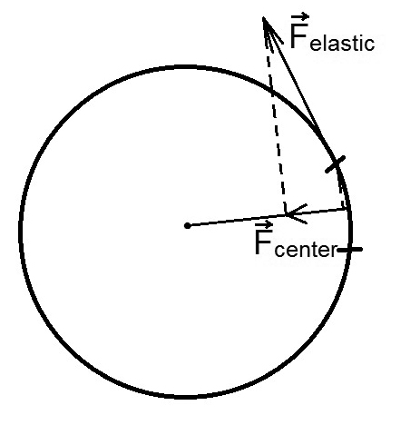However, to use this formula we need to know pressure in the balloon and it’s volume. Finding it through experiment every time ends up with very tired me and a lot of broken equipment. So, it would have been great if we found theoretical dependence of the pressure on balloon’s volume. Let’s try: they can be connected through the mechanical stress in the balloon’s shell. On one hand, relative increase of area of some small part of the shell can be found as:



where E is Young modulus, μ is Poisson’s ratio, σ is mechanical stress. Relative increase of area of the whole surface of the balloon will be the same, and as soon as our balloon is a sphere, it will be 3/2 of relative increase of balloon’s volume.

Figure 1. Elastic force, acting on a small piece of shell, and it’s component, directed towards center.

On the other hand, if we consider elastic force acting on a small part of the balloon’s shell, because of the curve of surface it will have some projection towards balloon’s center (as shown on fig.1). This small force should be equal to the pressure force acting on this part of shell, so difference between pressure inside the balloon and atmospheric pressure is:



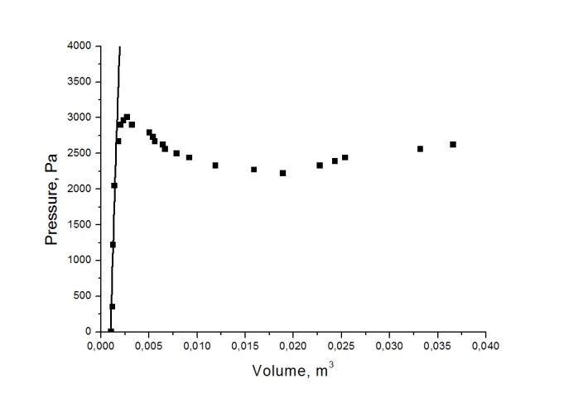where d is width of the shell, R is balloon’s radius. Now, if two equations are combined, we get king-sized burger:



where V0 is original volume of the balloon. On the fig.2 this burger is checked. For volumes less than 1.8 liters results are correct; however, for bigger volumes rubber starts misbehaving – it doesn’t behave according to Hook’s law anymore, and goes into super-elastic steady. Therefore, we approximated that after volume of 1.8 liters pressure will remain constant.

Figure 2. Line is plot of theoretical formula, while dots are experimental. Average error of volume measurements is 0.0008 m3

But we remember, that rubber itself also stores energy. Knowing mechanical stress in the shell, energy density can be calculated as:



Therefore, energy in the shell is:



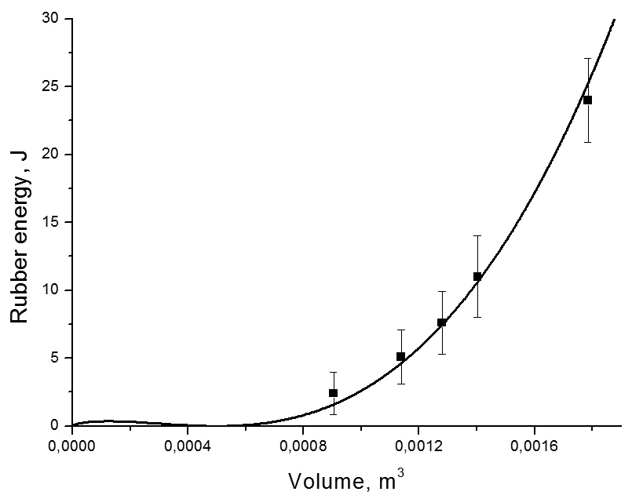That’s just great, but it definitely requires checking. So how can be energy stored in rubber measured? Well, we can easily find work done by the pump, when we are inflating balloon (for example, we can put a weight on the pump – change of weight’s potential energy will be equal to the work done by the pump). The difference between work, done by the pump, and energy of air inside the balloon should be equal to the energy of rubber. And, unfortunately, to all losses which occurred while inflating the balloon. How can we avoid adding these losses? The answer is: let’s inflate something else, with shell which can’t be stretched. For example, a frog. No, wait, it’s forbidden – if inflated too much it can explode and I’ll have to clean everything… Then let’s inflate a plastic bag. All useful work of the pump will turn into energy of the air; and losses won’t be included. Now we should do the same work with the pump to inflate our balloon. Difference between the energy of air inside plastic bag and balloon will be energy, stored in rubber. Result of this brilliant idea is shown on fig.3. Again, after volume of 1.8 liters rubber goes into super-elastic steady; therefore energy density will remain constant, and rubber energy will increase because of the increase of the volume of the shell itself.

Figure 3. Dependence of the rubber energy on the volume. Line shows theoretical prediction, dots are experimental data.

Now we know full energy stored in the car; but in order to find it’s efficiency we have to decide what is useful work for our system. What is main purpose of the car? Why do we use it? To understand it I’ve painted fig.4. And it became obvious: car is used 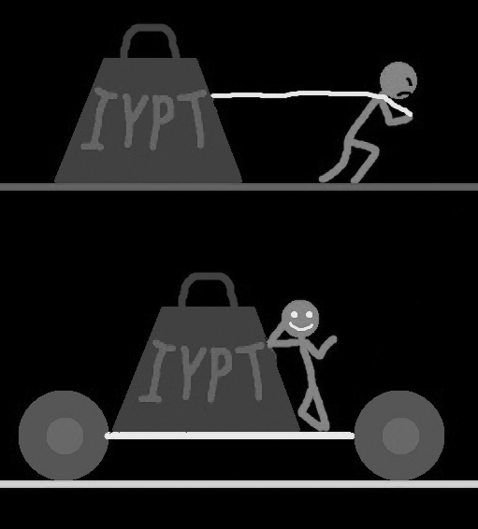to overcome friction. If energy from the balloon was used to overcome friction, it means that car has moved something forward, and, therefore, done something useful. And if energy was spent on the turbulence in the nozzle or on air drag, then it was wasted.

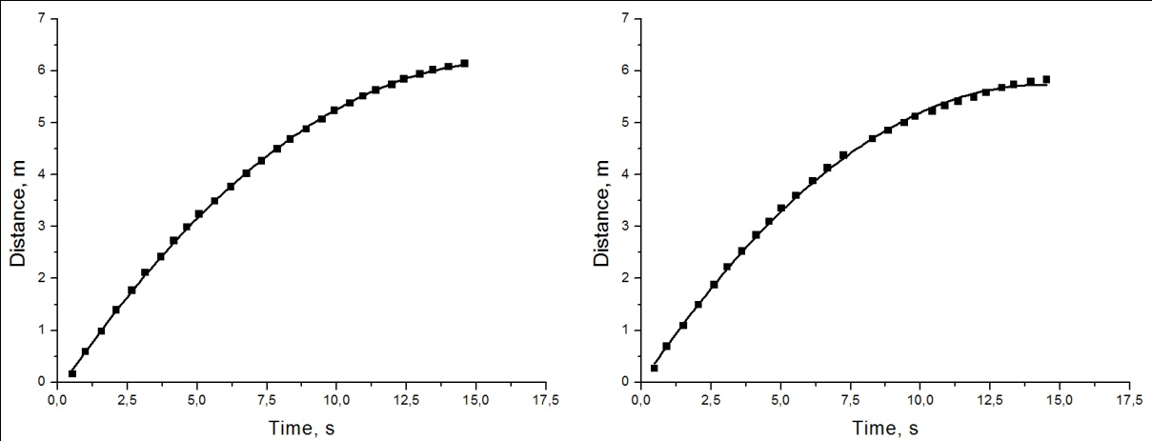So we know our enemy: we should fight losses in the nozzle and air drag. However, fighting air drag is like fighting a baby. It’s just too small. To prove it, an experiment was made: we had put a sheet of cardboard on our car; first time – horizontally (for small drag), second time – vertically (for increased drag). Then we kicked car forward and plotted law of it’s movement (fig.5). The difference between forces, which were stopping the car in two cases is less than 5%. Therefore, air drag can be ignored. Unfortunately, losses in nozzle can not.

Figure 4. Smile makes everything obvious.

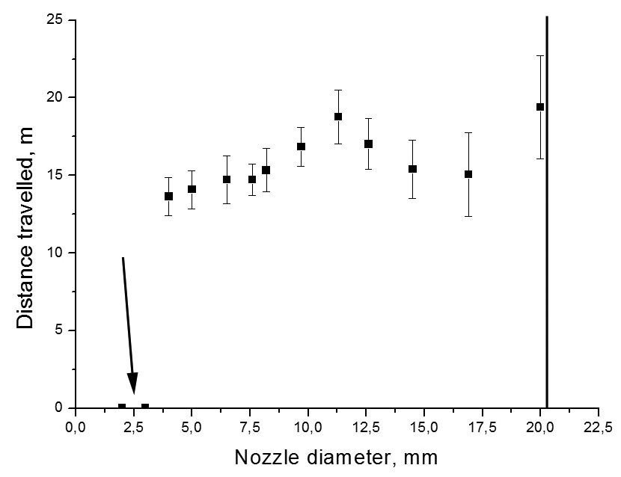There are three reasons of loosing energy in nozzle: turbulence, viscous drag and scattering of the jet, after it exits nozzle. Amount of energy, lost in any of this ways, strongly depends on the length and width of the nozzle. It is difficult to describe this dependence even for just one of the effects; describing all three effects at once is almost impossible. Therefore, we tried to research these dependences experimentally. And even through experiments we havn’t found dependence on the length of the nozzle: dots were jumping randomly. However, on the fig.6 you can see dependence of distance travelled on the diameter of the nozzle. With too small diameter car just can’t move forward (first two dots). Then we have a local maximum, and in the end dependence is growing. Unfortunately, with nozzle diameters bigger than 20 mm car becomes unstable (tries to kill itself by crashing into closest wall). But we can predict, that there will be another local maximum, after which dependence will fall to 0. It is easy to prove: if we take our balloon and stick adhesive tape over it’s equator, and then pierce it. The side, which we’ve pierced, will explode and let the air out; adhesive tape will prevent the other side from tearing apart. So we will achieve nozzle diameter equal to the diameter of the balloon. But when we performed such experiment, our car travelled only 5 cm. Knowing all this, we can say that for maximal efficiency we should use the nozzle diameter from the first local maximum.

Figure 6. Arrow points at the dots, where car hasn’t moved at all. Black line shows nozzle diameter, after which car becomes unstable.

Figure 5. Left plot shows travel when a sheet of cardboard was placed horizontally, right – when vertically. Both are fitted by square parabola.

It is very interesting, that our losses do not depend on the distance, travelled by car: losses in nozzle depend only on nozzle parameters, and air drag is too small. At the same time, energy, stored in the balloon, also doesn’t depend on the travelled distance. So, if we have inflated our balloon and attached a nozzle to it, we have already determined how much energy will be spent on useful work – overcoming friction. Therefore, the only way to change travelled distance now is to change friction forces.

There are two friction forces, acting in our system: rolling friction force (F1) and static friction in the axes (F2). These forces will be calculated as:



where R is wheels radius, M is car’s body mass, n is number of wheels, σ is surface density of wheel’s material, k and μ are static and rolling friction coefficients respectively. If car has travelled distance L, then work of rolling friction will be F1*L; however, work of static friction will be F2*L*(r/R), where r is radius of the axis; it is so because static friction force is applied closer to wheel’s center, where smaller distance will be covered. In total work of friction forces is equal:



Since we want for L to be maximal, we have to make X(R) minimal; to find it’s minimum we can take it’s derivative and put it equal to 0:



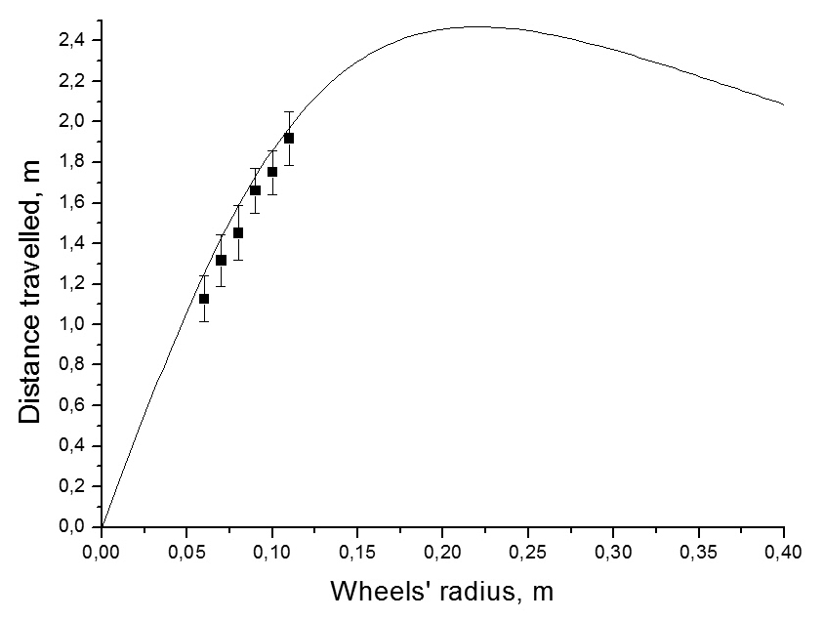After solving these equations, a formula for optimal wheel radius is achieved:



It is interesting to note, that total mass of the wheels in this case is connected with car’s body mass by this equation:



To check dependence of the distance travelled on wheels’ radius it was necessary to transfer constant amount of energy to the car. Inflating balloon so many times seemed too difficult, so, instead of it, a pendulum was used: it was hitting car, and car was moving forward (fig.7). It should be noted, that we hadn’t checked wheels with radius close to optimal value, because they were too big to fit the car. Well, just one wheel was size of the whole car.

Figure 7. Dots show experimental data, line is theoretical dependence.

Ok, while trying to destroy the car with pendulum, my fingers had some rest after cutting lots of wheels out of cardboard; so now I can write conclusions.

Full energy stored in the balloon is a sum of energy of pressurized air and of stretched rubber. With help of the equation, which connects pressure and volume of the balloon, we can calculate both those energies.

All this energy goes into two places: some is used to overcome friction forces – that’s useful work; other is wasted on the losses in the nozzle. Air drag for our car was negligibly low.

Amount of losses in the nozzle depends on it’s length and diameter; however, it’s impossible to describe these dependences theoretically. Experimentally we have found two peak values for the nozzle diameter; the first one should be used, because with second car’s driver becomes a drunk suicidal teen.

Distance travelled by car depends mainly on the wheels’ parameters. They all can be connected in order to calculate optimal radius; however, it is pretty big and not very convenient to use.

In the end I will ask you to keep silence for a minute, in memory of the car model, which was used during experiments. When trying to find dependence on the length of the nozzle at some moment I had become very angry, and kicked the car in the rear wheel. Doctor said, car had no chances with such injuries. Thanks God, I managed to clone the car and continue experiments.