BREAKING SPAGHETTI

Stanislav Krasulin
BSU Lyceum, Belarus
Introduction
This problem asks us about conditions, under which dry spaghetti falling on a hard floor will not break. Certainly, one of the main parameters of a strike is angle at which spaghetti hits the floor. There are three possibilities: spaghetti can fall prone, it can jump in the tin-soldier position, and also it can hit the floor at some angle between 0° and 90°. Because of the difficulty of the task and both size of the report and time for it’s preparation being limited, we had focused our research on just one case: when spaghetti falls vertically (tin-soldier position).
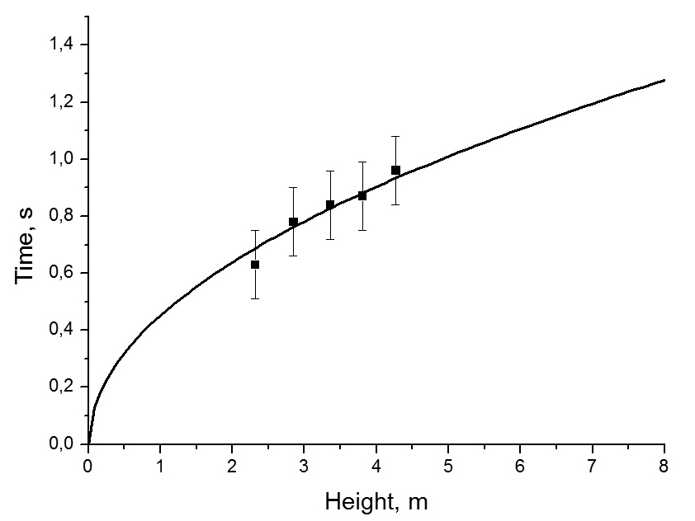
Air drag influence
Another very important parameter is velocity spaghetti has right before the strike. However, velocity isn’t very graphic value; everything is easier to understand if use height of fall instead. But vacuum is rather uncommon environment for spaghetti; so before connecting these two parameters, it is necessary to check if air drag should be taken into account:
Figure 1. Time of falling depending on height. Line is theory, without taking drag into account; dots are experimental.
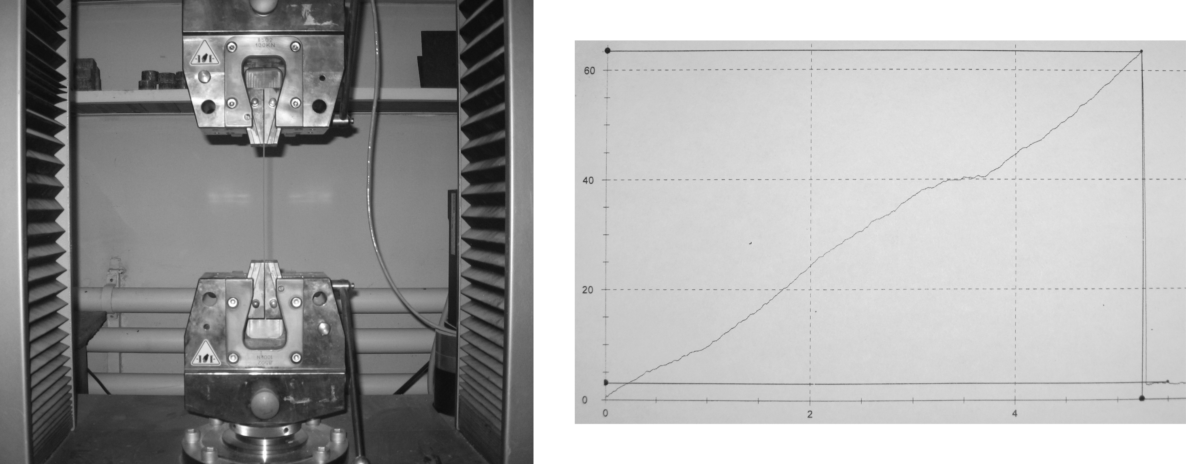
where S is reference area (for long cylinder it is it’s basement area), v is velocity, ρ is air density, C_{d} is drag coefficient (for long cylinder it is 0,82). Fortunately, it turned out that in our range of heights drag influence is negligibly small (see fig.1). At the same time, this equation helped us to calculate the maximal velocity spaghetti can achieve falling in the Earth’s atmosphere: about 60 m/s (for tin-soldier position). This is rather big value; at least big enough for us not to be able to achieve it in the lab. However, if spaghetti falls horizontally (prone) the maximal velocity is significantly lower (due to a bigger drag coefficient and reference area); it turns out to be 5.6 m/s. Experiments have shown that it is easy to throw spaghetti at even bigger velocity; but no spaghetti were broken during such an experiment: if spaghetti hits the floor prone, this velocity just isn’t enough. That is why we can state, that if falling prone, spaghetti just can’t achieve velocity required for breaking, due to air drag.
Relative stretch, %
Force, N
Figure 2. Spaghetti, mounted into Zwick Z100 tensile-testing machine and an example of it’s output for “pastaZARA” spaghetti (horizontal axis is relative stretch, %; vertical is force, N).
Spaghettis’ mechanical properties
The research of deformation and possible destruction of an object requires knowing some mechanical properties of it’s material, like Young’s modulus and critical relative deformation. For obtaining these data we used Zwick Z100 tensile-testing machine (see fig.2). Output data can be seen in the Table 1.
Table 1. Results of testing of different spaghettis.
Name | Diameter d, mm | Young’s modulus E, GPa | Critical relative stretch ε_{crit}, % | Critical stress σ_{crit}, MPa
“pastaZARA” 1 | 1.45±0.03 | 0.59±0.02 | 5.25±0.05 | 31.0±0.5
“pastaZARA” 3 | 1.65±0.03 | 0.59±0.02 | 5.25±0.05 | 31.0±0.5
“pastaZARA” 5 | 2.05±0.05 | 0.59±0.02 | 5.25±0.05 | 31.0±0.5
“Monte Banato” | 1.40±0.02 | 0.63±0.01 | 4.71±0.03 | 29.7±0.2
“Makfa” | 1.40±0.03 | 0.92±0.05 | 2.63±0.06 | 24.2±0.4
“Borimak” 1 | 1.40±0.05 | 1.36±0.08 | 1.12±0.07 | 16.3±0.5
“Borimak” 2 | 1.70±0.05 | 1.36±0.08 | 1.12±0.07 | 16.3±0.5
“Borimak” 3 | 2.00±0.05 | 1.36±0.08 | 1.12±0.07 | 16.3±0.5
However, it is hard to believe that whole spaghetti during strike is stretched or compressed like in this machine; it is more likely to break because of curving. Certainly, it’s also a combination of these deformations – some layers of spaghetti are stretched, some are compressed. And some are not deformed at all. Let’s assume that the very central part of spaghetti isn’t stretched whenever spaghetti is curved¹ and has length L₀. Then, if radius of curvature is R and diameter of spaghetti is d, relative stretch (ratio between absolute elongation and original length) of it’s outer layer L₁ can be easily calculated:
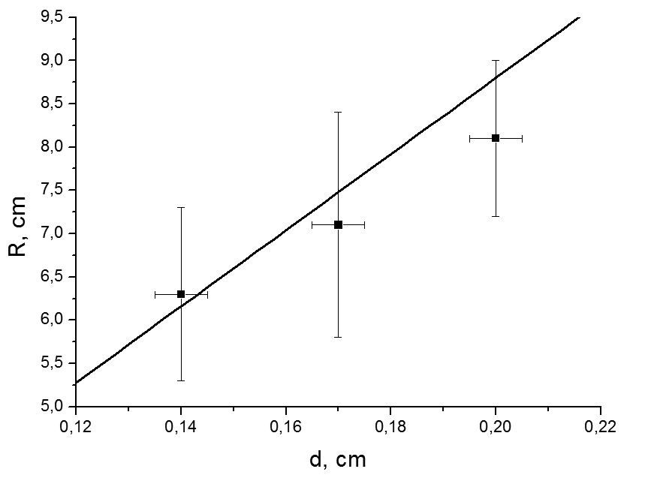
For spaghetti not to break, this value should be smaller than ε_{crit}; thereby, maximal radius of curvature:
Checking this dependence is rather complicated because we can’t change values ε_{crit} and d. However, some manufacturers (“pastaZARA”, “Borimak”) do produce spaghettis of the different diameters, but same recipe. Unfortunately, number of such diameters is still strongly limited; that is why fig.3 has only three experimental points. We were curving spaghettis around a number of cylinders, which radiuses differed by 0.5 cm. Vertical error bars on the fig.3 depict the range of radiuses for which less than 100% but more than 0% of spaghettis broke. The point is set in the middle of the range. Within accuracy of our measurements even this very simple mathematical model gives results, close to real. It means, that there’s no need in it’s improvement: anyway we can’t detect that it has come closer to the real value.
Figure 3. Critical radius of curvature vs. diameter of spaghetti (“Borimak”): points are experimental, line is theoretical.
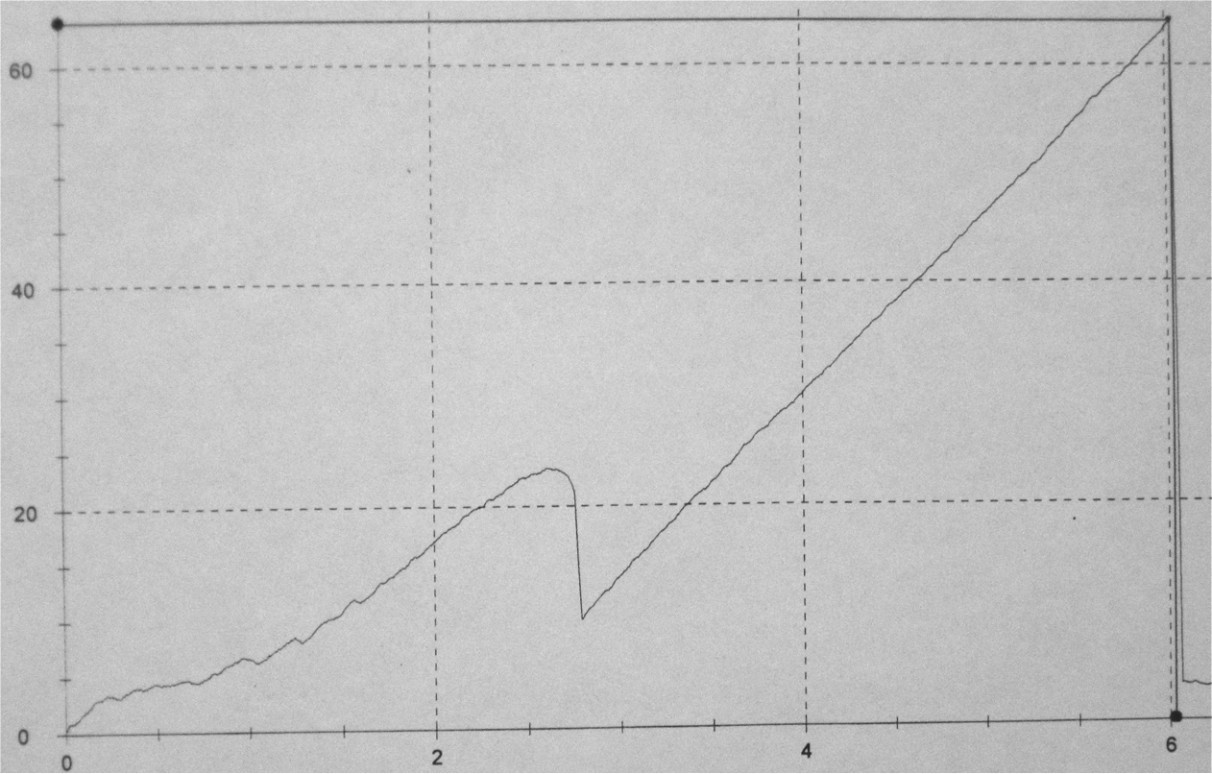
Stochasticity of the phenomenon
Force, N
Also, it should be mentioned that not all experiments with tensile-testing machine were successful (fig.4). There you can see that at some point inner parts of spaghetti had moved relatively to each other; however, spaghetti hadn’t fractured. Such results were marked as “mistake” and weren’t included in the values given in the table. But same things can occur in the experiments with falling spaghetti, thus allowing it not to break under conditions it normally should. That is why we can’t just set a range for each parameter, within which spaghetti will break; there will be only some certain frequency of breaking for each set of parameters. We defined the frequency of breaking as the ratio N/N₀, where N₀ is total number of spaghettis dropped, and N is number of spaghettis that were broken. Therefore, in our work we were researching this frequency of breaking depending on different parameters.
Figure 4. Another test of “pastaZARA” spaghetti. A random jump in the dependence significantly increases critical stretch.
Relative stretch, %
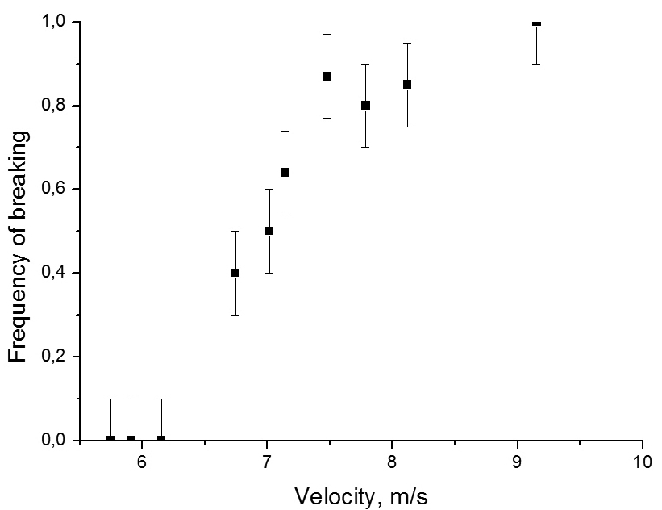
Gravity force
During discussions of this task there was often raised question about influence of gravity force during the impact. When spaghetti hits the floor it is reflected upwards, or, at least, stopped. It means that it’s momentum changes at least by m*v, where m is spaghetti’s mass. Through filming strike on a high-speed camera, it was found out, that it lasts less than t=0.001 of a second. Therefore, average force acting on the spaghetti during strike is:
Figure 5. Frequency of breaking vs. velocity (“Borimak” 1).
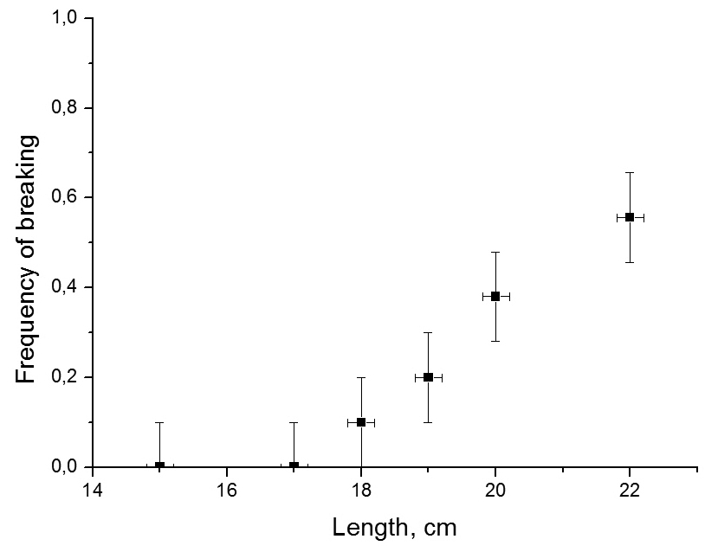
At the same time gravity force acting on this spaghetti is about 4.5*10⁻⁴ N – thousand times smaller. So, gravity force is negligible during strike.
Different parameters
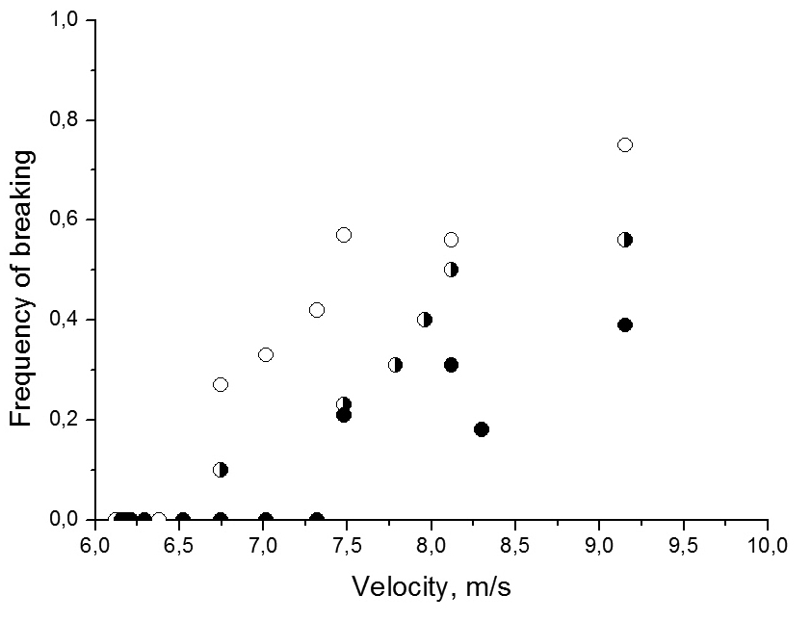
It was already mentioned, that one of the main parameters is velocity. Fig.5 shows dependence of frequency of breaking on the velocity spaghetti has right before the strike. There are velocities, for which this frequency is zero; but as velocity gets higher, frequency increases too. It is easy to explain: spaghetti breaks, if it reaches critical curvature; but this bending requires energy. So, the higher is the kinetic energy of spaghetti, the higher is possibility, that critical curvature will be reached.
Figure 6. Frequency of breaking depending on spaghettis’ length for velocity 8 m/s (“pastaZARA” 3).
But changing velocity isn’t the only way of changing kinetic energy; mass of spaghetti also can be varied; for example, through varying it’s length. Fig.6 shows that increase in length (and, respectively, mass) causes increase in frequency of breaking – additional kinetic energy gives higher possibility of reaching critical radius of curvature.
Figure 7. Empty circles are for d=1.45 mm, half-full – d=1.65 mm, full – d=2.05 mm. Average error of frequency is 0.12. (“pastaZARA”).
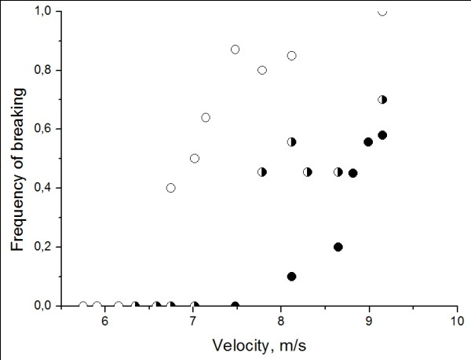
Changing of diameter also will cause changing of kinetic energy. However, fig.7 (dependence of frequency of breaking on velocity for different diameters) shows that here additional kinetic energy does not increase frequency: because of bigger diameter, it requires more energy to deform spaghetti to it’s critical curvature (even though the critical curvature itself decreases). The plot shows that this increase in required energy overcomes gain in kinetic energy.
It is also interesting that there is a correlation between spaghettis’ price and frequency of breaking: in general, cheaper spaghettis are easier to break (fig.8). It can be explained by differences in the chemical structure: expensive spaghettis (“Monte Banato”) have eggs as their ingredient. And in this situation eggs work as some kind of glue, increasing spaghettis’ critical relative stretch, therefore increasing energy, required for breaking.
Figure 8. Empty circles are for cheap spaghettis (“Borimak” 1), half-full are for medium priced (“Makfa”), full are for expensive (“Monte Banato”). Average error of frequency is 0.11.
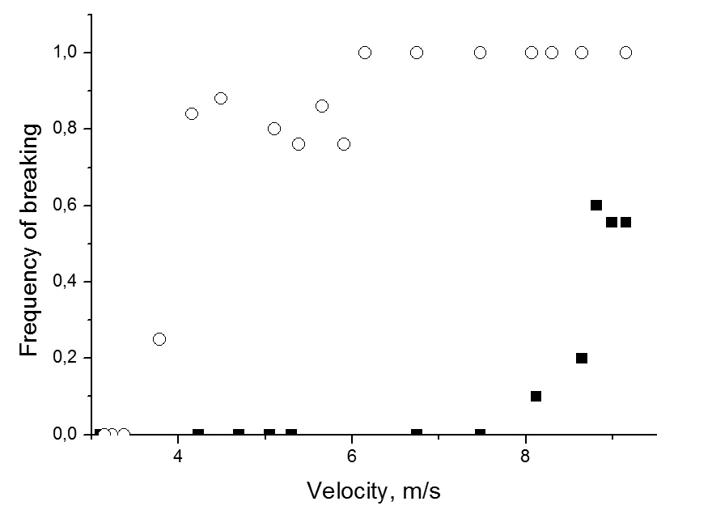
Also, it should be noticed, that all such comparative experiments should be run within one day; otherwise there will be mistakes, because of the changes in the humidity of air; and humidity of air affects that of spaghettis. Water increases elastic properties of spaghettis and decreases their fragility. This is shown on the fig.9, where usual spaghettis are compared to the very dry ones.
Point of breaking
During experiments we have noticed that spaghetti always breaks in the point, close to the hitting end. After we had measured lengths of broken parts in experiments with “pastaZARA” spaghettis, it turned out that spaghettis were breaking in the point approximately 1 cm away from the hitting end; and it hadn’t depended on the length (fig.10) or diameter (fig.11) of spaghetti. We decided that probably something in the way spaghettis are produced causes this point to be the weakest; however, when we had cut off 1 cm long parts from both ends of spaghetti and then dropped it, once again length of broken part was 1 cm, proving that something in the process of breaking defines the point, not in the spaghetti initial structure. That led us to a conclusion that spaghetti breaks because of standing wave.
Figure 9. Squares are for usual spaghettis, circles are for Spaghetti Extra Dry. Average error of frequency is 0.07. (“pastaZARA” 5)
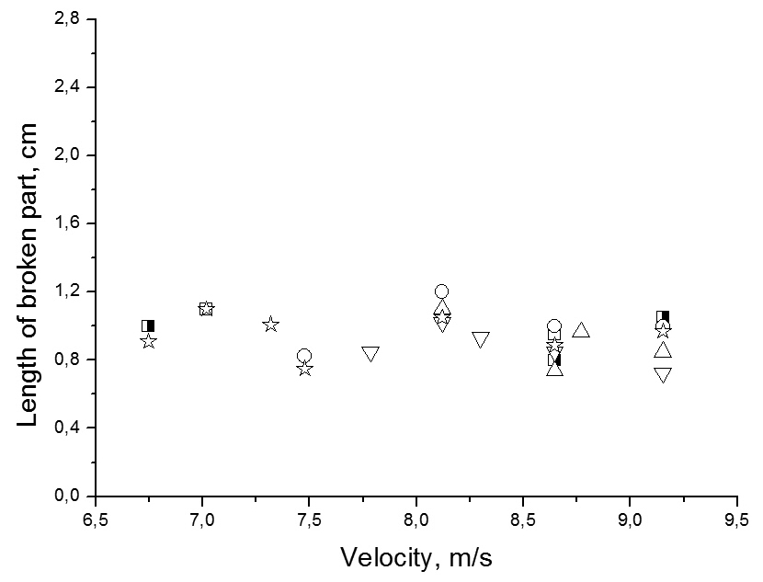
Standing wave
When spaghetti hits the floor a bending wave occurs. And if the wave reaches opposite end of spaghetti it is being reflected and summed with itself, producing standing bending wave. Now, spaghetti should break in the point of first antinode² (since second one will be smaller due to losses). And we know, that hitting end of spaghetti is the place of first node. So, distance between the end of spaghetti and breaking point should be a quarter of wavelength; therefore, wavelength λ=4*x, where x=1cm was found experimentally. At the same time, spreading rate of the wave can’t be higher than spreading rate of the sound wave, travelling in spaghetti:
Figure 10. Length of broken part depending on velocity for different original length: empty square – 15 cm, half-full square – 17 cm, upwards triangle – 18 cm, circle – 19 cm, downwards triangle – 20 cm, star – 22 cm. Average error of length is 0.20 cm. (“pastaZARA” 3)
where ρ is spaghetti’s density. Thereby, frequency of the bending wave is less than:
At the same time, we can say that whole strike lasts for a half of the bending wave’s period: this time is enough for spaghetti to bend to it’s maximal curvature and return into it’s initial shape, thus forcing it to jump upwards. And it has already been found through experiments that impact lasts for less than 0.001 s. So, period of wave is less than 0.002 s; and frequency of bending wave is higher than ν_{min}=0.5 kHz.
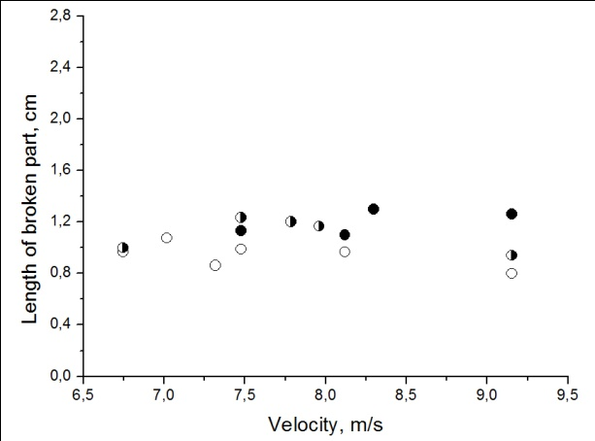
Different angles
Talking about possibility of spaghetti to fall on the floor at some angle between 0° and 90°, we can say that there are two different cases: the hitting end of spaghetti may remain fixed during the impact (it generally happens if spaghetti falls in position close to vertical, or if hitting end gets stuck because of some small obstacles on the surface of the floor); also it can slide to the side. The first situation is very close to the one described in our solution; it’s highly possible that all is need is to take into account that smaller part of original kinetic energy of spaghetti is transferred into energy of bending wave.
Figure 11. Length of broken part vs. velocity. Circles show same diameters, as on fig.7. Average error of length is 0.18 cm. (“pastaZARA”)
The second case is more complicated; first bending caused by friction force and normal reaction force occurs, and then a bending wave starts. Spaghetti can be broken both by just bending and by bending wave.
We have run an experiment to compare frequency of breaking in two situations. To resemble the second case we were dropping spaghetti on the sheet of acrylic resin. To resemble the first case we were dropping spaghetti on the sheet of the same acrylic resin, but with a number of scratches put with intervals of 1 cm; hitting end of spaghetti was caught on this scratches and, therefore, remained fixed during the strike.
Experiment has proven that frequency of breaking is higher if hitting end is fixed.
Conclusions
If spaghetti falls prone in Earth’s atmosphere it can’t reach velocity required for breaking. If spaghetti falls in tin-soldier position, it will be broken in the first antinode of standing wave, which is situated 1 cm away from hitting end. Frequency of this wave is between 0.5 kHz and 21.75 kHz. But breaking will occur only if spaghetti’s kinetic energy is higher, than energy required to bend spaghetti to it’s critical curvature. So, for spaghetti not to break, kinetic energy should be decreased; for example by decreasing velocity or mass (by decreasing length). However, if mass is decreased through changing diameter required energy decreases either. Other way of changing energy, required for breaking is changing chemical structure: adding water or eggs increases critical relative stretch, thereby requiring more energy for spaghetti to break.
However, in all this situations we can discuss only energy, required for breaking of ideal spaghetti. In real life, we can say only about increasing in breaking frequency, when close to described values.
References
[1] D. Sivuhin, “General Course of Physics”, vol.1 “Mechanics”, MIPT publishing, 2005;
[2] J.R. Gladden, N.Z. Handzy, A. Belmonte, E. Villermaux, “Dynamic Buckling and Fragmentation in Brittle Rods”, Physical Review Letters 94, 2005.

