REMOVING A PIECE OF ADHESIVE TAPE FROM A HORIZENTAL SURFACE

Hossein Azizinaghshª, Hamid Ghaednia^{b}
ªSharif University of Technology, School of Computer Engineering, I. R. Iran
Hossein.Azizi@gmail.com
^{b}Amir Kabir University of Technology, School of Civil Engineering, I. R. Iran
Ghaednia.Hamid@gmail.com

Abstract
The current article is an investigation on possible methods of determining the force, necessary to remove a piece of adhesive tape from a horizontal surface. Initially, the force was determined based on an energy-oriented method. In order to increase the accuracy and avoid some simplifications, a numerical simulation was developed.
The force was accurately measured and based on experimental measurements, theoretical predictions were verified.

Introduction
Adhesion occurs due to various types of interactions between the molecules of the adhesive and adherent materials. Depending on the type of the adhesive tape and adherent, different types of interactions are involved e.g. Van der Waals forces, physical interlocking, diffusion of polymers, electrostatic forces, etc.
There are various adhesion theories. None of these theories cover different aspects of adhesion. “A promising combination of different adhesion theories does not exist” [1] thus, adhesion is not a well-known phenomenon.

Adhesive tapes are a subject of various measurements [1][2][3][4]. But there is no comprehensive method to model the adhesive tape and predict its behaviour under different conditions. Various types of chemical and mechanical bonds [4] involved in adhesion, seem too complicated to be theoretically modelled. In the present work, a simplified model will be introduced. Despite its simplicity the predictions are much accurate and are in great agreement with experimental measurements.

It was observed that in some cases (Low pulling angle), detaching the adhesive tape from the adherent material is mainly due to deformation. A significant difference was observed when a paper adhesive tape and a plastic adhesive tape with similar adhesive coats were removed. Thus, aside from adhesive coat and its properties, the stretching of the adhesive tape is also decisively important.

When the force is applied, stresses propagate along the adhesive tape. These stresses cause the adhesive coat to deform. When the force reaches to a critical amount, the bonds between adhesive-adhesive or adhesive-adherent or adherent-adherent cannot provide enough force. Therefore they will be removed. In either case, the adhesive tape is removed from the surface.

Due to the low stress propagation velocity in the adhesive tape, the rate in which the adhesive removes will be of significant importance. When the rate of removing the adhesive tape is high, there would be a stress concentration in some areas. Thus, it will be removed with lower amount of force. In order to avoid the effect of pulling rate, in all measurements, the force is gradually increased, until the adhesive tape starts to remove. This way, the stresses have enough time to propagate the adhesive along tape. The adhesive tape will be removed under a slow and steady condition.

Theoretical Analysis:
In order to remove a piece of adhesive tape, all the bonds between adhesive-adhesive or adhesive-adherent or adherent-adherent should be removed. Removing each of these bonds requires a certain amount of energy. We define this energy as: $Aγ$, A is the area of the adhesive tape that has been removed from the surface and $γ$ is the adhesion energy per area. $γ$ is a function of environmental conditions. Aside from this, the deformation of the adhesive tape also consumes energy.

The change in the length of the adhesive tape is described by its modulus of elasticity, E, which is considered to be constant.

Based on these assumptions, and the conservation of energy, the force F can be found. (Fig. 1)
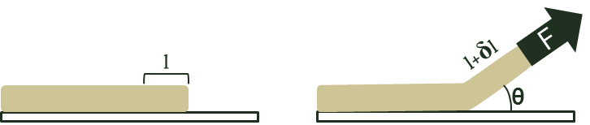
Figure 1: Declaration of parameters
$$W=\vec{F}.∆\vec{r}=- γA+ \frac{1}{2}k{δl}^{2} \left(1\right) \\ F=Etw\left[\left(\cos{θ-1}\right)+\sqrt{{\left(1-\cos{θ}\right)}^{2}+2\frac{γ}{Et}}\right] (2)$$

Numerical Analysis
The adhesive tape was modelled as a series of vertical and horizontal springs (Fig. 2). Vertical springs indicate the adhesive coat and the horizontal springs indicate the adhesive tape. When the force is applied to the first point, the equilibrium state of system (All points are in equilibrium state) will be found. At his point, if the length of the first spring is higher than a critical amount the adhesive tape will be removed. Otherwise the force will gradually increase and the process will repeat.
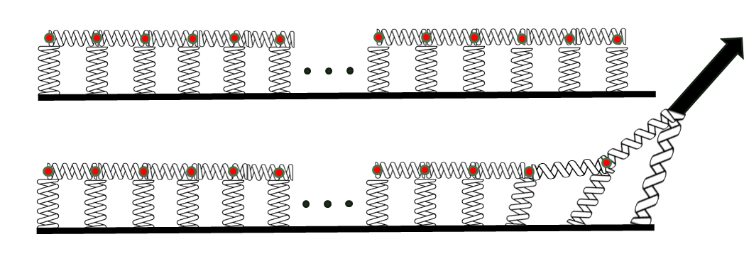
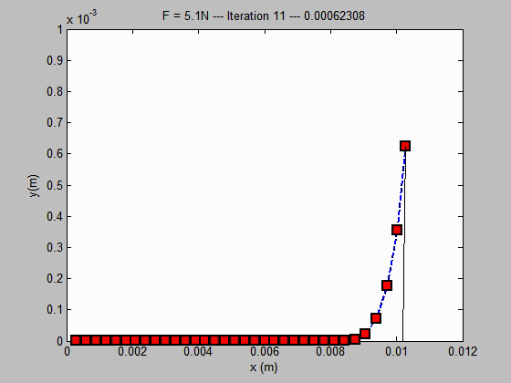
Figure 2: Modeling the adhesive tape as series of vertical and horizontal springs
Figure 3: resulted from the numerical model, developed with MATLAB

The main algorithm to find the equilibrium state of the system can be described in three steps (Fig. 4):
- The force is applied to the first point; the first point is moved to its equilibrium position, assuming other points to be fixed. In this condition, the second point is no longer in equilibrium position.
- The second, third, and all other points will be moved to their equilibrium position. For each point, we assume that other points are fixed.
- The first point is no longer in equilibrium position. Thus the process will repeat from point a (Iteration). After repeating the process, the system reaches to a condition in which all the points are in equilibrium (Fig. 3 and Fig. 4).

After finding the equilibrium state:
- If the length of the first spring is higher than a critical amount the adhesive tape will be removed (Fig. 3 and Fig. 4). (The bonds can no longer provide the necessary force)
- Otherwise, the force will gradually increase and the whole process will repeat until the adhesive tape is removed from the surface (Fig. 3 and Fig. 4).
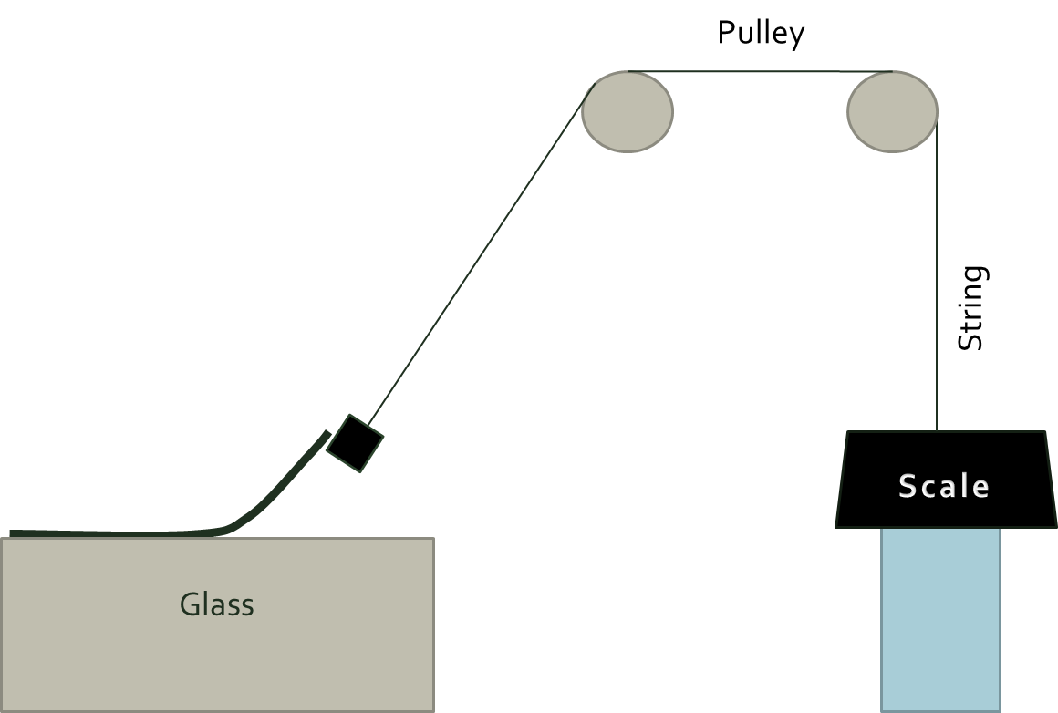
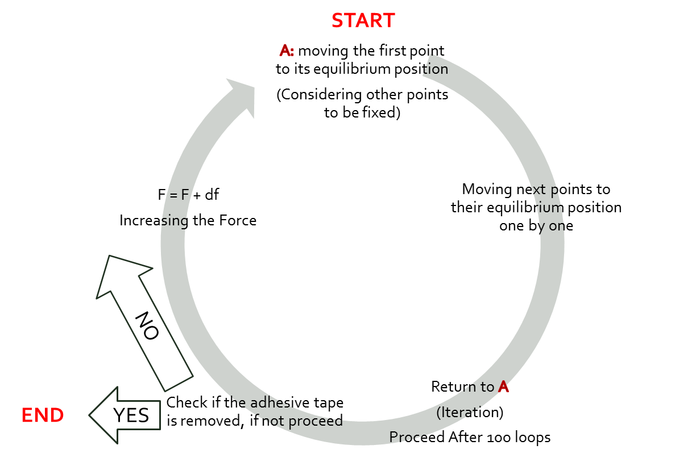
Figure 5: Experiment setup
Figure 4: Illustration of main algorithm

Experiments:
Measurement of the force:
The force necessary to remove a piece of adhesive tape was measured. A digital scale with the resolution of 0.1 gr is placed on a surface. The height of this surface is adjustable. One end of a string is attached to the scale; the other end is attached to the adhesive tape. By decreasing the height of the scale, the tension in the string will gradually increase until the adhesive tape starts to remove from the surface. The number indicated by the scale is the force necessary to remove the adhesive tape.

Measurement of modulus of elasticity
The applied force was measured when the adhesive tape is deformed (Fig. 6).
A scale with the resolution of 0.1 gr is placed on a surface. The height of the surface is adjustable. One end of the adhesive tape is attached to the scale. The other end is attached to a fixed point. By decreasing the height of the surface, the adhesive tape will deform and the corresponding force is indicated by the scale. This force was measured as a function of deformation (Changes in the width and length of the adhesive tape). Modulus if elasticity can be found by calculating the slope of force-strain graph (Fig. 7).

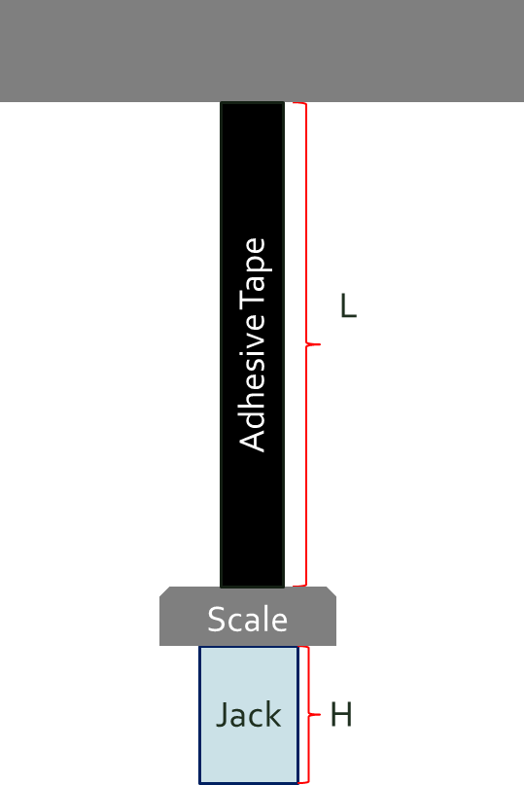
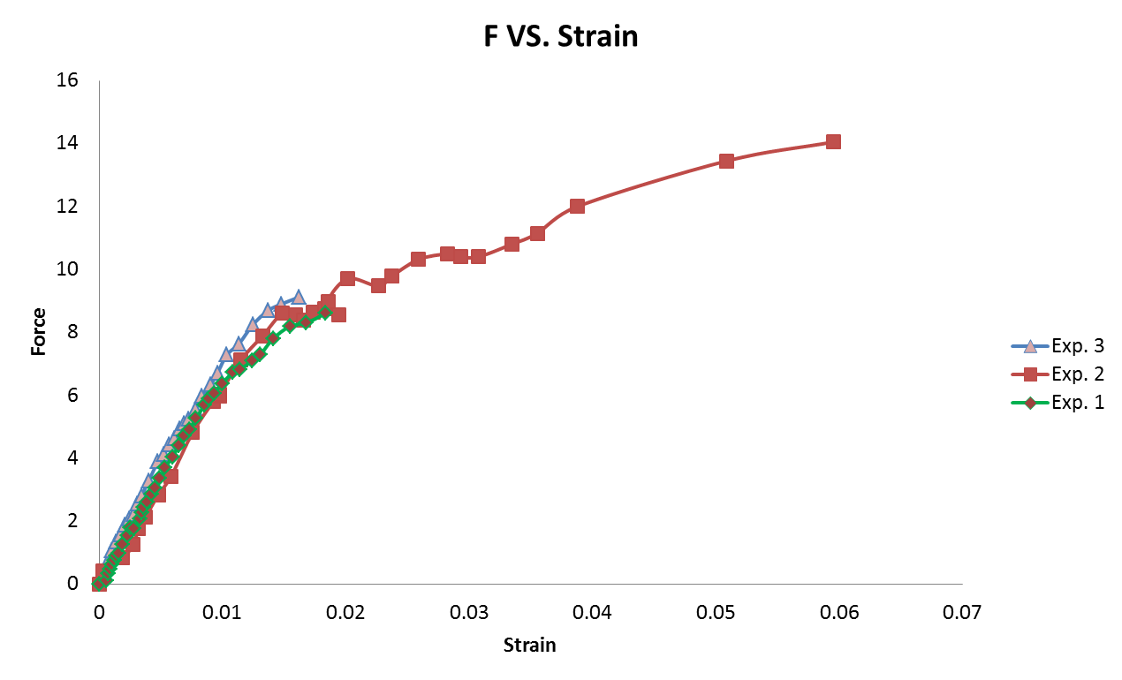
Figure 6: Experiment Setup
Figure 7: Force vs. Strain, the slope of initial, linear part is proportional to the modulus of elasticity

Calibration:
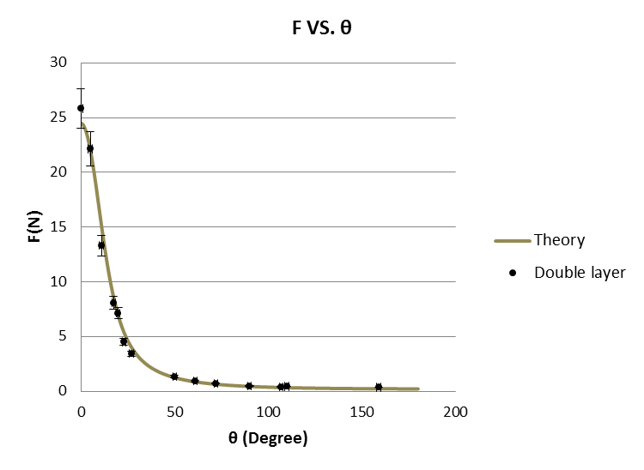
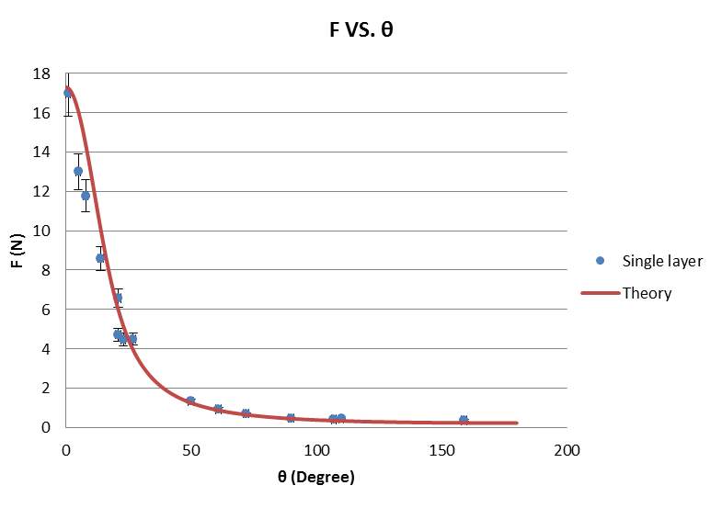
The theory requires some parameters that are dependent on environmental conditions and they cannot be directly determined, in order to measure these parameters, based on the experimental force vs. angle of pulling ($(θ)$ graph, both theories were calibrated and then another experiment was designed in order to verify the calibrated theory: A double layer adhesive tape was used, and force vs. angle of pulling ($θ)$ was measured, the result was compared to the prediction of the calibrated theory (Fig. 8).
Figure 8: the theory was calibrated (left graph-single layer adhesive tape), and then the calibrated theory was verified in another experiment (right graph-double layer adhesive tape)

Discussion
Both analytical and numerical methods provide accurate predictions (Fig. 9). The prediction of the numerical method is more precise in lower amounts of theta while the prediction of the analytical method is more precise in higher amounts of theta.

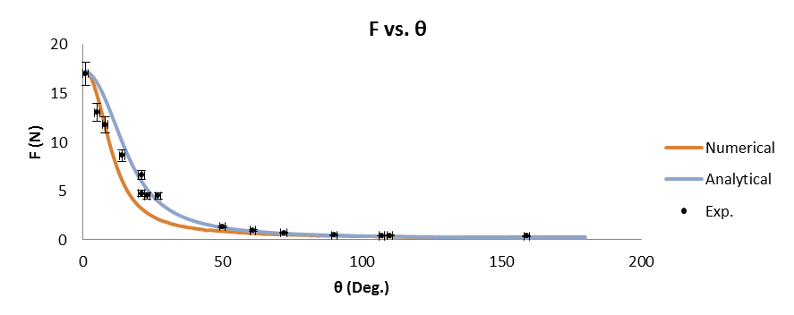
In the analytical method, it was assumed that the amount of energy, required to remove a piece of adhesive tape is independent of how it has been removed. This assumption is proved to be an appropriate estimation but in lower amounts of theta it seems unreasonable. The amount of work done on the adhesive tape may defer depending on the angle of pulling. Also the deformation of adhesive coat consumes energy which is not included in equations.
Figure 9: Predictions of numerical and analytical methods and experimental measurements
In the numerical method, the two vertical and horizontal springs may not be an appropriate modelling. In very low ($0<θ<20$) and very high ($90<θ<180$) angles of pulling the prediction is quite accurate in these ranges, only one of the springs acts. While in the $0<θ<20$ range, in which the two springs act together, the prediction is not accurate.

References:
[1] G.Gierenz, W. Karmann, “Adhesives and Adhesive Tapes”, Wiley-WCH.
[2] Istvan Benedek, “Pressure-Sensitive Adhesives and Applications”, Marcel Dekker Inc., New York – Basel.
[3] Sina Ebnesajjad, “Adhesives Technology Handbook”, William Andrew, Norwich - NY- USA
[4] Gerd Habenicht, “Applied Adhesive Bonding”, Wiley-WCH

