ADHESIVE TAPE

Nives Bonačić

University of Zagreb, Physics department, Croatia

**Abstract**

This paper focuses on determining the force necessary to remove a piece of adhesive tape from a horizontal surface and investigating the influence of relevant parameters. It explains a simple and fairly accurate experimental setup which enables changing the angle, width and temperature as well as the surface to which the tape is attached. It gives an insight to both microscopic and macroscopic process of removing the tape and a theoretical model compared with obtained results.

**Adhesion, cohesion**

Adhesive tape sticks to the surface due to intermolecular interactions between the glue molecules (long polymers) and their interactions to the surface. These forces are adhesion forces (between molecules of glue and the surface) and cohesion forces (between molecules and layers of glue). Thus, there are two easily observed basic fracture types, depending primarily on the velocity of removing the tape from the surface, adhesive and cohesive rupture. A previous study [1] has shown that typically under rupture velocities of ~10-3.5 (m/s) cohesive rupture occurs and above ~10-3 (m/s) adhesive rupture occurs. More thorough rupture explanations can be found in the Temperature section. While conducting the experiments, the rupture velocity was measured to assure an almost constant peel-off rate (minimum force) and a phenomenon of forming threads between glue layers was observed. During peel-off the stick-slip phenomenon was noticed, but the average velocity was not increasing so no further analysis of it was done.

**Model**

Assume that the total glue volume is preserved during the thread formation according to $V=Nr^{2}πl$, *N* being the number of formed threads which remains approximately constant over peel-off, *r* the radius and *l* the length of a thread. Critical condition of thread fracture depends on surface tension minimum. At a certain thread length it is more favourable to break into two parts than remain a single very long thread (Rayleigh’s instability criteria).

The adhesive energy per surface area of glue *G* holding the tape needs to be overcome by the peel-off force to remove it. Every tape and surface have a characteristical *G* which can be used as a comparison between measurements with different angle, backings and other conditions. This *G* depends on the above mentioned surface tension criteria and therefore on the temperature of the whole system.

The mentioned adhesive energy equals the work done by the peel-off force minus the stretching *S* and dissipation work *D $d\left(S+D\right)=bh\int_{0}^{ε}{σdε dx}$* where *b* and *h* are tape dimensions (thickness and width respectively), *σ* is tensile strength and *ε* is elongation ( $∆x/x_{0})$ of the backing material.

The work of the peel-off force removes the tape from the surface as well as elongates it. It is described by the relation $dU=F\left(1+ε\right)dx$ where *F* represents the peel-off force. Since the tape does not shear, work done in the plate direction by component *F1* (figure 1) is 0. The reduced expression being $dU=F\left(1+ε-cosθ\right)dx$.

All above considered, *G* (adhesive energy per surface) is:

$$G=\frac{F(1+\frac{ε}{2}-cosθ)}{b}$$

Elongation differs between measurements depending on the applied force. Hook’s diagram of plastic materials (such as these referred to as backing) shows that there is a small part of strain possible after elastic limit before failure and thus I find the use of Hook’s law appropriate. Elongation is calculated using the expression below, *E* being the Young's modulus, a backing characteristic $ε=\frac{F}{bhE}$.

**Tape properties**

Equations pointed out so far help to decide which important tape properties are to be evaluated such as tape width, thickness and Young's modulus. Measurements were done on two types of tape: transparent tape and creped tape (named after backing). Results were compared with factory data.

**Experimental setup**

A piece of tape (15 cm) was attached to an adjustable slope (aluminium and laminate surface) (figure 1) from the bottom side and evenly pressed with a metal cube. It was detached using a weight – various sized pots filled with water/grains. An empty pot hanged on a thin thread. The pot was slowly filled till the peel-off started. To assure that the minimal necessary force was applied a time measurement of the detaching process was done. Time was measured every cm of the peel-off, these intermediate times were compared and only experiments done at a constant peel-off rate were taken into consideration. Peel-off rates were mostly in the interval of both cohesive and adhesive rupture (~10-3.5 (m/s) to ~10-3 (m/s)).

The pot was afterwards weighed to find its mass and thus the peel-off force $F=mg.$

Angle variations were simple on this slope as it was completely moveable.

Tape width measurements were done using a 5 cm tape cut width a scalpel on a horizontal surface.

Temperature variations required a different setup. A long and wide metal plate (aluminium) was placed horizontally, warmed from one end with an electric stove and cooled down from the other with a constant water stream along the entire edges. This resulted in a linear temperature gradient from one to the other plate side measured with a laser thermometer to mark the same temperature sections.

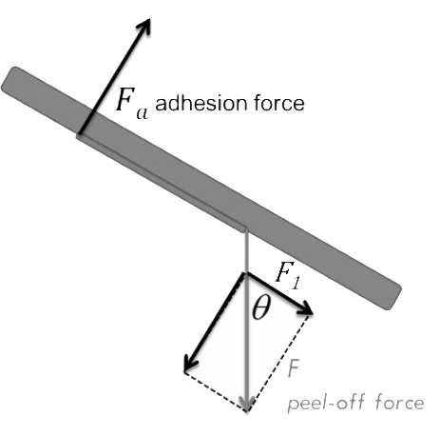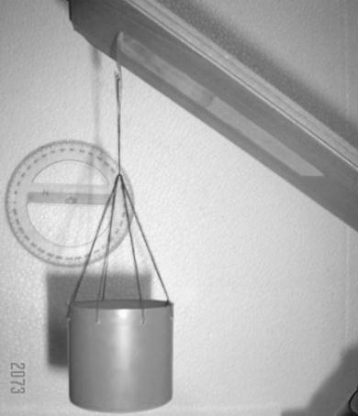

Figure 1: Force analysis on the slope with a marked angle and experimental setup consisting of an adjustable slope and a filling pot.

Relevant parameters

The focus of this study is on angle, width and temperature parameters as these can be evaluated by the presented theory.

A comparison of tapes is included with two tape types (transparent and creped tape). Other tapes were not taken into consideration. Tape differences could not be considered a true parameter due to variations between glues and backings (on which *G* depends on) and as these they are less relevant. Surface dependance is of importance as it influences peel-rate and is connected with pressure magnitude. Other surfaces besides aluminium and laminate were not investigated because it was not simple to express surface differences. Presented results just enhance that *G* is a surface-glue not just a glue property.

**Angle**

A complex relation between angle and the peel-off force requires an indirect representation. The x-axis includes $ε$, which is dependent on F but changes in a smaller order of magnitude than $cosθ$ and thus this is indeed an force/angle relation.

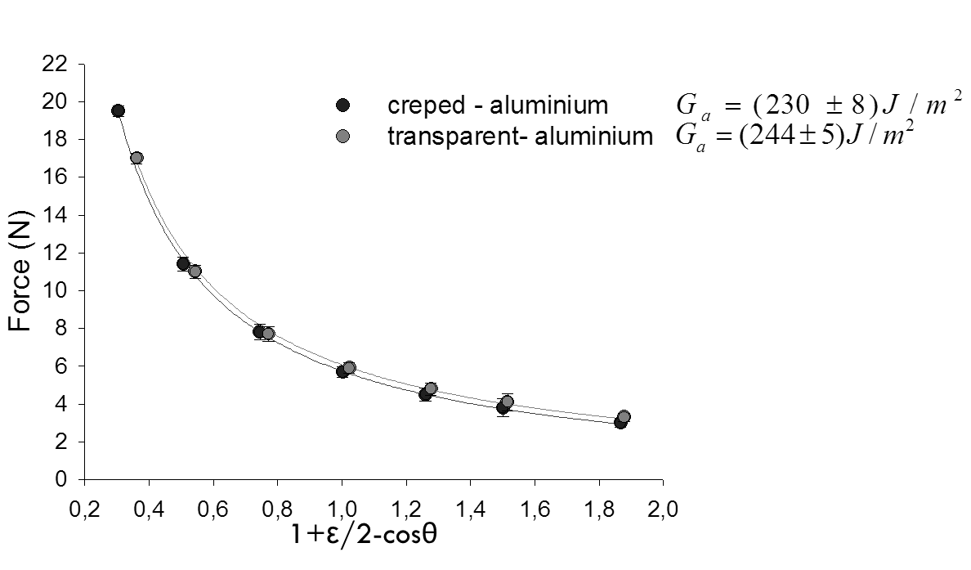All errors are from the progression plot.



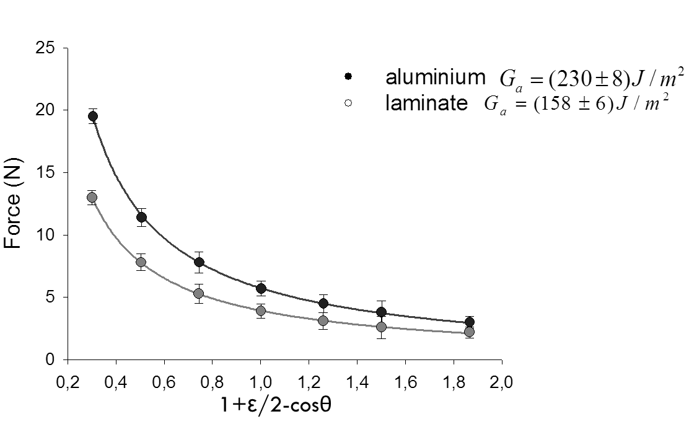Figure 2: Angle-force dependence on the aluminium surface for tapes, temperature 20°C, first order inverse function plots.

Figure 3: Angle-force dependence on aluminium and laminate surface for creped tape, temperature 20°C, first order inverse function plots.

Width

asdaskdhsakdhaksdhakdhakdhkashdkahdakhdkashdkadkadhakdajsada Tape used for this parameter is the same type and manufacturer transparent tape which is initially wider and cut for the purposes of this experiment. This relation is also shown indirectly and follows the equation variation:



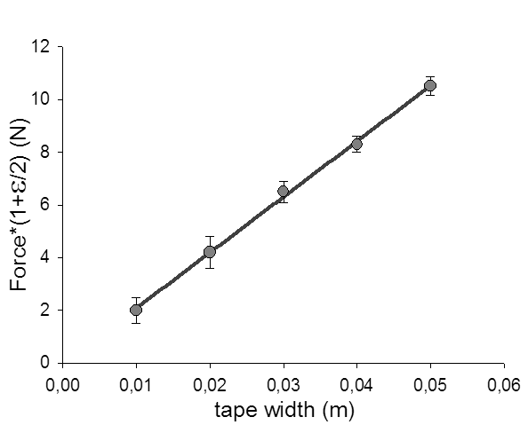



Figure 4: Tape width-force dependence on laminate surface for transparent tape, temperature 20°C, linear regression at a constant angle 90°.

**Temperature**

Observing the tape as a thermodynamic system helps us determine a minimum free energy condition from which the number of forming threads is found. Since surface tension depends on temperature it links the energy condition to temperature dependance.

Thermodynamic free energy $Ϝ$ is the amount of work that a thermodynamic system can preform related with $Ϝ=U-TS$ where *U* (the internal energy of the system) is surface energy. *U* follows the relation $U=N2rπl γ\left(T\right)$, $γ\left(T\right)$ being the surface tension of a surface formed of *N* threads. *S* is the system entropy for which a greater number of threads is more favorable and $S\sim kNlnN$ (entropy of an ideal 2D gass).

There is a minimum free energy condition which gives the *N0* number of formed threads

$$U=TS/\frac{d}{dN}$$.

Energy condition can be related to the force needed to peel-off the tape by surface energy/length derivation $F=\frac{∂U}{∂l}$, $U=N2rπl γ\left(T\right)$ resulting in

$$F=α\frac{{γ\left(T\right)}^{2}}{T}$$

This equation is obtained by expressing *r* by the constant volume relation $V=Nr2πl$.

Including surface tension temperature dependence $γ\left(T\right)=y_{0}{\left(1-\frac{T}{Tc}\right)}^{n}$, $y_{0}\left[\frac{J}{m2}\right]$,

where *n* is an empirical value (11/9 for organic liquids such as glue [2]), the final expression is

$$F=β\frac{{\left(1-\frac{T}{Tc}\right)}^{22/9}}{T}$$

with $Tc$ being the system critical temperature and $β$ a coefficient**.** These coefficients were read from the fit and $T_{c}$ showed agreement with factory data.

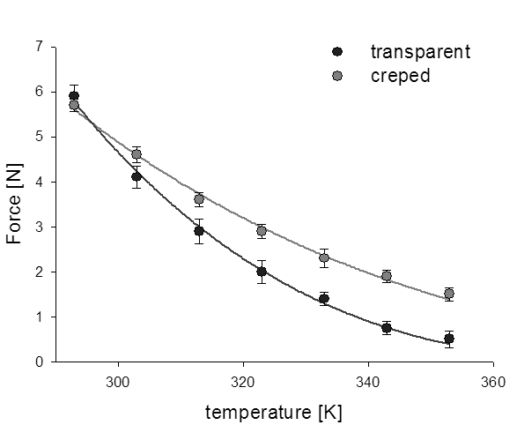

Figure 5: Temperature-force dependence on aluminium surface for both tapes, equation presented regression at a constant angle 90°.



**Conclusion**

In this work a comprehend answer to peel-off force determination and relevant parameters investigation was presented. The peel-conditions were set with fracture energy / surface *G* property evaluated for:

creped tape on aluminium , laminate  and

transparent tape on aluminium , laminate .

This energy determines the necessary force. Conducted experiments show the changes of this force *F* in accordance to predictions - preserving the same *G* for relevant parameters.

Angle (45°-135°), width and temperature (surface tension microscopic view) parameters show an excellent agreement of the experimental results and the theoretical model.

References

[1] A. J. Kinloch, C. C. Lau, J. G. Williams, The peeling of flexible laminates. Int. J. Fracture 1994, Vol:66, Pages:45-70

[2] Wikipedia: surface tension http://en.wikipedia.org/wiki/Surface_tension