ADHESIVE TAPE

Stanislav Krasulin

BSU Lyceum, Belarus
All right, so our task is to “determine force necessary to remove a piece of adhesive tape from a horizontal surface” and also we should “investigate relevant parameters”. Let’s take a closer look at some of these words. There are no explanations about how the tape should be detached from the surface: we get an object with tape, we have to make it object AND tape. However, word “necessary” points that we have to find minimal force required, and, therefore, the most effective way of removing should be used. My brain said that the most effective way is peeling. After a small social study we can state that 10 out of 10 brains say the same. Another disputable word is “horizontal”: it means “at right angles to the vertical; parallel to level ground”¹. However, I can’t imagine any possible affect of the gravity forces on the interactions between tape and surface; neither can anyone I’ve asked. So the real reason for using word “horizontal” remains scientific mystery. Therefore, we will replace it with word “flat”.
Now, when we got familiar with the task, we can start solving it. Well, ok, just one more cup of tea and I’ll start solving it. Honestly. Anyway, it is necessary to create an experimental setup, making experiments without it is a bit difficult. Certainly, everything will be much easier if tape is peeled with constant force. At the same time, since the tape is peeled, the point of application of force is all the time moving. That is why the best option is to use gravity force: it’s constant, it always follows the object. So, experimental setup will be like this: a flat sheet of material (we used acrylic resin), which can be placed at different angles to the horizon (to change peeling angle – angle between already peeled tape and surface). The tape is placed on the lower side of the sheet, and a weight is attached to tape’s end. Then, dependence of coordinate of the border of still attached to the sheet tape on time is measured.
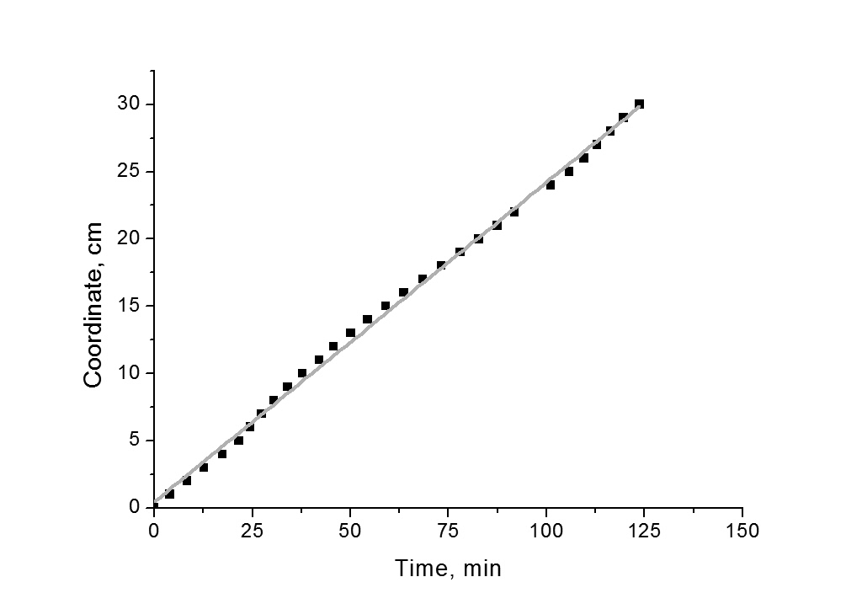
As you can see on the fig.1, this dependence is linear, therefore force, holding tape, is equal to the gravity force, acting on the weight. However, if attached mass is changed, dependence remains linear. Conclusion: tape “resists” detaching with the force equal to applied. To study this phenomenon, we should take a closer look at the clue behavior and interaction between tape and surface.
Figure 1. Peeling weight is 0.5 kg, velocity is (2.38±0.02) mm/min.
There exist different types of adhesives; however, we had focused our research on the most common one: pressure sensitive adhesive. It uses Van der Vaal’s interactions between it’s and other surface’s molecules.

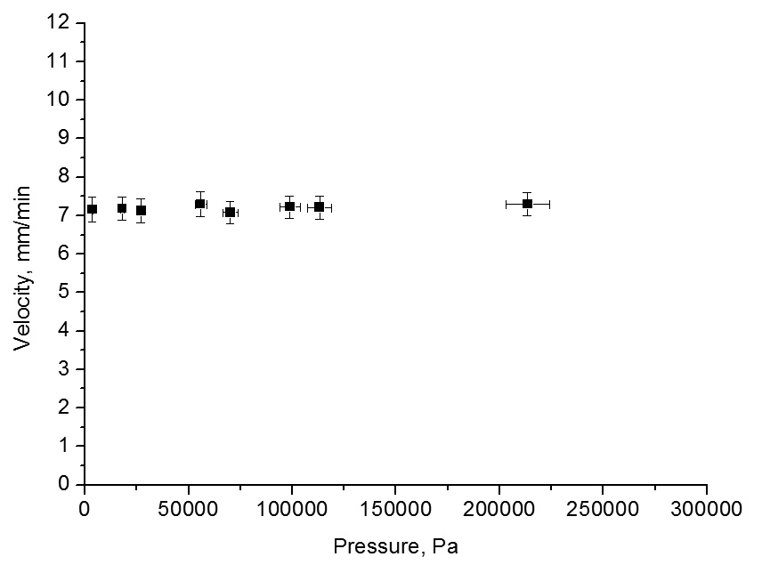
Certainly, after hearing words “pressure sensitive”, the first thing to do is to study dependence of the detaching velocity on the pressure, applied when sticking tape to the surface. As you see on the fig. 2, this dependence… well, there’s no dependence between the two values. In fact, it’s even obvious: once two molecules have met and started to interact, further pressing won’t change anything.
Figure 2. You call this pressure sensitive? Peeling weight is 0.5 kg, pressing mass ranges 0.1-30 kg.
But since no one likes when a thing and it’s name doesn’t correspond each other, we started to search for the pressure sensitive tape which will be sensitive to pressure. And we have found it. Unlike usual scotch tape, two-sided tape has rather not flat surface: there are notable “hills” on it (see fig.3). That is why, when putting this tape to some object, first the “hills” meet surface; and to make the lower parts of glue to reach the surface “hills” should be compressed. To describe this effect we had used “contact area” – area of the glue which actually interacts with the surface, in percents of all area of a sample.
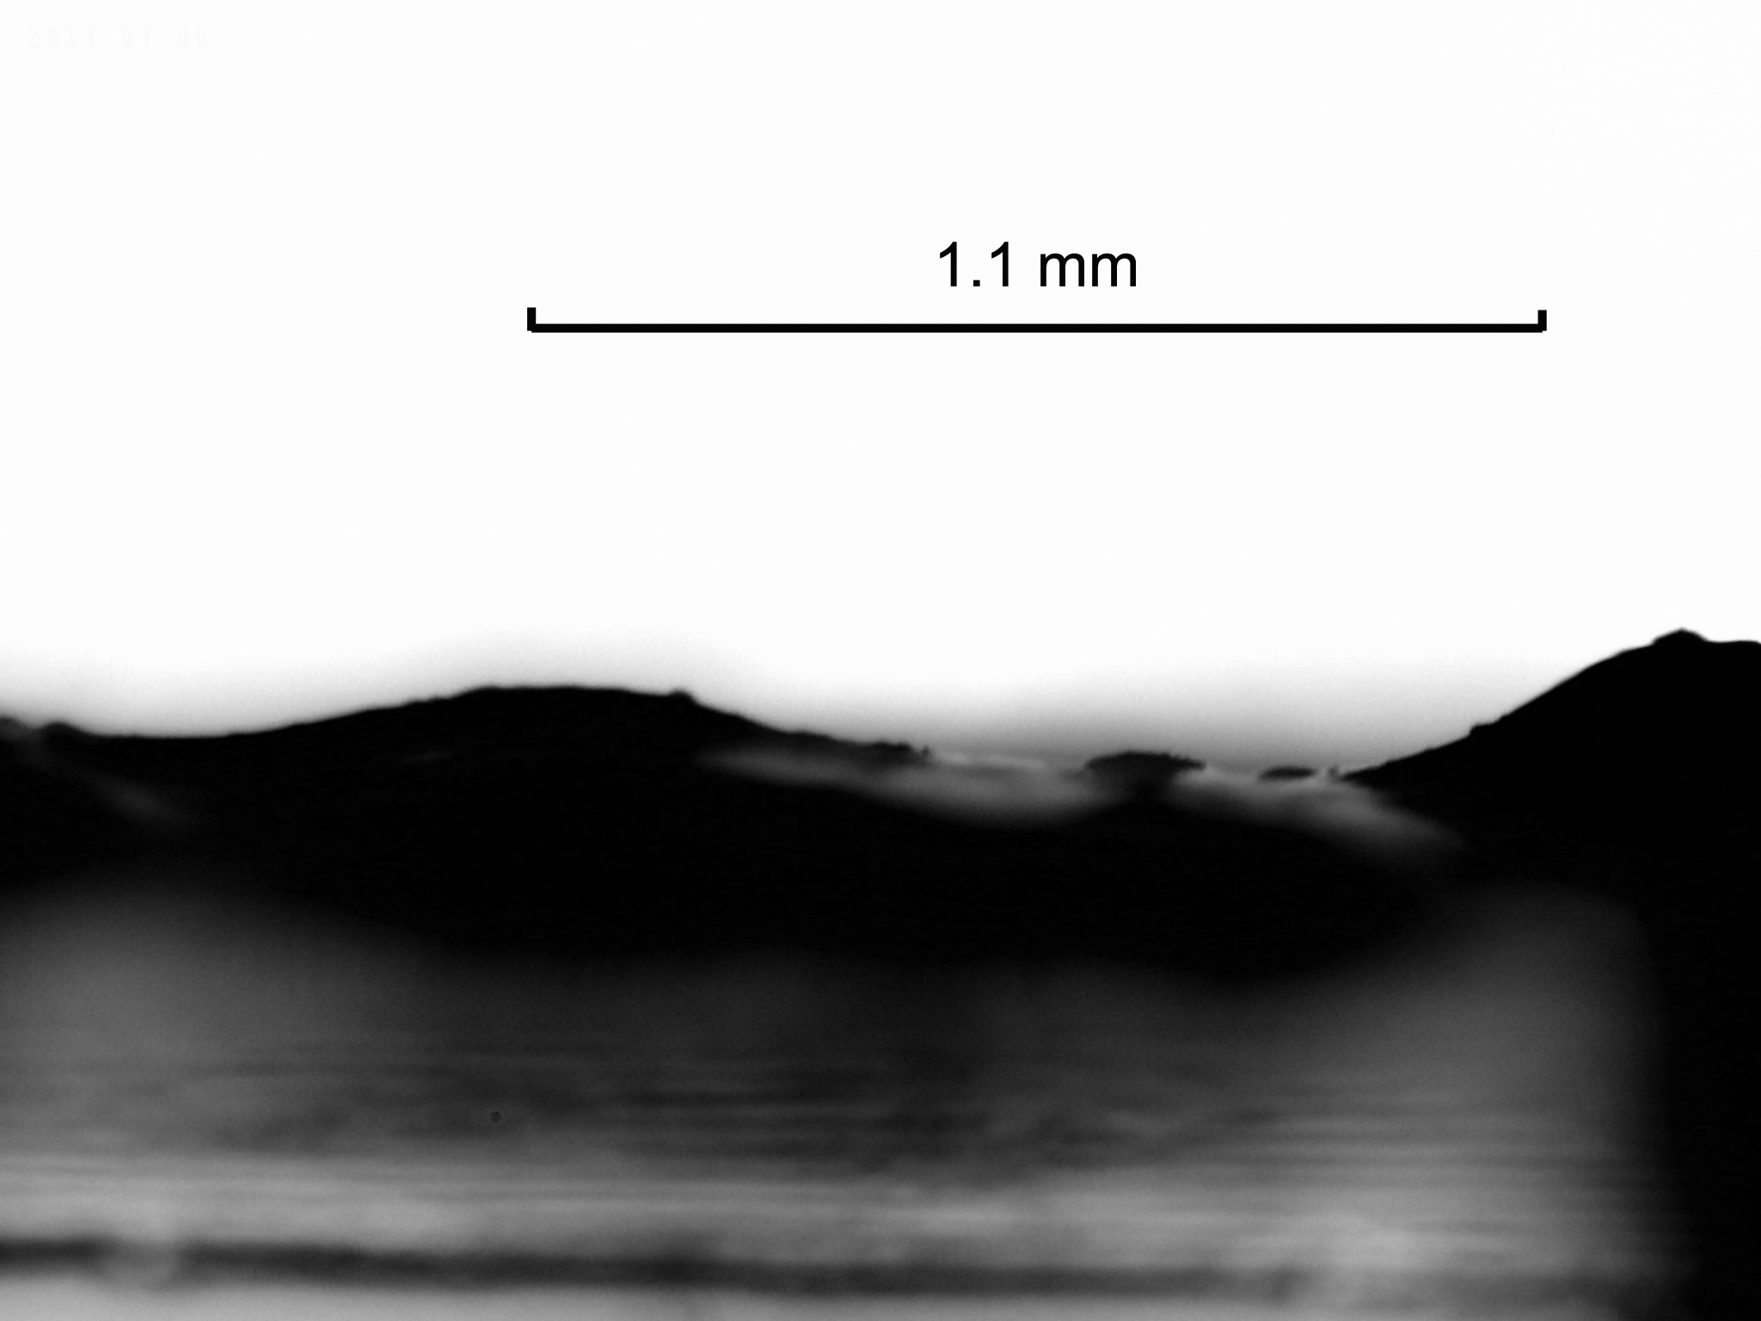
To measure this value another experimental setup was built. With one side tape was attached to a small panel (area of the panel was equal to the area of the sample). The other side of the tape was attached to the upper side of a sheet of glass and weights were placed on the panel. A small LED was attached to the side of the sheet and under the sheet a camera was placed. Then everything is placed in the dark place. Then I cry, because I’m afraid of darkness.
Figure 3. Two sided tape through the microscope.
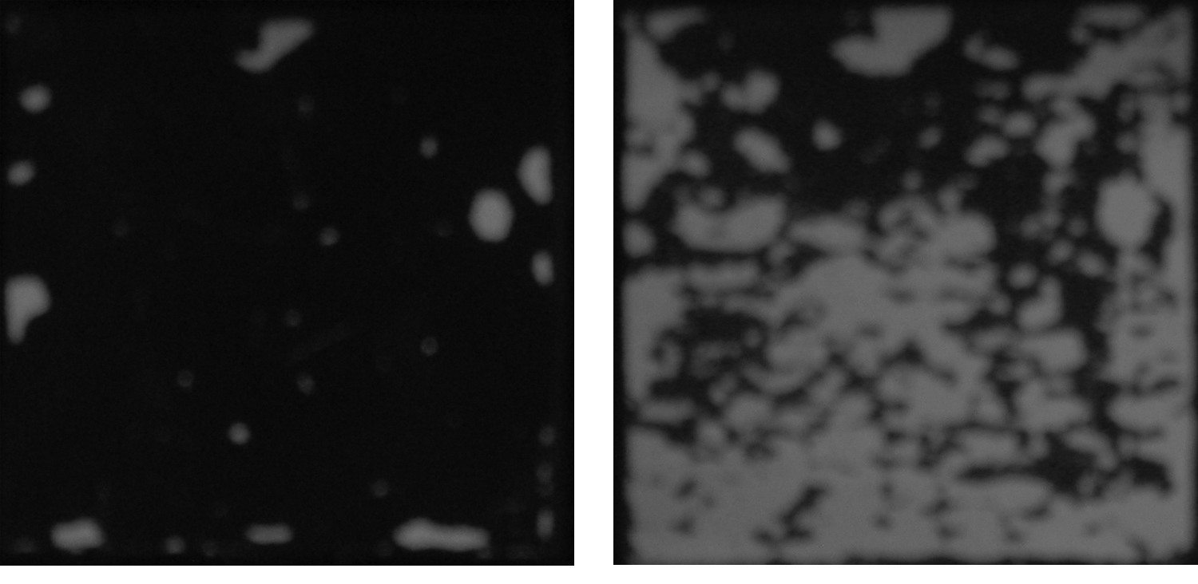
The main idea is that the glue, which interacts with surface, is in optical contact with it; and other glue is not. Therefore, light, emitted by diode, is scattered by the interacting glue, causing it to glow. A picture of the sample is taken (for example, fig.4 – it’s awesome! Too bad you see it in grayscale – in fact, it’s glowing red), and then percentage of bright pixels is calculated using software.
Figure 4. Same sample after putting on it just a panel (89gr) and after putting on that panel 6 kg weight.
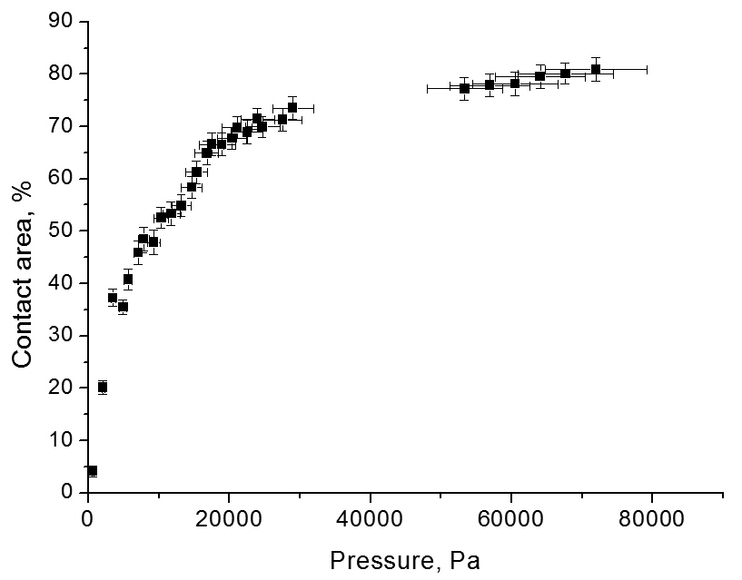
Fig.5 shows dependence of the contact area on the applied pressure. At first it grows very fast: not many hills are touching the surface, and it’s not necessary to press hard to deform them. However, when the pressure is increased, the amount of glue which should be squeezed increases too; at the same time, deformation of the already compressed glue also increases. Therefore, 100% contact area is almost unachievable (I had even jumped several times on the sample, but it became only something like 96%).
Figure 5. Pressing mass ranges 0.1-10 kg, sample area is 3.7X3.7 cm
This qualitative explanation can be expanded into quantitative model. For example, after applying some force, distance between the panel and the surface became x. Let’s approximate that thickness of the glue follows Gauss distribution. Then amount of glue, which isn’t interacting yet, is:
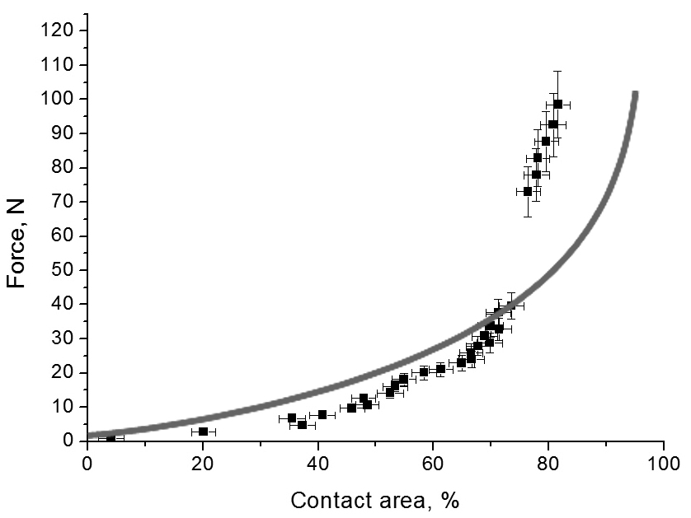
where μ is average thickness of glue, and σ is difference between biggest and smallest thickness, divided by 6. Now, if we want to find the force, caused by the deformation of glue (considering, that it behaves according to Hook’s law):
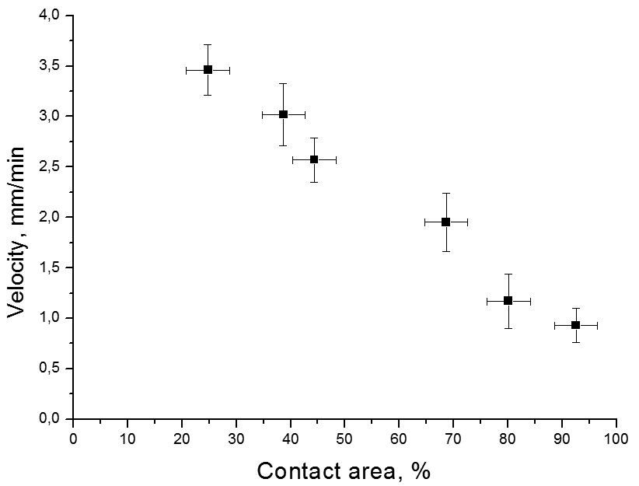
where X_{max} is highest thickness of the glue, S is area of the sample, (N(x_{n}+Δx)-N(x_{n}))*S describes area covered with the glue, which had original thickness between (x_{n}) and (x_{n}+Δx), and ((x_{n}-x)/x_{n}) shows relative deformation of such glue. And contact area C(x) will be calculated as C(x)=(1-N(x))*100%. Now, using software, it is possible to plot F(x) vs. C(x). You can see comparison between results of the model and actual experimental data on the fig.6. Differences can be explained by the fact, that our approximations with Gauss distribution and Hook’s law are not 100% correct; however, results are pretty close.
Figure 6. Line shows output of our mathematical model. Dots are, in fact, re-plotted fig.5
Further research of contact area isn’t very interesting: it’s almost obvious, that dependence of the detaching velocity on the contact are should be linear. If you don’t believe it, proof is on fig.7.
However, not-believing me is a correct thing. Especially if you noticed that when F(x) was calculated Young’s modulus E was involved, and no explanations were given about where have we taken it from.
Figure 7. Peeling weight 0.5 kg. Here we face increased errors, because it is difficult to take a high-quality picture of a long piece of tape.
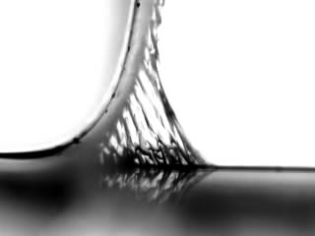
To measure Young’s modulus of the glue a thin stripe of the tape was taken, and a very small weight (8.8 gr) was attached to it. Then everything was put under the microscope (take a look at fig.8). In the very beginning of detaching small oscillations can be observed. Approximating the whole system as a spring pendulum it is possible to find Young’s modulus through the period of these oscillations.
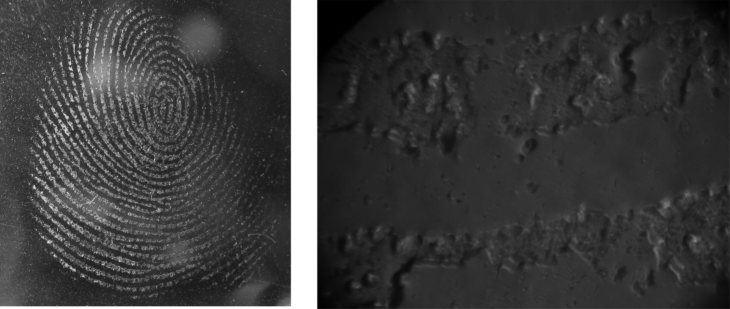
However, after several oscillations glue stops following Hook’s law, and finally starts tearing. It should be noticed, that it’s exactly glue tearing into two parts – not glue detaching from the surface (see fig.9).
Figure 8. Picture taken when measuring Young’s modulus of usual scotch tape, period of oscillations 0.7 s.
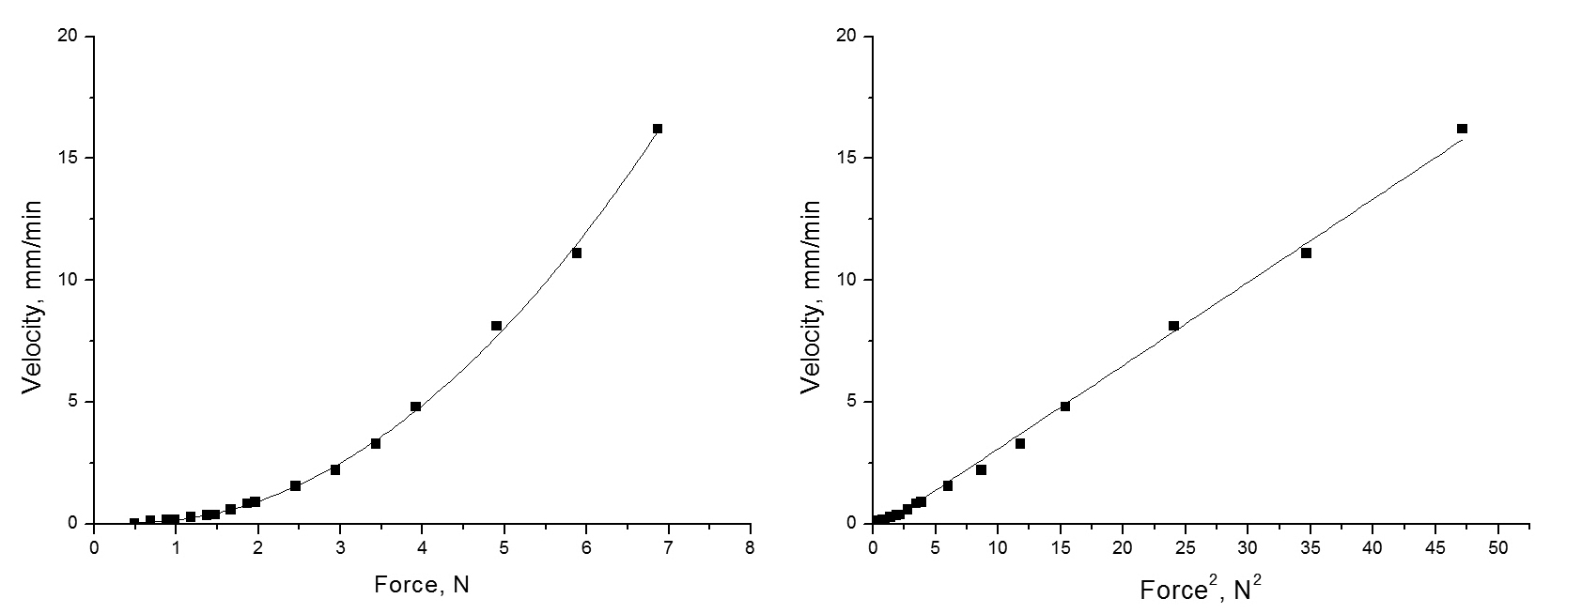
Once the glue stopped following Hook’s law it can be described as a non-Newtonian liquid. While behaving like this, all interactions in glue will depend on the velocity and applied forces. Exactly this behavior explains why tape resists detaching with the force equal to applied.
Figure 10. Dependence of velocity on force and it’s linearization. Line shows fit with square parabola. Average error of force is 0.05 N, of velocity 0.02 mm/min.
Figure 9. A fingerprint left on the tape, as seen in real life and through the microscope. On the right picture you can notice, that big part of glue is missing – it had remained on the finger. However, finger doesn’t become sticky because glue on it has very uneven surface – contact area effects are applied.
On the fig.10 you can see dependence of the detaching velocity on applied force. Experimentally, we have found that it is square parabola:
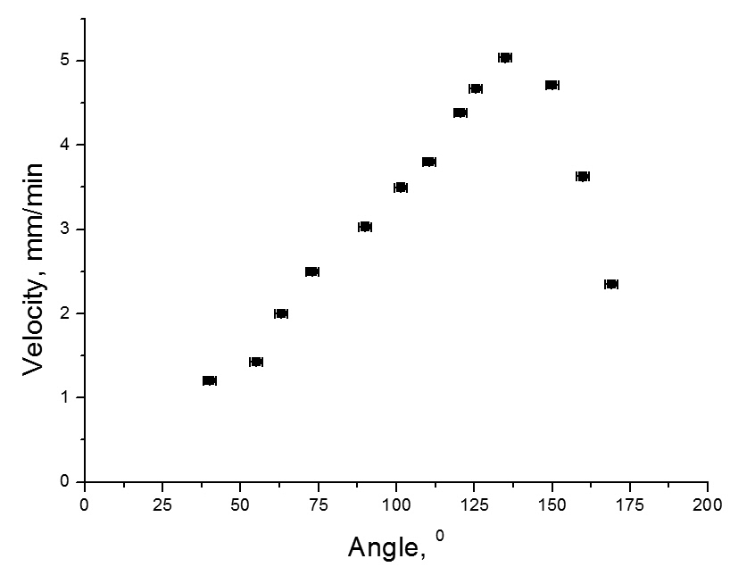
It shows that velocity will be zero only if no force is applied. It means that there is no such thing as “force necessary to remove”; there is a dependence between force and velocity. However, it must be taken into account, that if a really small force is applied, detaching will be very slow; it is impossible to say, is it just detaching, or detaching because of changes in the chemical structure of the glue, caused by the contact with air, for example.
While making all this experiments, we had to remove tape from the surfaces to which it was accidentally attached due to my irresponsible behavior; and we have noticed, that people almost always peel the tape at some angle to the surface. After a small social study we have found out that in average, people are peeling tape at the angle of 136.4° between the detached tape, and the side of surface, from which the tape is already removed. Fig.11 shows that it really is very close to the optimal value.
Figure 11. Peeling weight is 0.5 kg.
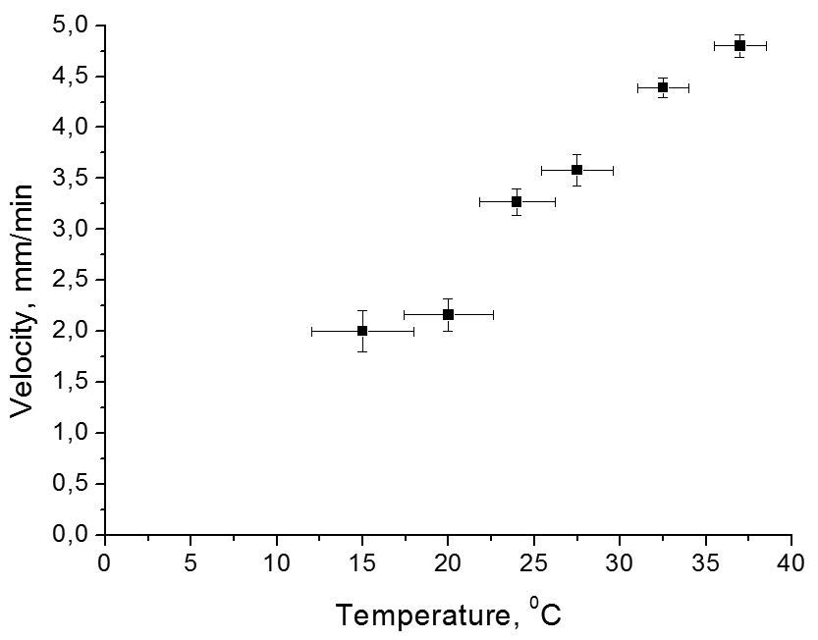
Another thing we have noticed, was that if experiment is lasting for too long, or first part is done on one day, and second on the other, we get giant errors and sudden jumps of dependences. Only some time later we managed to explain it. The reason was simple – the weather. Or, being more specific, temperature. Since glue behaves as a non-Newtonian liquid, it is very sensitive to temperature (fig.12).
Figure 12. Peeling weight is 0.5 kg. The higher is temperature, the easier it is to detach the tape.
In general, during this research we have found out several interesting facts. Mainly that I am afraid of darkness and irresponsible, and that adhesive tape sticks to everything in sight, except for the surface with which I’m making experiment. Being serious, we can state: there is no such thing as “force necessary to remove”, only dependence between applied force and velocity. This dependence appears to be square parabola. The parabola can be affected by the temperature, peeling angle and contact area. Contact area effects can be noticed if thickness of the glue layer isn’t constant. For quantitative analysis we can consider that thickness of glue follows Gauss distribution, and glue behaves according to Hook’s law. Same approximations can be used if measuring Young’s modulus of glue through the period of small oscillations. However, if we are describing detaching of the tape, we should take into account, that glue behaves as a non-Newtonian liquid. That is why tape resists detaching with force, equal to the applied. And the main thing: everyone somehow knows best way and angle for detaching adhesive tape. Probably, that’s because those, who didn’t know became extinct².
References
[1] Webster’s Encyclopedic Unabridged Dictionary of the English Language, Gramercy Books, New Jersey, 1989;
[2] Charles Darwin, Origin of species.

