Adhesive Tape
The forces necessary to remove adhesive tape from a horizontal surface
Katharina Ehrmann
November 2011

Abstract

This paper aims to determine the minimal force to remove adhesive tape from a surface. The total force can be seperated into two parts according to the results of this paper: One component to pull off the tape and another one to stretch it. As a result, a minimal force could be found that is dependend on the angle of pulling. The main effort thereby was to calculate the surface energy, a value dependend on the parameters surface, adhesive and temperature. This acchievement could be maintained by conducting a stationary experiment. Furthermore, a second, kinetic experiment was held to point out the surplus of force needed when the tape is being pulled off at a certain velocity.

Introduction

The removal of adhesive tape from a horizontal surface is a multiple layered problem. The force necessary to remove the tape is varying according to the speed and way of pulling at it and may vary at greater velocities. Therefore, this paper concentrates on determining the minimal force necessary to remove a piece of tape from a horizontal surface. The most difficult part thereby was to find the surface energy as it varies from tape to tape and is dependend on the surface. In the experimental part it will be described how the surface energy can be found experimentally. The resulting data then will be used to indicate the minimal force of removal by applying the law of energy conservation.

Before turning on finding the minimal force, the nature of adhesive tape as well as the act of pulling need to be examined more closely.

Adhesive tapes consist of backing material with a thin layer of adhesive on it which may alter in its chemical composition. The chemical substances of which adhesive is made of are polymeres. These have viscoelastic properties, which will be of importance later on. The tape’s “stickyness”, or rather attraction towards a surface, results from the Van der Waals forces existing inbetween adhesive and surface. This so-called surface energy can be described by the following equation (Ciccotti and Giorgini, 2002).

$γ=γ_{TA}+γ_{SA}-γ_{ST }$[1]
where γ is the adhesion energy per area and γ_{x} is the surface energy in J/m² or N/m. TA stands for the interface between tape and air, SA for the interface surface – air and ST for the interface surface – tape (Figure 1). According to equation [1], adhesion exists if γ < 0.

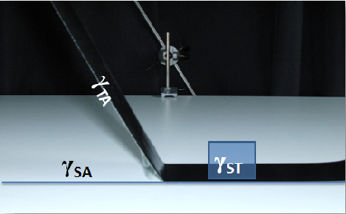

Figure 1: Visualization the different interfaces

The principle of pulling brings along a change in angle. As visible in figure 2, this change results in a shift of the force components which has to be considered: As the horizontal force-component will only result in strain and eventually elongation of the tape, only the vertical force-component can be considered responsible for pulling off the tape.

Figure 2: Change of the angle α after a change ∆l in length of the sticking tape

Assumptions
As this is a complex problem with various parameters having enormous effects on the results, it was necessary to cut down the variations in our experimental setups in order to remain straightforward and concentrate on crucial points.
Obviously, the two crucial parameters surface energy and Young’s modulus are different for various set ups. Data and results gained through the conducted experiments and presented in this paper have been acchieved for the Nopi® - Tape with a breadth of 5cm and a thickness of 0.04mm ± 0.005mm. Furthermore, the same, alcohol-cleaned surface has been used for all measurements. Various parameters such as surface-roughness, adhesive and temperature that would affect the surface energy have been held constant through the previously described arrangements. Only qualitative analysis of these parameters will be included in this paper.
The velocities used in the kinetic experiments were held low enough in order to assume a constant velocity when pulling. Had higher velocities been used, a phenomenon would have occurred that is commonly referred to as stick-slip – phenomenon in literature and velocities would not have been constant over time.
Two further simplifications were the neglection of the weight of the wires when applying the law of energy conservation and the solely study of angles up to 90°. There may not be a significant difference in the minimal pulling-force if the angle in between the surface and pulled off tape is bigger than 90° according to trigonometric considerations, however, this is not subject of this paper.

Theory

As mentioned above, the total force can be devided into two parts. The vertical component is responsible for pulling off the tape and the horizontal component for elongating the tape due to elasticity:

$$F_{Pull}=F_{Elasticity}+F_{Remove} [2]$$

To remove the tape, the pulling force needs to overcome the adhesion energy inbetween tape and surface. For the minimal force this denotes:

$${F_{Adhesion}=F}_{Pull}$$

As a result, equation [3] can be derived:

${F_{Adhesion}=F}_{Elasticity}+F_{Remove}$ [3]

Thus, to find the minimum of the pulling-force F_{Pull} , the adhesion force F_{Adhesion} (dependend on the adhesion energy) and the force F_{Elasticity} used to strain the tape (dependend on the Young’s modulus) need to be found.

In the following, the results of our studies on these two relevant parameters adhesion energy and Young’s modulus under the described conditions will be discussed.

- Young’s Modulus
To determine the horizontal fraction of energy needed, the following commonly known equation needs to be considered:
$\frac{l}{∆l}=\frac{1}{E}∙\frac{F}{A}$ [4]
where l is the original length, ∆l the length-growth when the tape is stressed, E stands for the Young’s modulus, F for the force applied and A for the affected area. Through the experimentally found stress-strain curve which is shown in figure 4 in the experimental part, we concluded that the Young’s modulus for the Nopi® - Tape is 269 ± 1 MPa.
- Suface Energy
As mentioned in the beginning, there are no certain values for the surface energy due to its high dependence on the parameters composition of the tape, temperature and surface. It is oblivious that the composition of the tape and surface impacts the strength of the Van der Waals forces and therefore, every tape sticks differently well to various surfaces. However, the composition of the tapes’ adhesives are unknown and therefore will not be altered in this paper. Furthermore, a row of experiments have shown that the range of temperatures accessible for our setups is too small to make a difference for the planned set of experiments. As for the impact of surface roughness on the surface energy, this paper will only give a short qualitative explanation on how it impacts the sticking-behaviour:

Obviously, a tape will stick best if there is as much interface between the adhesive and the surface as possible. Therefore, rough surfaces with cracks that augment the area contribute to strong adhesion. When these cracks turn too big, however, the adhesive will not be able to fill the gaps anymore. At that point, adhesion energy becomes smaller again. In conclusion it can be said that an even surface can develop stronger as well as weaker adhesion to the tape if compared to a rough surface (figure 3). In the case of the Nopi® - Tape which has a 5 ± 1 µm thick adhesive-layer, cracks with a depth of 4 µm would present the optimal size.

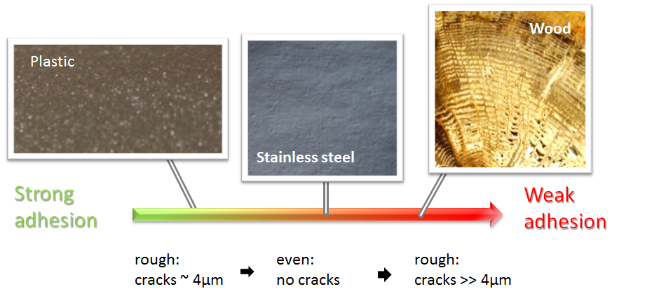

Figure 3: Overview over the development of adhesion energy
depending on the size of cracks in the surface

As discussed, the surface energy γ is different for every set up. Therefore, it had to be found experimentally which appeared to be difficult due to its many dependences. However, through the law of conservation of energy it was possible to be found by conducting a stationary experiment. All involved energies can be summed up through formula [5]:

$$∆E_{Pot }=∆E_{o}+∆E_{D}+∆E_{Pot2} [5]$$
with

$$∆E_{Pot}=m_{w}∙g∙h$$

$$∆E_{o}=γ∙b∙x$$

$$∆E_{D=}\frac{mg}{bd}∙\frac{1}{E}∙x∙m_{w}∙g$$

$$∆E_{Pot2}=\frac{h_{h}}{2}∙\overline{l}∙g∙h∙ρ+h_{h}∙m_{s}∙g$$

In these equations, m_{w} stands for the mass of the weight that is pulling at the tape, h for the height of the weight, b for the broadness of the tape, x for the length of the surface being released of the tape, m for the mass of the entire construction as well as the tape, $\overline{l}$ for the peeled length, d for the tape thickness $ϱ$ for the tape density and h_{h} for the height of the tape’s pulled off end.

Through inserting values for all these variables except for γ, γ can be calculated with formula [5]:

$$γ=\frac{m_{w}gh-\frac{mg}{bd}∙\frac{1}{E}∙xm_{w}g-\frac{h_{h}}{2}∙\overline{l}ghρ-h_{h}m_{s}g}{bx}$$

Having found the surface energy for the used setup, the minimal force to pull off a tape can now be calculated by this formula:

$$F_{crit}=\frac{γb}{\sin{α}} [6]$$

Having acchieved a result for the minimal force in a stationary case, it was necessary to observe the tape’s behaviour when being pulled off at a constant speed rate. Therefore, a new setup was developed. Its schema can be seen in figure 7 in the experimental part of the paper.

The purpose of this new experiment was to find wether or wether not more force would be needed if the tape was pulled off at a certain speed rate. Due to the presumption of adhesive being a non-newtonian viscoelastic fluid, a change of the needed force was expected. Neither a change in the ratio of the force components nor a change of the angular dependence but an increase in the total force needed was the anticipation. Through the experiments, this was varified and the adhesive then could be identified as a shear-thickening non-newtonian fluid. As will be shown in the results, not the shape of the curve, and therefore the angular dependence, or the contingent of the vertical force-component towards the total force changed, but a shift upwards of the equally shaved curve could be seen.

Experimental

The curve in figure 4 shows how the length changes at a certain stress. As expected, it develops linearly in the beginning until the point at which the tape will not go back into its original length at about 13 MPa. This linear section also is the one relevant to the calculation of the Young’s modulus.

Figure 4: Stress-strain curve of the Nopi® - Tape

The data inserted into formula [5] originates from 10 equal stationary experiments with the Nopi® - Tape as shown in figure 5: Differently heavy weights were attached to the tapes sticking to the standard surface through wires and were left hanging for 5 days. The resulting data then was filled in into equation [5]. The mean of these 10 experimental results for the surface energy γ is 14±3 J/m² (or also: 14±3 N/m).

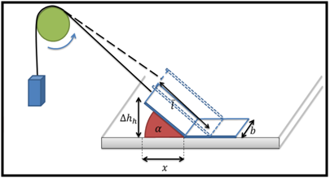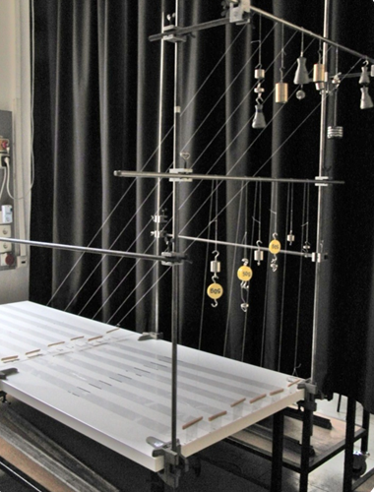

Fig 5: Schema and setup of the stationary experiment

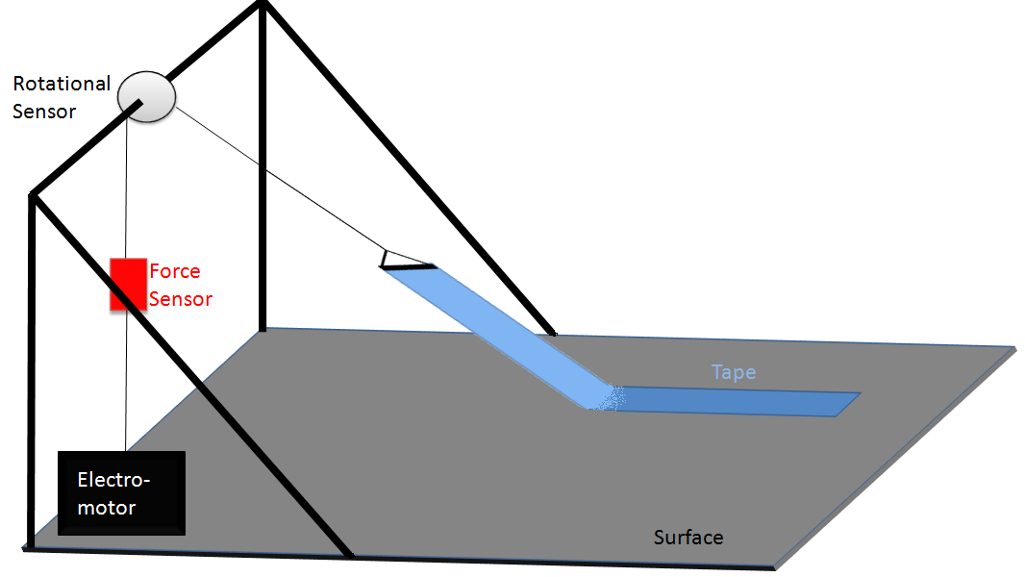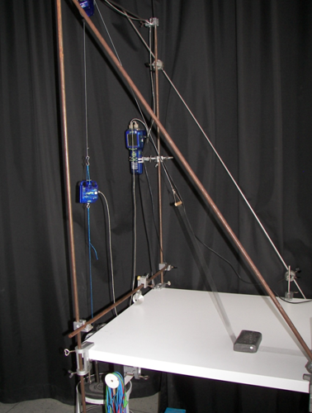

Figure 6: Schema and picture of the setup for pulling the tape at a constant rate

Figure 6 depicts the setup for the kinetic experiments. Through the electromotor, constant velocities could be acchieved and altered accurately after each measurement. The sensors measured the force applied, the length of the tape that was pulled off and the angle inbetween tape and surface. This acquired data produced the graphs presented in the paper’s Results:

Results

The critical force of the Nopi® - Tape caclulated from equation [6] on the used surface equals 0.7N ± 0.15 N at 90°. Expressed as a function of the angle F_{crit} , this result can be written as $F_{crit}=\frac{0.7N}{\sin{α}}$ . Figure 7 shows the belonging plot:

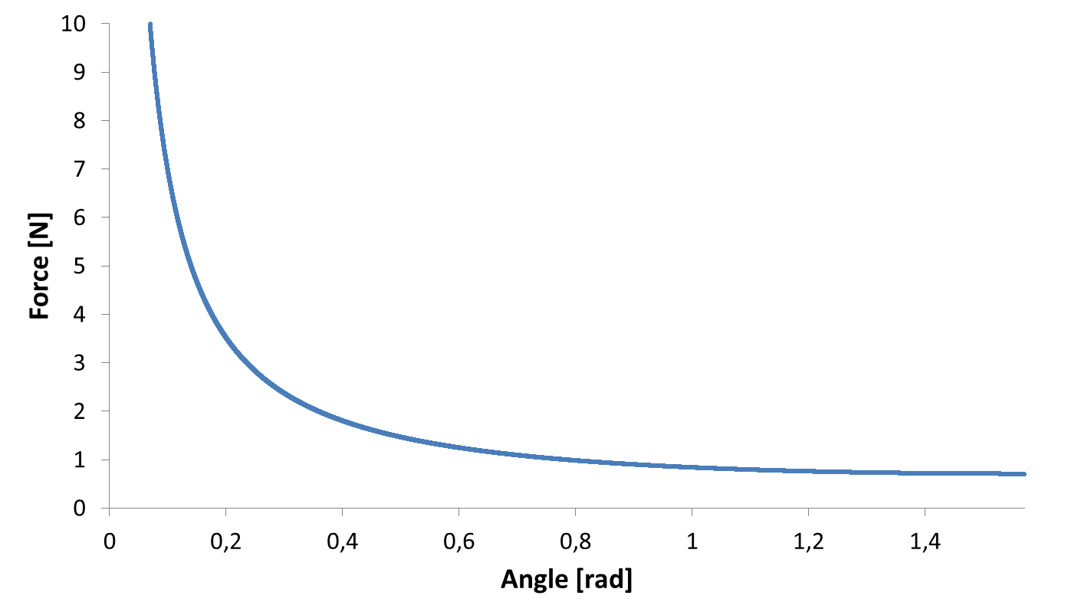

Figure 7: Plot of the critical force to pull of the Nopi® – Tape in dependence on the angle

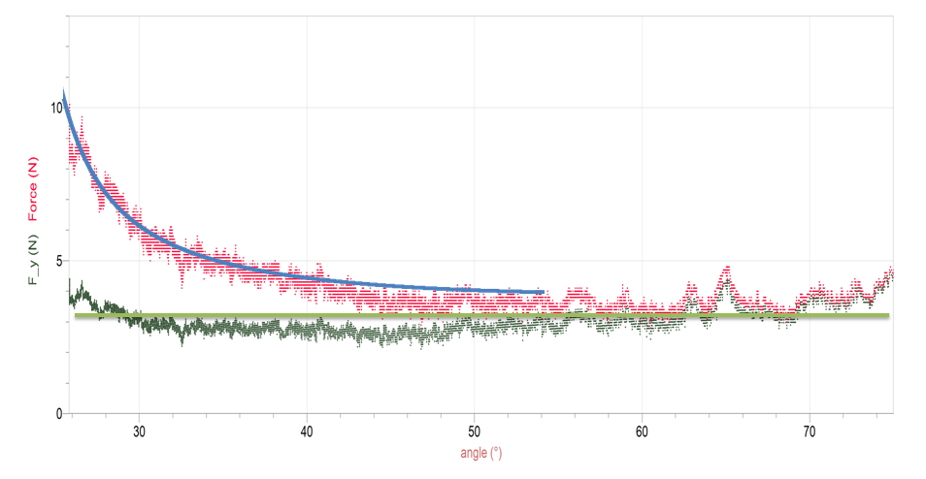

Figure 8: Total force (red graph) and vertical force - component (green graph) in dependence on the angle between tape and surface at 0.16 ± 0.01 m/s (10 mesurements per second)

As indicated in figure 8, the graph picturing the vertical force – component F_{v} can be assumed as linear according to these experimental results, whereas the total force F inclines with the decrease of the angle α inbetween tape and surface as stated in [7].

$$F_{v}=F∙\sin{α=const.} [7]$$

This corroborates the theory applied for and results acchieved from the stationary setup: The smaller the angle α becomes, the more energy has to be dedicated to the strain of the tape. Furthermore, the plotted graph in figure 7 which shows the dependence of the force necessary to pull off the tape on the agle, fits the measurements shown in figure 8.

Figures 9 and 10 show slightly higher velocities than figure 8. Still, the theoretical prediction seems to fit. However, the graphs shift upwards: At an angle of 60°, for example, 3 N are needed to pull off a tape at 0.16 m/s (figure 9), whereas 4 and 5 N are needed at 0.25 and 0.3 m/s for the same angle (figures 9 and 10). Additionally, figure 10 includes the horizontal force - component which again appears roughly constant.

Whenever this paper referred to “fits” of the theoretically predicted graph derived from the stationary experiment, this can only be seen as a fit concerning the graph’s shape. As can be seen in figures 8, 9 and 10, the graph experiences a shift upwards whenever velocity is increased. Still, the development of the forces always procceeds in the same way: the vertical component responsible for seperating the tape from its surface remains roughly constant whereas the horizontal component increases with decreasing angles due to the elasticity of the tape. Thus, the minimal force necessary to pull off a tape indeed occurs in the stationary case and can be described for any angle of pulling by our model. Furthermore, this paper has shown a qualitative approach on the influence of surfaces on the adhesion energy.

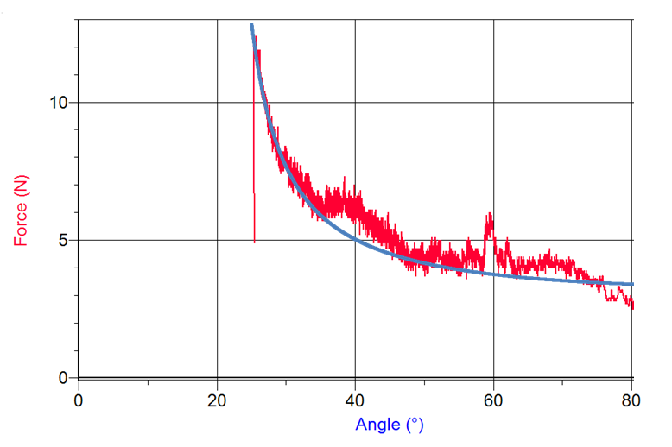

Figure 9: Total force needed to pull off the tape at 0.25 m/s;
red graph: measured, blue graph: theoretical prediction

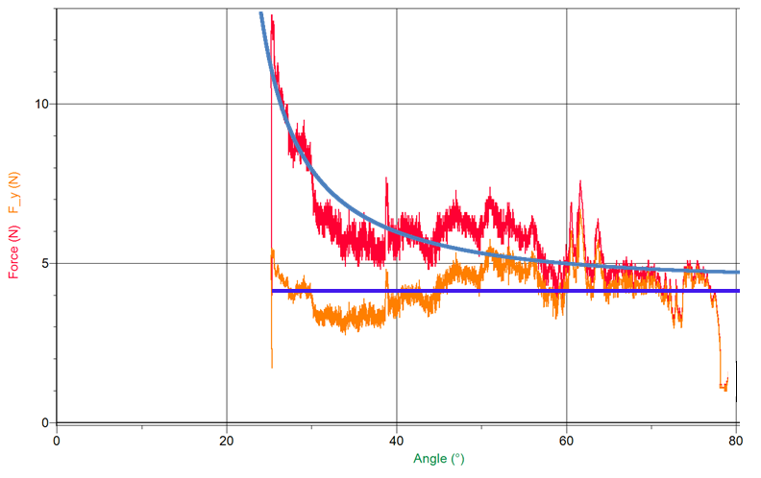

Figure 10: Total force and its vertical component at 0.3 m/s

Discussion

The acchieved results presented above show that the force necessary to pull off adhesive tape from a horizontal surface is dominated by two parameters: surface energy and elasticity. This conclusion was drawn from equation [3]. Therefore, this paper set out to characterize these two quantities further.

Through energy conservation, it was possible to calculate γ for the Nopi®-Tape within an acceptable range out of the stationary experiment. Furthermore, the Young’s Modulus was found experimentally and these results then could be used to calculate the critical force for every angle. This is visualized in figure 7. Comparing this result with our experiments, they produced graphs in the exact same manner which varifies the developed formula. Figures 8 to 10 show the described fit of the curves.

As suggested additionally in the theoretical part, it could be proved that the horizontal force component remains roughly constant if there is no change in material or surface whereas the total force inclines with decreasing angles. This can be explained through the additional force that has to be applied due to increasing strain at smaller angles. Figures 8 to 10 anticipate this behaviour.

Another phenomenon observed with the kinetic experiments was the horizontal shift of the curves whenever the velocity of pulling was changed. Therefore, whenever this paper referred to “fits” of the theoretically predicted graph derived from the stationary experiment, this can only be seen as a fit concerning the graph’s shape. As can be seen in figures 8, 9 and 10, the graph experiences a shift upwards whenever velocity is increased. Still, the development of the forces always procceeds in the same way: the vertical component responsible for seperating the tape from its surface remains roughly constant whereas the horizontal component increases with decreasing angles due to the elasticity of the tape. This shift can be explained through the tape’s viscoelastic properties: If we assume that the material to be shear-thickening, it can be explained that higher velocities and thus bigger forces contribute to a worse pulling-off behaviour. The more shear forces dominate, the more particles enter a state of flocculation and are no longer held in suspension.

Adding this fact to the theoretical approach, the minimal force necessary to pull off a tape indeed occurs in the stationary case and can be described for any angle of pulling by our model. Furthermore, this paper has shown a qualitative approach on the influence of surfaces on the adhesion energy.

To sum up what has been acchieved it could be said that the two experiments have fully proved a novel theory developed in this paper.

Conclusion

In this paper, a theory was developed to predict the force fractions involved in pulling off a tape and their developments when altering pulling-angle or –velocity were observed. The idea was to find the two crucial parameters surface energy and Young’s modulus by filling in missing data into equation [5] through the stationary experiment where the conservation of energy is being considered. As a result, a minimal force could be determined in dependence on the angle: 0.7N/sinα. The resulting plot can be seen in figure 8. Through conducting another experiment where the tape is being pulled off at a constant speed-rate, it was possible to observe the development of the total force. As a matter of fact, all curves from the stationary and kinetic experiments fit the theoretical plot. The only difference can be found in the vertical shift upwards that takes place with increasing velocity for which has also been found an explanation. Through observation of the vertical force-component which was linear in any experiment, the theory again was affirmed.

Sources
M. Ciccotti and B. Giorgini; “The emergence of complexity in a common scotch roller”; Physics Department and INFN, Bologna, Italy; April 2002
K.Kendall; “The adhesion and surface energy of elastic solids”; British Railways Research Laboratories, Derby; J. Phys. D.: Appl. Phys., 1971, Vol. 4

