DESCENT OF A PAPER-MADE DEVICE

Hossein Azizinaghshª, Reza M. Namin^{b}
ªSharif University of Technology, School of Computer Engineering, I. R. Iran
^{b}Sharif University of Technology, School of Mechanical Engineering, I. R. Iran

Abstract
The ultimate goal in this article is to design a device, using one sheet of A4, 80 gr per square meter paper that takes the longest possible time to fall to the ground from a specific height. A large number of varied devices have been made. These observations, as a starting point, leaded us to find some of the specifications of the most appropriate device. A general numerical model of a falling rigid paper device was developed in order to optimize the device. The validity of numerical modelling was then verified by precisely capturing the motion of falling devices. Ultimately the ideal device was designed using the predictions of verified numerical model. This article is based on the solution of team of Iran for the 15th problem of IYPT 2011.

Introduction
For us, there is no certainty in finding the best possible device. Because a theoretical method to predict the best possible device is undeniably unreachable as both mediums; air as a fluid and paper as a flexible material are too complicated to be modelled comprehensively and there is an infinite number of totally different devices to be considered. Therefore the most effective method to find an answer for this problem seems to be observation. A large number of observations can lead us to approach to the answer. However this method requires a broad range of varied paper-made devices and a high level of creativity in the matter of designing.

In order to maximize the efficiency of this method, this stage of problem was investigated from different points of view and varied devices were made by different individuals. A great number of diverse paper devices were made during a period of four months. Rotating and non-rotating devices, stable and unstable devices, devices inspired by airplanes, helicopters and even birds were designed. Based on these observations some deductions were made.

In different falling devices, generally two main types of motion were observed: Rotating motion and non-rotating motion. However the rotating motion is not necessarily a rotation about a specific axis, the rotation is usually observed without any primary rotation axis. The motion of devices was classified in three main categories: 1) rotating without a primary axis (e.g. a sheet of paper), 2) rotating with a primary axis (e.g. paper whirligig), 3) non-rotating (e.g. paper airplane)
A statistical analysis of data leaded us to find our ideal category. This analysis was based on the average time of fall and the variance of time of fall in each category. The result of this analysis is as follows:

- Rotating devices without a primary axis (e.g. a sheet of paper): the variance of time of fall for these devices was considerably high and average time of fall was usually low. However in some test cases the time of fall was significantly high. Without any exceptions the reproduction of these numbers was not easily possible. Equivalently the motion of these devices is too unstable to be reliable. Due to the instability and random like motion of these devices, there is no well-defined time of fall, thus our ideal device is not included in this category.

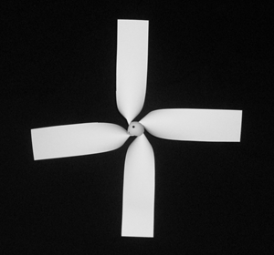
- Rotating devices with a primary rotation axis (e.g. figure 1): in this category due to the high stability of the motion of devices the variance of time of fall was relatively low. This stability is because of the large angular momentum vector, which critically increases the stability of motion. Therefore the time of fall can be defined as the average time of fall.
Figure 1: helicopter model

- Non-rotating devices: in this category the variance of time of fall was relatively low. In most cases, the rotating motion was diminished either because of large amount of rotational inertia or aerodynamic shape (e.g. paper airplane). However the average time of fall was lower compared to rotating devices.
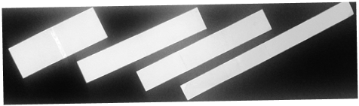
Figure 2: rectangular rotating devices, rotation axis is parallel to the length
Based on this classification, further investigations are specific to rotating devices.

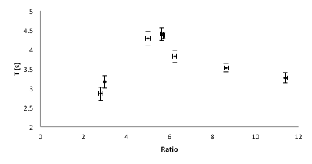
Two major types of motion were observed: rotation about a horizontal axis and rotation about a vertical axis.
Figure 3: time of fall vs. the ratio of width and length of the rectangular rotating device
For devices with a horizontal rotation axis a rectangular device was designed (Figure 2). The rotation of this device not only increases the stability of motion, but also critically increases the time of fall. Since the ratio of width and length is the only influential parameter, based on adequate experimental data, optimization is easily possible (Figure 3).
For devices with a vertical rotation axis, a model inspired by helicopters was designed (Figure 1). The blades were firmly attached to a conic shaped center. The whole device could be considered rigid and deformations were negligible.
Since due to the variety of influential parameters, experimental optimization was not easily possible, a comprehensive numerical model was developed in order to optimize this device.

Theoretical Analysis
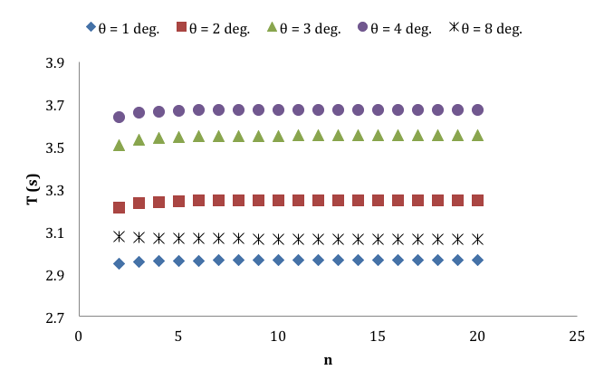
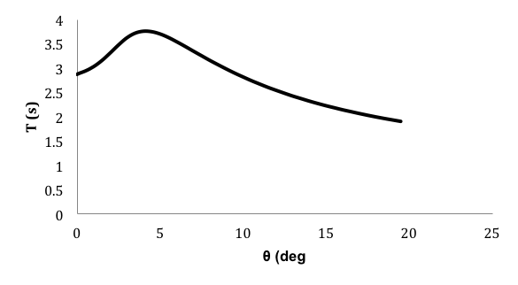
While the paper-helicopter device falls in the air, a vertical force and a vertical torque applies to it.
Figure 4: From top to bottom: Time if fall vs. angle of blades – Time of fall vs. length of blades – Time of fall vs. number of blades
The force and the torque are functions of the linear vertical velocity and the angular velocity about the z-axis. By finding these functions, the motion of the helicopter can be predicted.

Due to the rotation of the helicopter, depending on the radial distance of each segment of the helicopter from the rotation axis, it would have a different velocity, thus we cannot directly calculate the total force applied to the helicopter. This force and torque should be calculated as a summation of infinitesimal forces acting on each portion of the helicopter. Each infinitesimal segments on the blades of the helicopter, is a 2 dimensional surface and it would have a certain velocity. The force applied to each of these segments can be calculated using the equations of drag and lift forces. Each segment has the horizontal velocity of lω and the vertical velocity of V_{z} and makes an angle of α with the horizon (Figure 5). Using the drag and lift coefficients for a flat 2D surface and based on the equations of drag and lift force, the forces normal and parallel to the flow are found.
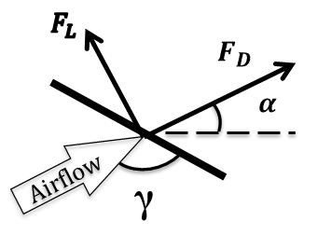
Figure 5: illustration of infinitesimal segments, and the definition of angle of attack and angle of blades

$F_{D}=\frac{1}{2}C_{D}ρA\left(l^{2}ω^{2}+{V_{z}}^{2}\right) (1)$ $F_{L}=\frac{1}{2}C_{L}ρA\left(l^{2}ω^{2}+{V_{Z}}^{2}\right) (2)$

The drag and lift coefficients, as a function of angle of attack, were calculated by simulating the flow around a 2 dimensional flat plate using CFD solver, FLUENT (Figure 6).
Figure 6: simulation of flow around a 2D flat surface; contours of velocity magnitude, resulted from FLUENT

The vertical force and torque were found as functions of V_{z} and ω. Equations of motion were solved using Euler method and the motion of the helicopter was predicted. The theory was then verified and the best helicopter was designed based on the predictions of the theory (Figure 4 and Figure 9).

Experiments
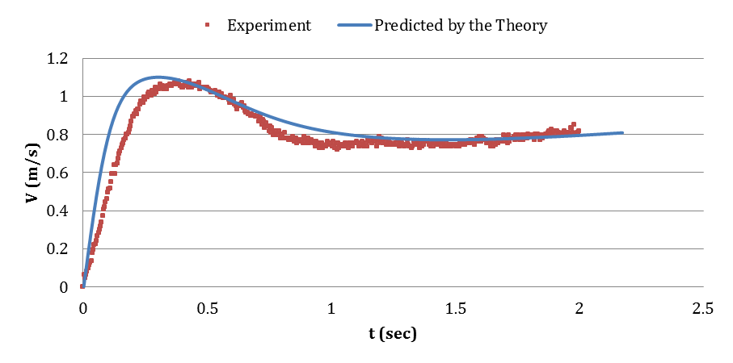
- The vertical motion of a falling helicopter was recorded using a high-speed camera in 1000 FPS. Using MATLAB image processing tool-kit, the location of the lower point of the helicopter was found in each frame. Velocity as a function of time was then derived from these data and was compared to the prediction of the numerical theory. In order to minimize the error, ratio of the distance of camera and the height of fall was about 5 (figure 7).
Figure 7: Predicted velocity as a function of time vs. measured velocity resulted from image processing

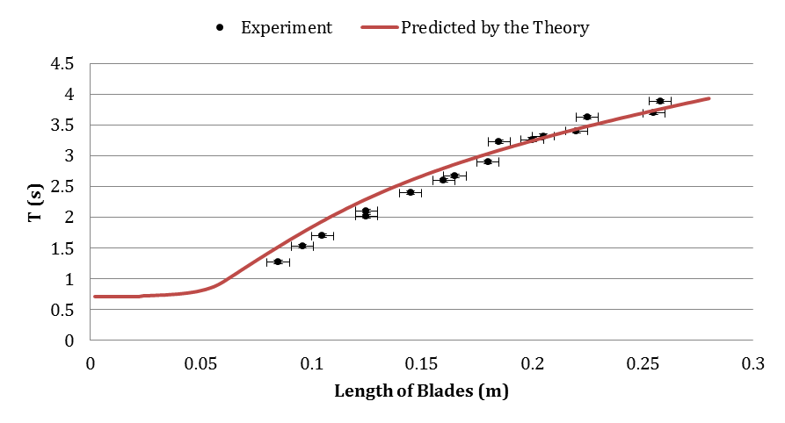
- Numerous helicopters were made with different length of blades. The time of fall was measured for each device. By increasing the number of measurements the error of each number was minimized. The time of fall as a function of the length of blades was then compared to the prediction of the numerical theory (Figure 8).
Figure 8: Predicted time of fall vs. length of the blades
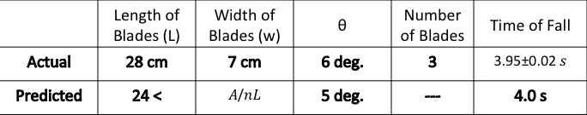
Figure 9: Specifications of the optimized helicopter based on diagrams plotted in Figure 4
Discussion
 | Vertical Axis | Horizontal Axis
Minimum time of fall | 3.8 | 2.9
Maximum time of fall | 4.1 | 5.4
Average time of fall (10 measurements) | 3.95 ± 0.02 | 4.4 ± 0.2
According to the results of measurements, both rotating devices can be considered the best device (Figure 10). For the vertical axis device, due to the rotation and high angular momentum vector, the motion is highly stable compared to other devices. For the horizontal axis device, it may fall within a longer time but due to instability it is not reliable. Both time of fall and variance of time of fall are important parameters; therefore, it is not clear which can be considered the best device.
Figure 10: Time of fall of best devices

