NO. 13, LIGHT BULB: NUMERICAL AND EXPERIMENTAL EVALUATION OF THE EFFICIENCY

Reza Montazeri Naminª

Alireza Tahmaseb Zadeh^{b}

ªSchool of Mechanical Engineering, Sharif University of Technology, I. R. Iran.

^{b}School of Electrical and Computer Engineering, University of Tehran, I. R. Iran.

Abstract

The present paper is a theoretical and experimental investigation on the efficiency of incandescent light as a function of applied voltage. Theoretically, radiation is modeled in means of the Planck function, and heat is modeled considering convection and conduction. Experimentally, the luminous power is measured using an Integral Sphere, where luminous efficiency is considered, to estimate the radiation. Heat flux is measured in means of the changes of surrounding water temperature in the designed setup. The precise agreement between the theoretical predictions and experimental results proves the theory, which leads to a final conclusion on the efficiency of the bulb as a function of applied voltage.

Introduction

An incandescent light bulb is consisted of three main parts; tungsten filament, inert gas and glass mount. When electric current passes through the filament, it raises the temperature. This heated filament emits energy in two ways; one is Electromagnetic radiation and the other is heat flux. In the steady state, where the temperature of all the parts remains constant, all the given electrical power transforms into these two kinds.

$P=IV=P(rad)+P(heat)$ (1)

Heat flux happens in two levels. First is the convection in the inert gas, transferring the heat energy from the filament to the inner layer of the glass mount. Second is the conduction in the glass surface.

Electromagnetic radiation is either in the visible and invisible spectrum. However, only the visible part is used for illumination. In addition, illumination of different wavelengths in the visible spectrum is also different. This difference is described in means of luminosity function. This function, demonstrates a coefficient between zero and one for every wavelength, describing the sensitivity of human eye to the specific wavelength.

Efficiency is normally defined as the ratio between efficient work and given energy. For lamps, which are aimed for illumination, the efficiency could be defined more precisely. In this research, it is defined as the ratio between the energy of the part of the radiation that is used for illumination and all the given electrical power.

$Ra=\frac{P_{illumination}}{P_{total}}$ (2)

Theory

- Heat Flux

Since the heat transfer is a sum of the transfers by convection and conduction, and both convection and conduction have an energy transfer rate proportional to the temperature difference, the total energy transfer is proportional to the differences of temperature of the filament surface and the temperature of the environment far from the light bulb. The coefficient must be determined experimentally.

$P\left(heat\right)=K(T-Tout)$ (3)

- Electromagnetic Radiation

The tungsten filament could be considered as a twisted cylinder, similar to a spring. Assuming R as the radius and L as the length of this cylinder, all the radiation power is found using Stephen-Boltzmann law for a gray body.

$P\left(rad\right)=\left(2πRL\right)εσT^{4}=cT^{4}$ (4)

ε is the emissivity of the material and c would be determined experimentally.

Some part of this electromagnetic radiation is visible and the other part is invisible. Using Planck Function, power of each of the wavelengths could be found. Planck's law describes the energy emitted at a certain wavelength for different temperatures:

$J\left(λ,T\right)=\frac{2hc^{2}}{λ^{5}}\frac{1}{e^{\frac{hc}{λkT}}-1}$ (5)
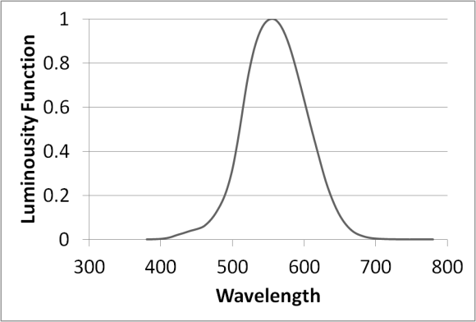
Figure 1: CIE Photopic V(λ) modified by Judd (1951) and Vos (1978) [also known as CIE V_{M}(λ)]
Ref: http://www.cvrl.org/lumindex.htm

Human eye does not respond equally to different wavelengths. This means that illuminations of different wavelengths are different. Luminosity Function describes the average visual sensitivity of the human eye to light of different wavelengths. This function attributes a coefficient between 0 and 1 for each of the wavelengths in visible spectrum. The amount of this coefficient is absolutely zero for wavelengths in invisible spectrum.

Considering the Luminosity Function, Luminous Efficiency could be defined. This describes the ratio between the amount of electromagnetic radiation which is used for illumination (considering the coefficient of luminosity function) and all the electromagnetic radiation.

$Luminous Efficiency:= \frac{Illuminating Radiation}{Electromagnetic Radiation}:=\frac{\int_{λ=0}^{∞}{J(λ,T)y(λ)d}λ}{\int_{λ=0}^{∞}{J(λ,T)dλ}}$ (6)

In which, $J\left(λ,T\right)$ is Planck Function and $y\left(λ\right)$ is Luminosity Function.

The calculation of this amount was done using a C++ numerical solution program. This program integrated the terms above to calculate the luminous efficiency using the luminosity function and plank functions.
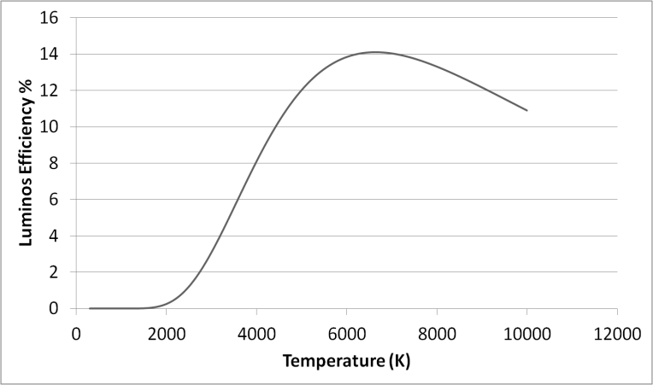
Figure 2: Luminous Efficiency Calculated

Luminous Efficiency is found as a function of filament temperature. In case there exists a relation between Voltage and temperature of the filament, the illuminating part of all the given energy could be found (Equation 1).

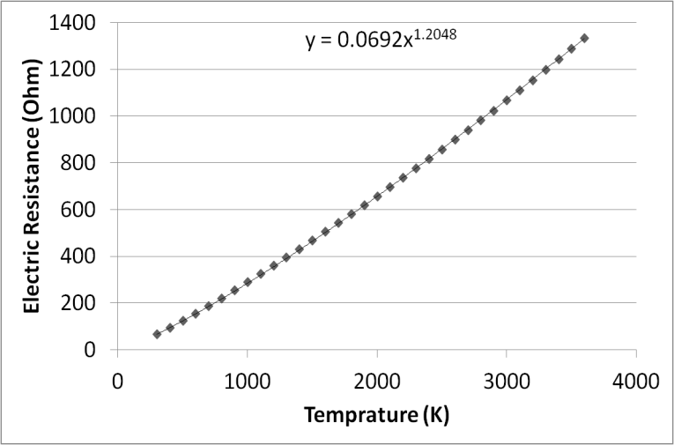
The amount of special resistivity of tungsten was found using a material Handbook. Measuring the resistivity of our lamp in 300 K, (Bulb is switched off) the resistivity is found as a function of temperature.
Figure 3: Filament Resistance; Calculated using the resistivity of tungsten and resistance at 300K

$R(T)=R_{0}{\left(\frac{T}{T_{0}}\right)}^{1.2048}$(7)

Where T = 1K leads to R = 0.0692 Ω.

Finally, using equation (1) and the resistance function, the equation relating voltage and temperature is found:

$\frac{V^{2}}{R(T)}=cT^{4}+K(T-Tout)$ (8)

Conducting two different Heat and illumination experiments temperature is found in means of Voltage. Therefore, heat and radiation are calculated as a function of Voltage. This results in calculation of efficiency as a function of voltage.

Experiments

Two experiments have been done in order to verify the theory and measure the constants; Heat Experiment and Illumination Experiment.

- Heat Experiment

Initially, the temperature of the filament at each voltage is measured in means of the resistance of the filament. The resistance is calculated knowing the current pass and voltage, and resistance as a function of temperature has already been explored.

According to equation (3), theory has predicted that heat flux power is proportional to the temperature difference between the filament and outside air far from the lamp. In these series of experiments, heat flux is measured for difference temperatures and result shows that these amounts are in a linear trend. General idea is to warm up some amount of water using the sample lamp.
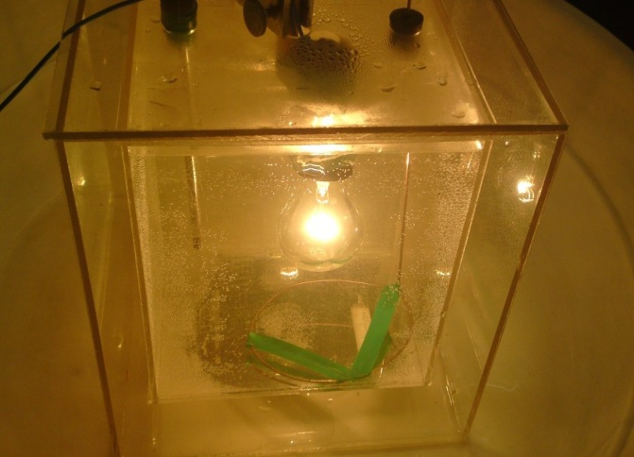

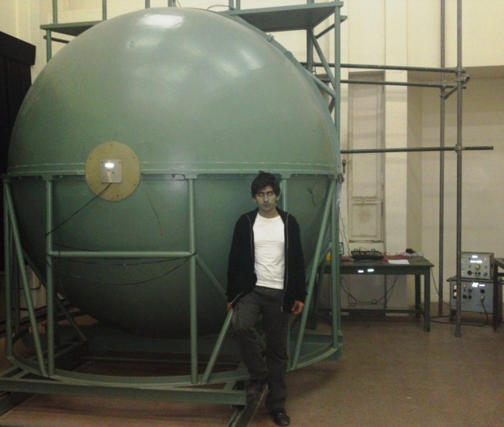
A two-layered box was made using Plexiglas. A 20x20cm cubic square was placed in a 25x25cm one and there was air in between. Lamp, digital thermometer were placed in water. When the lamp is switched on, chronometer starts. The difference of temperature of water with its initial temperature is plotted vs. time. Using the data, the heat constant of the theory was found:
Figure 4: The thermal experimental setup

$K=1.2∓0.2 mW/K$ (9)

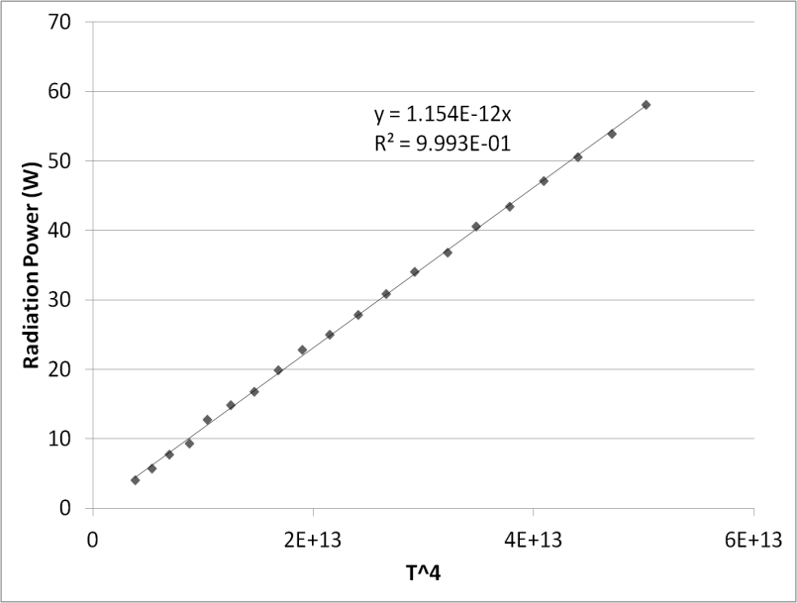
To minimize the heat loss from the container to the environment, in addition to using a two-layered container, the experiments were conducted in a range of 20º difference in temperature. Also the leakage of heat from the box was measured by doing another experiment; turning off the bulb and plotting temperature of water vs. time while it is decreasing. Using the gradient of the mentioned graph, the heat loss was calculated and added to the main graphs. The water may absorb some of the radiation, and show it as heat as an error. Using the Beer-Lambert law, using the absorption coefficients for water, glass and Plexiglas less than 5% of the radiation will be reported as heat in the experiments.
Figure 5: the integral sphere used in the illumination experiments, at University of Tehran

- Illumination Experiment

The luminous flux of a lamp could be measured using Integral Sphere. This instruments, measures the amount of luminous flux. The given relation for the amount that integral sphere measures follow:
Figure 6: Analyzed result of the illumination experiments

$Luminous Flux=F=683.002\frac{lm}{W} \int_{0}^{∞}{y\left(λ\right)J\left(λ\right)dλ}$ (10)

Using relation (6) and this equation, radiation power is found as a function of temperature of filament. The radiation power vs. T4 was plotted. This graph was linear that shows that our theory and special resistivity are precise. The amount of c was found using this graph:

$c=1.15 ∓0.02×10^{-12} W/K^{4 }$ (11)

Results and discussion

Having the amounts of C and K from the experiments, equation (8) was solved numerically to obtain the temperature as a function of voltage. Having the temperature, all the other parameters could be found and results were compared with the theory.

The theoretical predictions match the experimental results very well in various cases, confirming the basic theoretical assumptions and the numerical method validity. So we were allowed to use the numerical solution to describe the efficiency of the light bulb in different voltages. As it is shown in figure 10, the efficiency increases when voltage increases. This increasing has two major reasons as discussed: with voltage increase, the total radiation power increases as in figure 8, and more important, with the increasing voltage, the temperature of the filament increases (as in figure 9) causing the luminous efficiency to increase (figure 2). This means that in higher voltages, a greater part of the electromagnetic radiation is consisted of the visible light.

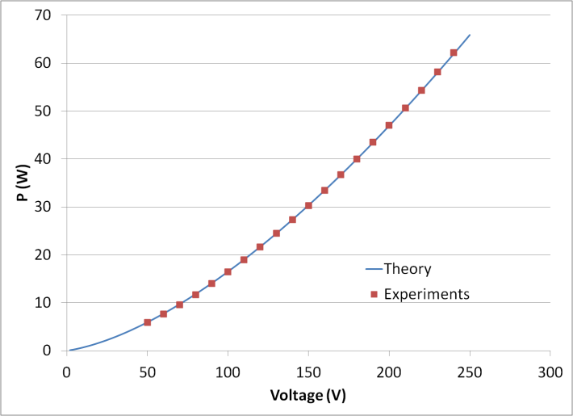
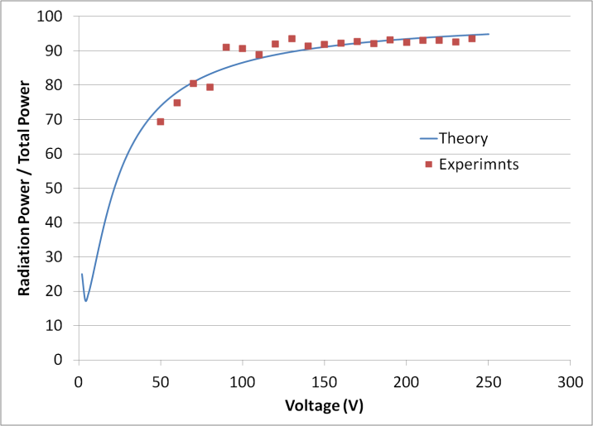

Figure 7: Theory-Experiment comparison, Total Power as a function of voltage
Figure 8: Theory-Experiment comparison, Radiation Percentage
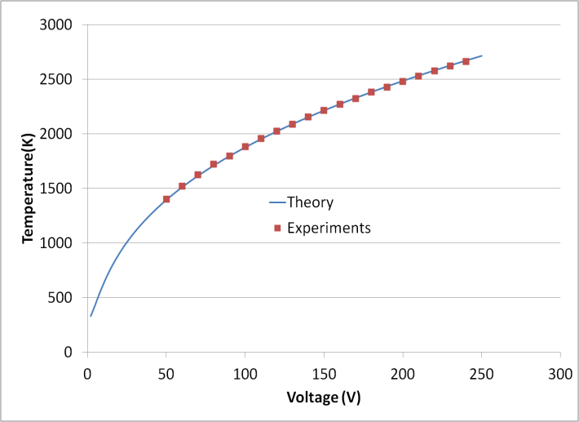
Figure 10: The final result, percentage of the visible power to the total power as a function of voltage

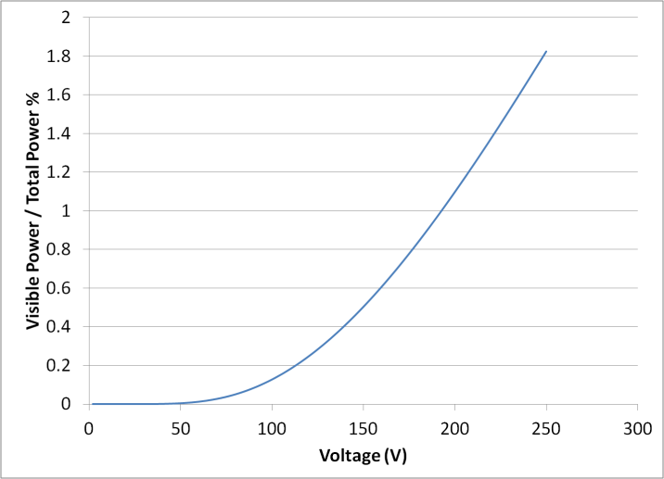
Figure 9: Theory-Experiment comparison, Filament temperature as a function of Voltage

