MOTION OF STABILIZED MAGNETIC LEVITATING SYSTEMS
Alireza Tahmaseb Zadeh¹
Reza Montazeri Namin²
¹School of Electrical and Computer Engineering, University of Tehran, I.R Iran
²School of Mechanical Engineering, Sharif University of Technology, I.R Iran

Abstract
A levitating spinner system is a toy consisted of a spinning magnetic top which levitates above a magnetic base for several minutes without being in touch with an external object. In the present paper the authors have developed a numerical solution which is able to fully simulate the motion of the top according to the basic principles. The magnets have been modeled as electric current loops. Next, physical experiments have been developed in terms of magnetic field, force and top’s motion. Image processing has been made to get quantitative data of the motion of the top. Based on the acceptable agreement between the experiments and numerical results, the simulation program is used to demonstrate all the limitations of the levitating systems.

Introduction
The Levitron™ is a toy consisted of a magnetic spinning top and a magnetic base (usually a tube or box magnet). The equilibrium of the system in the vertical direction is a result of the equality of the weight and magnetic force in opposite directions. According to Earnshaw’s theorem of 1842 [1], the stability of such a system cannot be explained if the rotation axis of the top remains vertical. The stability against the flipping and direction change of the top is a result of the top’s rotation as a gyroscopic motion; however position stability in the vertical and horizontal directions cannot be obtained easily. As proposed by Simon et al. [2], this stability must be a result of the orientation changes of the top, so this phenomenon must be investigated dynamically. As reported by the manufacturers [3], there is a very precise and narrow range of top’s mass and base dimensions to cause the stable motion. We will investigate the effect of the mass, the upper and lower spin limits and initial perturbations in radial and vertical directions. Our experiments and investigation was based on Levitron® Platinum Pro which’s properties could be found at [3].
Force Evaluation
There are two magnets present in this system and we must be able to find the force and torques that they exert to each other. The magnets were modeled as electric current loops. Every small length of one current causes a magnetic field on every point on the other magnet as mentioned by the Biot-Savart law:
$\vec{B}=\frac{μ0}{4π}\int{i }\frac{\vec{dl}×\vec{r}}{{|\vec{r}|}^{3}}$ (1)
Integrating all the fields caused by every small length on the bottom magnet, the magnetic field on every top magnet’s points would be computed. Now at the top magnet, since there is a current in the presence of the magnetic field, magnetic force occurs, known as the Lorenz Force:
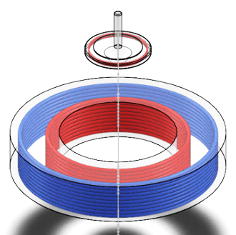
$\vec{F}=\int{i^{'}\vec{dl'}×\vec{B}}$ (2)
A single current loop simulates a simple cylindrical magnet. To simulate a Tube magnet, we assumed it to be two current loops in each other one with a smaller radius; cancelling the magnetization of the inner area; the outer loop causes a positive magnetization in the entire aria, while the inner loop cancels the magnetization with the same current but opposite direction. The radios of the outer and inner loops were physically measured to 12 cm and 9 cm respectively. These current loops should be considered to be distributed in the width of the tube, therefore n=10 current loops were assumed to get precise results (Figure 1).
Figure 1: Modeling
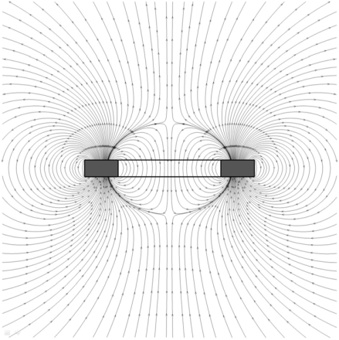
A C++ program was developed to do the calculations. The input parameters were r_{i} and r_{o}, the inner and outer radius of the bottom magnet, d the thickness of the bottom magnet, r_{t} and d_{t} the radius and thickness of the top magnet; r vector and orientation vector; parameters describing the position and orientation of the top magnet despite the bottom magnet. I, the current intensity was also given to the program as a parameter that describes the magnet strength and was to be calibrated later in experiments.
Next numerical force evaluation was confirmed experimentally. Orientation of the magnetic field was measured experimentally using a needle compass and compared to numerical results (Figure 2) in 13 different points which showed an acceptable match (Figure 3a). Next, to measure the magnetic force in different heights, a scale with the precession of 0.001g was used. The base magnet was put on the scale, the top magnet was positioned in several distances (d) in the symmetric axis, and the force on the scale illustrated the magnetic force. This experiment also showed a good match (Figure 3b).
Figure 2: Field Orientation
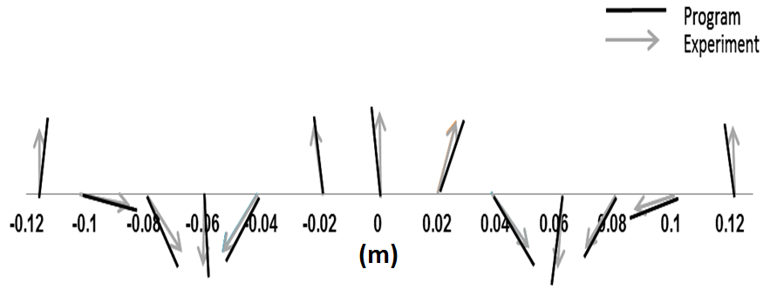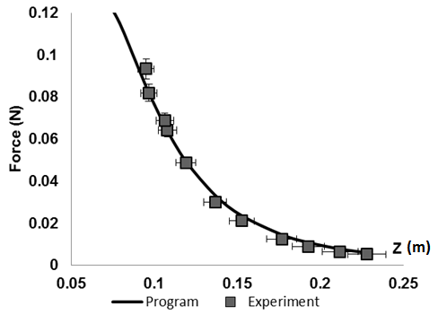
Figure 3a: Field Orientation Experiment
Figure 3b: Force Experiment

Stability
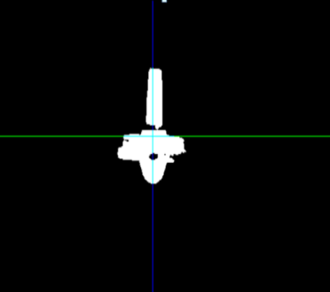As a result of the previous section, we had a function that could output the forces and momentum on the spinning top based on its position and orientation. The top’s height must be justified to equalize the magnetic repulsion and weight. As it is illustrated by figure 5a, there are two possible points in vertical plane allowing the equilibrium. As figure 5b shows, equilibrium exists in radial direction in all heights. But equilibrium is not enough, the stability must also be considered. It must be satisfied that after when the conditions defer than the equilibrium condition, the top gets back to equilibrium point (i.e. the partial deviation of force despite displacement must be negative in every direction).
Figure 4: Video Analysis
The force simulation results showed that in the case when the top’s orientation remains vertical, the stability cannot exist in both directions (This could be proven analytically as well [2]). In the case when the top is free to orient itself parallel to the field lines in its location, there will appear a small range of height where stability occurs in both directions (Figures 5c and 5d). The equilibrium condition relates the height of levitation to the top mass. Considering this point, the mass range in which levitation is possible is calculated in every levitating system. This range happens to be 20.3 g to 21.1 g for our set of magnets.
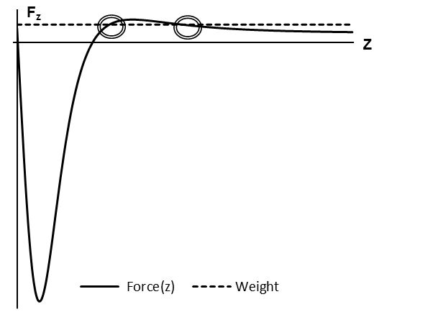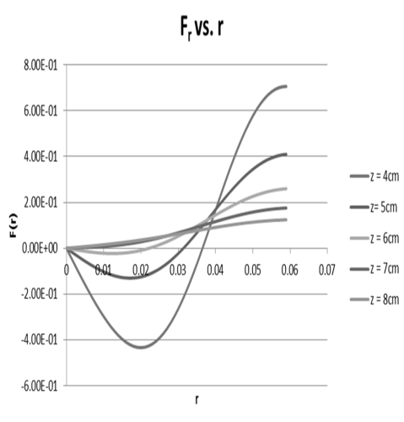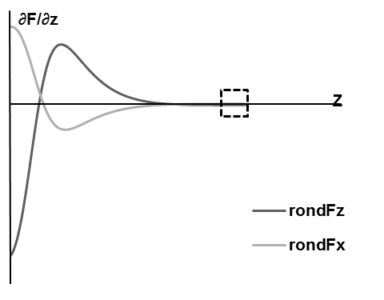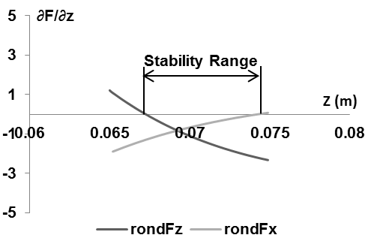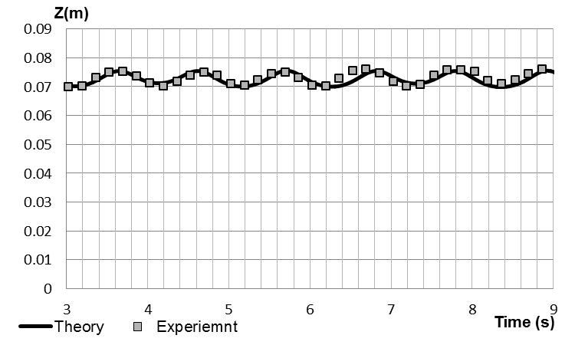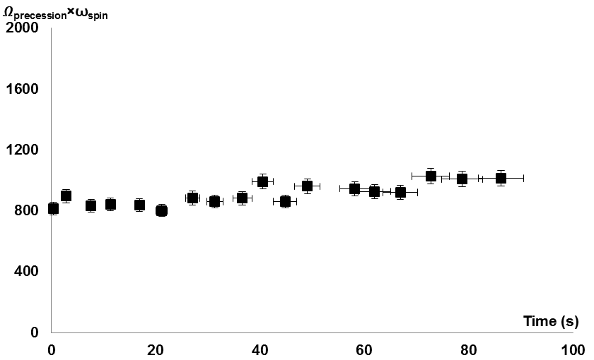
a)
f)
e)
d)
c)
b)

Figure 5: a) Force in vertical direction; equality of magnetic force and weight in two points b) Force in horizontal direction; Equilibrium at different heights c) Partial derivatives of force in vertical and radial direction; the dashed box is zoomed next graph d) Small range of stability e) Motion in vertical direction experiment; high agreement between video analyzed data and simulation program f) Multiplication spin frequency and precession frequency versus time; constant line confirming theory

Simulation Program
To get more information about the levitation and find out the dynamic conditions in which levitation is possible, the motion of the spinning top was to be fully simulated. The governing equations include the equations of linear motion and an equation regarding the angular momentum and torque:
$\frac{d\vec{r}}{dt}=\vec{v}$ (3)
$m\frac{d\vec{v}}{dt}=\vec{F}$ (4)
$\frac{d\vec{L}}{dt}=\vec{τ}$ (5)
We assumed the top to have a high enough angular velocity so that the orientation of the angular momentum is the same as the orientation of the magnetic moment. We used the second order Runge-Kutta numerical method to solve the equations above. The simulations need the angular velocity and initial conditions as inputs, as well as all the parameters needed to find the force and torque.
Discussion
The motion could be analyzed in vertical and horizontal plane.
A) Vertical Plane: The top is in a stable equilibrium in vertical direction. Therefore a small perturbation in that direction leads to an oscillation. The oscillation is obvious in simulation program motion graphs (Figure 6a). To experiment this motion physically, high speed videos of 1000 Frames per Second were recorded. An image processing program was developed using MATLAB®, which could convert these motion videos to graphs (Figure 4). The results did show a great agreement between the theory and experiments, assuring that the numerical theory is functioning correct (Figure 5e).
This oscillation happens only if the initial perturbation in vertical direction is less than a critical amount (Figure 6c). This shows the maximum initial velocity for the motion. For our set of magnets, the amount of critical initial velocity was found to be $\dot{z}$=8.5 mm/s.
B) Horizontal Plane: The top gains a precession spin in addition to its spin frequency which is a result of gyroscopic action. The results of the numerical simulation also illustrate this motion (Figure 6b). Simulation program results also suggest that precession frequency is inversely proportional to the spin frequency. This was checked experimentally using high speed videos, again showing a good match between the theory and the experiments (Figure 5f).
It was observed that the top would have a curved motion back to the initial position when gained a velocity in the radial direction. If this initial velocity is more than a critical amount, the top will be thrown away (Figure 6g). The amount of critical initial velocity was found to be $\dot{r}$=12 mm/s using the simulation program.
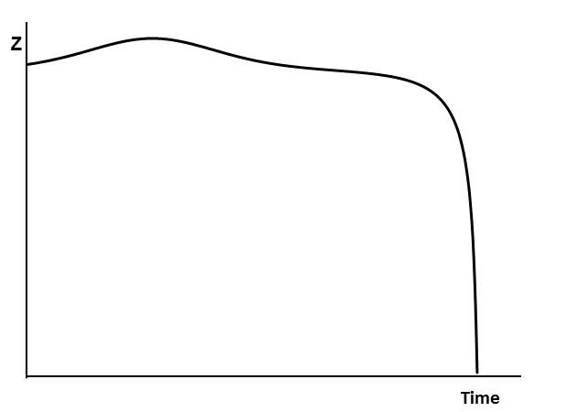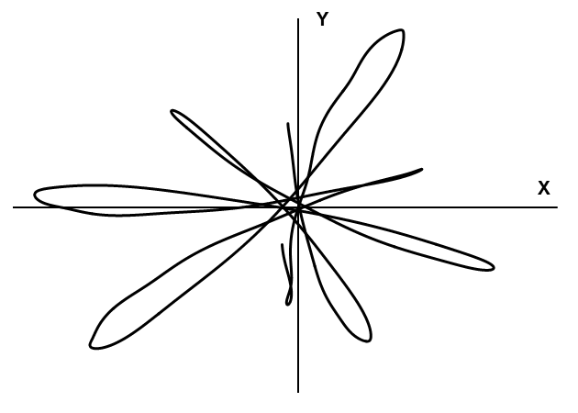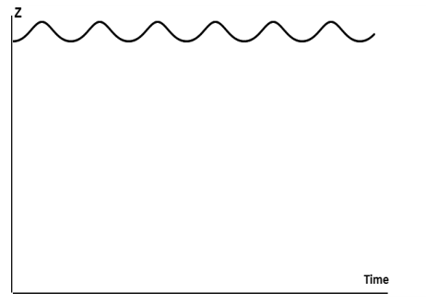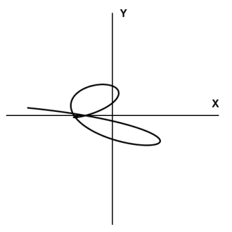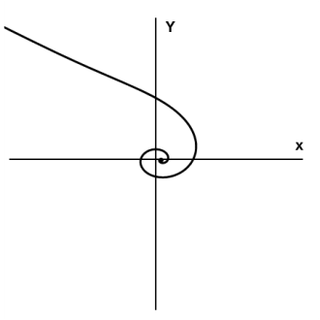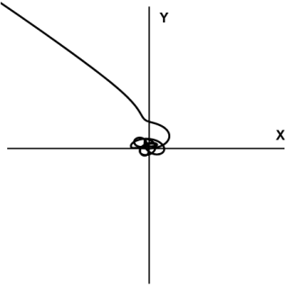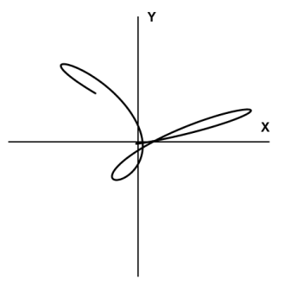
a) b) c)
d) e) f) g)
Figure 6: a) Oscillatory motion in vertical plane b) Curved returning motion in horizontal plane c) Out of range initial vertical velocity 10 mm/s; the top is pulled to the base d) Returning curve in spin frequency 180 Rad/s e) Returning Curve in spin frequency 280 Rad/s; bigger curves in comparison with previous graph f) Out of range spin frequency 330 Rad/s; passing the upper spin limit g) Out of range initial radial velocity 15 mm/s; the top is thrown away
While the increase of the angular velocity causes more stability against flipping, the axis of the top becomes too rigid; where the top cannot orient quickly enough with the field lines. This leads to an upper spin limit for the top which is ω_{upper}=311 Rad/s for our system (Figures 6d, 6e and 6f). If the top is spun too slowly, then the top becomes unstable against rotations. The top will then flip over and will be pulled quickly to the base. This is the instability that is well known from classical top physics. This amount was found experimentally using a tachometer detecting one point on the top. For our levitating system, it was ω_{lower}=118±5 Rad/s.
Conclusion
The theory and modeling of the magnets was applied to a simulation program to demonstrate the motion of the top. The simulation, works as well, in every other shapes and dimensions of magnets to calculate the motion of the top as a function of time. Using this program, the optimum dimensions of magnets to provide greater levitation heights or higher stability, could be found to design better levitating spinner systems.
References
[1] S. Earnshaw, Trans. Cambridge Philos. Soc. 7, 97-112
[2] Martin D. Simon, Lee O Heflinger, Torrance CA, SL Ridgway 1997 Spin Stabilized Magnetic Levitation, Am J. Physc. 65 (4)
[3] Levitron Physics. (n.d.). Retrieved from Levitron Official Website: http://www.levitron.com/physics.html
[4] Roger F Gans, Thomas B Jones, Masao Washizu 1997, Dynamics of the Levitron, J. Phys. D: Appl. Phys. 31
[5] S. Gov, S. Shtrikman, H. Thomas 1998, On the Dynamical Stability of The Hovering Magnetic Top

