STICKY WATER

Stanislav Krasulin
BSU Lyceum, Belarus
Sometimes in our life it happens that water falls down. When we are taking shower, for example. Hot steam makes mirror grow misted, diffidently leaving you alone; splashes jump around, reflecting cold artificial light; jets of water fly vertically down, but once their purposeful flight has been interrupted by some object, they tend to stick to it, following all it’s curves….
In this task we are asked to investigate one particular part of this effect: if a horizontal cylinder is placed into vertical stream of water, it can follow it’s circumference along the bottom and continue up the other side before it detaches. Certainly, as almost all of the IYPT tasks do, this one also wants us to find dependences on relevant parameters.
So, since making experiments in a shower isn’t welcomed (other people also want to use it), it is necessary to build an experimental setup. My poor imagination hasn’t came out with anything better than just a vessel with a hole in it’s bottom, with a tap attached to it. Cylinder should be mounted in a support, under the tap. And almost forget, there should be another vessel under the cylinder, because big amounts of water on the floor require taking a crucial decision about who’s gonna clean.
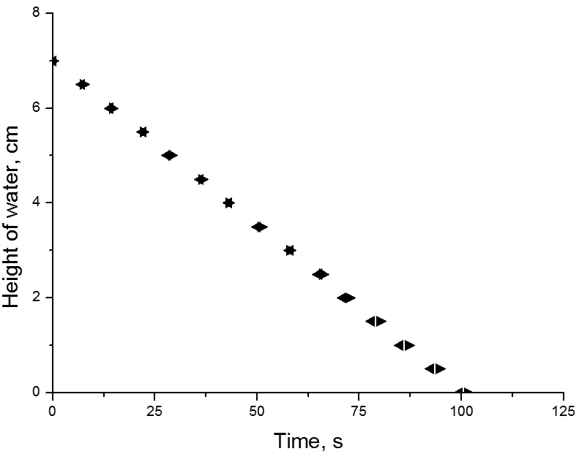
However, even in such a simple scheme we can vary two main parameters of the jet: it’s diameter (thanks to tap); and it’s velocity (through the height of water level in the vessel). Certainly, you can object that water level moves all the time; but if we need to get some data from experiment, we can just take a picture of the water on the cylinder, and water’s velocity at the moment will be known exactly. Important note: when taking pictures/filming such experiments, do not put the camera on the table above vessel with water. Important note to myself: when next time taking pictures/filming such experiments, DO NOT put the camera on the table above vessel with water…
Unfortunately, there still is a problem about calculating velocity through the height of water level: in fact, when we place cylinder in the stream, it affects on the speed of water leaking; this fact is experimentally checked on the fig.1. Good news is that this influence is negligibly small.
Figure 1. Left-arrows are for jet without cylinder, and right-arrows are for jet with cylinder.
After all these manipulations setup is ready for making… something. A correct answer is 50% made of correct question; and to ask our setup a correct question we need at least some information about the effect.
Jet’s attraction to different obstacles can be explained by Coanda’s effect, discovered by Romanian inventor, who’s surname was – surprise! – Coanda. The main idea is that when stream of water is travelling through the air, due to friction, air starts moving together with water. But if there is an obstacle on the one side of the jet, it slows air down. However, air velocity on the other side of the jet remains the same. Air with higher velocity applies higher pressure to the stream; thereby, water is pushed towards the obstacle. But in fact, this effect is not enough to explain our phenomenon. To prove it, let’s put in the stream a cylinder with super-hydrophobic surface.
If you need a super-hydrophobic surface you can take 2 million dollars, build a huge NASA lab, and then wait for couple of months. Or, you can take a candle and hold a cylinder in it’s flame for couple of minutes, until it is covered with soot. For obvious reasons, we have chosen second option (waiting for two months is too long).
The reason for soot to be super-hydrophobic is the structure of it’s surface. It has a lot of hollows, big enough for holding air particles inside. Therefore, water droplet, placed on soot, contacts mostly air, and a very small area of higher parts of soot’s surface. And when we place a super-hydrophobic cylinder into water stream, stream doesn’t stick to the cylinder. In fact, it jumps away, screaming. It leads to a conclusion, that main reason for water to stick to the cylinder is force of surface interaction between them.
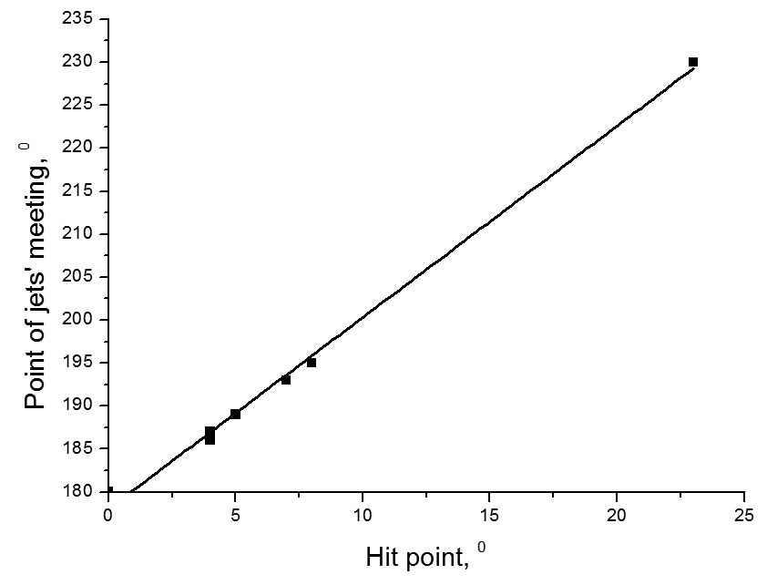
So, what happens if a cylinder with normal surface is placed into a jet? Something we have named “ellipse” is formed. It is a thin layer of water, surrounded by a thick water stream; it’s length is bigger than width; and in the lowest part water streams from the sides meat each other, forming one jet. Let’s explain this structure.
When the water hits the cylinder, it starts moving into all directions on cylinder’s surface. The water, which is moving upwards, is soon stopped by gravity force. Although, it is possible, that it will pass the top of the cylinder. If it happens, all this water will be finally united into one stream on the one side of the cylinder, all other water will form one jet on the second side; and in most cases, they will meet each other in the lower part of the cylinder. We have described point of jets’ meeting and point, where stream hits cylinder, through the angle between cylinder’s radius, drawn through this point, and vertical. The connection between two this values is shown on the fig.2: these points are almost opposite.
Figure 2. Place of jet’s meeting depending on the point of original stream meeting cylinder. Line shows linear fit.
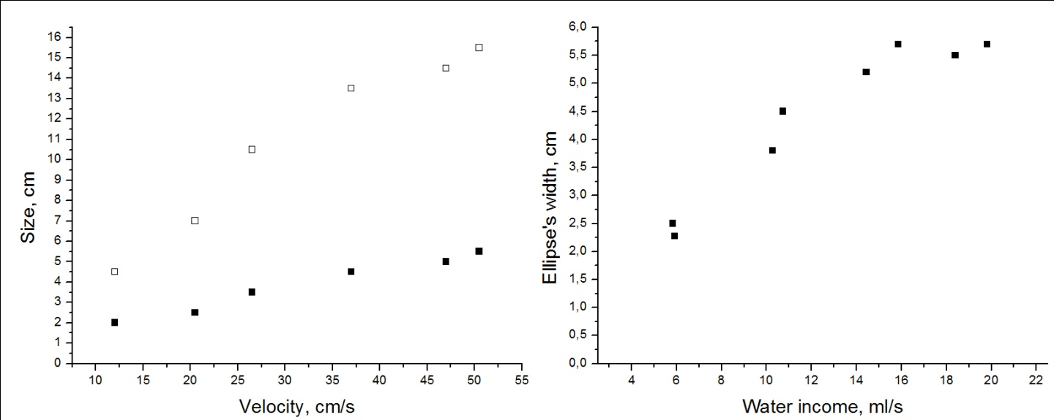
But let’s get back to the structure of the “ellipse”. Besides water, going upwards, there is water, going into the sides. Certainly, the higher was original velocity of the stream, the higher are velocities directed into sides; thereby, bigger is width of the ellipse (see fig.3). But what stops the water? Gravity force can’t stop it; however, plot proves that “ellipse’s” width isn’t eternity. There are two possible explanations: viscous friction and surface tension. Certainly, we would like to know, which answer is correct. Or, maybe both effects work together like Batman and Robin? In order to check it, we tried to vary corresponding parameters of liquid (surface tension and viscosity) separately. First, we added soap to the water: it changes surface tension, but without affecting viscosity. With soapy water width of ellipse has significantly grown, comparing to usual water. Then, we took some water, and decreased it’s temperature down to 2°C, and compared it’s ellipse to the one of water with temperature 27°C. In this range of temperatures surface tension changes negligibly; however, viscosity is changed significantly. But no difference between the two ellipses was found. Both tasted like chicken. Therefore, we can conclude that water’s movement to the sides is stopped by surface tension. By the way, also surface tension is responsible for forming the thick border of the ellipse, and for these borders to unite into one stream; that’s because water tries to have the smallest area of surface. It is interesting, that when borders of ellipse unite back in one jet, decrease in area of surface also causes decrease in cross-section area of the overall stream; therefore, according to the continuity equation, velocity of the stream increases (remember, that viscous friction is low).
Figure 3. Left plot shows dependence of length (empty squares) and width (full squares) of the ellipse on the plane surface on the original velocity of the stream. Right plot is dependence of the width of ellipse on the cylinder on the volume of incoming water per second.
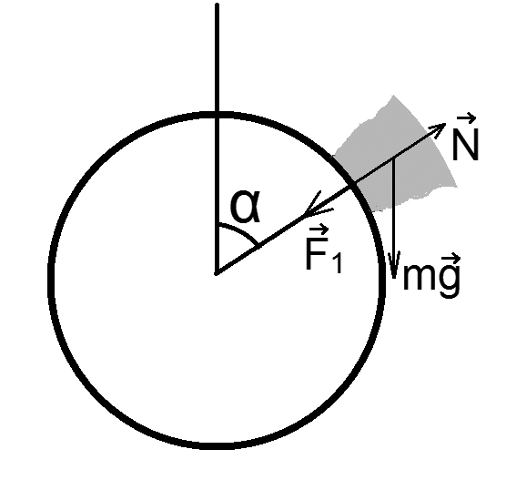
Why is it interesting for us? Because we are too curious. And because it’s directly connected to our task (however, main reason is the first). Take a look at fig.4 where a small amount of water, moving around the cylinder, is shown. Under Newton’s second law:
Figure 4. Forces, acting on a small amount of water on the cylinder’s surface.
where m is mass of this amount of water, F₁ is force of surface interaction between water and cylinder, N is cylinder’s normal reaction force, and v is water’s velocity. So, in order for water not to detach from the cylinder, it’s velocity should obey. Obey this equation:
It says that critical velocity is different in all points of cylinder. So let’s plot dependence of this velocity on the point of cylinder in polar bears. Excuse me, polar coordinates. You can see these plots on fig.5. They show that in any situation critical velocity is lowest in the bottom point of cylinder; it means that if the water has successfully passed this point, it won’t have enough velocity to detach anywhere else. It will move upwards, until stopped by gravity force; then it will try to slide backwards, but will meet coming water and, therefore, fall down.
However, there is one exception: if borders of an ellipse unite in one stream after passing bottom point of the cylinder. Because of the velocity increase, it is possible that water will detach from the cylinder.
Another interesting thing is that not only water can detach from the cylinder; it can also just tear apart, if the jet is too big for surface tension to overcome gravity forces. For this not to happen, Laplace’s pressure should be bigger than hydrostatic:
where r is radius of the jet (approximating that cross-section of the jet is semicircle), σ and ρ are surface tension and density of the liquid respectively. So, we can find maximal radius of the liquid’s stream on the cylinder’s surface:
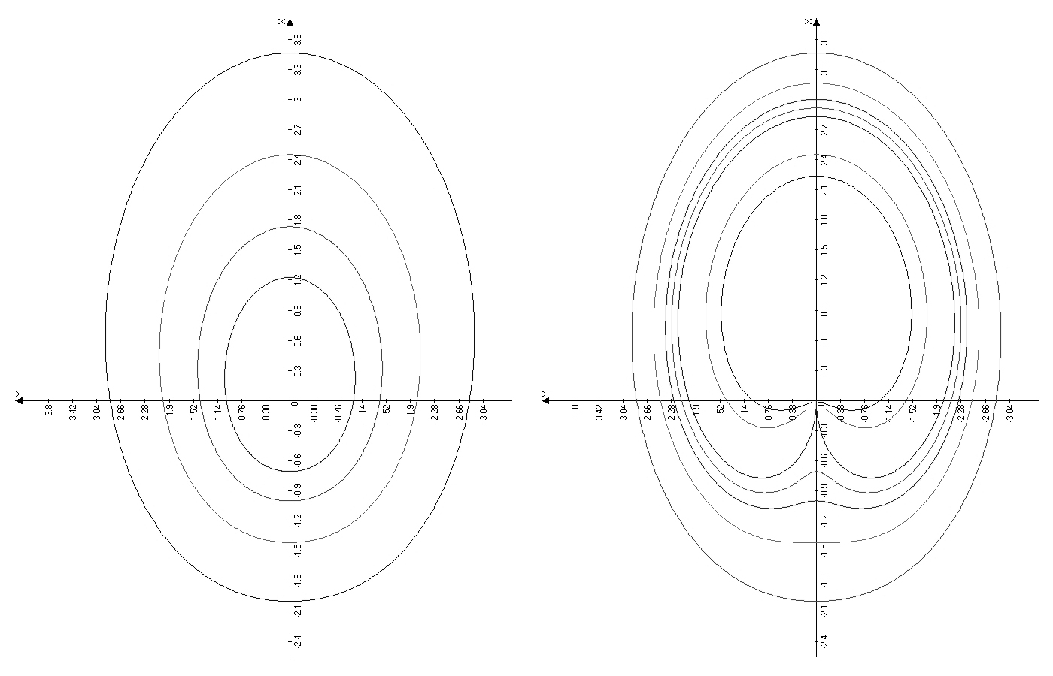
For water this value is r=2.4 mm.
The last relevant parameter in our task is point, where stream hits a cylinder. It’s pretty obvious, that if angle between the cylinder’s radius, drawn through the hit point, and vertical is 0°, then we have maximal width of ellipse; as this angle approaches 90°, width decreases, while length increases. But unfortunately everything isn’t that simple. As if this ellipse wasn’t complicated enough, it has it’s own bistability. For some points of cylinder there are two variants of ellipse: one is wider and shorter; another is longer and less wide. The first variant is achieved when moving cylinder in the jet; the second is achieved when moving it out. This is the only thing in this task we hasn’t managed to explain; however if there’s just one such thing, it’s a huge success.
Huh, finally we’re almost done. Now the only thing left is to squeeze all previous text into several paragraphs and call them conclusions.
Figure 5. On the left plot different lines show different radii, on the right different lines are for different values of (F₁/m). Both plots are just demonstrational; they only show connection between values.
The reason for water to stick to the cylinder is force of surface interaction between them. But if water’s velocity in the given point is bigger than critical value, it will be accused of breaking speed limit and, for that reason, detached from the cylinder. The smallest critical value is in the bottom point of cylinder; so, if the jet of water has passed the lowest part of the cylinder it will continue moving upwards until stopped by gravity force.
However, water exists on the cylinders surface not only in the form of a jet, but also in a form of an ellipse. Ellipse is a thin layer of water, surrounded by thicker streams, which finally unite back in one jet. It’s form is explained by surface tension forces; it’s linear dimensions – by surface tension, original velocity of water, and point, in which stream hits the cylinder; it’s name is explained by the lack of imagination. In the point where ellipse unites back in one jet, velocity of water increases, allowing it to detach even after passing bottom point of cylinder.
Also, some parts of water right after hitting cylinder can start moving upwards and pass the top point, forming second stream of water. If two streams will unite back into one, they will make it in the point, almost opposite to the one, where the stream had originally hit the cylinder.
And the last thing is that since surface tension isn’t a champion in weightlifting, amount of water which it can hold is strongly limited.
Here I can state that my first case is closed. Investigation is complete. All relevant parameters are in their prison cells. All fallen heroes are buried with honors (I’m talking about the camera, which has fallen into the water). As for me, I probably will never fully forget this investigation; whenever I see a jet of water, I spend hours by putting different objects in it and observing motion of water… And yes, it really is my first IYPT problem.

