ICE

Stanislav Krasulin
BSU Lyceum, Belarus
This task asks us to investigate a very interesting phenomenon: if a wire with weights attached to each end is placed across a block of ice, this wire may pass through the ice without cutting it. After I had heard about this problem, I’ve immediately decided to solve it. Who knows, maybe results will help me to pass through concrete walls (spoiler: they won’t).
Certainly, in the beginning there were some doubts even that wire may actually pass through the ice and not divide it into two parts; therefore, first thing to do was to check, if it is possible. But together with ice cubes, a trouble had jumped out of refrigerator: those ice cubes had a non-transparent region in their central part. The explanation is hidden in the water itself: it’s air and other gases, dissolved there. These gases can’t freeze together with water, and when it crystallizes they just leave it. However, when a vessel with water is put in a refrigerator, first the outer parts of water will turn into solid state, and gasses in the water in the inner part will be captured inside. And when this water finally crystallizes, gases form small bubbles, which make ice non-transparent. Certainly, they also change mechanical and thermodynamic properties of the ice, and it’s difficult to predict how exactly. Fortunately, this non-transparent region isn’t too big, and it is possible to run experiments in the region with clear ice.
Anyway, first experiments were successful: ice really remained in one part. In fact, even if we have two blocks of ice, they tend to become one. If environment temperature is positive, there is a thin layer of melted water on the ice. But when two ice cubes are put I contact, heat from this water is sucked by ice (we had accidentally dropped Dracula into the water, while it was freezing); thereby, water crystallizes, connecting two blocks together. However, after it had happened, there is no slit on the surface of the ice in the place, where cubes had connected. And if wire passes through the ice, it lefts a notable slit; it proves that these are two different phenomena.
But what have happened to the ice, which was in the place of the slit? It have definitely melted. And it definitely was melting faster, than all other ice. Everything has some reason (even though sometimes this reason is “God wants it to be so”); and so does this accelerated melting. The matter is that volume of a portion of ice at the temperature 0°C is bigger than volume of the same portion of water at the same temperature; therefore, if we apply pressure to the ice, we help it to decrease it’s volume, correspondingly, assisting in melting. For example, if ice is under pressure of 130 bar, it will melt at the temperature -1°C. And everybody knows, that in atmospheric pressure ice melts at 0°C. Approximating, that between these two points dependence of melting temperature on applied pressure is linear, we can write:
where P is applied pressure, and T(P) is temperature at which ice will start melting.
So, let’s describe what’s exactly happening in our experiment. When a wire is placed across a(n ice) cube, pressure is applied to a small portion of ice, so it melts at negative temperature (it certainly requires some heat, but it comes from the environment). Once it is turned into water, pressure pushes it upwards, around the wire. During this movement water heats up almost to 0°C. But when water reaches top side of the wire, there is no more pressure; water now is super-cooled, therefore it instantly crystallizes, releasing heat. This heat is transferred down through the wire and is used to melt a new portion of ice. And the whole story repeats.
This theory can be used to build a mathematical model. A correct theory can be used to build a correct mathematical model. Unexpectedly, our theory is correct: it is proved by the fact that wire leaves a turbid trace in the ice. It occurs exactly because of super-cooled liquid crystallization. Liquid starts to crystallize around different dirt particles; as there’s always lots of dirt everywhere, a lot of crystals are growing at the same time. That is why not one solid crystal is formed, but a set of small ones. Borders between these crystals scatter light, making the whole structure less transparent than usual crystal of ice.
Now, once we believe that our mathematical model will be correct, we can start building it. Our theory says, that all the ice involved in the cycle one time melts into water, and one time heats up. Thereby, our Need for Heat is:
where c is water’s heat capacity, λ is specific heat of fusion,T₀ is original temperature of ice, and m is mass of ice under the wire, it can be calculated as m=ρhdl; where ρ is ice’s density, h is height of the ice block, d is wire’s diameter and l is length of the part of the wire which touches ice. We know, that all this heat have to pass through the wire. Heat flux through the wire is:
where K is wire material’s heat conductivity, S is area of contact of wire with crystallizing water. Thereby, time, required for the wire to pass through the ice, is:
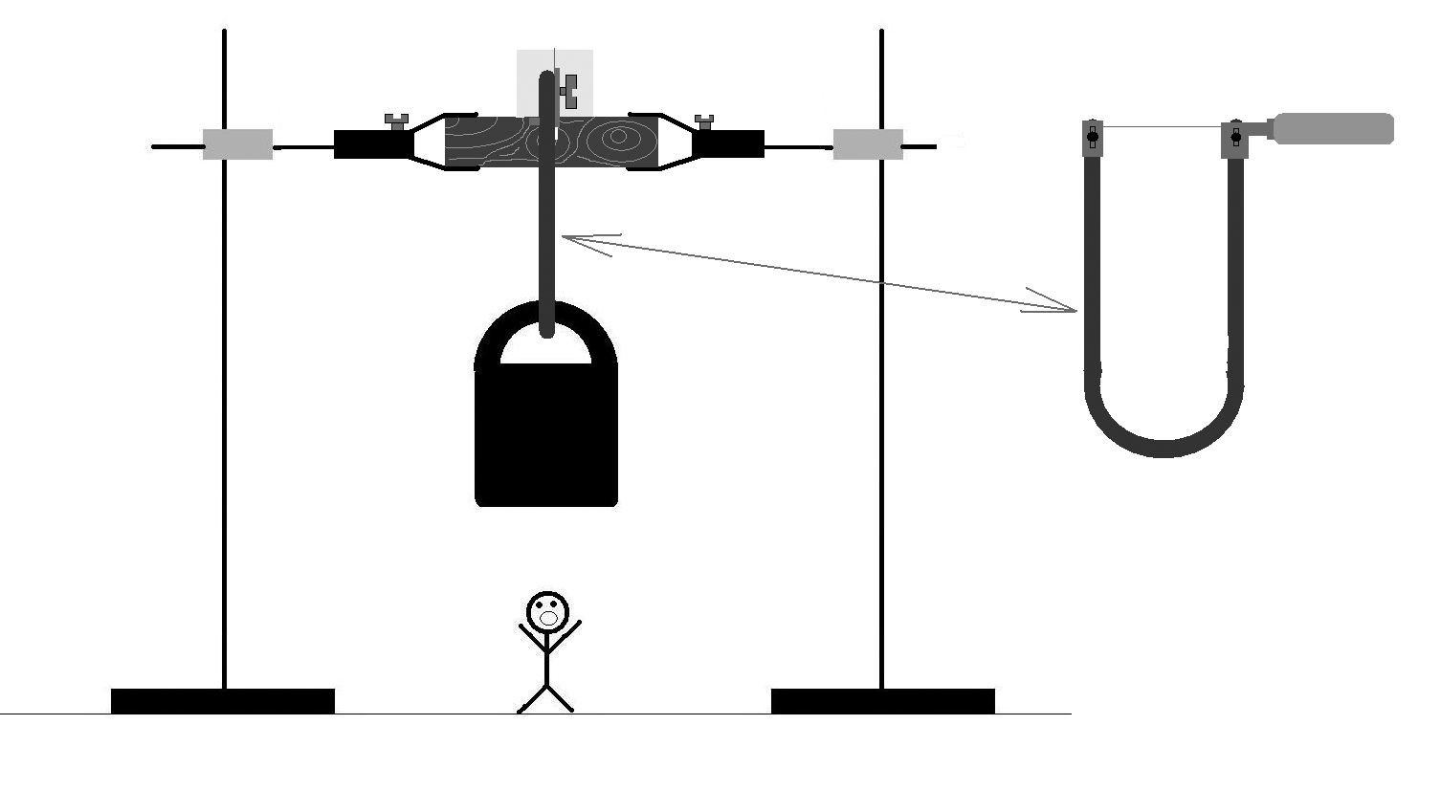
where M is total mass of the weights attached to the wire. We can see, that time is proportional to the square of wire’s diameter and inversely proportional to the mass of load. Certainly, we want to check if it’s true. And it requires an experimental setup.
A block of ice is placed onto a piece of wood (to reduce melting), which is mounted in two supports. There is a slit made in the wooden block, so that wire could continue moving down after exiting ice cube. In our calculations we have assumed, that wire inside the ice isn’t curved. To achieve it in experiment the wire is mounted in a fretsaw, instead of it’s blade. Load is attached to the fretsaw (fig.1).
Figure 1. Experimental setup. After wire exits ice, it falls onto the wooden block and tears apart because of the impact. Too bad for the small human…
Using this experimental setup dependence of the time of cutting on the load’s mass was checked (fig.2). Experiment proves our theory. I’d like to say the same about dependence of the time on the wire’s diameter (fig.3). Unfortunately, it is rather difficult to find several wires of different diameters, but with 100% equal chemical
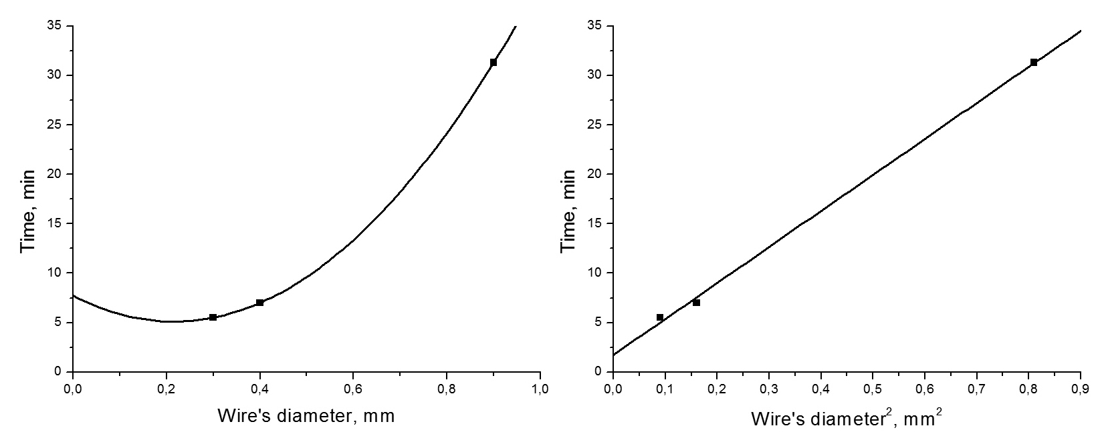
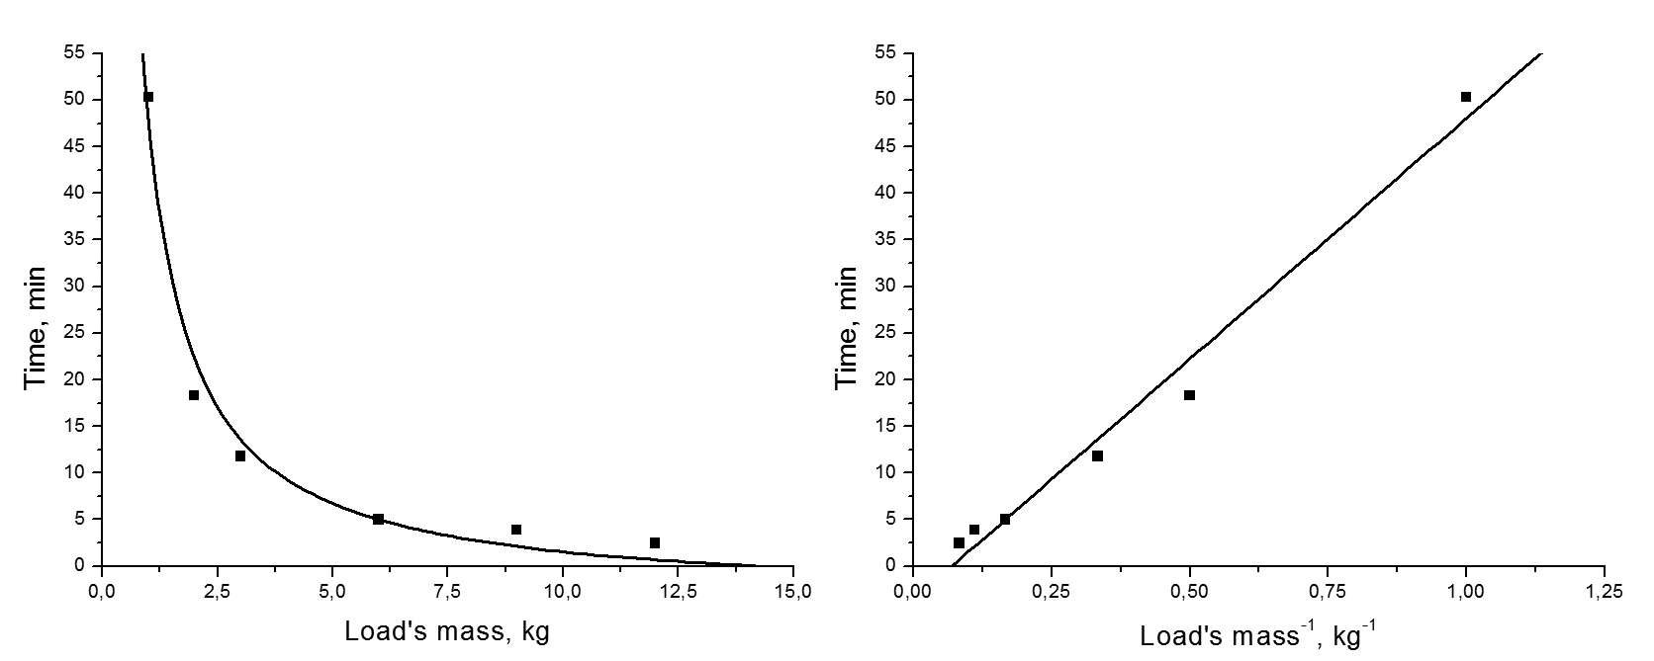
composition. We had found only three wires, in composition of which we were completely sure. And three dots are a little bit not enough to say that everything’s fine. In fact, everything is awful. Just take a look at Table 1.
Figure 2. Plot of cutting time subject to loads mass for the nichrome wire (d=0.4 mm), and it’s linearization. Fitted by hyperbola.
Figure 3. Time of cutting for three nichrome wires with 6 kg weight attached, and linearization of this dependence. Fitted by square parabola.

Table 1. Cutting times for copper wires with different parameters.
Wire’s diameter, mm | Load’s mass, kg | Cutting time
0.6 | 5 | 18 min 20 s
1.35 | 5 | 8 min 50 s
1.45 | 5 | 8 min 08 s
1.45 | 1 | 9 min 20 s

You can see, that for copper wire increase in diameter decreases time, and changing of load’s mass almost doesn’t affect anything. But why our dependences stopped working? What’s so special about copper, comparing to previously used nichrome? It is heat conductivity: copper’s heat conductivity is about 8 times higher than nichrome’s. When wire invades ice, it serves as a bridge for heat transfer from environment. For nichrome, such heat inflow was significantly smaller than heat, released from crystallizing water; for copper, however, the picture is different. And if we increase wire’s diameter we increase heat income from environment; if mass of load is changed, it affects temperature of water melting, which is, in this case, less important. So, to make our model work for wires with high heat conductivity, it is required to take into account heat income. Since above the wire temperature is 0°C and under it it’s T(P), we can approximate, that whole wire has temperature T(P)/2. Experimentally we have found, that distance y between the last point of wire, where temperature is equal to air one, and the first point where it is equal T(P)/2, is about 3 cm. Thereby heat flux through the one side of the wire:
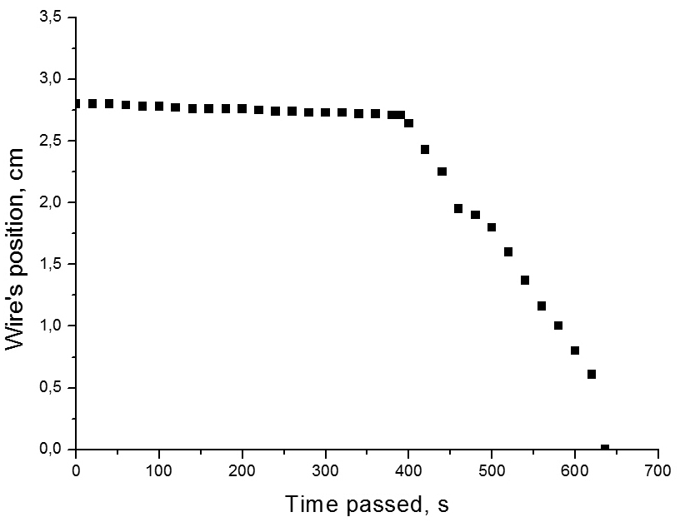
where T_{air} is air temperature. Since wire has two ends, total income of heat from environment is 2*W₂. But we not only have made theory to correspond experiment; we’ve also forced experiment to be like theory: we have established an inflow-less experiment. I’ve been kicked outside (T_{air} was about 0.5°C) together with experimental setup; I’ve also put melting snow around free ends of the copper wire, so there were almost no heat income. Most results of this experiment can be seen on the fig.4. The result which isn’t shown there, is that I’ve almost turned into an ice sculpture, while writing down data.
But once we have taken into account what we gain, we should also calculate what we are loosing. You remember, there’s an angry Transylvanian count somewhere inside our ice cube, and he continues to suck out heat from the crystallizing water. And if you say that trip through Romania has damaged my brain, I can answer that there’s nothing to be damaged. And that it’s true, that not all heat from crystallizing water goes down through the wire; part of it escapes into surrounding ice. Once again, it was experimentally found, that on the distance of about 1 cm from the wire ice’s temperature hasn’t changed during experiment. Assuming that heat escapes from the wire, and from the zone above wire, heat flux into one side can be calculated as:
Figure 4. At first wire moves slow, as it’s only accumulating heat, required for melting first portion of ice. But then cycle finally starts, and wire moves with constant velocity.
Total lack of heat will be 2*W₃. And once we’ve started to be so precise, let’s take into account, that specific heat of fusion depends on the temperature, at which melting occurs: for water at 0°C λ=330 kJ/kg, and at -7°C it’s 317 kJ/kg. Once again, in this part the dependence can be approximated as linear; which means that dependence on the pressure is also linear. Now, combining this all, General Formula is born:
If you understand what all these letters mean, then you’ve been REALLY attentive… But if you don’t understand something, it just means that you don’t have superhuman abilities.
And while you are regretting not-having superhuman abilities (or designing your new super suit – who knows?), I’ll proceed to the conclusions. Because of the pressure ice under wire melts at negative temperature; in liquid form it goes upwards and freezes back under the wire, creating turbid region. Then cycle continues again and again. However, for materials with high heat conductivity it is necessary to take into account income of heat from the environment through the wire. To improve mathematical model further, it is possible to calculate heat losses and affect of melting temperature on the specific heat of fusion.
Experiments prove these qualitative and quantitative models; however, it should be noted that wire must go through the transparent region of the ice block, because properties of the non-transparent region are significantly different.
Had it any practical sense? I still can’t pass through concrete walls… However, thanks to General Formula, we now know how much time has left for the small human, who is standing under the load. Tick-tock…

