ICE

Stanislav Krasulin
BSU Lyceum, Belarus
Introduction
This task asks us to investigate a very interesting phenomenon, which was first observed over a century ago¹: if a wire with weights attached to each end is placed across a block of ice, this wire may pass through the ice without cutting it.
In our work, most experiments were held in the room with air temperature 23 °C (unless otherwise mentioned); for producing ice blocks we had used usual ice cube tray, which was filled with usual water and placed in the refrigerator at temperature of -11.5 °C for at least 12 hours.
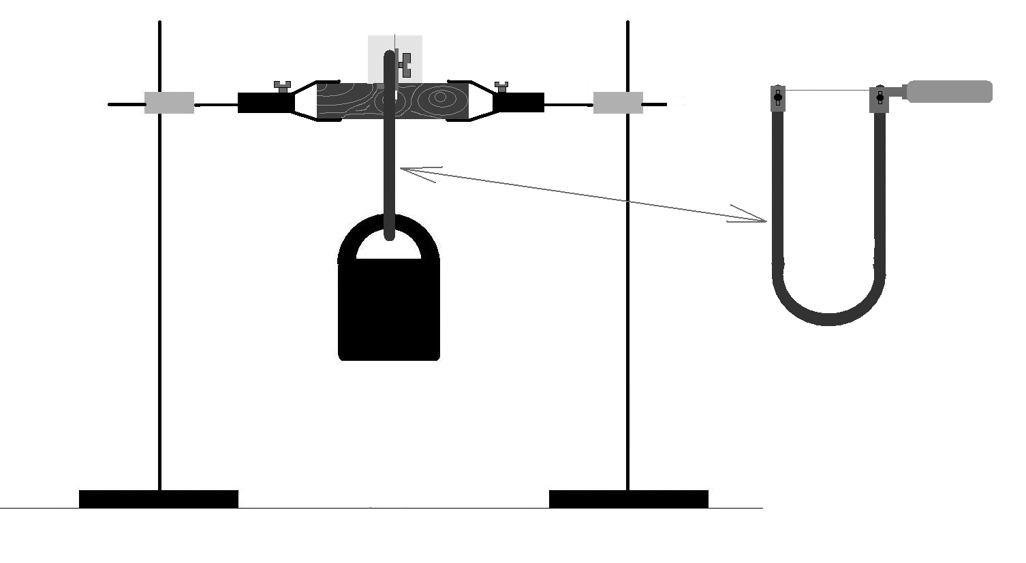
It should be noted, that ice blocks, produced such way, have a non-transparent region in their central part. It happens due to the presence of air and other gases, dissolved in water. These gases can’t freeze together with water, and when it crystallizes they just leave it. However, when a vessel with water is put in a refrigerator, first the outer parts of water will turn into solid state, and gasses in the still liquid water in the inner part will be captured inside. And when this water finally crystallizes, gases form small bubbles, which make ice non-transparent^{2,3}. Certainly, they also change mechanical and thermodynamic properties of the ice, and it’s difficult to predict how exactly. Fortunately, the non-transparent region wasn’t very big, so it was possible to make a cut through ice without entering it; so, in our experiments we were placing wire so that it would go only through the transparent region.
Experimental setup
Scheme of our experimental setup is presented in fig. 1. A block of ice is placed onto a piece of wood, which is mounted in two supports. Wood is used because due to less efficient heat exchange it reduces melting (compared to the ice, mounted directly into metal supports). There is a slit made in the wooden block, so that wire could continue moving down after exiting ice cube. In all our calculations we have assumed, that wire inside the ice isn’t curved. To achieve it in experiment the wire is mounted in a fretsaw, instead of its blade. Load is attached to the fretsaw.
Figure 1. Experimental setup.
Qualitative explanation
Already first experiments had shown that effect, described in the problem, does take place: ice really remained in one part. But we also had noticed that even two originally separate blocks of ice tend to become one. If environment temperature is positive, there is a thin layer of melted water on the ice; and when two ice cubes are put in contact, heat from this water is “sucked” by ice; thereby, water crystallizes, connecting two blocks together. However, after it had happened, there is no slit on the surface of the ice in the place, where cubes had connected. And if wire passes through the ice, it lefts a notable slit; it proves that these are two different phenomena.
But what have happened to the ice, which was in the place of the slit? Surely, it had melted. And, for some reason, it was melting faster than all other ice. This reason is additional pressure, applied by the wire. This effect is called “regelation”, and was first observed by Michael Faraday⁴. The matter is that volume of a portion of ice at the temperature 0 °C is bigger than volume of the same portion of water at the same temperature; therefore, if we apply pressure to the ice, we help it to decrease it’s volume, correspondingly, assisting in melting. For example, if ice is under pressure of 130 bar, it will melt at the temperature -1 °C. And in atmospheric pressure ice melts at 0 °C. Approximating, that between these two points dependence of melting temperature on applied pressure is linear, we can write:
where P is applied pressure, and T(P) is temperature at which ice will start melting.
So, let’s describe what’s exactly happening in our experiment. When a wire is placed across an ice cube, pressure is applied to a small portion of ice, so it melts at negative temperature (it certainly requires some heat, but it comes from the surrounding air). Once it is turned into water, pressure pushes it upwards, around the wire. During this movement water heats up almost to 0 °C. But when water reaches top side of the wire, there is no more pressure; water now is super-cooled, therefore it instantly crystallizes, releasing heat. This heat is transferred down through the wire and is used to melt a new portion of ice². And the cycle repeats.
This theory is proven by the fact that wire leaves a turbid trace in the ice. It occurs exactly because of super-cooled liquid crystallization. Liquid starts to crystallize around different dirt particles; so a lot of crystals is growing at the same time. That is why not one solid crystal is formed, but a set of small ones. Borders between these crystals scatter light, making the whole structure less transparent than usual crystal of ice.
Quantitative analysis
Our theory states that all the ice involved in the cycle one time melts into water, and one time heats up. Thereby, total heat required is:
where c is ice’s heat capacity, λ is specific heat of fusion, T₀ is original temperature of ice, and m is mass of ice under the wire, it can be calculated as m=ρhdl; where ρ is ice’s density, h is height of the ice block, d is wire’s diameter and l is length of the part of the wire which touches ice. Now, if we approximate our system as closed (no heat enters or leaves the system) than all this heat have to pass through the wire. Heat flux through the wire is:
where K is wire material’s heat conductivity, S is area of contact of wire with crystallizing water. Thereby, time, required for the wire to pass through the ice, is:
where M is total mass of the weights attached to the wire.
Experimental analysis
In the last formula time is proportional to the square of wire’s diameter and inversely proportional to the mass of load. We had checked correctness of these dependences for the nichrome (heat conductivity 12 W/(m*K)) wires (fig. 2). It can be seen, that dependence of the time of cutting on the load’s mass is correct; however, we can’t be so sure about dependence on wire’s diameter. The matter is that for precise measurements we had needed wires of different diameter, but 100% identical chemical composition; and we found only three such nichrome wires. In the fig. 2 this dependence is fitted by parabola, using the fact that it should go through (0; 0) point. It can be seen, that dependence is close to parabola; but due to the number of experimental points, we can’t state that dependence is proven. We can only say that for nichrome increase in wire’s diameter increases time, required for cutting; thus, at least qualitatively proving theory.
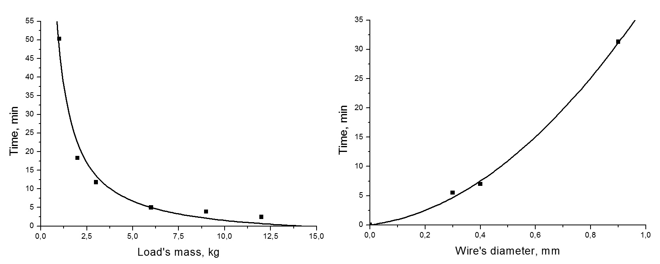
But these dependences do not work for the copper (heat conductivity 382 W/(m*K)) wires at all. As shown in Table 1, not only cutting time now decreases with increase of wire’s diameter, but also there is almost no dependence on the load’s mass.
Figure 2. Left plot shows cutting time subject to loads mass for the nichrome wire (d=0.4 mm), fitted by hyperbola; right is time of cutting for three nichrome wires with 6 kg weight attached, fitted by parabola.
Table 1. Cutting times for copper wires with different parameters.
Wire’s diameter, mm | Load’s mass, kg | Cutting time
0.6 | 5 | 18 min 20 s
1.35 | 5 | 8 min 50 s
1.45 | 5 | 8 min 08 s
1.45 | 1 | 9 min 20 s
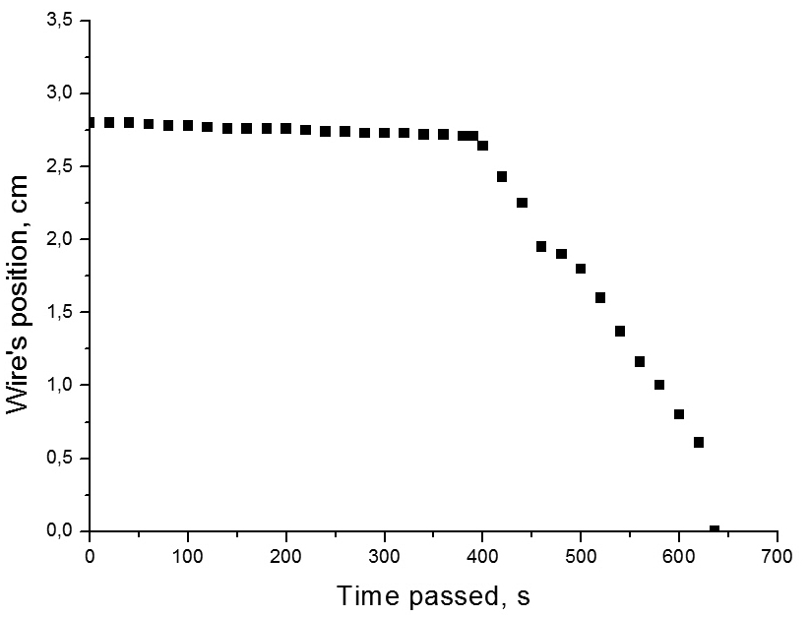
We had explained the failure of our theory for copper wires by its heat conductivity: copper’s heat conductivity is about 8 times higher than nichrome’s. For nichrome, we could ignore heat inflow from the environment through the wire; and for copper such inflow is significantly higher, and our approximation of system as closed doesn’t work anymore.
This idea successfully describes what we see in Table 1: if we increase wire’s diameter we increase heat income from environment; if mass of load is changed, it affects temperature of water melting, which is, in this case, less important.
Figure 3. Dependence of the wire’s position on time passed. Temperature of surrounding air 0.5°C.
Realization of the closed system for copper
In order to prove correctness of these explanations experimentally, we had run an experiment, where all heat exchanges with surroundings were reduced to minimum. Whole setup had been moved outside (temperature of air was 0.5 °C); melting snow had been put around free ends of the copper wire.
Results of the experiment can be seen in fig. 3. At first wire was moving very slow – the heat, required for melting of the first portion of ice, was being accumulated; the fact that it took so much time proves that heat inflow was very small.
It is also interesting to note, that if temperature of surroundings is lower than melting temperature of ice under given pressure, then process won’t start. Since even with high load’s masses this melting temperature is only slightly smaller than zero, we hadn’t observed wire cutting the ice if air temperature was lower than 0 °C.
While heat was being accumulated, ice under the wire was melting; finally, enough ice had melted, so that water had covered the upper side of the wire. Once it had crystallized, enough heat was released to melt another portion of ice; the cycle started; velocity of wire significantly increased. But after it, velocity remained constant until the end of experiment, proving that not only no heat enters the system, but also that losses of heat during cycle are negligible.
Quantitative analysis of not-closed system
First, it is required to take into account heat income. Since above the wire temperature is 0 °C and under it it’s T(P), we can approximate, that whole wire has temperature T(P)/2. By measuring temperature of the wire with thermocouple at various distances from the ice cube we had found, that distance y between the last point of wire, where temperature is equal to air one, and the first point where it is equal T(P)/2, is about 3 cm. Thereby heat flux through the one side of the wire:
where T_{air} is air temperature. Since wire has two ends, total income of heat from environment is 2*W₂.
Fig. 3 had shown that amount of heat, spread into ice is negligibly low; however, for full description of the not-closed system we had decided to take these losses into account too. We had frozen a block of ice with several thermocouples in it; then we let the wire cut the ice, while measuring temperature through all thermocouples. It had shown that on the distance of about 1 cm from the wire ice’s temperature hasn’t changed during experiment. Assuming that heat escapes from the wire, and from the zone above wire, heat flux into one side can be calculated as:
Total lack of heat will be 2*W₃.
Finally, we had also taken into account that specific heat of fusion also depends on the temperature, at which melting occurs: for water at 0 °C λ=330 kJ/kg, and at -7 °C it’s 317 kJ/kg. Once again, in this part the dependence can be approximated as linear; which means that dependence on the pressure is also linear:
So, now total heat, which is required for melting ice, equals:
and total heat flux, coming to the melting ice, is:
Combining all this we are now able to write a formula for finding time, required for cutting through the ice, if system can’t be approximated as closed:
Since it is hard to remember all these symbols, they are listed in the Table 2:
Table 2. List of symbols, used in the formula for finding time, required for cutting through the ice, if system can’t be approximated as closed.
Symbol | Meaning
ρ | Ice’s density
h | Height of ice block
d | Wire’s diameter
l | Length of wire’s part, which touches the ice
c | Ice’s heat capacity
T₀ | Original temperature of ice
λ(P) | Ice’s specific heat of fusion (linearly depending on pressure, applied by the wire)
K | Wire material’s heat conductivity
T(P) | Ice’s melting temperature (linearly depending on pressure, applied by the wire)
x | Distance between the wire and point of ice block, where temperature does not change during experiment
K_{ice} | Ice’s heat conductivity
y | Distance between the last point of wire, where temperature is equal to air one, and the first point where it equals T(P)/2
T_{air} | Air temperature

Conclusions
Because of the pressure ice under wire melts at negative temperature; in liquid form it goes upwards and freezes back under the wire, creating turbid region. Then cycle continues again and again.
If temperature of surrounding air is close to 0 °C (but still positive), then this system can be described as closed; wire cut through the ice with constant speed, proving, that heat losses are negligibly small.
For materials with low heat conductivity this system also can be approximated as closed; however, for materials with high heat conductivity it is necessary to take into account income of heat from the environment through the wire.
To improve mathematical model further, it is possible to calculate heat losses and affect of melting temperature on the specific heat of fusion.
It should be noted that wire must go through the transparent region of the ice block, because properties of the non-transparent region are significantly different.
References
[1] J.T. Bottomley, “Melting and Regelation of Ice”, Nature, London, 1872;
[2] E. Hahne, U. Grigull, “Some Experiments on the Regelation of Ice”, Physics of Ice, Pienum Press, 1969;
[3] Wikipedia contributors, “Ice cube”, Wikipedia, The Free Encyclopedia, 9 January, 2012;
[4] Michael Faraday, “On Regelation, and the Conservation of Force”, Philosophical Magazine, Vol. 17, 1859.

