The Electro Magnetic Cannon
Saba Zargham, Hamid Ghaednia
Sharif University of Technology, School of Electrical Engineering, Iran
Amirkabir University of Technology, School of Civil Engineering, Iran
Abstract: Kicking a ball by means of an RLC circuit can be done using various systems. The explanation of one such design is the main goal of this paper. When a capacitor is discharged into the solenoid, it forces the ferromagnetic plunger to slide through the solenoid and eventually kick the ball. Terminal speed of the ball is proportional to the velocity of the plunger which itself is only determined by the force applied to the plunger by the solenoid. Therefore calculating this force and studying the related factors are necessary which has been done both theoretically and experimentally. Numerical results were compared with experiments in order to prove and examine theoretical conclusions.
Keywords: plunger, solenoid
Introduction
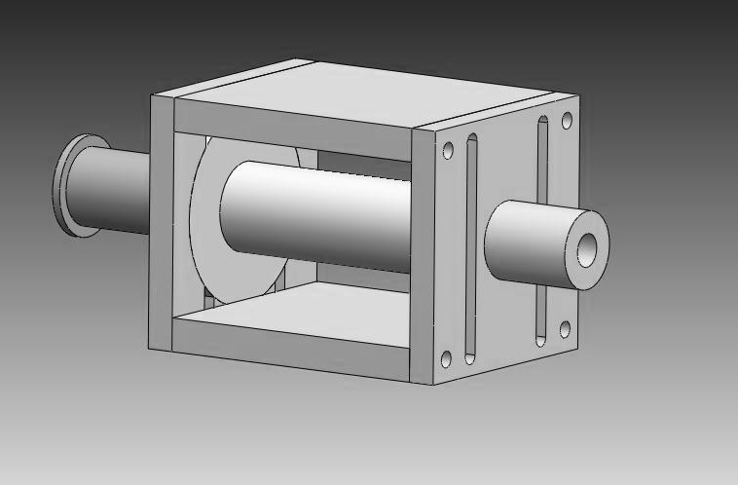
Building shooting device that uses a solenoid and a capacitor (as voltage source), is the goal of this article. Such systems are also used in Robocup soccer robots. When a capacitor is discharged into a solenoid, the solenoid generates a magnetic field, which can exert force on ferromagnetic material, (ex. ferromagnetic plunger). In order to provide the system with the necessary force required to kick a ball, a “plunger” was used which was consisted of two parts, a ferromagnetic part and a non-ferromagnetic shooter, that could slide through the solenoid with the minimum amount of friction possible. (See picture) Experiments were done with a golf ball of 45 grams mass.
Solenoid
Figure 1: Solenoid and Plunger
Plunger (Diamagnetic part, Shooter
)
Plunger
Ferromagnetic
part
Terminal velocity of the ball is dependent on the factors listed below: 1-Initial voltage 2-Capacitance, 3-Diameter of the solenoid’s wires, 4-Solenoid’s inner diameter, 5-Solenoid’s body material, 6-Plunger’s diameter, 7-Plunger’s length 8-Plunger’s mass, 9- Initial position of the plunger, 10-Initial distance between the plunger and the ball, 11-Number of wire turns.
The problem can be classified into three chief sections; we will first discuss the capacitor’s discharge procedure. In the second section, the motion of the plunger is studied. And finally, in section three, we present the equations governing the collision between the plunger and the ball. In order to reach a quantitative theory and investigate
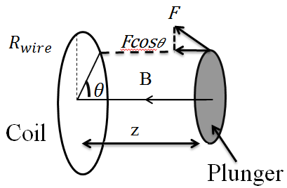
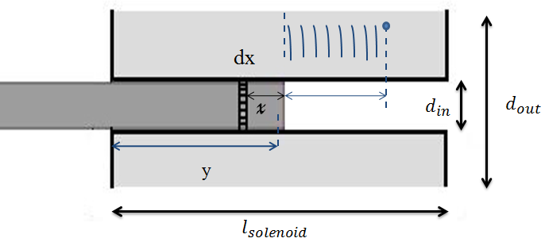
all three sections together , a MATLAB program was developed to simulate the design and solve the resulting differential equations (by Runge-Kutta method). Various effective factors mentioned above, are studied both theoretically and experimentally in order to find the optimized solenoid, which results in the maximum velocity at all times.
Figure 2: Exerted force to each element
from each wire

Theory (Mathematical model)
Figure 3: Total force exerted to each element
Section 1
Interactions between the capacitor and the solenoid are simulated (The solenoid is considered to be an inductor):
$+\frac{q}{c}+IR+L\frac{di}{dt}=0$ (1)
$L=μ_{0}n^{2}{A l}_{s}$ $R=\frac{ρ}{A_{w}}\left(\frac{l_{s}}{d_{wire}}\right)=\sum_{i=0}^{\left[\frac{d_{out}-d_{in}}{d_{wire}}\right]n}{2π\left(R_{p}+\frac{2i+1}{2}\right)}$ (2)
Where A is the surface area of the solenoid, $A_{w}$ is the cross section of the wire, $d_{wire}$ is the diameter of the wire, and $l_{s}$ is the length of the solenoid.
Section 2
The ferromagnetic part of the plunger, is considered as small current rings, therefore the force exerted on each element can be calculated. This current depends on the magnetic field, and the geometry of the elements.
$i=\frac{dv}{πR_{p}^{2}}(1-k_{m})\frac{N}{l_{s}}I$ (3)
Where dv is the volume of each element, $k_{m}$is a constant dependent on the magnetic properties of the ferromagnetic plunger, $R_{p}$ is the radius of the plunger, $l_{s}$is length of the solenoid, N is the number of current rings and I is the solenoid’s current. The force exerted on each element is:

$F_{x}=\frac{µ_{0}iI}{2}R_{wire}R_{plunger}z\int_{0}^{2π}{\frac{dθ}{{(z^{2}+R^{2}\cos^{2}θ+{\left(Rsinθ-R_{plunger)}\right)}^{2})}^{5/2}}}$ (4)

So the net force applied to the plunger is calculated by integration:$F_{x}=\frac{μ_{0}i I}{2}R_{wire}{ R}_{plunger }z\int_{0}^{2π}{\frac{dθ_{i}}{{\left[z^{2}+R^{2}\cos^{2}{θ+{\left(R\sin{θ}-R_{plunger}\right)}^{2}}\right]}^{\frac{3}{2}}}}$$F_{x}=λ\sum_{j=0}^{\left[\frac{l_{s}-y+x}{d_{w}}\right]}{\sum_{n=0}^{\left[\frac{d_{out}-d_{in}}{d_{wire}}\right]}{\int_{0}^{2π}{\frac{z dθ_{i}}{{\left[{\left(\frac{2J+1}{2}d_{w}\right)}^{2}+{\left(\left(R_{p}+\frac{2n+1}{2}d_{wire}\right)\right)}^{2}\cos^{2}{θ+{\left(\left(R_{p}+\frac{2n+1}{2}d_{wire}\right)\sin{θ}-R_{p}\right)}^{2}}\right]}^{\frac{3}{2}}}}}} -λ\sum_{j=0}^{\left[\frac{y-x}{d_{w}}\right]}{\sum_{n=0}^{\left[\frac{d_{out}-d_{in}}{d_{wire}}\right]}{\int_{0}^{2π}{\frac{z dθ_{i}}{{\left[{\left(\frac{2J+1}{2}d_{w}\right)}^{2}+{\left(\left(R_{p}+\frac{2n+1}{2}d_{wire}\right)\right)}^{2}\cos^{2}{θ+{\left(\left(R_{p}+\frac{2n+1}{2}d_{wire}\right)\sin{θ}-R_{p}\right)}^{2}}\right]}^{\frac{3}{2}}}}}}$$λ=\frac{μ_{0}i I}{2}R_{wire}{ R}_{plunger }$
$$F_{x}=λ\sum_{j=0}^{(\frac{l_{s}-y+x}{d_{w}})}{\sum_{n=0}^{(\frac{d_{out}-d_{in}}{d_{wire}})}{\int_{0}^{2π}{\frac{zdθ}{{({\left(\frac{2j+1}{2}d_{w}\right)}^{2}+{\left(R_{p}+\frac{2n+1}{2}d_{wire}\right)}^{2}\cos^{2}θ+{(\left(R_{p}+\frac{2n+1}{2}d_{wire}\right)sinθ-R_{p})}^{2})}^{\frac{3}{2}}}}}}-λ\sum_{j=0}^{(\frac{y-x}{d_{w}})}{\sum_{n=0}^{(\frac{d_{out}-d_{in}}{d_{wire}})}{\int_{0}^{2π}{\frac{zdθ}{{({\left(\frac{2j+1}{2}d_{w}\right)}^{2}+{\left(R_{p}+\frac{2n+1}{2}d_{wire}\right)}^{2}\cos^{2}θ+{(\left(R_{p}+\frac{2n+1}{2}d_{wire}\right)sinθ-R_{p})}^{2})}^{\frac{3}{2}}}}}}$$
$λ=\frac{µ_{0}iI}{2}R_{wire}R_{plunger}$ (5),(6)
Section 3:
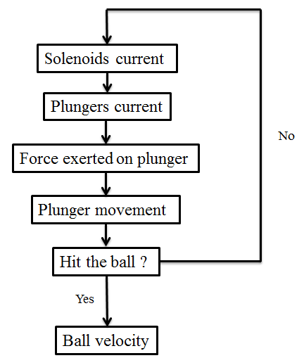
After solving energy and momentum equations, terminal velocity of the ball is determined:
$v_{b}=\frac{2μkv_{p1}+\sqrt{{(2μkv_{p1})}^{2}+4(1-μ)(μk^{2}+μk)}}{2(μk^{2}+μk)}$ (7)
Where $k=\frac{M}{m}$ (M is mass of the ball and m is the plunger’s mass), $v_{p1}$ is the velocity of the plunger before collision and µ is the contact coefficient.
Experimental Setup
Figure 4: Calculating Terminal Velocity
The entire system consists of a solenoid, a plunger and a ball. Both Aluminum and Teflon have been used for the solenoid’s body material. The plunger, as mentioned before, has two parts. The ferromagnetic part is made of iron and the diamagnetic part, aluminum.
A “speedometer” was designed to determine the speed of the ball. This device is consistent of four sensors in order to reach the most accurate result. Experiments were done with solenoids of 5 cm length, 3 cm outer diameter, and three different inner diameters of 10, 8, 6 mm. (Fig.5)
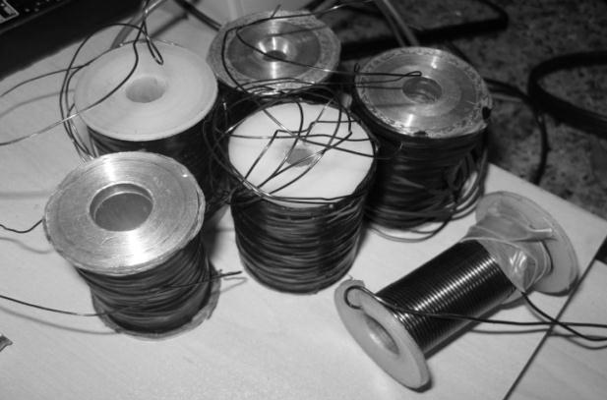
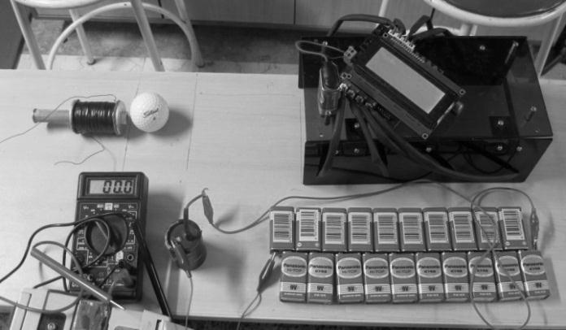
Figure 4: experimental setup
Figure 5: solenoids used in experiments

Experiment Analysis
The concurrence between the theory and experiments enables us to use this method in finding the optimum dimensions of the system for any given initial conditions. The theory shows that the velocity would alter linearly in respect to the increase of voltage. Experimental results are also in good agreement with this (Fig.7).
A capacitor with higher capacity, stores a greater amount of energy, but since this also extends the discharge time, the plunger won’t absorb all the energy before the collision.
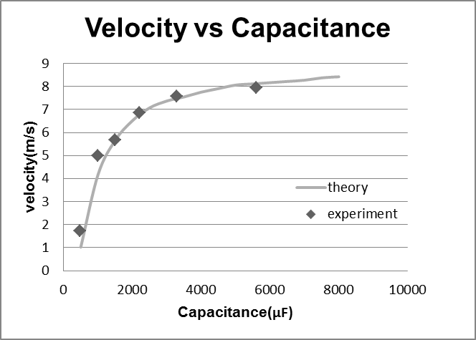
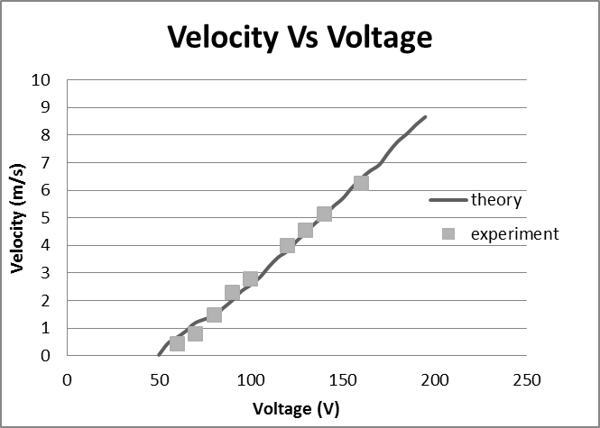
Therefore increasing the capacitance, more than a certain amount will not result in any changes in the velocity of the ball (Fig.8 & Fig 9).
Fig.8 Velocity (m/s) vs capacitance (µF)
Fig.7 Velocity vs Voltage
Figure 7: Velocity vs Voltage
Fig.8 Velocity vs Capacitance
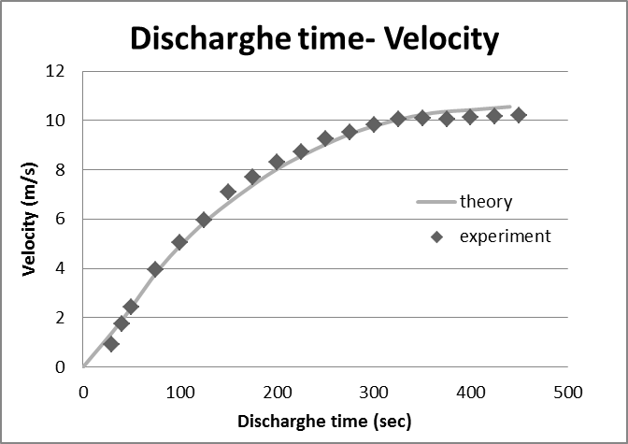
This is why the initial position of the plunger is an important factor. The plunger must be inside the solenoid when the current intensity reaches its maximum, in order to hit the ball with maximum velocity (Fig.10).
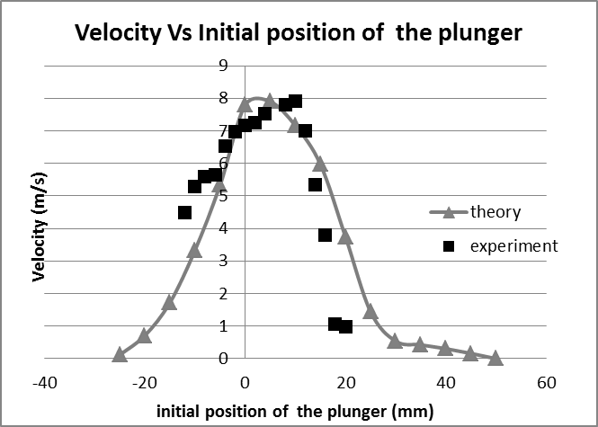

Figure 9: Discharge time vs velocity
Figure 10: Initial position of the plunger vs velocity

Increasing the number of layers has two different effects on the ball’s terminal speed. As the number of layers increase, the resistance of the circuit will also increase. As a result the current intensity inside the solenoid will decrease. Ergo, velocity reduces escalation of the number of layers also increases the inductance of the RLC circuit, so a greater force is exerted on the plunger. Consequently, there should be an optimum number for both of these factors. This point is where the inductor acquires the maximum quality factor, which can be calculated by our numerical method (Fig.11 & Fig.12)
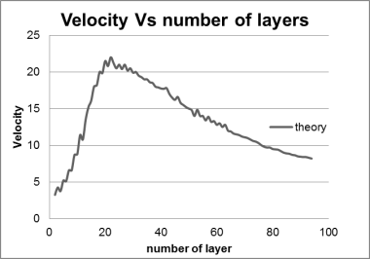
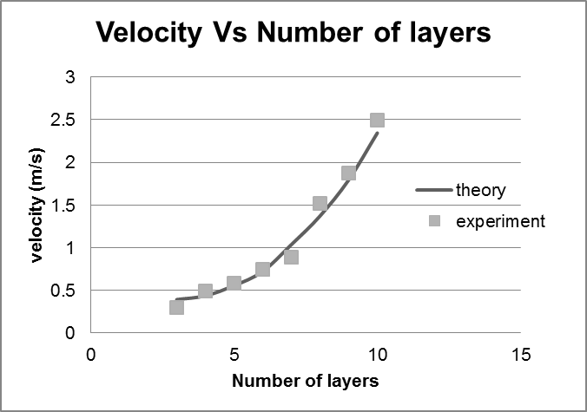

Figure 12: Velocity vs number of layers
Figure 11: Velocity vs number of layers

Conclusion
Comparisons between theoretical and experimental results prove our numerical model, hence the numerical solution, has the proper accuracy to predict the outcome of further experiments and can be used to find the optimum system, of any desirable size; One that creates the strongest magnetic field, so that the plunger can absorb maximum energy from the solenoid in the minimum time interval.
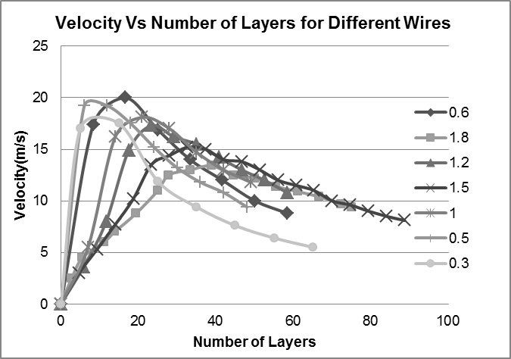
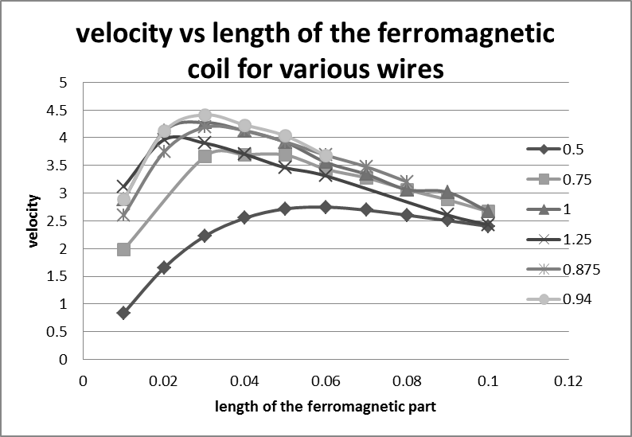
For each solenoid of certain dimensions, length of the ferromagnetic plunger, diameter of the wire and the number of layers should be optimized. e.g. for a solenoid with 5cm length, 3cm outer diameter and 1.4cm inner diameter, the outer diameter is proportional to number of wire layers which is 20 for a wire of 0.6mm diameter. (Fig. 13 & Fig. 14)
Figure 13: Velocity vs length of the ferromagnetic coil for various wires
Figure 14: Velocity vs number of layers for different wires

References
[1]Keith R.Symon, Mechanics
[2]Grant R. Fowles, Analytical mechanics
[3]Resnik, Halliday, Krane, physics
[4]Nayfeh M.Hasan, Electricity and Magnetism
[5]David J.Griffiths, Introduction to Electrodynamics
[6]K.SankaraRao, Numerical Methods for Scientists and Engineers
[7]B.P.T.vangoch, Optimizing a Solenoid for a Robocup kicker, DCT-number: 2006.051

