PAPER ANEMOMETER

Igor Marković¹
¹Department of Physics, Faculty of Science, University of Zagreb, Croatia

1. Introduction
Here is presented the original solution of team Croatia for the Problem 15, Paper Anemometer for the IYPT in Vienna, 2010. The problem was often presented that year, even at the finals, and each time with a different interpretation. Here is yet another one, conceptually different then any we saw presented at the IYPT. We deem this interpretation to be the one that follows the text of the problem the best.
.
2. Problem
„When thin strips of paper are placed in an air-flow, a noise may be heard. Investigate how the velocity of the air-flow can be deduced from this noise.“

3. Apparatus
The idea was to create controlable air-flow conditions in which to put the strips of paper, record the sound and determine the velocity vs. noise intensity dependence depending on the parameters of the strips (number, material, dimension…). Thus it would be enough to record the noise for a strip configuration on an unknown velocity and from the noise intensity thus obtained we get the air-flow velocity. The apparatus was set up in a special air-tunnel for better control and precision of air-flow characteristics and velocity. Inside it, a paper strip holder is fixed. A microphone was placed beneath the holder outside the tunnel so as not to disturb the air-flow.

3.1. Air tunnel
This air-tunnel was made by the Croatian IYPT team some years ago to help solve IYPT problems. It was made by a public-accessable NASA air-tunnel design. It is designed to provide maximal laminarity of the air-flow. This is achieved by applying a special-geometry tubes on both the entrance and the exit of the tunnel with grids covering them (Figure 1). The square to circle cross-section transition at the ventilator exit is very important for minimization of air-flow disturbance. For the same reason the ventilator, that is the source of the air-flow, is placed at the exit of the tunnel; it sucks the air in. In the small central part that is the operational part of the tunnel, the air-flow is very laminar. The air-flow velocity can be accurately changed by a voltage power source connected to the ventilator. Maximum air-flow velocity achievable in this air-tunnel is 15m/s. That corresponds to large wind velocities, and is enough to make an operable anemometer.
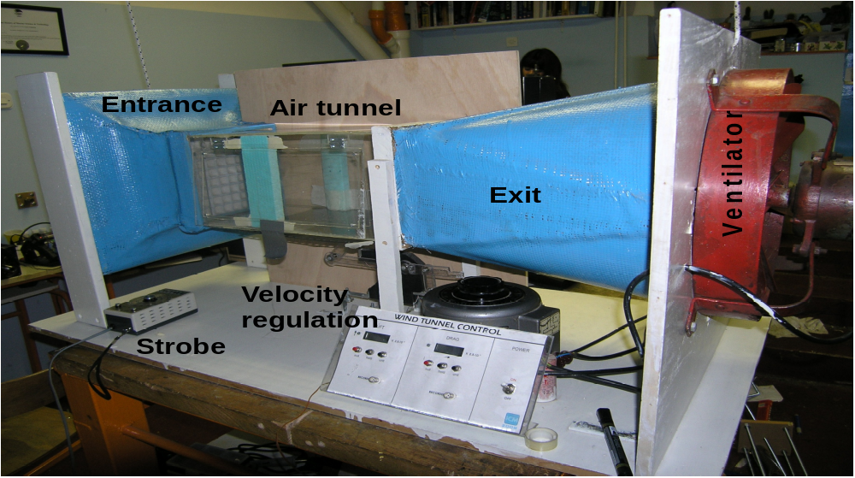
Figure 1: Air tunnel, home made for the purposes of the Croatian IYPT team
3.2. Paper holder
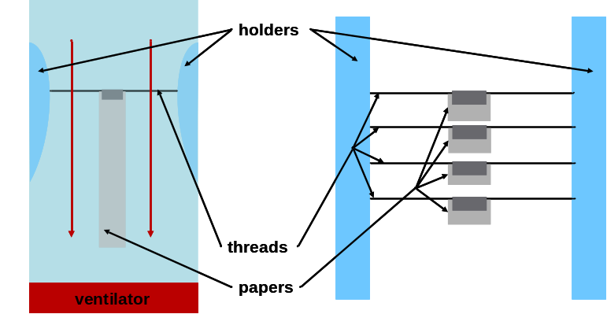
The paper hoder design had two main tasks. It had to hold various number of paper strips in the middle of the tunnel and still keep the flow laminar. For this purpose two polystyrene holders were made to be aerodynamic. They were fixed to the sides of the tunnel and threads were spread between them on which the papers were hung one above the other (Figure 2). Two kinds of strips were used to vary the material. One was plain 80g/m³ paper and the other was a plastic foil. All the strips used were 15cm long and 2cm wide. By changing the size of the strips the principle of how the anemometer works doesn't change so this anemometer was made in reference to this size of strips.
Underneath the holder there was a hole in the tunnel. The microphone was placed below the hole so the sound recorded would be as clear and loud as possible.
Figure 2: Scheme of the paper holder
Left: top view, red arrows represent the air-flow
Right: front view

4. Measurement
We believe that the noise that the problem text referes to is the loud flapping noise made, when more strips are present, from the strips hitting each other. Thus our measurements were designed to investigate when this hitting occures and how it can be related to the air-flow velocitiy.

4.1. Strobe measurements
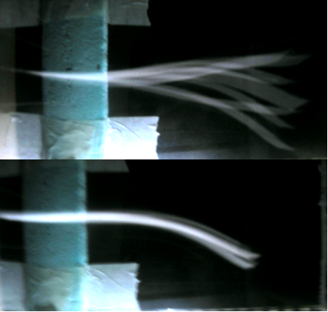
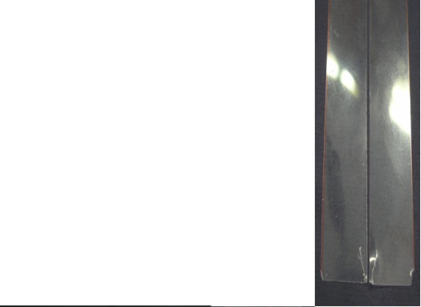
When a strip of paper is put in a moderate air-flow it will oscillate in a wave-like motion. In order to see how this happens and to determine the frequencies of the oscillations a strobe was used. The strobe provides periodic flashes at a set frequency and thus, when it shines on the paper in motion, provides a picture of the paper at time intervals set by the strobe frequency. By setting the strobe to the exact same frequency as the oscillations of the paper the image of the paper is frozen (Figure 3). This is a very accurate method of determining the paper frequency. If the strobe is set near the paper's frequency, the entire trajectory of the paper is seen in slow motion. Using this method three regimes were observed up to 15m/s. In the first regime, low velocities, the papers all oscillate together, in phase, and so no noise is heared. In the second regime, the oscillations are still regular, but the papers are in counter-phase. Still no noise is heard. The third regime is chaotic, there is no set frequecy at which the strips oscillate and they even bend sideways and hit each other. The noise from the papers hitting is now heard but the papers are also destroyed from the hitting (Figure 4). This demands an investigation of how the intensity of the noise deteriorates in time due to the strip edge destruction.
a)
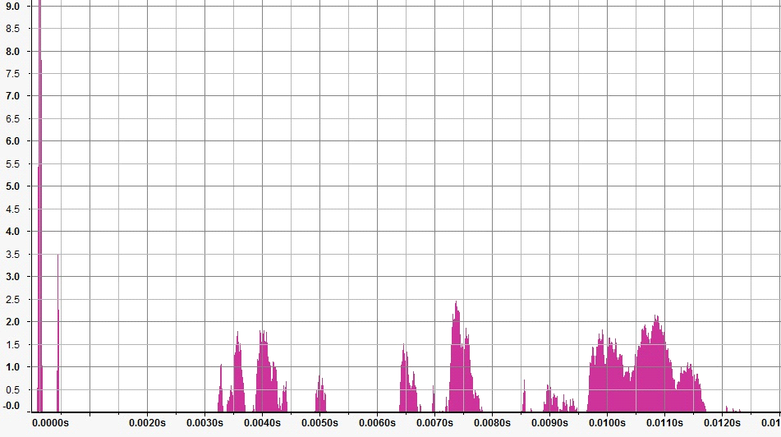
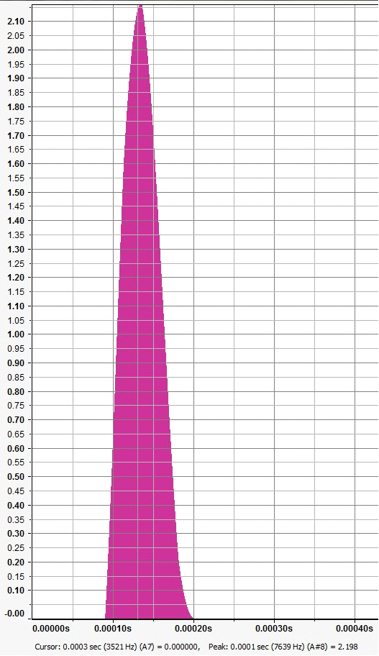
Figure 5: a) autocorrelation graph b) isolated peak that represents the signal (the highest, leftmoast peak from the graph in a)
Figure 3: Strobe measurements
a) wrong frequency b) correct frequency
Figure 4: Strip destruction for: a) paper b) plastic foil
left is before, and right is after being used
b)
a)
b)
4.2. Noise analysis
The sound recorded by the microphone was analysed by a specialized computer program. The interval chosen for the analysis was always the same length and it began when the ventilator reached its final velocity. This was done to minimize the effect of intensity reduction due to paper destruction. In the obtained recording the signal (i.e. paper noise), is indistinguishable form the ventilator noise. This was solved by applying the autocorrelation on the sound interval. Autocorrelation is a mathematical method that seaches for periodical events in a signal, it is a much used tool for time domain signal analysis. It has a peak at a time value if similar event occur within the signal with that time as the period. Such an autocorrelation graph for the time interval from this measurement is shown in Figure 5. Once identified as the strips hitting signal, the peak can be seen as a direct picture of the intensity in time of an average strip hit. It is very sharp due to the small duration of the sound of the hit while the height, the intensity, is proportional to the occurence frequency and to the square of the sound amplitude. The intensity of this peak is what is here interpreted as the parameter of the sound by which the air-flow velocity should be determined.
b)
a)
b)
5. Results
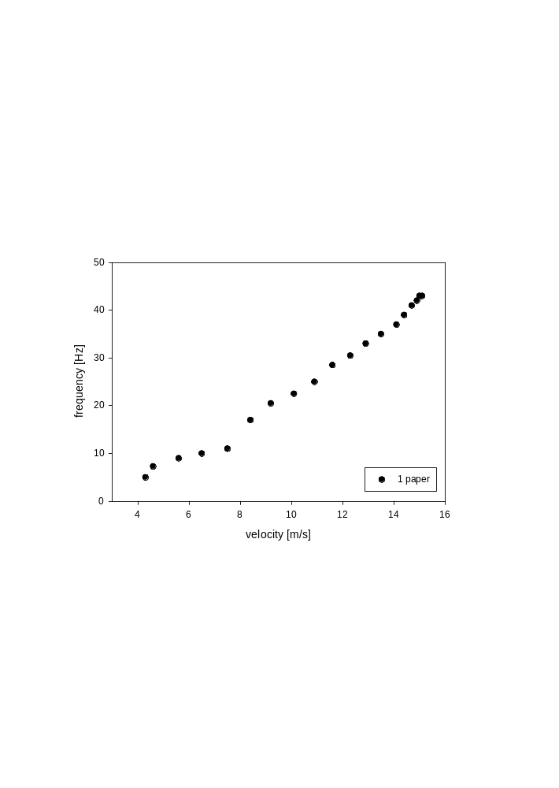
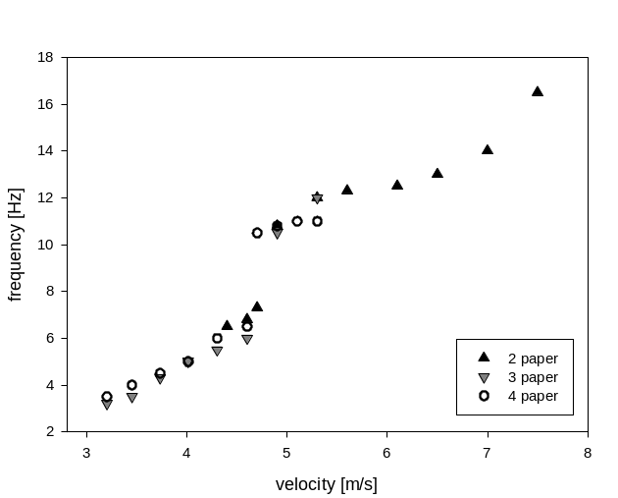
To shed light on the strip motion itself first measurements are those of the frequency to air-flow velocity dependence. This was measured for 1 up to 4 strips of paper. The measurement for 1 paper is shown in Figure 6a. It starts making the noise at about 8m/s where the graph has a jump. The dependence at the noise regime is approximately linear. The same dependence for 2 to 4 sprips is shown in Figure 6b but only the silent regimes. A discrete jump can here be seen at the same velocities regardless of the strip number, at the same moment when the strips go form oscillating in phase to counter-phase. It can also be seen that the more papers we have, the lower the velocity at which they begin to oscillate, but also the lower the velocity at which they go to the chaotic regime. The air-flow velocity for the silent regimes can thus be determined by measuring the frequency of the strip oscillations.
a)
b)
Figure 6: graph of frequency to air-flow velocity dependence for:
a) one paper. The vertical dashed line is the border between the silent regime and the noise regime
b) two, three and four papers. The vertical dashed line is the border between the first and second regime.
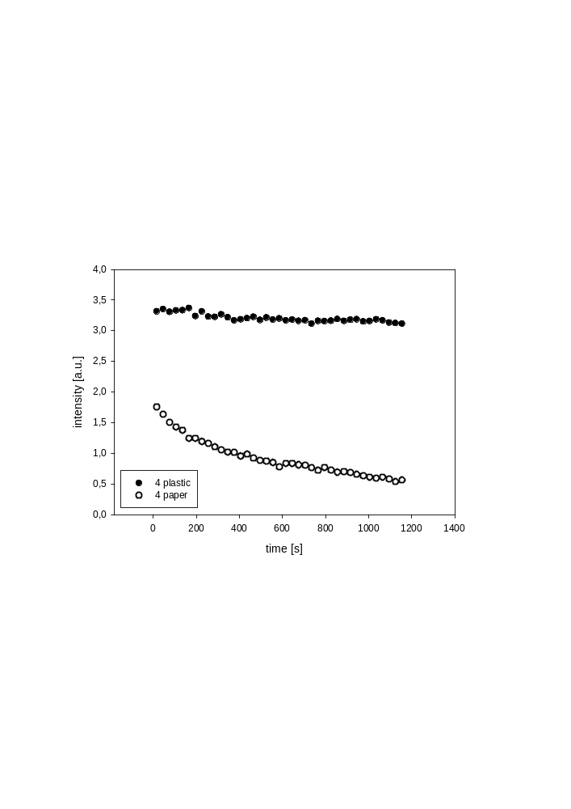
The problem of paper destruction with time was also investigated to ensure reproducibility oft he measurements. The graph (Figure 7) clearly shows that the intensity of the noise from paper strips drops with time while being relatively constant for plastic foil strips. Similar graphs at different air-flow velocities show that the destruction of the paper strips gets more intense the faster the air-flow. The intensity for plastic strips remains relatively constant at all velocities.
Figure 7: noise intensity in time for plastic and paper strips
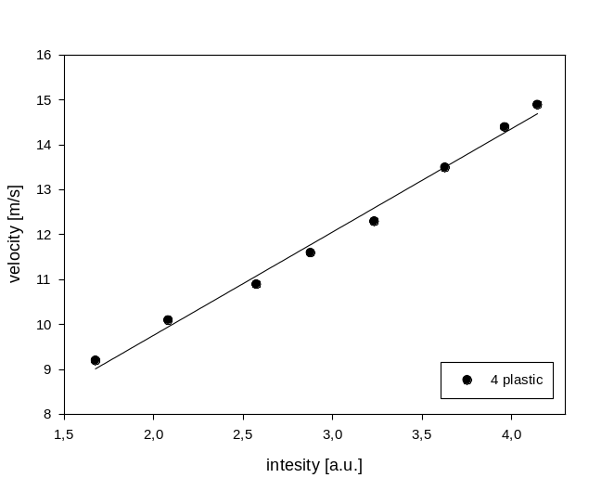
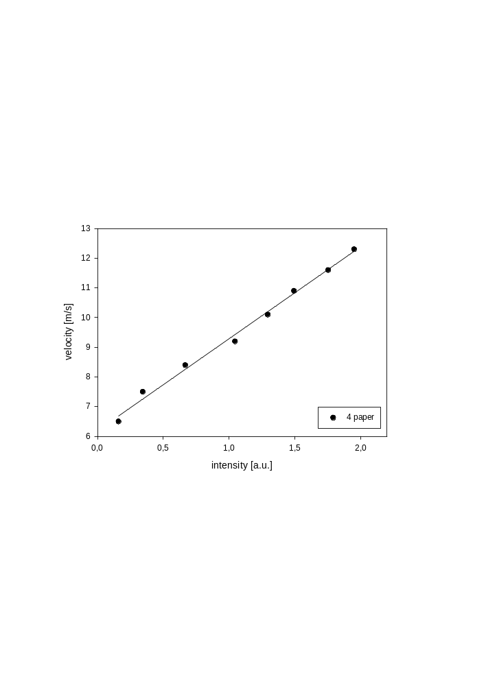
The main idea was to obtain a relation that would be in a good agreement with the measured dependence of air-flow velocity on the noise intensity. Thus the velocity to noise intesity dependences were plotted for four strips, both paper and plastic. The graphs obtained (Figure 8) are seen to be approximately linear so the linear fits are set to be calibration curve for this anemometer. For the four paper strips the fit is y=3.13x+6.19, and for the plastic strips y=2.33x+5.12, with y being the air-flow velocity and x the noise intensity. The measurement can be done with paper for somewhat lower velocities (6m/s instead of 9m/s).
a)
b)
Figure 8: graphs of dependences of air-flow velocities on noise intensity for:
a) 4 plastic foil strips b) four paper strips

6. Conclusion
In order to solve this problem a special apparatus was designed and used to achieve results as precise as possible. The basic characteristics of strip movement was explained through strobe measurements. Two essential regimes were registered, the silet and the noise regime. The silent regime divides into two in the case of more then one strip, the in-phase and counter-phase oscillation regimes. The transition between these regimes was allways at the same air-flow velocity. The destruction of strips was observed and quantified as shown in Figure 6 showing that plastic foil strips provide more accurate velocity measurements. At the noise regime sound autocorrelation was used as a known method to extract the necessary, signal dana from all other noise recorded. Thus strip noise intensity was obtained, and the most important part, the formulae, the calibration curves, by which to calculate the air-flow velocity. They were shown for four strip paper and plastic foil measurements. The plastic strips can undergo higher velocities without relevant destruction, but the paper strips can mesure at lower velocities than plastic. The measurable range can be further widened by changing the number of strips or their dimensions. Our interpretation of the problem was based on the fact that the problem uses the term noise which is by definition different to the tone (it doesn't have a frequency, pitch). That was the reason why this type of measurements and methods were used. By finding acceptable formulae for determination of air-flow velocity from the noise we deem the problem solved.

References
[1] Crawford F S 1965 "Waves" (Berkeley Physics Course, vol. III), McGraw-Hill
[2] Landau L D , Lifshitz E M 1959 "Fluid Mechanics", Addison-Wesley, Reading, MA

