MAGNETIC SPRING

Igor Marković¹
¹Department of Physics, Faculty of Science, University of Zagreb, Croatia

1. Introduction
This is the original solution of team Croatia for the Problem 14, Magnetic Spring for the IYPT in Vienna, 2010. I was then a senior high school student and in charge for this problem but never got to report it. Here are given: a theoretical model based on conservation of energy, description of the experimental apparatus and a discussion of the results.

2. Problem
„Two magnets are arranged on top of each other such that one of them is fixed and the other one can move vertically. Investigate oscillations of the magnet.“

3. Theoretical model

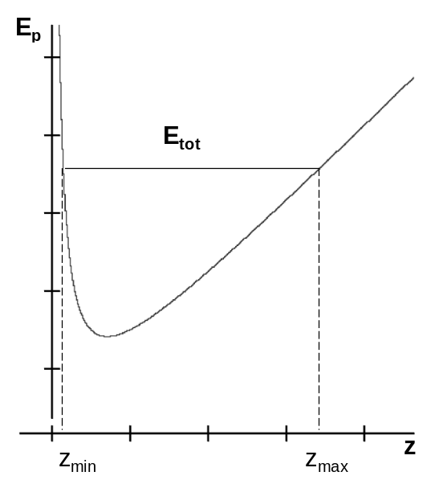
3.1. Oscillation period
There are two physically important aspects in this setup that cause the oscillations; gravitational force (attraction) and magnetic force (repulsion). For the theoretical model a simple dipole approximation was used for the magnets and friction was neglected. The problem was approached using the law of conservation of energy. The total energy of the system is given with:

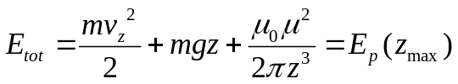 (1)^{1,2}

m being the mass of the magnet, z position on the vertical axis, v_{z} the corresponding velocity, and μ=B_{r}V_{m}/μ₀ its magnetic dipole moment¹ (B_{r} is the remanent field and V_{m} the volume of the magnet). This expression, upon extracting the time differential from the vertical velocity, putting E_{tot} = E_{p}(z_{max}) and integrating from z_{min} to z_{max} (from the lowest to initial height of the magnet), yields, after rearrangement:
Figure 1: Qualitative graph of potential energy. Total energy is determined from the initial hight, z_{max}
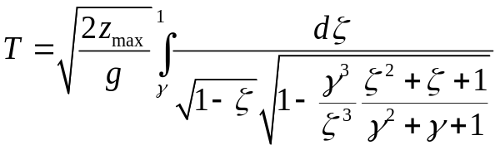 (2)

with T the period of oscillations and γ = z_{min} / z_{max ,} ζ = z / z_{max} substitutions made to simplify of the formula. The integral can be thought of as a correction of the free fall due to magnetic repulsion. The substitutions make the integral dimensionless and store all the parameters of the magnet in a single parameter of the formula, γ:

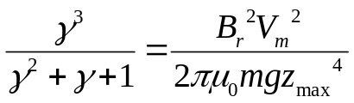 (3)

The theoretical predictions thus come from solving the expression (2) with given parameters of the system whereby we have a quantitative theoretical model of the first oscillation period with no free parameters.

3.2. Oscillation trajectory
In the trajectory prediction two extremes are analyzed: the magnet moving far from the equilibrium and oscillations near the equilibrium. In both cases approximations are used on the potential energy (Figure 1). In the first case, we can approximate the potential with two straight lines.The gravitational part gives a linear dependence (as in (1) ) while the magnetic part gives a vertical potential barrier. Behaviour of the magnet is then similar to a bouncing ball (the energy here being drained by, along with air resistance, the eddy currents¹ instead of deformations). The trajectory for each period in that case is a parabola². In the second case, near the equilibrium, the potential energy can be approximated with a parabola, thus making the magnet behave as a harmonic oscillator³ (damped because of air resistance, eddy currents and friction with the tube). This means that the trajectory near the equilibrium is a damped sine³.

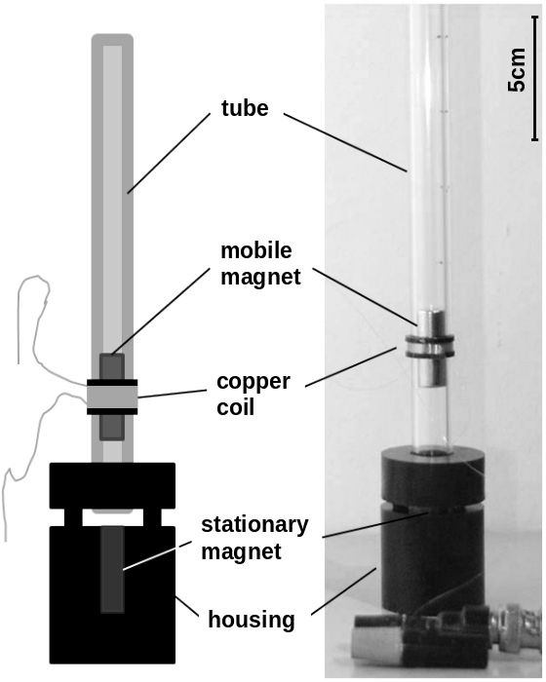
4. Apparatus and measurements
For any measurement, what is needed first is a setup that enables the magnets to behave as the problem states. That was achieved using the apparatus shown in Figure 2. The tube enables only vertical motion of the mobile magnet and is lifted form the housing so that the airflow through the tube would be unobstructed and cause less damping. The magnets used were long and cylindrical to improve the dipole approximation. They were NdFeB, with the remanent field of B_{r}=1.4T.

4.1. Period measurements
A hand made copper coil, made of 50μm thick wire, was placed around the tube for period measurements. It was attached by a sliding plastic ring at the equilibrium position (Figure 2). Moving through the coil, the magnet induces a voltage proportional to its speed¹. The voltage is measured by a high internal resistance voltmeter, and the signal from it is than stored on a computer via an AD converter. A typical measurement is shown in Figure 4a.
Figure 2: Magnets housing with the coil to measure the period
Mass was changed by stacking M4 nuts upon a threaded rod attached to the magnet. The bottom nut was made of steel so that is 'sticks' to the magnet while the other nuts and the rod were brass so as not to change the geometry and the parameters of the magnet. Period and equilibrium position were measured in dependence of mass of the magnet. Period was also measured in dependence of initial height, z_{max.}

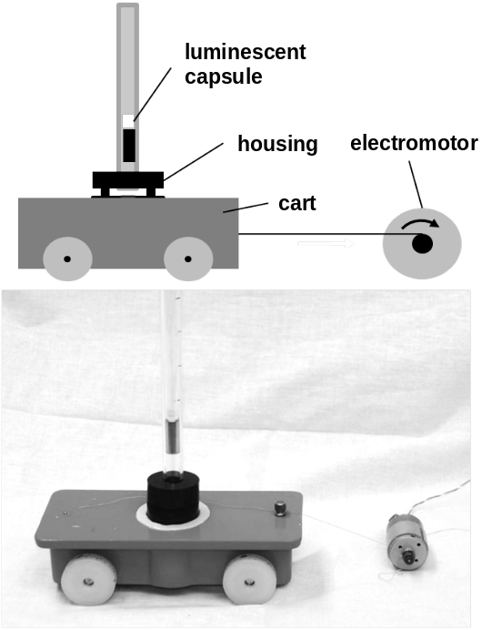
4.2. Trajectory measurements
To find the trajectory of the mobile magnet the housing was placed upon a small wheelcart pulled by an electromotor at a constant velocity. This provided an x axis in space that is linear with time. A luminescent fluid (from fishing gear) was attached on top of the mobile magnet in a capsule (Figure 3) and the magnet was set to oscillate on the moving cart. A photo with a 6 second exposition was taken in complete darkness giving the position z of the magnet in time, an oscillogram of the magnet (Figure 4b). Also, using this method, the z_{min} vs. z_{max} dependence was determined.
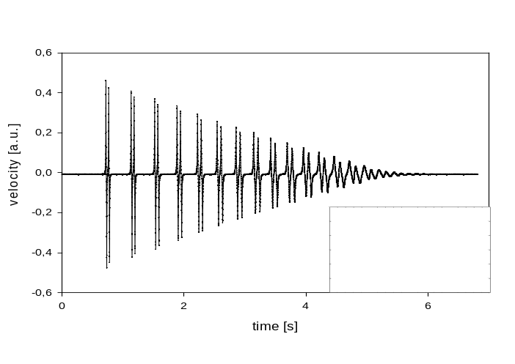
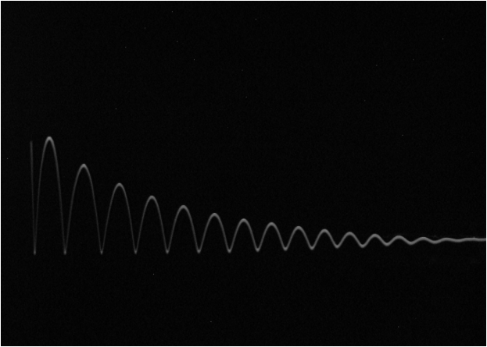
The period measurements give the behaviour of the first period for the corresponding initial height while the trajectory (position) measurements explain the way the system evolves from there. That means that, if it proves that our theoretical model can predict both of those with satisfying accuracy, we can predict the magnets oscillations entirely.
Figure 3: Trajectory measurement apparatus
b)
a)
Figure 4: typical measurements of
a) period (insert is a closeup of one period) b) trajectory (oscillogram)

5. Results
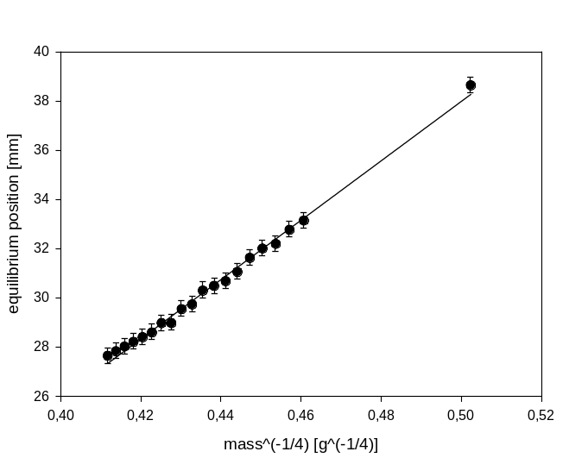
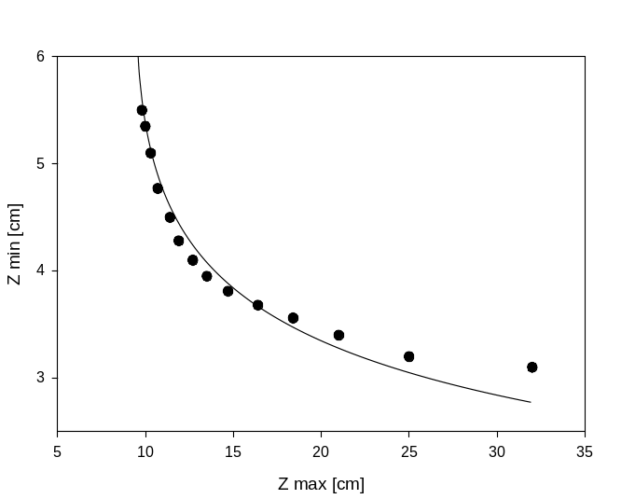
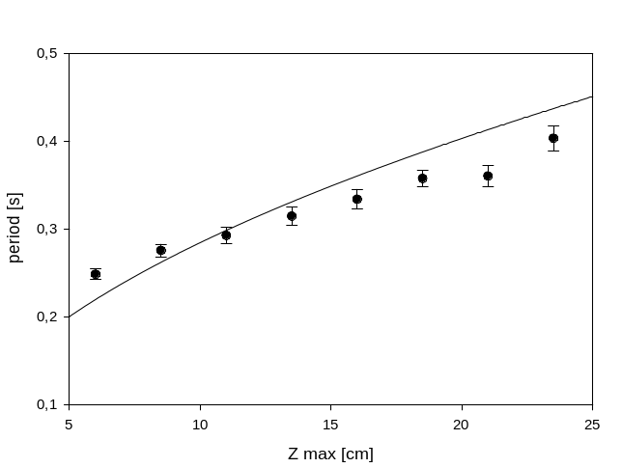
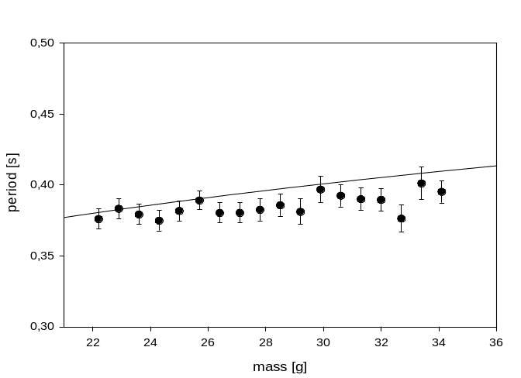
Some measurements were made to verify the validity of the dipole approximation and the consistency of the theoretical approach (Figure 5). To verify the dipole approximation, static case when the magnet is motionless in the equilibrium position is examined. The sum of forces that act on the magnet in that case is zero (differentiating E_{p} at z=z_{eqilibrium})². The dipole approximation is in the magnetic repulsion force. In the expression obtained that way equilibrium position is proportionate to mass to the power of -0.25 (z_{eq}~m^{-1/4}). Figure 5a is a graph of that dependence with a linear fit which shows that the approximation is valid in this experimental range. To connect the „period“ and „trajectory“ aspects as well as to check the consistency, the z_{min} vs. z_{max} (within one period) dependence is crucial. In the theoretical model it is given with γ, which is the ratio of the two but also connects to all parameters of the magnet as given in (3). Good agreement of experimental data with the theoretical prediction (Figure 5b) truly gives strength to the proposed theoretical model. It only begins to disagree for large initial heights, where obviously friction needs to come into account.
Figure 5:
a) graph of the dependence of the equilibrium position on mass to the -1/4. The line is a linear fit to verify the dipole approximation
b) graph of minimal to maximal height dependence. The line is the theoretical prediction from (2). Estimated error is given with the point size.
Figure 6: a) dependence of period on initial height, b) dependence of period on mass
The lines are theoretical prediction from (2).
In Figure 6a is given the graph of the dependence of period on initial height. Each local trajectory maximum can be seen as an initial height point; the graph than shows that the period is not constant during the oscillations but decreases. The experimental mass dependence of the period (Figure 6b) follows the theoretical line well with only a small offset and shows the expected behaviour of slight period increase for bigger masses.
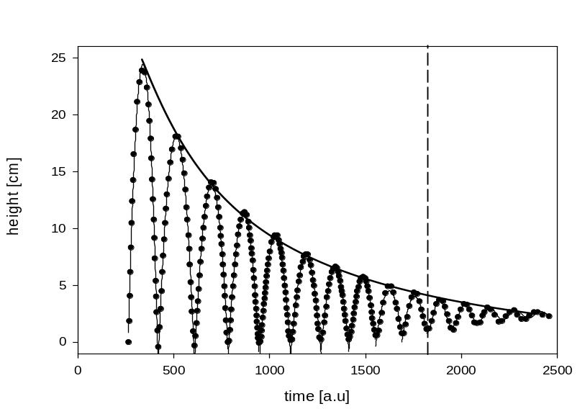
The trajectory measurements (Figure 7) consist of analyzing pictures such as the one in Figure 4b. Two regimes are separated by a vertical line in Figure 7. In the first regime the magnet goes far from the equilibrium and is in a free fall scenario. Thus, parabolas were fitted to the experimental curve. The second regime is when the magnet is near the equilibrium position and behaves as a damped harmonic oscillator. There, a damped sine is fitted to the curve. The envelope fit over the peaks is parabolic. That is consistent with the fact that the speed of the magnet was decreasing linearly with time (Figure 4a).
Figure 7: analyzed oscillogram with fitted parabolas, damped sine and the parabola envelope. The vertical line is the boundry between regimes

6. Conclusion
The solution to this problem was based on two approaches, the period and the trajectory. The first one includes a quantitative theoretical model with no free parameters that gives good agreement with the experiment even in spite of its simple approximations. The dipole approximation is shown to be valid by the dependence of equilibrium position on mass. The period was observed to increase both with the increasing mass and the initial height (not constant during oscillations). Deviations from the experimental data were observed for large initial heights. That is contributed to the lack of friction in the model. The mutual consistency of the two approaches is tested twice. First, the dependence of the lowest on the highest point of oscillations within a period is determined experimentally from the trajectory and agrees well with the prediction from the period theory. Second, from period measurements we see that the speed drops linearly whereas the maximal hight drops parabolically in the trajectory measurements.
A quantitative theoretical model was given with (2) that has no free parameters, experiments were developed and the obtained results were in good agreement with the theoretical prediction. The oscillations of the magnet were thus thoroughly explained.

7. References
[1] Purcell 1965 Electricity and magnetism: Berkeley physics course, vol.2

[2] Kittel 1965 Mechanics: Berkeley physics course, vol.1
[3] Crawford 1968 Waves: Berkeley physics course, vol.3

