Problem No 13 (2010). “Shrieking Rod”

Alexander BARNAVELI

I.Vekua Phys-Math school No 42. Tbilisi, GEORGIA

( [s.barnaveli@gmail.com](mailto:s.barnaveli@gmail.com) )

Problem: ***A metal rod is held between two fingers and hit. Investigate how the sound produced depends on the position of holding and hitting the rod?***

1. ***Wave types in rod***

It is clear, that the sound appearing when someone hits the metal rod is created by the waves which originate in the rod due to hit. So let us list down different types of waves which can be originated in the rod. They are of three types.

A. Quasi-longitudinal *Compression waves* (Fig. 1a). They are *Quasi* longitudinal due to transverse strains – as rod stretches, it grows thinner.

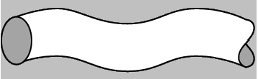B. *Bending waves* (Fig. 1b). These waves involve both compression and share strains. Their velocity depends on frequency so they are dispersive.

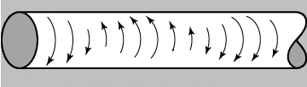C. Transverse *Torsion waves* (Fig. 1c). They represent a lateral displacement ***χ*** which varies with ***x*** and gives rise to a shear strain*.* In thin rod torsion shear waves travel at a speed which is always littleless **Figure 1.(a,b,c)**

than longitudinal wave speed.  **Wave types in thin rod.**

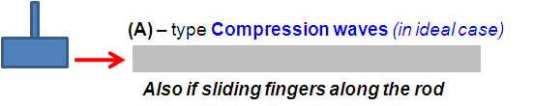The type of waves arising in a thin rod depends on the way one hits the latter.

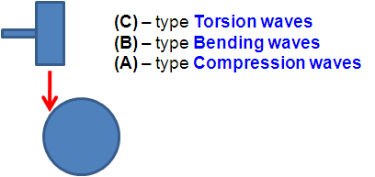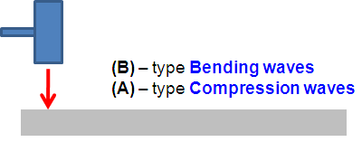When one hits a rod along its axis, type (A) waves do arise (Fig 2a). Of course if the hit is ideally central. Such waves arise also if one slides the fingers along the rod. When one hits the rod normally to its axis, two types of waves – (A) and (B) do arise. When one hits the rod tangentialy to its diameter (Fig 2c), all three types of waves are generated because it will strain, bend and compress.

Now let us discuss all these cases. Let us start with longitudinal waves.

1. ***Longitudinal waves.* Figure 2 (a,b,c).**

Compressional waves in a thin bar or rod are described **Waves depending to hit.**

by a one-dimensional wave equation of second order[1,2]:

, (1)

where ***w(x,t)*** is an axial displacement of a small volume element, ***x*** is coordinate along the rod, ***E*** is Young’s modulus, ***ρ*** is the rod dencity. From this equation one concludes that such waves propagate along the rod with the velocity

$C_{L}=\sqrt{E/ρ}$.(2)

Harmonic standing wave solution of the wave equation (1) for the boundary condition when the ends of the rod are free has the following form[1]:

(3)

with the frequency modes

$ν_{n}=\frac{ω}{2π}=n\frac{c_{L}}{2l} ;n=1,2,3,…$ (4)

and corresponding wave lengths

$λ_{n}=\frac{c_{L}}{ν_{n}}= \frac{2l}{n} ;n=1,2,3,…$ (5)

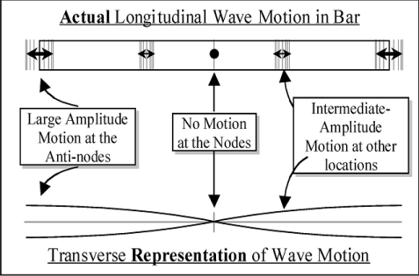For clear understanding we can represent these modes in the following way (Fig. 3). The Abscissa axis is along the rod, while on rhe ordinata axis we can show the vibration amplitude. In the places of nodes there is no vibration, while in the places of antinodes the vibration amplitude is largest[3].

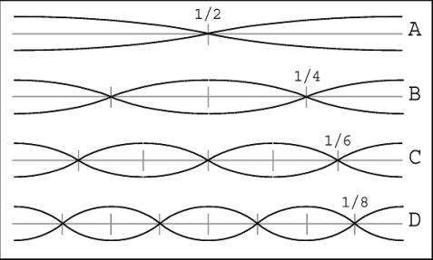Here from we can conclude that in order to get some particular frequency modes one must hold the rod in the node places of these modes. For example let us consides first three harmonics.

*The First Harmonic:*

From (4) and (5) we can see that wave length $λ_{1}=2l$;frequency $ν_{1}=\frac{\sqrt{E/ρ}}{2l}$; nod position can be calculated assuming that the left end of the rod is antinode and nearest nod to it is at ***λ/4*** distance, i.e for **Figure 3.**

the first harmonic nod is at ***x=l/2***. **Longitudinal wave modes.**

*The Second Harmonic*:

Similarly wave length $λ_{2}=l$;frequency $ν_{2}=\frac{\sqrt{E/ρ}}{l}=2ν_{1}$; nod position at ***x1=l/4; x2=3l/4.***

*The Third Harmonic*:

Wave length $λ_{3}=2l/3$;frequency $ν_{2}=\frac{3\sqrt{E/ρ}}{2l}=3ν_{1}$; nod position at ***x1=l/6; x2=l/2, x3=5l/6.***

Using similar calculations we can find the parameters of higher modes. Note, that all these vibration modes (*n = 0, 1, 2, 3, 4, 5, … ) have the same longitudinal* speed of sound propagation in the rod ***cL= = νi λi*** .

1. ***hold a rod at its center and hit it with a malletExperiments with Longitudinal waves.***

Now let us try to exite the quasi-longitudinal waves in the rod and investigate the sound we’ll hear.

To make rod sound clearer and louder, we tried to: hit the rod as fast as possible; hit it not very hard, because in other case harmonic form of waves will be violated; hit the rod with thing, that doesn't produce high sound itself (e.g. Ebonite Rod), so it will not mix with the sound of rod; hit it axially or normally, and not intermediate.

Also we excited the longitudinal waves by *sliding the hand*along the rod axis. We used the *Rosin powder* to make fingers more sticky. **Figure 4.**

In our experiments we observed that the pitch of the **Making Longitudinal waves** sound can be varied by changing the places when we held

the Rodor by changing the length of the rod itself.

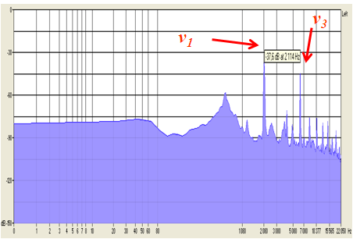Let us describe the results of our experiments.

At first we took *Aluminium* rod ***(ρAL =2,7·103 kg/m3 ; EAL =70×109 N/m2 ; CL(Al) = 5082.4 m/s )*** of length ***l=1,2m***. According our theoretical calculations, for this rod:

The first harmonic has such parameters: ***λ1=2.4m ; ν1=2117 Hz*** ; nod is at***: x=0.6m .***

The second harmonic has such parameters:

***λ2=1.2m***; ***ν2=4234 Hz;*** nodes are at: ***x1=0.3m,***

***x2 =0.9m.*** **Figure 5.**

The third harmonic has such parameters: ***Al* rod (holding in center).**

***λ3=0.8m***; ***ν3=6351 Hz;*** nodes are at: ***x1= 0.2m , x2= 0.6m , x3= 1.0 m.***

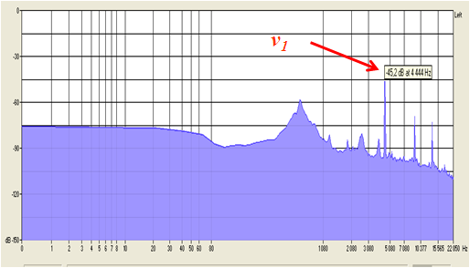We recorded the sound of the rod and made its analysis by means of “Sound Forge” program. On Fig 5 we represent the analysis of the frequencies of sound generated by this ***Al*** rod when we hold it in the center and hit axially or slide the fingers along it. As we see, in such case several modes having nodes in the center are excited. We see clearly modes “1” and “3”. Their frequencies match with theoretical calculations. The second mode is damped because it has no node in the center. Higher modes have lower amplitudes (for given energy the amplitude of oscillation is inversely proportional to its frequency) so they are more difficult to detect. Thus we can see that if one holds the rod in the place where are the nods of several modes, all these modes will occur. Touching the rod at the ends will stop the sound.

We made experiments with rods of different lengths and different materials. For example here we present also the sound generated by the *Brass* rod ***(ρBr =8,5·103 kg/m3 ; EBr =95×109 N/m2 ; CL(Br) = 3480 m/s )*** of length ***l= 0.4m***. According our theoretical calculations, for this rod:

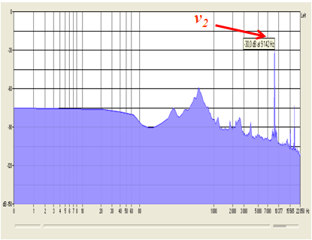The first harmonic has such parameters: ***λ1=0.8m***; ***ν1=4350 Hz;*** nod is at: ***x= 0.2m***.

The second harmonic has such parameters: ***λ2=0.4m***; ***ν2=8700 Hz;*** nodes are at: ***x1=0.1m, x2 =0.3m.***

The third harmonic has such parameters: ***λ3=0.27m***; ***ν3=13 050 Hz;*** nodes are at: ***x1= 0.07m, x2= 0.2m, x3= 0.33 m.***

On Fig 6 we represent the analysis of the frequencies of sound generated by this ***Brass*** rod when we hold it in the center (a) and at ***l/4*** (b). We can see that in the first case first mode is excited and in the second case – the second mode. **Figure 6 (a,b).**

Note, that on Figures 5,6 we see ***Brass* rod (a - center, b – *l/4*).**

also pikes at lower frequencies. They correspond to other waves – bending waves which we will discuss below. Of course in our experiments we could not hit the rod ideally to excite only longitudinal (A)-type waves.

1. ***Bending waves.***

Now let’s consider the bending waves arising in the rod when we hit it normally to its axis. Bending waves in the thin rod are expressed by the Eyler-Bernoulli beam theory equation of motion[1,2,4]:

, (6)

where ***K*** is so-called “Gyration Radius” of the rod cross section:

$K^{2}=\frac{1}{S}\int{z^{2}dS}$**,**

***S*** – cross-section area of the rod, ***z*** – is the radial distance from the rod central axis, ***y*** - is the displacement in the direction perpendicular to ***x*** (average symmetry center axis of the process), that describes the oscillations of the rod segments. For example, for the solid cylinder of radius ***a***:

$K^{2}=\frac{1}{πa^{2}}\int_{0}^{2π}{\int_{0}^{a}{r^{2}}}·\frac{1}{2}rdr·dθ=\frac{1}{πa^{2}}∙\frac{2π}{8}a^{4}=\frac{a^{2}}{4}$**.**

In (6) the shear deformations and rotary inertia are neglected. This is fourth order differential equation. Thus the velocity of transverse waves is dependent on the frequency. So a *dispersion* takes place.

Solution of equation (6) has the following form[1,2]:

(7)

where ***k=ω/v*** is the wave (propagation) number. As we mentioned above, wave velocity is dependent on frequency:

$v=\sqrt{2πνKc_{L}}$. (8)

This Eyler-Bernoulli beam theory gives the solution of bending waves in a thin beam or rod at low frequency. For the thick bars and for a high frequencies it does not work.

Now let us consider the transverse vibration modes in thin bar. They depend on the “end conditions”. For our task we consider *“both free ends”* condition - no torque and no shearing force. They give the following restrictions on standing wave frequencies[1,2]:

(9)

and wave lengths:

$λ_{n}= \frac{4l}{[3.011 ;5 ;7 ;…;\left(2n+1\right)…]}$, (10)

where for ***n=1*** we use 3.011 instead of 3.

The frequencies and nodal points (forwhich x satisfies equation (7)=0 for all the time ***t***) for the first modes are given in the table 1[1,2]:



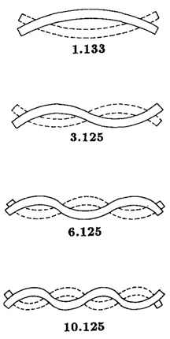The graphs of bending rod are given on the fig 7. On this figure the numbers are relative frequencies; to obtain actual frequencies one must multiply them by $\frac{πK}{l^{2}}\sqrt{\frac{E}{ρ}}$**.**

Here we must note that for thin rods the first several modes of the binding waves have frequencies sufficiently lower than those for the the longitudinal waves due to extra coefficient $\frac{K}{l}$ (compare (9) with (4)). So they are below the hearing range and we can hear only the higher modes of binding waves. However higher modes are vanishing very rapidly (we shall discuss it below).

Also, if one will consider the different “end conditions”, the case with condition (a) “both free ends” begins with modes of higher frequency than case (b) “one clamped end one free end” and (c) “two supported ends”[1,2], thus the second mode in case (a) is in “hearing frequency range”, but in cases (b) and (c) - not. **Figure 7.**

This is why we considered only *“both free ends”* condition. **Bending modes.**

Let us calculate the frequencies for the rods we used in experiment.

1. ***Experiments with Bending waves.***

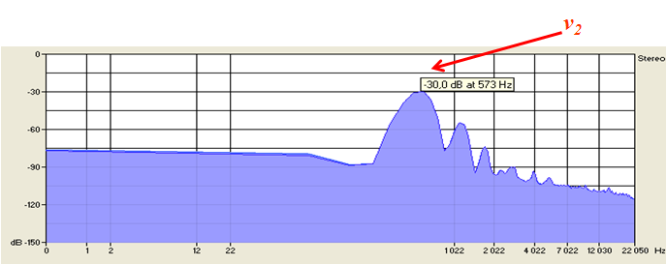Now Let us describe the results of our experiments when we hit the rod normally to its axis with the Ebonite stick.

For our experiments we took *steel* rod(***ρSt =7,8·103 kg/m3; ESt =200×109 N/m2; CL(St) = 5150 m/s*** ) of length ***l= 0.6m***; radius ***a= 0.007m***; Gyration radius  ***K=0.0035m.***

According our theoretical calculations, for this rod:

The first harmonic has such parameters: ***λB1=0,8m***; ***ν1=190Hz***; nodes are at: ***x1=0.13m, x2= 0,47m***.  **Figure 8.**

The second harmonic has such parameters: ***Steel* rod (holding at center).**

***λB2=0,48m***; ***ν2=525Hz***; nodes are at: ***x1=0.08m , x2=0.3m , x3=0.52m***

The third harmonic has such parameters: ***λB3= 0.34m***; ***ν3=1029Hz***; nodes are at: ***x1=0.056m, x2=0.21m, x3=0.39m, x4=0.544m.***

As it was expected, if one holds the rod in the point where nods of several modes are placed all these modes will occur. Touching the rod at the ends damped the sound (because, as we discussed above, in such a case with the one clamped end only the high modes are in the “hearing range” but the high modes are damped very rapidly).

On Fig 8 we represent the analysis of the frequencies of sound generated by this ***Steel*** rod when we hold it in the center. We can see that in this case the second harmonic mode is excited.

Here it is worth to recall that the low frequency pikes we saw on Figures 5,6 correspond to these bending waves. Of course in that experiments we occasionally excited such waves too.

As to (C)-type ***Torsion Waves***, we did not focused on them due to technical difficulties, in particular the exciting of such type of waves without exciting other types of waves of large amplitude. We want to return to this subject infuture.

1. 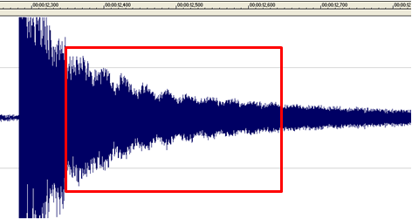***Beats.***

In our Experiments we noticed that sound became sometimes stronger, sometimes weaker (see picture 9). This was because of Beats - an interference between two sounds of slightly different frequencies.

**Figure 9.**

**Beats.**

1. 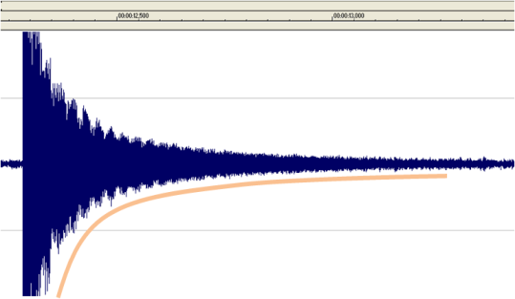***Sound damping.***

Damping of rod vibrations generally speaking can be caused by the following reasons: 1. Air damping; 2. Internal Damping; 3. Transfer of energy to other systems (e.g. fingers holding the rod).

Sound damping is the exponential function. For vibration amplitude one can write[1,2]:

where ***τ*** is the so called “decay time” – the time at which amplitude damps in ***e***-times. This decay time for the mentioned damping reasons has the following form[1,2]:

For Air dumping: $τ_{a} \sim ρr/\sqrt{ν}$ where ***r*** is rod radius, ***ρ*** its density and ***ν*** – vibration frequency.

For Internal damping: $τ_{int} \sim \frac{1}{πν}$

For the case of energy transfer to other systems: $τ_{sup} \sim \frac{1}{lGν^{2}}$

As we can see, in all cases dumping is higher for large frequencies. So, we can conclude that higher modes damp sooner, also, longitudinal waves damp faster than bending waves because the latter have the lower frequency modes. This we saw in out experiments – the longest lasting were the low modes of bending waves.

1. ***Conclusion.***

We investigated different types of waves which are excited if one hits the thin rod.

We find that:

* There are different types of waves in the rod
* The type of wave depends on how do we hit the rod.
* The frequency of standing wave depends on where we hold the rod - if one holds the rod in the place where are the nods of several modes, all these modes will occur. Touching the rod at the ends will stop the sound..
* The frequencies of bending waves are lower than of compression waves
* Damping of the waves depends on frequency.

References

# [1] Rossing T.D., Fletcher N.H. “Physics of musical instruments”. New York etc., Springer-Verlag 1991.

# [2] Rossing T.D., Russell D.A. Am.J.Phys Vol 58, No 12. 1990. P.1153.

[3] S. Errede. “The Physics of a Longitudinally Vibrating Metal Rod”. University of Illinois, 2009

[4] D.R.Lapp. “The Physics of Music and Musical Instruments”. Medford, Massachusetts.