DOMINO EFFECT MOTION INVESTIGATION: A NUMERICAL APPROACH
Alireza Tahmaseb Zadeh¹
¹ School of Electrical and Computer Engineering, University of Tehran, I.R Iran
Correspondence: info@tami-co.com

Abstract
This paper presents an investigation on the motion of a falling row of dominoes with different dimensions. Motion is described in means of Falling and Collision. Dominoes are assumed not to slip on the surface. The equations are solved numerically and a comprehensive simulation program is developed by the means of angle specification of dominoes as a function of time. The program works for any given arrangement of dominoes with different heights and distances. Video processing is used to measure the angle of dominoes in real experiments. Precise agreement between experimental results and simulation verifies the theory. In each collision, some percentage of the energy remains, some is transferred and the other part is wasted. These percentages are compared for different height increase rates and are used to designate limitations.

Theory
Motion is divided to Falling and Collision. The former refers to the falling of n dominoes lying on each other before reaching n+1. The latter is related to the collision procedure of n and n+1.
- Falling
Forces applied to one of the dominoes are: 1) Normal force k-1 and k 2) Friction force k-1 and k 3) Normal force k and k+1 4) Friction force k and k+1 5) Weight 6) Normal force from surface 7) Friction force between domino and the surface.
Referring to the third law of Newton, the forces that k applies to k+1 (normal force and friction force) is equal to the force that k+1 applies to k. Angular acceleration of dominoes could be found using the torques applied to them.
$I\ddot{θ}(k)=Torque\left(F\left(k-1\right) , μF\left(k-1\right) , F\left(k\right) , μF\left(k\right), weight \right)$ (1)
More precisely:
$I\left(k\right)\ddot{θ}(k)= - F\left(k-1\right)×\left\{{\left[{\left(l\left(k-1\right)-\frac{d\left(k\right)}{\sin\left(θ\left(k\right)\right)}\right)}^{2}+{\left(h\left(k-1\right)\right)}^{2}-2h\left(k-1\right)\left(l\left(k-1\right)-\frac{d\left(k\right)}{\sin\left(θ\left(k\right)\right)}\right)\cos\left(θ\left(k-1\right)\right)\right]}^{0.5}-d\left(k\right)\cot\left(θ\left(k\right)\right)\right\}+μF\left(k-1\right)d\left(k\right)+F\left(k\right)h(k)cos\left(θ\left(k+1\right)-θ\left(k\right)\right)+ μF\left(k\right)h(k)sin\left(θ\left(k+1\right)-θ\left(k\right)\right)-m\left(k\right)g\frac{\sqrt{h{\left(k\right)}^{2}+d{\left(k\right)}^{2}}}{2}cos⁡(θ\left(k\right)+atan⁡(\frac{d(k)}{h(k)}))$ (2)
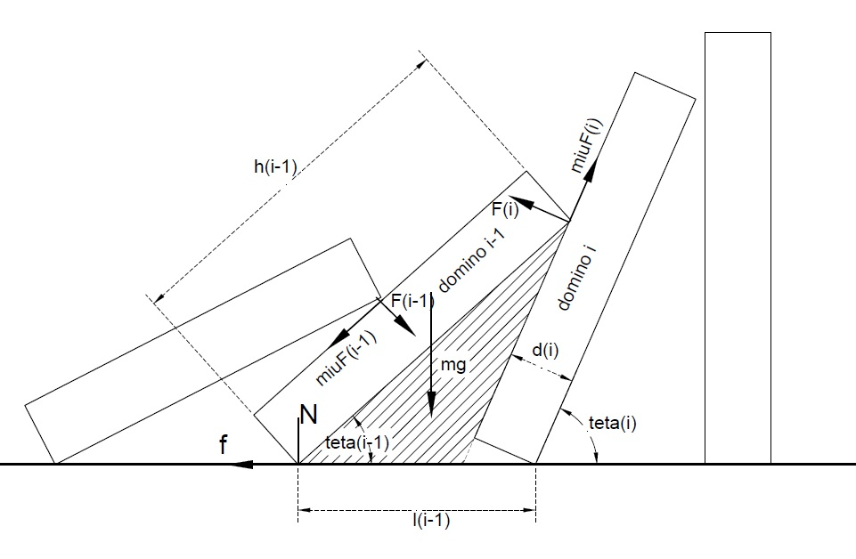
Dominoes always remain in contact. This results in an equation between height $h(k)$, distance between right sides of k and k+1,$l(k)$, width$d\left(k\right)$ and angle with surface $θ\left(k\right)$.(Using the sinusoids law in the hatched triangle in Figure 1)
Figure 1: Forces applied to the domino
$\frac{h(k-1)}{sinθ(k)}=\frac{l(k-1)-\frac{d(k)}{sinθ(k)}}{sin⁡(θ(k) -θ(k-1)) }$ (3)
Second derivative of this equation gives an equation between angular accelerations of k and k-1.
$\ddot{θ}(k-1)+\ddot{θ}(k)[-1+\frac{l\left(k-1\right)\cos\left(θ\left(k\right)\right)}{h\left(k-1\right)\sin\left(θ\left(k\right)-θ\left(k-1\right)\right)}]=\frac{l\left(k-1\right)\dot{θ^{2}\left(k\right)}}{h\left(k-1\right){\cos\left(θ\left(k\right)-θ\left(k-1\right)\right)}^{2}}[\sin\left(θ\left(k\right)\right){\cos\left(θ\left(k\right)-θ\left(k-1\right)\right)}^{2}-\frac{{\cos\left(θ\left(k\right)\right)}^{2}sin⁡(θ\left(k\right)-θ(k-1))}{h(k-1)}]$ (4)
In better words, two equations are available for each of n dominoes.
$C1\left(k\right)F\left(k-1\right)+C2\left(k\right)F\left(k\right)=C3(k)$ (5)
$P1\left(k\right)\ddot{θ}\left(k-1\right)+P2\left(k\right)\ddot{θ}\left(k\right)=P3(k)$ (6)
Where C1(k), C2(k), C3(k), P1(k), P2(k), P3(k) are known constants ( These constants could be calculated using equations (2), (4)).
There are n dominoes and 2 equations for each, making 2n equations totally. Also there happens to be 2n unknown parameters which are $F\left(k\right)$ and $\ddot{θ}\left(k\right)$ for all n dominoes. This system of 2n equations and 2n unknowns could be solved numerically.
Collision
Based on high speed videos, the following procedure is observed: As n hits n+1, some energy is wasted. Angular velocity of n and consequently preceding dominoes decrease. n+1 obtains an angular velocity greater than the angular velocity of n after collision; therefore n and n+1 separate. The large mass of the first n dominoes causes n to reach n+1 soon again. n lies on n+1 and the set of n+1 dominoes continue to fall. Collision is immediate and the friction force between the domino and the surface is rather minor, hence conservation of momentum in horizontal direction is available. Restitution coefficient gives the relation between velocity before and after the collision.
$\sum_{1}^{n}{m(k)v(k)}=\sum_{1}^{n}{m(k)v'(k)}+m(n+1)u$ (7)
This equation could be exactly expressed.
$\sum_{1}^{n}{m\left(k\right)h\left(k\right)|\dot{θ}(k)|sin⁡(θ(k))}=\sum_{1}^{n}{m\left(k\right)h\left(k\right)|\dot{θ}'(k)|sin⁡(θ(k))}+m\left(n+1\right)h\left(n+1\right)|\dot{θ}(n+1)|$ (8)
First derivative of the geometric constraint against time gives the relation between angular velocities of any neighbor dominoes:
$\dot{θ}\left(k-1\right)=\dot{θ}\left(k\right)[1-\frac{l\left(k-1\right)cos⁡(θ(k))}{h\left(k-1\right)cos⁡(θ\left(k\right)-θ(k-1)}]$ $0<k≤n$ (8)
This equation indicates that if $\dot{θ}\left(k\right)$ decreases by coefficient α after the collision, $\dot{θ}\left(k-1\right)$ will also decrease by the same coefficient. Therefore, if $\dot{θ}'\left(n\right) =α\dot{θ}\left(n\right),$ it could be inferred that $\dot{θ}'\left(k\right) =α\dot{θ}\left(k\right)$ for$0<k≤n$
Re-writing equation (7) we get:
$\sum_{1}^{n}{m\left(k\right)h\left(k\right)|\dot{θ}(k)|sin⁡(θ(k))}=α\sum_{1}^{n}{m\left(k\right)h\left(k\right)|\dot{θ}(i)|sin⁡(θ(k))}+m\left(n+1\right)h\left(n+1\right)|\dot{θ}(n+1)|$ (9)
For simplification we call S=$\sum_{1}^{n}{m\left(i\right)h\left(i\right)|\dot{θ}(i)|sin⁡(θ(i))}$. Equation (9) gives
$S(1-α)=m\left(n+1\right)h\left(n+1\right)|\dot{θ}(n+1)|$ (10)
The other equation is the restitution coefficient. The relative velocities of n and (n+1) becomes –e times (e<1) after the collision.
$v^{'}(rel)=-ev(rel)$ (11)
Which is:
$-e\left(h\left(n\right)\left|\dot{θ}\left(n\right)\right|\sin\left(θ\left(n\right)\right)-0\right)= h\left(n\right)\left|\dot{θ}\left(n\right)\right|\sin\left(θ\left(n\right)\right)-h(n+1)\dot{θ}(n+1)$ (12)
The coefficient e, is calibrated in experiments. Solving equations (10) and (12), two unknowns of α and $\dot{θ}\left(n+1\right)$ are calculated.

Simulation Program
Using MATLAB®, a program is developed to fully simulate the motion. The angle and angular velocity of the first domino and properties of dominoes namely: height, width, distance, density and friction coefficient are inputs. In each of the iterations, angular accelerations of dominoes are calculated solving the system of 2n equations and 2n unknowns discussed above. Next, angular velocities and angles are updated by following equations:
$\dot{θ}\left(k\right)(t+dt)=\dot{θ}\left(k\right)(t)+\ddot{θ}\left(k\right)dt$ (13)
$θ\left(k\right)(t+dt)=θ\left(k\right)(t)+\dot{θ}\left(i\right)dt$ (14)
The program continuously checks if domino n has reached n+1. In case that it has reached, it solves equations (10) and (12) to find velocities after collision. Then it uses equation (8) to find angular velocities of preceding dominoes. Here is the phase that dominoes are separated for a short period. The program resumes the falling motion of first n dominoes and n+1 separately until n reaches n+1 again. The program assumes n+1 to be in contact with n in the rest of the motion and upgrades the system to n+1 in contact dominoes. This process continues until the last domino reaches the surface. Finally a movie from this motion is made.
Figure 2: The movie simulating the motion

Experiments
Dominoes were made of Plexiglas in different heights and widths. Experiments were done on an abrasive to provide the non-slipping condition which was assumed in the theory. A screw was used to firmly tilt first domino to ensure free falling for the first domino with no initial angular velocity (Figure 3).
Videos with 1000 frames per second were recorded. The dominoes, along with the background, were colored in black and a thin white line was drawn on dominoes. Analyzing videos by MATLAB, white lines were detected and traced to measure the angle of dominoes. The time between initiation of the motion and first collision was used to calculate the initial angle. Giving this angle and zero value for initial velocity as inputs, the simulation program plotted the angle of each of dominoes vs. time graph. The same graph was plotted using video processed data. Precise agreement between simulated and experimental graphs demonstrated accuracy of the theory. Three chief experiments are presented.
Figure 3: Setup Scheme
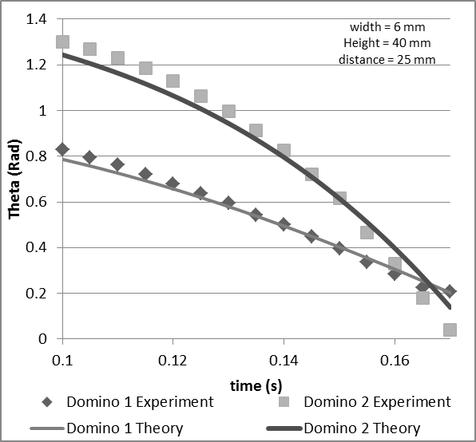
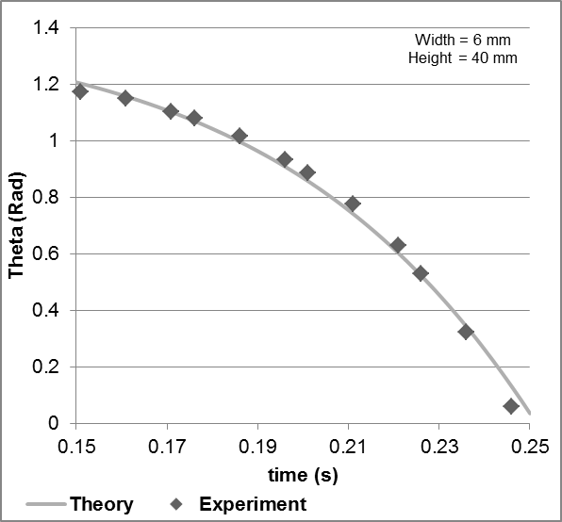
A) One Domino: This experiment was done using one domino to check the falling procedure of the program (Figure 4).
Figure 5: Two Dominoes Experiment
Figure 4: One Domino Experiment
B) Two Dominoes: Two identical dominoes were located. Falling time of the second domino was used to find the restitution coefficient. The great match verified equations of the collision (Figure 5).
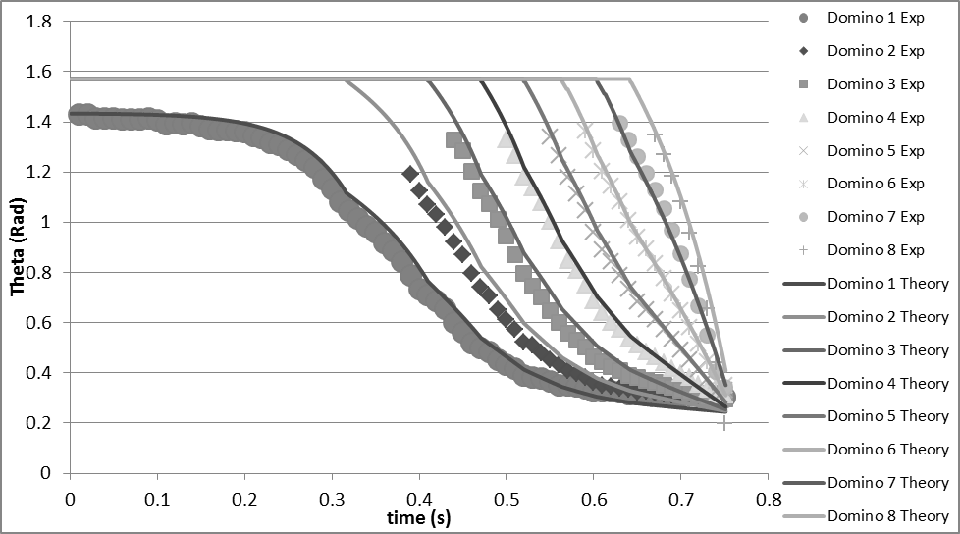
C) Increasing Height Dominoes: Eight dominoes with different heights were placed in a row. The dominoes were each increased by 4 mm in height. The agreement between simulation program and video processing results in this experiment verifies theory’s reliability (Figure 6).
Figure 6: Increasing Height Dominoes Experiment
Discussion
Considering the high agreement between experiments and the theory, the simulation program was used to demonstrate energies and limitations. An increasing height arrangement was studied. Dominoes, all with a constant width, were located in a fixed distance from each other. The height of dominoes were increased by a constant rate (i.e h(i)=h(i-1)+rate). In order to illustrate height increase effect, four situations were analyzed: identical height and increasing height rates of 2, 6 and 10 mm by each domino.
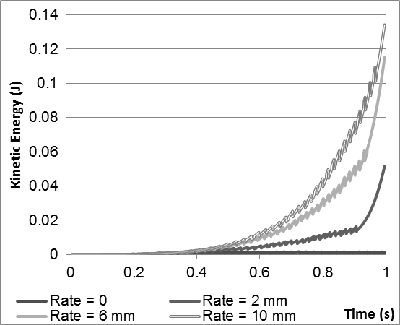
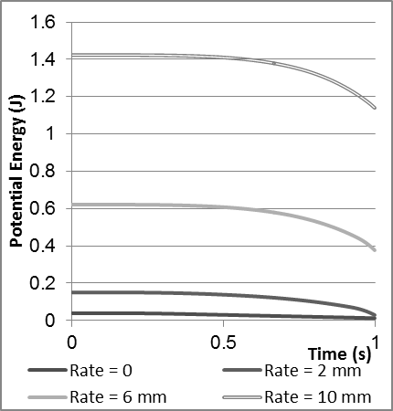
The initial gravitational potential energy transforms into kinetic energy (Figure 7). Since dominoes are assumed to be stable on the surface, the kinetic energy is only rotational kinetic energy. In each collision, some energy is wasted. Using experiments, the restitution coefficient was calculated to be $ε=0.2$ for our set of materials.
Figure 7: Potential Energy transforms into Kinetic Energy
Considering the collision of n and n+1, some part of the total kinetic energy remains in the first n dominoes, some transfers to n+1 and the rest is wasted. Figures 8 and 9 illustrate this concept (e.g. In the collision of dominoes 20 and 21, in a 6 mm rate, 17 percent of the sum of kinetic energies before collision, will be transferred to 21st domino)
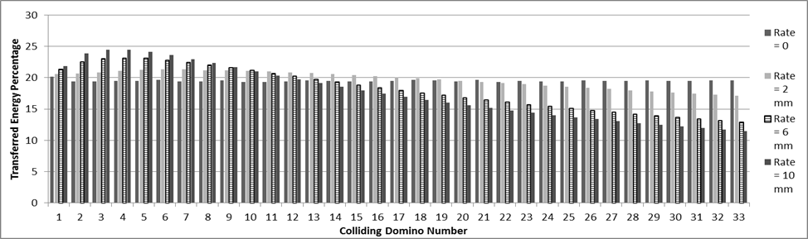
In case of identical dominoes, after approximately 5 collisions, the energy that the system gains due to the transformation of potential energy becomes equal to the energy loss in the collision. Moreover, the time between collisions converges to a constant. Therefore, a wave of falling dominoes which moves with a constant velocity is observed.
Figure 8: Transferred Energy Percentage at all collisions for4 rates
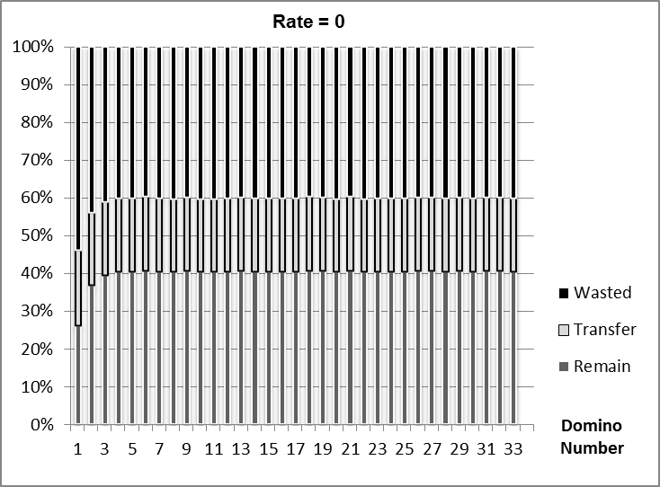
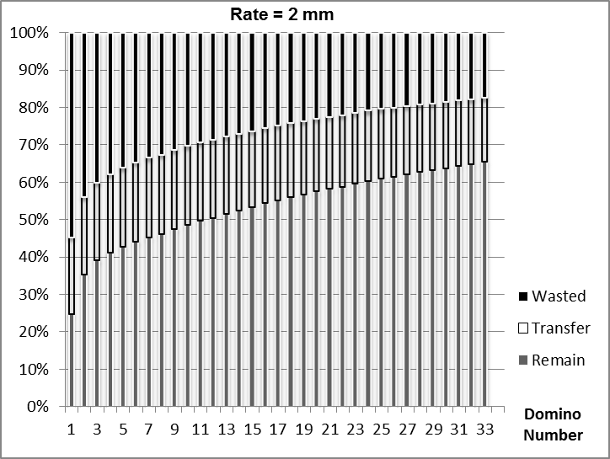
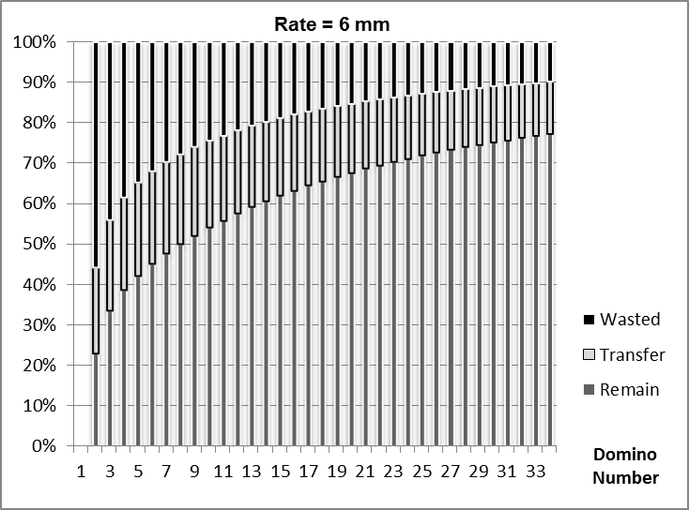
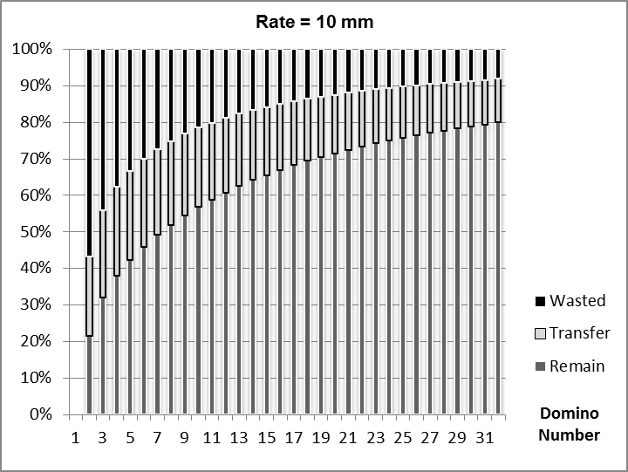
Figure 9: Remained, Transferred and wasted energy Percentages

Limitation
The situation in which a domino withstands when it is hit could be defined as a limitation. Considering the potential energy of a domino (Figure 10), it requires an initial energy to be toppled. This energy is required because the height of its center of mass should be increased when tilting the domino. This energy is supplied by transferred energy. Hence, transferred energy should be greater than the initial potential energy. Such kinds of limitations are acquirable using the simulation program. If width of the domino exceeds a critical amount, the motion will cease. As the width increases, the motion stops sooner. For instance, figure 11 shows the limiting domino number against width for a particular set of dominoes. (e.g. if width is between 3.21 cm to 4.01 cm, the motion will stop in the 3rd domino)
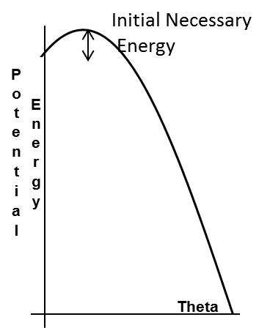
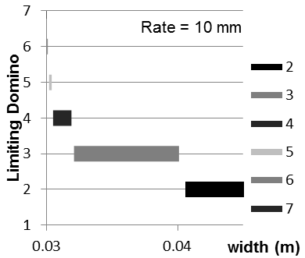
Figure 11: a) Potential Energy of a domino b) Limiting Domino against width

Figure 10: Potential Energy of the domino

Conclusion
The theory has been several times modified to present the best model. The program works as well in every arrangement and height functions of dominoes and reports all parameters including transfer rate, energies, collision times and etc. In this paper, there was more attention on the effect of height increase rate. The simulation program is capable of recognizing any motion failure and limitations.

References
[1] J. M. J. van Leeuwen. The domino effect. Am. J. Phys. 78, 7, 721-727 (2010), arXiv:physics/0401018v1 [physics.gen-ph
[2] Steve Koellhoffer, Chana Kuhns, Karen Tsang, and Mike Zeitz. Falling dominoes (University of Delaware, December 9, 2005), http://www.math.udel.edu/~rossi/Math512/2005/Team3.pdf
[3] Robert B. Banks, Towing Icebergs, Falling Dominoes and other adventures in Applied Mechanics, Princeton University Press, 1998.

