Supplementary material on:
DOMINO EFFECT MOTION INVESTIGATION: A NUMERICAL APPROACH
Alireza Tahmaseb Zadeh

This document includes more information about the theory and modeling of the problem which is not appeared on the original paper.
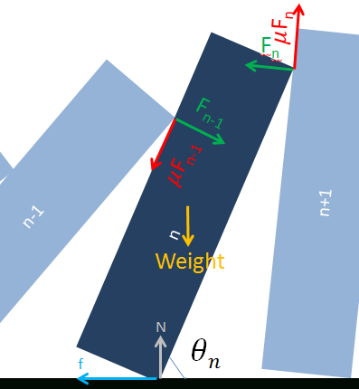
Physical modeling:
Consider the forces applied to one domino (Figure 1):
These forces are:
1) Normal force i-1 and i 2) Friction force i-1 and i 3) Normal force i and i+1 4) Friction force i and i+1 5) Weight 6) Normal force from surface 7) Friction force between domino and the surface
The equation for the torque applied to the i^{th} domino is:
$I\ddot{θ}(i)=Torque\left(F\left(i-1\right) , μF\left(i-1\right) , F\left(i\right) , μF\left(i\right), weight \right)$
More precisely:
Figure 1: Forces applied to one domino

$I\left(i\right)\ddot{θ}(i)= - F\left(i-1\right)×\left\{{\left[{\left(l\left(i-1\right)-\frac{d\left(i\right)}{\sin\left(θ\left(i\right)\right)}\right)}^{2}+{\left(h\left(i-1\right)\right)}^{2}-2h\left(i-1\right)\left(l\left(i-1\right)-\frac{d\left(i\right)}{\sin\left(θ\left(i\right)\right)}\right)\cos\left(θ\left(i-1\right)\right)\right]}^{0.5}-d\left(i\right)\cot\left(θ\left(i\right)\right)\right\}+μF\left(i-1\right)d\left(i\right)+F\left(n\right)h(i)cos\left(θ\left(i+1\right)-θ\left(i\right)\right)+ μF\left(n\right)h(i)sin\left(θ\left(i+1\right)-θ\left(i\right)\right)-m\left(i\right)g\frac{\sqrt{h{\left(i\right)}^{2}+d{\left(i\right)}^{2}}}{2}cos⁡(θ\left(i\right)+atan⁡(\frac{d(i)}{h(i)}))$ (1)

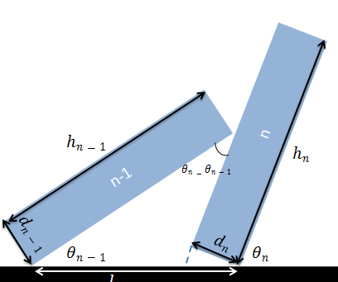
The other equation is the geometric constraint that is calculated by sinus law:
$$\frac{h(i-1)}{sinθ(i)}=\frac{l(i-1)-\frac{d(i)}{sinθ(i)}}{sin⁡(θ(i) -θ(i-1)) }$$
Second derivative of this equation against time results in:

$\ddot{θ}(i-1)+\ddot{θ}(i)[-1+\frac{l\left(i-1\right)\cos\left(θ\left(i\right)\right)}{h\left(i-1\right)\sin\left(θ\left(i\right)-θ\left(i-1\right)\right)}]=\frac{l\left(i-1\right)\dot{θ^{2}\left(i\right)}}{h\left(i-1\right){\cos\left(θ\left(i\right)-θ\left(i-1\right)\right)}^{2}}[\sin\left(θ\left(i\right)\right){\cos\left(θ\left(i\right)-θ\left(i-1\right)\right)}^{2}-\frac{{\cos\left(θ\left(i\right)\right)}^{2}sin⁡(θ\left(i\right)-θ(i-1))}{h(i-1)}]$ (2)

In better words, we can write two equations for each of dominoes.
$C1\left(i\right)F\left(i-1\right)+C2\left(i\right)F\left(i\right)=C3(i)$ (3)
$P1\left(i\right)\ddot{θ}\left(i-1\right)+P2\left(i\right)\ddot{θ}\left(i\right)=P3(i)$ (4)

Where C1(i), C2(i), C3(i), P1(i), P2(i), P3(i) are known constants.
The program has to solve this system of 2n equations (2 equations for each of dominoes) and 2n unknowns ($F\left(i\right)$, $\ddot{θ}\left(i\right)$) in each time iteration. It is obvious that F(n)=0, F(0)=0.
Therefore if we make these matrices (examples of 4 dominoes are shown):

M =

0 0 C2(1) 0 0 0 0 0
0 P1(1) 0 P2(1) 0 0 0 0
0 0 C1(2) 0 C2(2) 0 0 0
0 0 0 P1(2) 0 P2(2) 0 0
0 0 0 0 C1(3) 0 C2(3) 0
0 0 0 0 0 P1(3) 0 P2(3)
0 0 0 0 0 0 C1(4) 0
0 0 0 0 0 0 0 P1(4)
$X=\begin{matrix}\begin{matrix}\begin{matrix}F(1) \\ \ddot{ θ}(1)\end{matrix} \\ \begin{matrix}F(2) \\ \ddot{ θ}(2)\end{matrix}\end{matrix} \\ \begin{matrix}\begin{matrix}F(3) \\ \ddot{ θ}(3)\end{matrix} \\ \begin{matrix}F(4) \\ \ddot{ θ}(4)\end{matrix}\end{matrix}\end{matrix}$ $B=\begin{matrix}\begin{matrix}\begin{matrix}C3(1) & P3(1)\end{matrix} & \begin{matrix}C3(2) & P3(2)\end{matrix}\end{matrix} & \begin{matrix}\begin{matrix}C3(3) & P3(3)\end{matrix} & \begin{matrix}C3(4) & P3(4)\end{matrix}\end{matrix}\end{matrix}$
This equation is available:
M=X*B
So X=B*inverse (M) and F(i) and $\ddot{ θ}(i)$ is found for all i<=n (i.e solving a 2n*2n matrix)
After solving this matrix in each of iterations, the program updates amounts of $θ\left(i\right), \dot{θ}\left(i\right)$ for all i<=n by using the following equations:
- $\dot{θ}\left(i\right)=\dot{θ}\left(i\right)+\ddot{θ}\left(i\right)*dt$ (5)
- $θ\left(i\right)=θ\left(i\right)+\dot{θ}\left(i\right)*dt$ (6)

Collision:
Several methods for modeling the collision were assumed and tested. The best method is presented. The equations used are Reservation of momentum in x direction and using the restitution coefficient. Reservation of momentum in x direction is available since the collision time is pretty small. We have:
$\sum_{1}^{n}{m(i)v(i)}=\sum_{1}^{n}{m(i)v'(i)}+m(n+1)u$ (7)
Which could be rephrased:
$\sum_{1}^{n}{m\left(i\right)h\left(i\right)|\dot{θ}(i)|sin⁡(θ(i))}=\sum_{1}^{n}{m\left(i\right)h\left(i\right)|\dot{θ}'(i)|sin⁡(θ(i))}+m\left(n+1\right)h\left(n+1\right)|\dot{θ}(n+1)|$ (8)

First derivative of the geometric constraint against time gives relation between angular velocities of any 2 neighboring dominoes:
$\dot{θ}\left(i-1\right)=\dot{θ}\left(i\right)[1-\frac{l\left(i-1\right)cos⁡(θ(i))}{h\left(i-1\right)cos⁡(θ\left(i\right)-θ(i-1)}]$ (9)
This equation indicates that if $\dot{θ}\left(i\right)$ decreases by coefficient α after the collision, $\dot{θ}\left(i-1\right)$ will also decrease by the same amount. Therefore, if $\dot{θ}'\left(n\right) =α\dot{θ}\left(n\right),$ it could be inferred that $\dot{θ}'\left(i\right) =α\dot{θ}\left(i\right)$ for 0<i<=n
Re-writing equation (7) we get:
$\sum_{1}^{n}{m\left(i\right)h\left(i\right)|\dot{θ}(i)|sin⁡(θ(i))}=α\sum_{1}^{n}{m\left(i\right)h\left(i\right)|\dot{θ}(i)|sin⁡(θ(i))}+m\left(n+1\right)h\left(n+1\right)|\dot{θ}(n+1)|$ (10)
For simplifying we call S=$\sum_{1}^{n}{m\left(i\right)h\left(i\right)|\dot{θ}(i)|sin⁡(θ(i))}$. Equation (8) gives
S(1-α)=$m\left(n+1\right)h\left(n+1\right)|\dot{θ}(n+1)|$ (11)
The other equation is restitution coefficient. The relative velocities of n and (n+1) get –e times (e<1) after the collision.
$-e\left(h\left(n\right)\left|\dot{θ}\left(n\right)\right|\sin\left(θ\left(n\right)\right)-0\right)= h\left(n\right)\left|\dot{θ}\left(n\right)\right|\sin\left(θ\left(n\right)\right)-h(n+1)\dot{θ}(n+1)$ (12)
The coefficient e, is calibrated in experiments. Solving equations (11) and (12), with two unknowns of α and $\dot{θ}\left(n+1\right)$ two important parameters are calculated. The program updates $\dot{θ}\left(n+1\right)$ from 0 to its new amount and also multiplies $\dot{θ}\left(i\right)$ by the coefficient α for 0<i<=n.

