EFFICIENCY EVALUATIONS OF A BALLOON POWERED CAR
Parham Zendedel Nobariª, Reza Montazeri Namin^{b}, Hossein Azizinaghsh^{c}

ªMofid Gheytarie High School, Tehran, I. R. Iran.

^{b}School of Mechanical Engineering, Sharif University of Technology, I. R. Iran.

^{c}School of Computer Engineering, Sharif University of Technology, I. R. Iran.

Abstract
The present paper is an investigation of the efficiency of a car, powered by an air-filled toy balloon in which the deflating balloon produces jet propulsion. The causes of energy loss have been investigated theoretically and several precise experiments have been made to determine the amount of energy loss that occurs for different causes. Experiments were done using image processing techniques, measuring the volume of the balloon and its changes in several cases and leading to energy analysis. It will be shown that about 50% of the energy will be lost as a result of the Moulin’s effect, and a variable amount will be lost as a result of the head loss.

Introduction
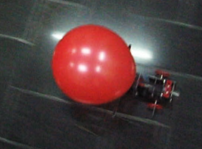
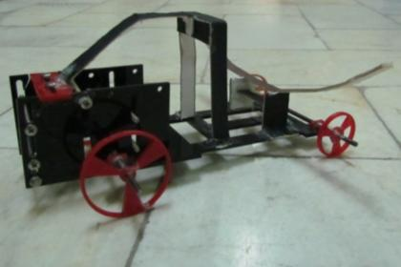
The main design we will emphasize in this paper on, is the installation of a filled balloon on the car, with its end pointing towards the back of the car, deflating and causing propulsion (rocket type car). In this case, because of the momentum of the outgoing air jet, a force will be exerted to the car, forcing it to move. There are other designs which could utilize a balloon as a source of energy to mobilize the car as used in the Balloon Car Contest at NASA's Jet Propulsion Laboratory [1], many of which do not fill the balloon with air but use it as a rubber band instead (and since our task is to investigate air filled balloon cars, this approach was not a subject of our investigation). Another design is to chronically release the outgoing air jet into a turbine-like structure and use the energy to rotate the wheels. This way, the efficiency may increase due to head loss decrease resulted by the velocity decrease. This method has not been used elsewhere before, and we also did not investigate it. However, further investigations are suggested on this method.
Figure 1: The Model Car

In our case, the balloon is attached to a cylindrical nozzle and deflates through it (Figure 1). A cylindrical nozzle with diameter of 4cm and length of 10cm was used in our experiments. In this case three forces are exerted to the car; the motivational force which is exerted to the balloon due to the momentum of the outgoing air flow, and two resistive forces which are: Aerodynamic drag force and the friction forces applied to the car. Regarding the conservation of momentum, the motivational force could be calculated as a function of the relative velocity of the outgoing air flow.
According to the Work and Energy Theorem, the total work done by all the external forces exerted to the car must be equal to its alterations of kinetic energy. Since the initial and final kinetic energies of the car are of zero value (initial and final velocities are zero), the total work done by all the forces exerted to the car must be zero. Thus the amount of work done by the motivational force equals to the work done by the resistive forces. It is desired to maximize the work done by the motivational force, since our definition of efficiency is the ratio of the work done on the car by the motivational force to the energy needed to fill the balloon.

In view of the motivational force to be much greater than the resistive forces (since it functions in a much shorter time and does the same amount of work) the work done by the motivational force is independent from the resistive forces. The energy released by the balloon air flow will be divided into two main compartments; the energy which moves the car and the energy which moves the air. The input energy given to the car would mainly waste in two ways (other than the kinetic energy of the air). Initially, a fraction of the energy will be lost during the inflation process due to the balloon’s plastic deformation. This phenomenon is entitled as the “Moulin’s Effect” [2]. Note that a filled and emptied balloon will be larger than the initial balloon. This means that a part of the energy given to a balloon while inflation will be used to deform the rubber material, which is not given back when it deflates.

The second form of energy loss occurs when the fluid is in rapid motion during deflation. This energy loss is widely known as “Head Loss”, and has two main factors: Head Loss caused by the viscous friction forces with the inner membrane of the balloon, and the head loss resulted by the turbulent motion which arises from the high velocity. Both of these factors are proportional to the velocity square and the proportions are functions of the system’s size and geometrical properties (in our case, the head loss coefficient alters during time and cannot be considered as a constant.)

In the following, we will determine the amount of these energy losses.

Several factors were to be experimented physically, mainly to measure the constants in the system and the amount of energy losses in different steps. The physical experiments would also approve the theoretical assumptions. During the experiments, each balloon was used only once to avoid changes in the results because of the Moulin’s Effect. About 200 balloons were experimented totally.

Initial Energy and Moulin’s Effect
The first set of experiments was designed to measure the amount of energy needed to fill the balloon and the amount of the restorable energy. To do so, our method was to find the relation between the internal pressure of the balloon and its volume.

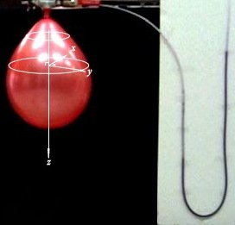
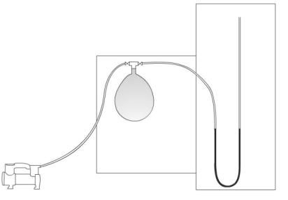
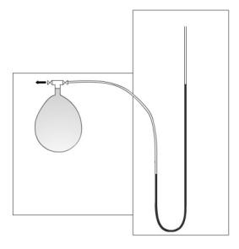
To find the Pressure-Volume relation in emptying and filling stages, the balloon was attached to a leak-proof valve-pipe system, which could simultaneously fill the balloon with an air pump with a known small flow rate and demonstrate the internal pressure (Figure 2). A manometer gauge filled with inked water, was used to signify the internal pressure and two valves were attached in that the pressure alteration during deflation or inflation would visually materialize. The process was filmed by a camera far enough to minimize the effect of the perspective view subsequently, both the volume of the balloon and the pressure were calculated in each frame by a program using MATLAB™ image-processing. The balloon volume was calculated assuming axial symmetry about the z-axis (As demonstrated in Figure 2), and the internal pressure was calculated measuring the difference of water elevation in the two sides of the manometer gauge (Figure 2). In order to provide $P-V$ diagrams in the case of inflation (Figure 3), the experiment was reversely accomplished so that both valves were initially open and the balloon’s inflation was recorded along with the changes in internal pressure and was ultimately analysed by the program. Using these techniques, the Pressure-Volume diagrams could be achieved.
Figure 2: The $P-V$ Experiment Setup illustration ($i$) indicates the inflation setup and ($d$) indicates the deflation setup. (Note: in the deflation setup $h≮0$ thus flow rate (a) was dramatically minimized.)
$${Valve}_{1}$$
$${Valve}_{2}$$
$$∆h$$
$$Pump$$
$$Manometer$$
$$(a)$$
$${Valve}_{1}:open\left(d\right), open(i)$$

$$∆h=0 \left(d\right)$$
$∆h>0 (i)$

$$∆V>0$$

$$Phase Two$$

$${Valve}_{1}:open\left(d\right), closed(i)$$

$$∆h≥0$$

$$∆V<0 \left(d\right)$$
$$∆V=0 (i)$$
(
$${Valve}_{2}:open\left(d\right), closed(i)$$

$${Valve}_{2}:closed\left(d\right), open(i)$$
$$Phase One$$

While measuring the Pressure, there were some errors caused by the dynamic motion of the water in the tube, particularly in the inflation process, which the discharge could not be smaller than a specific amount. Therefore, at the beginning of the inflation process, where there is no maximum point for the pressure, the dynamic behaviour of the water would not seem to be crucial, since it is the integration of the $P-V$ diagram which will be used later, and this oscillation does not have a significant effect.
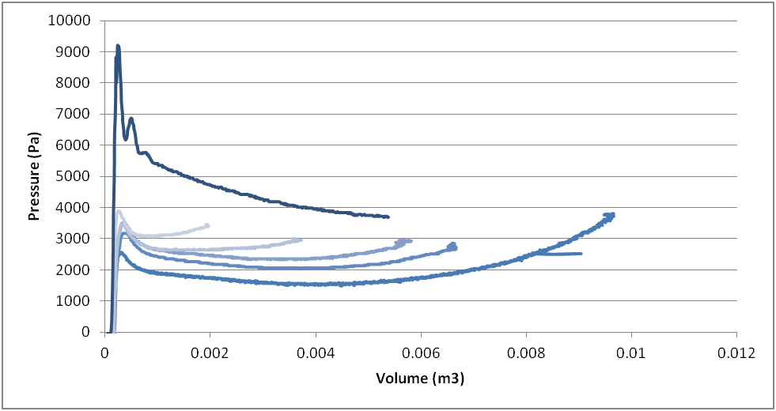
$$Volume (m^{3})$$
$$Pressure (Pa)$$
Figure 3: The P-V Diagram for Several Deflation Cases and an Inflation case (the Top Curve) Each Curve is consisted of about 1000 Points outputted from the Image Processing.

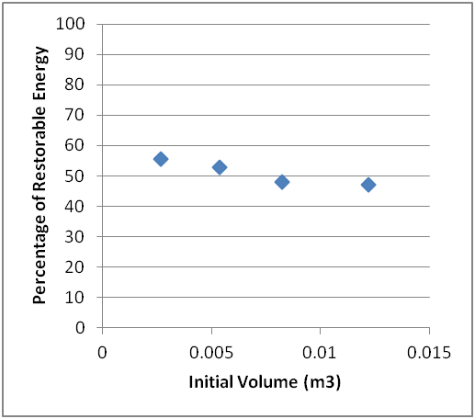
Having the $P-V$graphs for inflation and deflation from different initial volumes, the energy was to be calculated. To inject an infinitesimal volume $dV$ of a gas to a container with a pressure of $P$, the energy required is $PdV$. Thus, the energy to fill the balloon is the integration of pressure that is a function of volume:
Figure 4: The Ratio of the Restorable Energy to the Total Given Energy
$$Initial Volume (m^{3})$$
$$Percentage of Restorable Energy$$

$$E= \int_{V_{0}}^{V}{P\left(V\right)dV} (1)$$

The same occurs for the deflation process. Hence, the energy needed to fill the balloon was calculated by numerical integration. Moreover, the restorable energy was calculated by integrating the relation for the deflation case.
Our results illustrate that about half of the work required to fill a balloon is not restorable, (Figure 4) in other words; 50% of the energy is used to cause the plastic deformations among the rubber-like material.

Fast Deflation Process and Head Loss
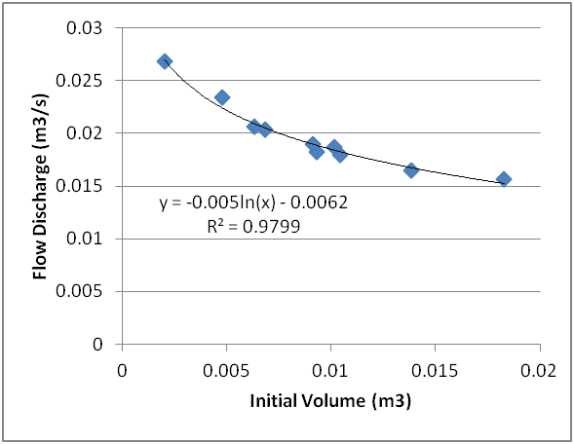
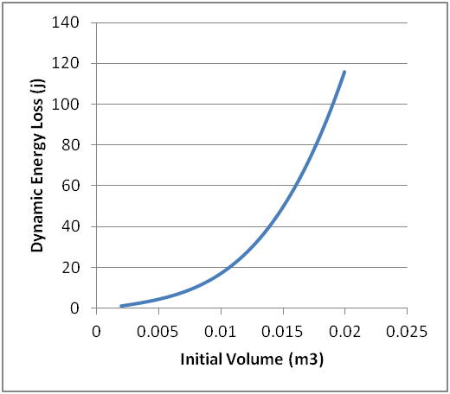
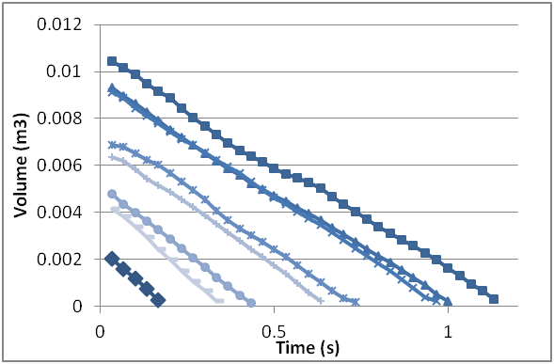
The entire energy loss is not limited to the Moulin’s effect. Some energy will be lost due to the dynamic of the outgoing fluid during the fast deflation, e.g. the viscous force between the fluid layers will do some negative work, converting the mechanical energy to heat. Flow turbulence also wastes some energy [3]. We must determine the amount of the energy lost during the deflation process, which is of course a function of the volume, varying the deflation velocity and deflation time. In order to investigate the reproduced energy by the balloon, we attach the balloon to a cylindrical nozzle (similar to the ones used on the car) and let it deflate. A high speed video was captured from the deflating balloon, and again using image processing, the volume of the balloon was found as a function of time (Figure 5). This was done for several initial volumes, and the experiment reproducibility was also checked by repeating the experiments.
Figure 6: Flow Discharge
$$Initial Volume (m^{3})$$
$$Flow Discharge (m^{3}/s)$$
Figure 7: Dynamic Energy Loss
$$Initial Volume (m^{3})$$
$$Dynamic Energy Loss (J)$$
Figure 5: Some Emptying Diagrams

It was observed that the rate of volume change (flow discharge) remains slightly constant during the emptying time. The discharge is plotted against the initial volume, and a decreasing behaviour is observed (Figure 6). This behaviour is acceptable, since the average internal pressure of the balloon also has a decreasing behaviour regarding the initial volume. Note that the discharge was interpolated to be used for countless un-experimented points in that specific range. The interpolation was made by fitting a logarithmic trend to the data, and the only reason of using a logarithmic function (and not a linear curve for instance) was that it could give a better prediction for un-experimented points. Using the discharge, the emptying velocity and time can also be calculated for a known initial volume.
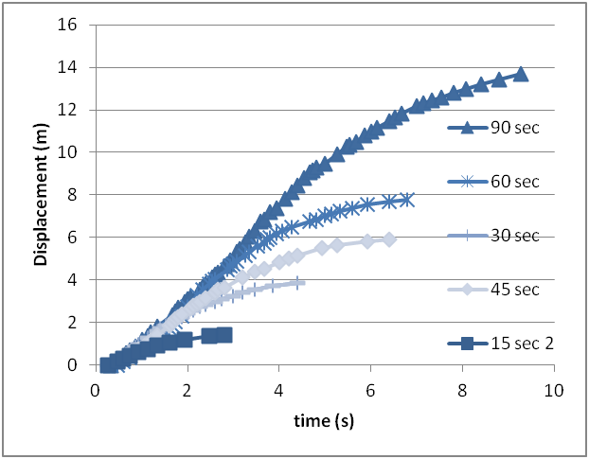
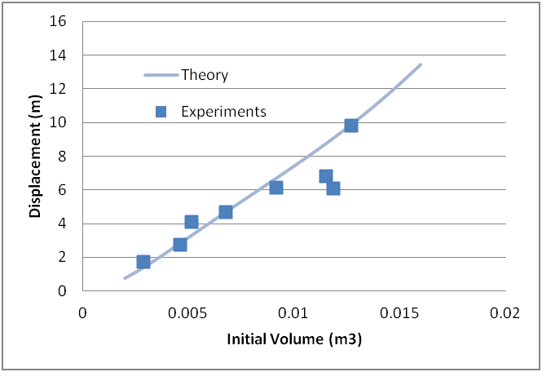
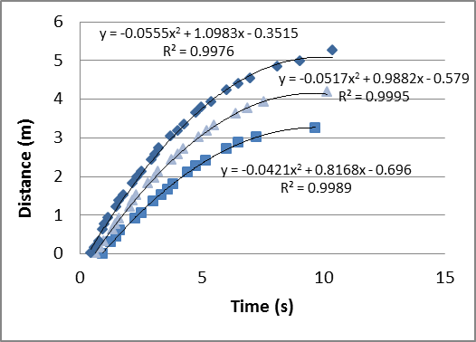
Figure 8: Motion of the Car
$$Time(s)$$
$$Displacement (m)$$
Figure 10: Distance Travelled by the Car, Theory and Experiments
$$Total Displacement (m)$$
$$Initial Volume (m^{3})$$
Figure 9: Friction Measurement
In this case, the energy released by the balloon is equal to the sum of the kinetic energy of the outgoing air. By calculating the mass and velocity of the outgoing air, the following equation would be achieved:

$E_{released}=\frac{1}{2}\left(ρAv∆t\right)v^{2}=\frac{1}{2}ρAv^{3}∆t (2)$

Where $v$ is the relative velocity of the air flow. Using the experimental data, the amount of energy loss resulted by fluid flow was calculated in different initial volumes of the balloon. (Figure 7)

Car Motion Investigation
Until this point, the total energy released by the balloon has been investigated, as well as the discharge of the outgoing flow. Now it must be specified what portion of this energy is transferred to the car as kinetic energy, and the overall car motion must be investigated. According to the momentum conservation for the Car-Air system, the force exerted to the car can be calculated regarding the velocity of the outgoing flow:

$$F=ρAv^{2} (3)$$

Experimentally, we built a car and attached the balloon to its end, the balloon was filled using an air pump with a known discharge and filling time, consequently, the initial volume of the balloon was calculated. The car was set on the floor which its textures made it possible to find the distance travelled by the car. Videos were captured with a camera chasing the car from the top, and the motion diagrams were obtained (Figure 8). Furthermore, the total distance travelled was measured (Figure 10).

To find the friction forces, the car was pushed and released forward with varying velocities and its acceleration was measured (Figure 9).

Since the outgoing velocity and duration of deflation is known as a function of the initial volume (Figure 5 and Figure 6), the motivational force can be calculated using formula 3 and since the resistive force is experimentally measured (Figure 9), the total force applied to the car in each phase of motion (increasing velocity and decreasing velocity) is known and the acceleration can be calculated as F / m, so theoretically the motion of the car can be predicted. The total displacement of the car, predicted by the theory, was compared with the experiments; evincing an acceptable concurrence (Figure 10).

Using the theory discussed above, it could be shown that the amount of the released energy which will be the kinetic energy of the car, obeys this equation:

$$\frac{E_{Car}}{E_{released}}=\frac{ρAvΔt}{m} (4)$$

Where $m$ is the car mass and $∆t$ is the emptying time.

Conclusion
In this investigation we tried to determine the sources of energy loss and describe the behaviour of each cause. We suggested three sources of energy loss: One caused by the plastic deformation of the rubber material, known as the Moulin’s effect, and the energy loss caused by the dynamic fluid as a result of viscosity and turbulence which is known as head loss, and at last a small portion of the remaining energy will be used to move the car, and the rest will be transferred to the air.

Note that the plots and numbers can only be applied to our specific model and materials. As if the balloon changes, the $P-V$diagrams will change since it is a function of the shape and material of the balloon.

By measuring the Pressure and Volume in the inflating and deflating balloon using image processing (Figure 3) and integration, to find the energy needed to fill the balloon and the reproducible energy, the ratio of the energy lost as a result of the Moulin’s effect was calculated (Figure 4). The results suggest that about 50% of the energy needed to fill the balloon will be lost as a result of this effect.

Next the amount of energy lost by head loss was to be estimated. The discharge rate of the balloon was measured using the same image processing technique, and it was used to calculate the kinetic energy released by the balloon. As shown in Figure 5, the discharge decreases as the initial volume increases, and this is because of the decrease of the mean internal pressure of the balloon as in Figure 3. The difference between the total reproducible energy and the kinetic energy produced during the deflation and the energy loss, as a result of head loss was found as in figure 7.

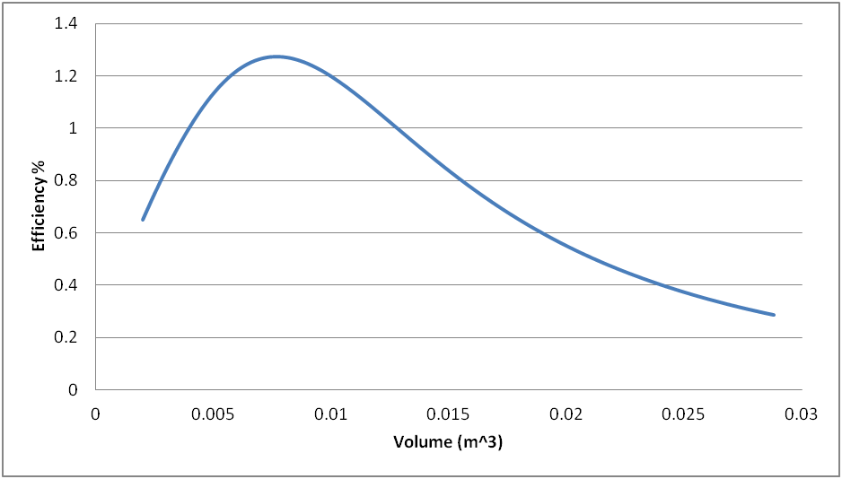
The flow discharge, as a function of initial velocity, as interpolated in figure 6, was then used to compute the motion of the car theoretically. So after estimating the friction force (Figure 9), the total distance travelled by the car as a function of the initial volume of the balloon was measured experimentally and was compared with theoretical predictions (Figure 10).
Figure 11: The Overall Efficiency of the Car

$$Volume (m^{3})$$
$$Efficiency \%$$
In conclusion, the overall efficiency of the car system as a function of the initial volume of the balloon could be calculated. As evinced in figure 11, there is a specific initial volume of the balloon which has the maximum efficiency overall. However, according to Figure 10, there is no maximum for the total distance travelled by the car, unless a maximum possible volume for the balloon exists.
References:
[1] Balloon Car Contest at NASA's Jet Propulsion Laboratory, http://balloonhq.com/balloon_car/balloon_car.html
[2] Treloar L R G 2005 The Physics of Rubber Elasticity, Oxford University Press.
[3] Shames I H 2003 Mechanics of Fluids, McGraw-Hill.

