EFFICIENCY EVALUATIONS OF A BALOON POWERED CAR
Parham Zendedel Nobariª, Reza Montazeri Namin^{b}, Hossein Azizinaghsh^{c}

ªMofid Gheytarie High School, Tehran, I. R. Iran.

^{b}School of Mechanical Engineering, Sharif University of Technology, I. R. Iran.

^{c}School of Computer Engineering, Sharif University of Technology, I. R. Iran.

Abstract
The present paper is an investigation on the efficiency of cars powered by an air-filled toy balloon. The causes of energy loss have been investigated theoretically and several precise experiments have been made to determine the amount of energy loss that occurs for different causes. Experiments were done using image processing techniques, measuring the volume of the balloon and its changes in several cases and leading to energy analysis. It will be shown that about 50% of the energy will be lost as a result of the Moulin’s effect, and a variable amount will be lost as a result of the head loss.

Introduction
The main method we will emphasize in this paper is by attaching the filled balloon to the car pointing backwards and emptying freely in the air. In this case, because of the momentum of the outgoing air jet, a force will be exerted to the car forcing it to move. There are other methods which could use a balloon to move a car as used in the Balloon Car Contest at NASA's Jet Propulsion Laboratory, many of which do not fill the balloon with air but use it as a rubber band instead. Another method is releasing the air slowly in a turbine-like structure and use the energy to rotate the wheels. This way, the efficiency may increase because the head loss decreases when velocity decreases. We neglected studying this approach because of complexity.
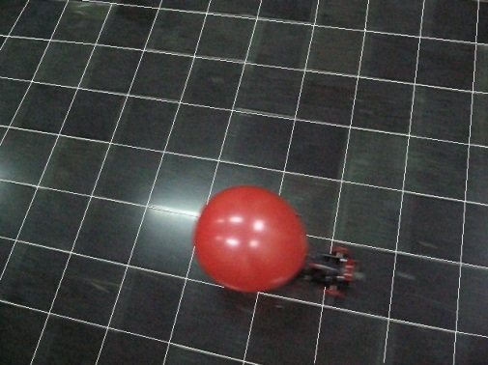
Figure 1: The Model Car
In our case, the balloon is attached to a cylindrical nozzle and deflates through it (Figure 1). There are three forces exerted to the car in this case. A motivational force exists which is exerted to the balloon because of the momentum of the outgoing air flow. The two resistive forces are the aerodynamic drag force and the friction forces to the car. Considering the conservation of momentum, the motivational force could be calculated as a function of the relative velocity of the outgoing jet.

After when the car is stopped, the total work done by all the forces exerted to the car must be zero. So the amount of the work done by the motivational force equals the work by the resistive forces. It is desired to maximize the work by the motivational force, which is related to the energy that will be reproduced by the balloon deflation (released energy).

Considering the motivational force to be much larger than the resistive forces (since it functions in a much shorter time and does the same amount of work) the work done by the motivational force is independent to the resistive forces. The energy released by the balloon air flow will be divided to two main parts; the energy which moves the car and the energy which moves the air. The input energy to the car will be wasted in two main ways (other than the kinetic energy of the air). First, the energy will be lost when the balloon inflates because of the plastic deformation it makes. In the case of rubber material, this phenomenon is known as the Moulin’s Effect. Note that a filled and emptied balloon will be larger than the initial balloon. This means that a part of the energy given to a balloon when inflating will be used to deform the rubber material, which is not given back when it deflates.

The other energy loss occurs when the fluid is in speedy motion during the emptying process. This energy loss is known as Head Loss, and has two main factors: Head Loss caused by the viscous friction forces with the walls of the balloon, and the head loss because of the turbulent motion which arises because of the high velocity. Both the head losses are proportional to the velocity square and the proportions are functions of the system’s size and geometry (in our case, the head loss coefficient changes with time and is not useable as a constant.)

In the following, we will determine the amount of these energy losses.

Several factors were to be experimented physically, mainly to measure the constants in the system and the amount of energy losses in different steps. The physical experiments were also in charge to approve the theoretical assumptions. During the experiments, each balloon was used only once to avoid changes in the results because of the Moulin’s Effect. About 200 balloons were experimented.
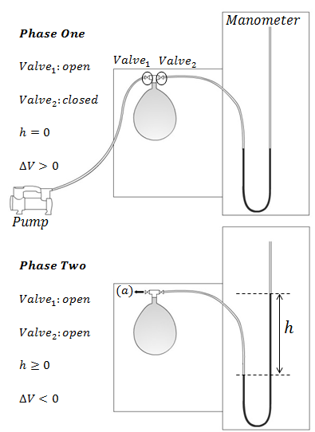
Figure 2: The P-V Experiment Setup Illustration
Initial Energy and Moulin’s Effect
The first set of experiments was designed to measure the amount of energy needed to fill the balloon and the amount of restorable energy. To do so, our method was to find the relation between the internal pressure of the balloon and its volume.

To find the Pressure-Volume relation in emptying and filling stages, the method was to attach the balloon to a system which could fill it with an air pump with a known small flow rate and show the pressure at the same time (Figure 2). A u-shape pipe with inked water in it was used to show the pressure and two valves were attached to make it possible to detach the pump and slowly empty the balloon and visualize the pressure also while getting empty. The process was filmed by a camera far enough to minimize the effect of the perspective view, and both the volume of the balloon and the pressure were calculated in each frame by a program using MATLAB image-processing. The balloon volume was calculated assuming axial symmetry about the z-axis, and the pressure was calculated measuring the difference of water elevation in the two sides of the u-shape pipe automatically. (Figure 3)

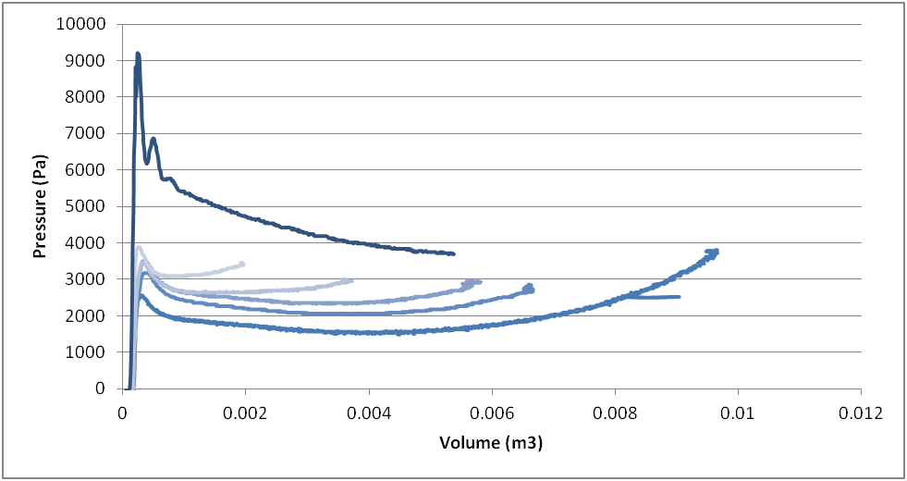
Figure 3: The P-V Diagram for Several Deflation Cases and an Inflation case (the Top Curve) Each Curve is consisted of about 1000 Points outputted from the Image Processing.

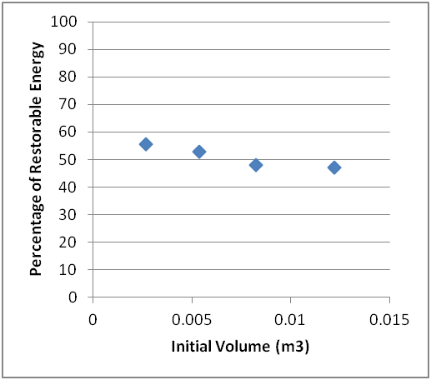
Having the P-V graph for filling and emptying from different initial volumes, the energy was to be calculated. To inject an infinitesimal volume dV of a gas to a container with a pressure of P, the energy needed is PdV. so the energy to fill the balloon is the integration of pressure which is a function of volume:
Figure 4: The Ratio of the Restorable Energy to the Total Given Energy
$$E= \int_{V_{0}}^{V}{P\left(V\right)dV}$$

It is the same for the emptying process. So the energy needed to fill the balloon was calculated by numerical integration. Also the restorable energy was calculated by integrating the relation for the emptying case.
Our results illustrate that about half of the work needed to fill a balloon is not restorable. (Figure 4) This means that this 50% of the energy is used to cause the plastic deformations among the rubber material.

Fast Emptying Process and Dynamic Head Loss
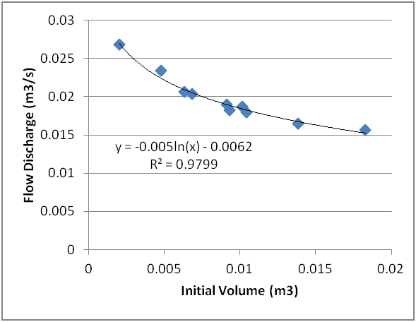
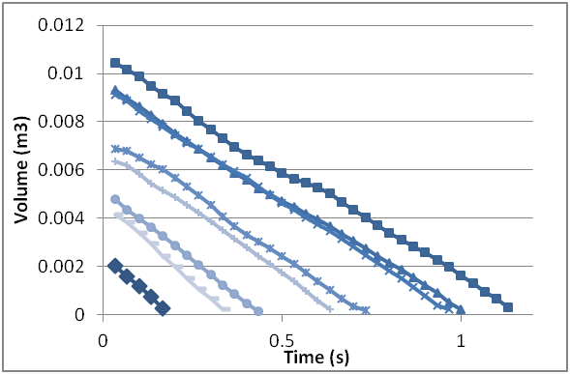
All the energy loss is not because of the Moulin’s effect. Some other energy will be lost because of the dynamic of the outgoing fluid during the fast deflation, e.g. the viscose force between the fluid layers will do some negative work converting the mechanical energy to heat. Flow turbulence also wastes some energy. We must determine the amount of the energy lost during the deflation process, which is of course a function of the initial volume of the balloon, varying the emptying velocity and emptying time. In order to investigate the reproduced energy by the balloon, we attach the balloon to a cylindrical nozzle (similar to ones used in the car) and let the air exit freely. A high speed video was captured from the deflating balloon, and again using the image processing, the volume of the balloon was found as a function of time (Figure 5). This was done for several initial volumes, and the experiment reproducibility was also checked by repeating the experiments.
Figure 5: Some Emptying Diagrams

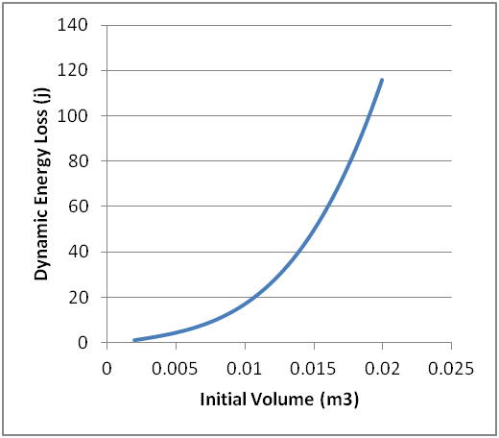
It was observed that the rate of volume change (flow discharge) remains nearly constant during the emptying time. The discharge is plotted against the initial volume, and a decreasing behaviour is observed (Figure 6). This behaviour is acceptable, since the average internal pressure of the balloon also has a decreasing behaviour regarding the initial volume. Note that the discharge was interpolated to be used for countless un-experimented points. Using the discharge, the emptying velocity and time can also be calculated for a known initial volume.
Figure 6: Flow Discharge

In this case, the energy released by the balloon is equal to the sum of the kinetic energy of the outgoing air. Calculating the mass and velocity of the outgoing air, the following formula would be achieved:
Figure 7: Dynamic Energy Loss
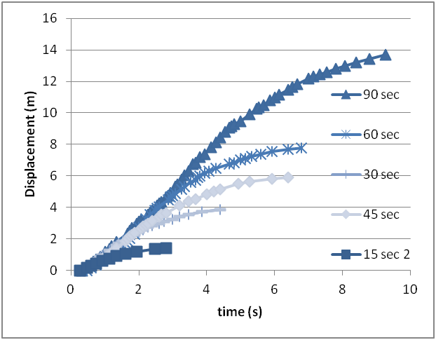
$E_{released}=\frac{1}{2}\left(ρAv\right)v^{2}=\frac{1}{2}ρAv^{3}$
Figure 8: Motion of the Car

Where v is the relative velocity of the jet. Using the experimental data, the amount of energy loss because of fluid flow was calculated in different initial volumes of the balloon. (Figure 7)

Car Motion Investigation
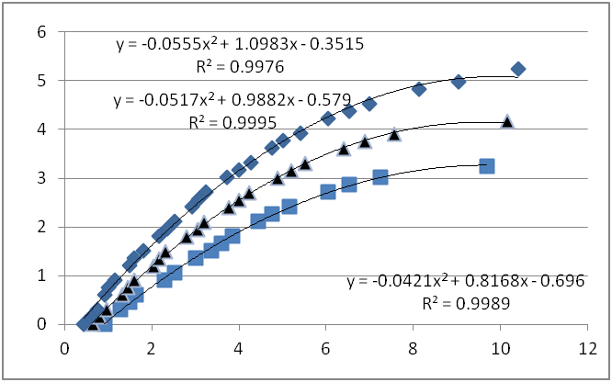
Until this point, the total energy released by the balloon has been investigated, as well as the discharge of the outgoing flow. Now it must be specified what portion of this energy is transferred to the car as its kinetic energy, and the overall car motion must be investigated. According to the momentum conservation for the Car-Air system, the force exerted to the car could be calculated regarding the velocity of the outgoing flow:
Figure 9: Friction Measurement
$$F=ρAv^{2}$$

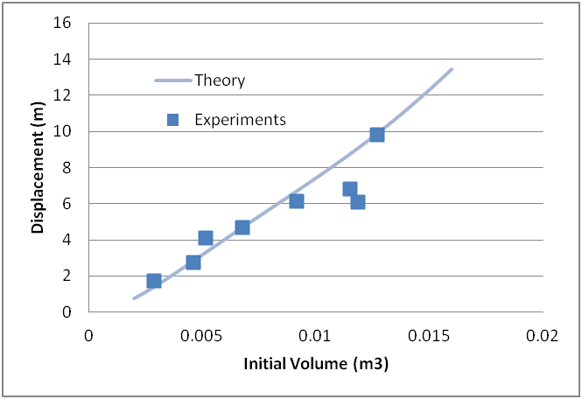
The acceleration can be calculated as F / m, so theoretically the motion of the car can be simulated, since the outgoing velocity and duration is known as a function of the initial volume. This simulation was done numerically using the Euler Method.
Figure 10: Distance Travelled by the Car, Theory and Experiments

Experimentally, we built a car and attached the balloon to its end, the balloon was filled with an air pump and knowing the discharge of the pump and the time of filling, the initial volume of the balloon was known. The car was set on the floor which’s tiles made it possible to find the travelled distance by the car. Films were captured with a camera chasing the car from top, and the motion diagrams were obtained (Figure 8). The total travelled distance was also measured. (Figure 10)

To find the friction forces, a car was released with different velocities and its acceleration was measured (Figure 9). Having the resistive forces and the emptying velocity, the theory was developed and compared with the experiments; showing an acceptable agreement. (Figure 10)

Conclusion
Using the theory discussed above, it could be shown that the amount of the released energy which will be the kinetic energy of the car obeys this formula:
$$\frac{E_{Car}}{E_{released}}=\frac{ρAvΔt}{m}$$

Where m is the car mass and ∆t is the emptying time.

The released energy its self is not all the energy that has been spent to fill the balloon. It was shown that 50% of the energy given to the balloon will be wasted because of the plastic deformation, and more than 40% of the remaining will be wasted because of the fluid head loss while getting empty. This amount was shown to be a function of the initial volume, and was extracted from experimental data. Thus, the overall efficiency of the car system as a function of the initial volume of the balloon could be calculated. As shown in figure 11, there is a specific initial volume of the balloon which has the maximum efficiency overall. However, according to Figure 10, there is no maximum for the total distance travelled by the car, unless a maximum possible volume for the balloon exists.

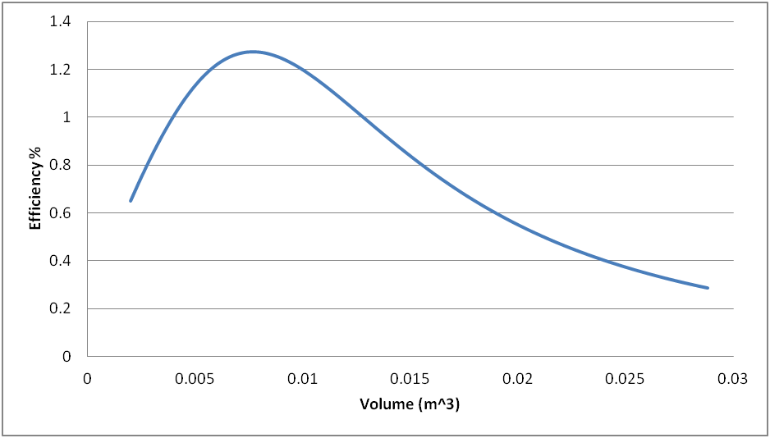
Figure 11: The Overall Efficiency of the Car

