CAR

Nives Bonačić
University of Zagreb, Physics department, Croatia

Introduction

This paper focuses on building a model car powered by an engine using an elastic air-filled toy balloon as the energy source and determining how distance travelled by the car and efficiency depend on relevant parameters and maximizing them.
Balloon observations were done using a piston inflation/deflation model to calculate energy input, output and rubber stretching losses. Car motion was observed and initial condition parameters (volume and pressure), different jet diameters and nozzle angles were taken into consideration.

Piston model

As the balloon deflates pressure, volume and the number of molecules in it change. Therefore, imagine a piston containing all air later used for inflation to which the balloon is attached to. Moving the piston slowly inflates the balloon and releasing it results in spontaneous balloon deflation.
Initial system state is $p_{0}\left(V_{10}+V_{20}\right)=nRT$, $p_{0}$being the atmospheric pressure, $V_{10}$ balloon volume before inflation and $V_{20}$ piston volume.
Ideal gas law equation states that at every moment $p\left(V_{1}+V_{2}\right)=nRT$ where $V_{1}$is the changing balloon volume and $V_{2 }$the piston volume, $R= 8.314\frac{J}{molK}$ is a gass constant.
Final state is $p_{f}V_{1f}=nRT$ where $p_{f}$ is the final balloon pressure and $V_{1f}$ the final volume (figure 1).
Integrating initial to final state of $dW=-\left(p-p_{0}\right)dV$ gives both inflation and deflation work as the same equations are valid. Energy needed for inflation and gained from deflation is:
$$W=\int_{p_{0}}^{p_{f}}{pdV_{1}}+p_{f}V_{f}(\ln{\frac{p_{f}}{p_{0}}-1)+p_{0}V_{10}}$$
where $p_{f}V_{f}(\ln{\frac{p_{f}}{p_{0}}-1)+p_{0}V_{10}}$are the known conditions and $\int_{p_{0}}^{p_{f}}{pd{V }_{1}}$is determined experimentally for both processes separately.
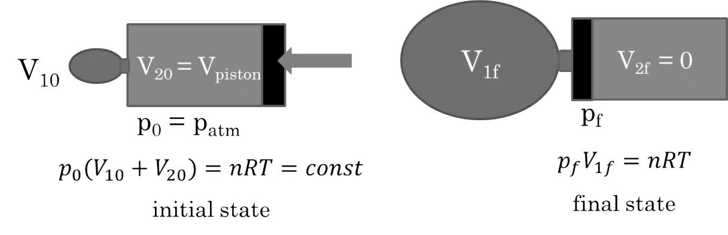

Figure 1: Piston model at initial and final state for inflation, valid also for deflation with inverted markings (left and right) provides a way to evaluate initial input energy and rubber losses.

Balloon inflation/deflation

Pressure was measured using a digital pressure sensor at different volumes. Balloon volume was indirectly calculated by taking photos at known pressures, marking the balloon edge coordinates to find a shape (radius/height) function and numerically integrating this function (using shape rotation). These data give us the overpressure/volume relation shown in figure 2, where the deflation curve is under the inflation curve as expected due to energy losses from rubber deformation.
Progression can be explained by balloon elastic energy $U=4πr_{0}^{2}κRT\left(2λ^{2}+\frac{1}{λ^{4}}-3\right)$ [1], where $λ=\frac{r}{r_{0}}$ is relative strain and $κ$ is a rubber property.

Work needed to increase radius from r to r+dr under pressure difference $∆P$ (being overpressure) is:
$$dW=∆PdV=∆P4πr^{2}dr=\left(\frac{dU}{dr}\right)dr$$
$$∆P=\frac{4κRT}{r_{0}}(\frac{1}{λ}-\frac{1}{λ^{7}})$$

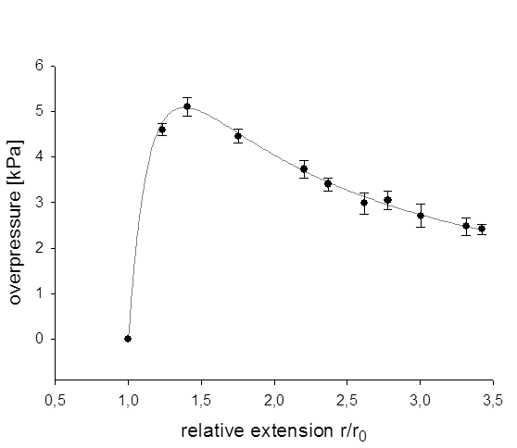
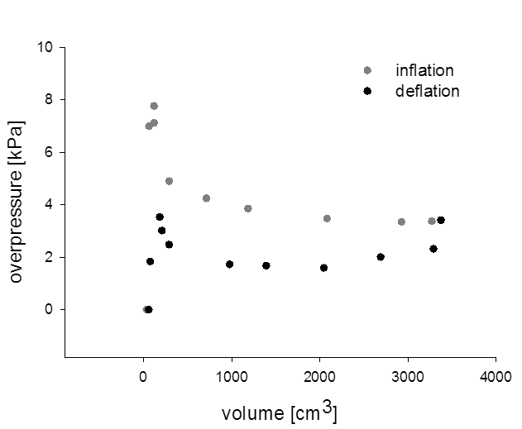
These equations were used to plot a regression, explain and confirm the obtained overpressure/strain curve (figure 2).

Figure 2: Left graph shows gradual inflation and deflation curve comparison, partial energy loss is due to rubber deformations. Right graph is a fit of elastic energy theoretical model to the experimental results which explains the initial maximum and gradual overpressure drop as the volume continues to increase.

Surface under the volume/pressure curve enlarges with greater initial volume and so do the input and output energy. Efficiency of the balloon is the ratio between deflation energy (work that can be later used to power the car) and inflation energy. Both of them are according to the piston model energies of the initial and final conditions plus surfaces under the curves of these processes.
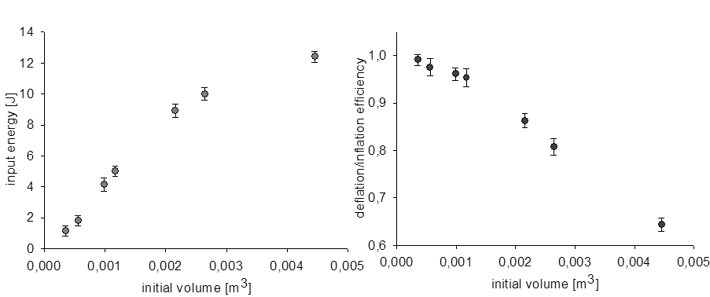
Maximising travelled distance is having the greatest possible energy after deflation (input energy), and maximizing the efficiency of the balloon is a comparison of remaining energy after deflation and total input energy for inflation (figure 3).

Figure 3: Left graph shows the increase of total energy with volume increase and the right graph showing the decrease of efficiency with volume increase (more rubber losses).

Construction and motion observation

Car consists of a plastic cart (length ~ 12 cm), styrofoam base for a plastic tube (d = 2,9 cm) and metal jets / cardboard nozzles, attached at the tube end. Car mass is ~ 120g. This car was placed on metal rails with distance scale to enable us its position determination and keep the movement straight.
A car with filled air-balloon was placed on the rails and a video of its motion was taken with a 120 fps camera. This video was later analysed do find distance/time coordinates and create a graph.
A computer program which analyses these coordinates with a 5 data points frame was created. This program fits a linear or cubic polynomial on the first 5 data points, derives this function and returns the value for the middle point. Frame than moves to the second point taking 2nd to 6th coordinate and repeats the procedure. The result of it is a velocity/time graph on which the initial accelerated motion caused by deflation is easily distinguished from the deceleration part when the car moves due to maximal velocity reached in deflation (figure 4).
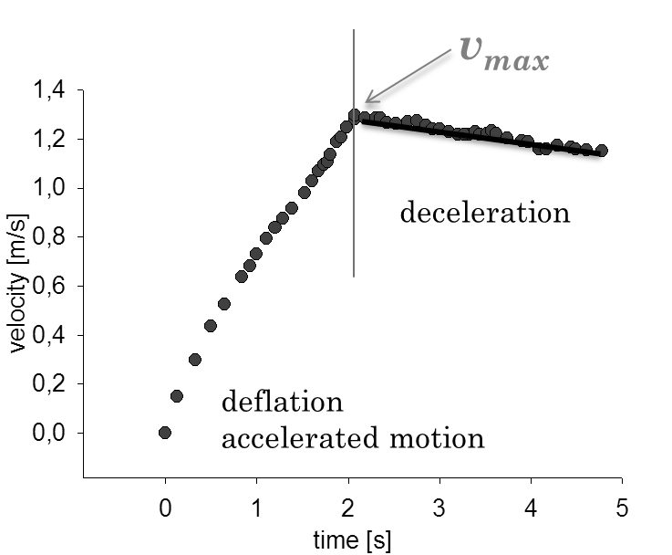

Figure 4: After the video analysis, distance/time coordinates were obtained and derived using a program especially created for this purpose. A velocity/time graph was obtained and shows the velocity increase during deflation and gradual decrease due to friction subsequently.
Travelled distance is observed as $s=s_{0}+s_{1}$, $s_{0}$ being the acceleration path distance in which the maximal velocity v_{max} is reached (determined from the video) and $s_{1}=\frac{v_{max}^{2}}{2a}$ being the deceleration path. The deceleration path was simply calculated with the presented equation in which both v_{max} and a are read from the graph (the latter as the linear coefficient from deceleration).

Basic working principle

Input energy defined previously is used for inflation. It is transformed into kinetic energy of the air molecules during deflation. Losses occur due to resistance to movement (mutual collisions).
Momentum conservation states ${d(m}_{a}v_{a})-F_{fr}dt=m_{c}dv_{c}$, $m_{a}$ and $v_{a}$ being the air mass and velocity respectively, $F_{fr}$ being the total friction force (air resistance, rolling friction) and $m_{c}$ and $v_{c}$ being the car mass and velocity respectively.
Simplified model describes the air behavior taking the mass inside the balloon as $\overline{p}V=\frac{m_{a}}{M}RT→m_{a}=\overline{p}V\frac{M}{RT}$, $\overline{p}$ being the average pressure evaluated from graphs as $\overline{p}=\frac{\int_{p_{0}}^{p_{f}}{pdV_{1}}}{V_{f}-V_{0}}$, $V$ balloon volume, M air relative atomic mass, and the velocity according to Bernoulli's principle (valid for turbulent flows) as $\frac{ρv_{a}^{2}}{2}=\overline{p}→v_{a}=\sqrt{\frac{2\overline{p}}{ρ}}$, $ρ$ being air density.
Momentum conservation equation is then $m_{a}v_{a}-F_{fr}t=m_{c}v_{c}$.
Friction force’s $F_{fr}$ main source is air drag $F_{fr}=\frac{1}{2}CρSv_{c}^{2}\sim V^{\frac{2}{3}}v_{c}^{2}$ and its duration is given from flow rate/volume relation as $t\sim \frac{V}{v_{a}}$.
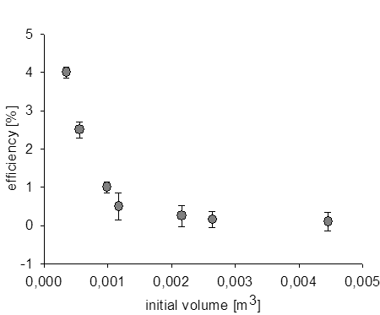
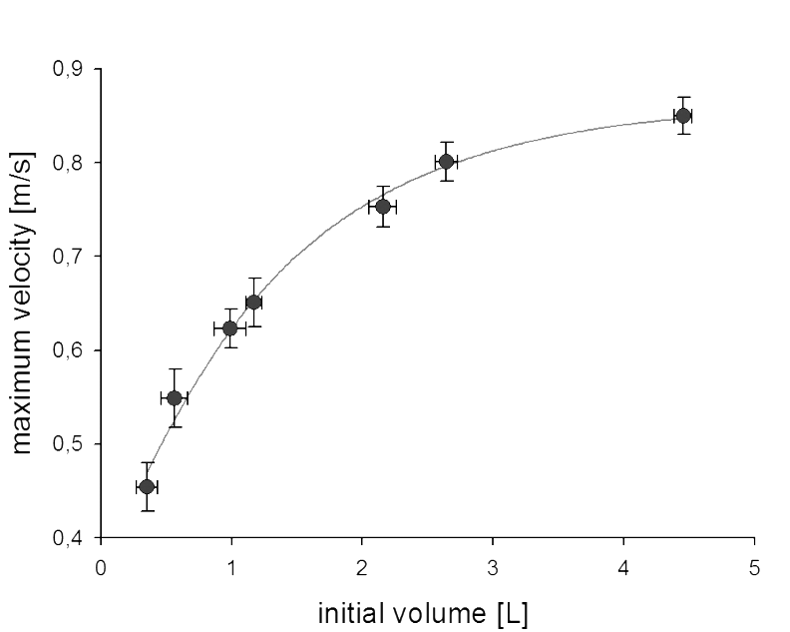
Regression for initial volume/maximal velocity relation is obtained using these equations (figure 5).

Figure 5: Left graph is the representation of the maximum velocity achievable at a certain volume and shows that the travelled distance also increases with an enlargement of initial volume (thus, input energy) as these are connected by $s=s_{0}+\frac{v_{max}^{2}}{2a}$. Right graph is the total efficiency defined with final kinetic energy and input energy ratio: $\frac{{mv}_{max}^{2}}{2}/E_{i}$ in relation to initial volume.
Jets and nozzles

Jets are metal circular tube openings which vary the diameter of the tube end. Jet diameter changes how much is the air directed, time needed for deflation, air drag force duration and the amount of resistance air molecules endure in mutual collisions. Flow inside the tube is turbulent with the estimated Reynolds number at the order of magnitude 10^5. Experiment was conducted for different diameters to find the maximum v_{max} value as both traveled distance and efficiency depend on v_{max}².

Nozzles are cardboard cone shaped extensions attached to the tube end to increase the effective velocity, horizontal component of rapid molecules movement. Different nozzles have different angles, changing how much is the air directed but also different tube length as one cone end has a fixed (tube) diameter and thus the amount of losses due to friction changes. Analogous to the jet diameter – maximal velocity relation, the best cone angle also depends on v_{max} as it was earlier explained.

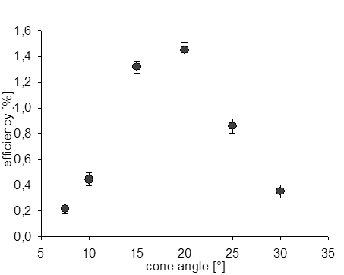
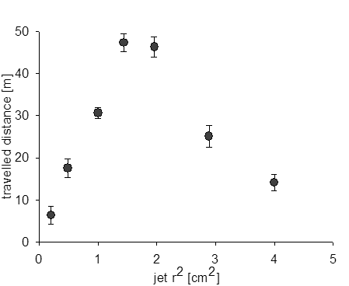
Best jet diameter and nozzle angle were found to be 1.2 cm–1.4 cm and 15°–20° respectively for this tube and conditions (figure 6).

Figure 6: Left graph shows that the travelled distance/jet diameter curve has a maximum which is same for the efficiency as both of these sizes depend primarily on $v_{max}^{2}$. Analogous to it the right graph has a maximal value to, also valid for travelled distance due to $v_{max}$relation.

Conclusion

Balloon was described with a piston inflation/deflation model which was verified by comparing the theory for stretching losses with an experimental curve. The basic working principle was explained and maximum conditions for jets and nozles are found. Longest travelled distance optimised with all parameters (maximal volume before breakage 4.5dm³, best jet and nozzle) is 70 m and the highest efficiency (minimal volume to start 1.5dm³, best jet and nozzle) is 6.4%.

References

[1] Y. Levin, F. L. da Silveira, Two rubber balloons: Phase diagram of air transfer, PHYS. REV. E (2004)

