IYPT 2011 – SOLUTION FOR PROBLEM 5 – CAR
Bárbara Cruvinel Santiagoª
ªTeam of Brazil in IYPT 2011

1. The problem
Build a model car powered by an engine using an elastic air-filled toy-balloon as the energy source. Determine how the distance travelled by the car depends on relevant parameters and maximize the efficiency of the car.
2. Definitions
Car will be adopted as any object which moves over wheels without getting off of the floor or overturning, just using an internal source that, in this case, is the air inside the balloon.
Efficiency^{[1]} is a dimensionless ratio between the energy used in the motion (not dispersed) and the energy that has been given to the system.
$$η=\frac{E_{out}}{E_{in}}=\frac{P_{out}}{P_{in}} (1)$$
In this equation; E_{in} is the internal energy, E_{out} is the useful energy, P_{in} is the internal pressure, P_{out} is the outside pressure.
As it would be difficult to measure this ratio empirically, we are going to use the travelled distance per a determined quantity of air (combustible) as the vehicle autonomy, making an indirect measurement of the efficiency. It could be done because the larger the travelled distance for a determined amount of combustible, the lower the loss of energy.
3. Forces acting over the car
The air is pushed backwards with a force F, pushing the car forwards with a thrust T, forces with the same magnitude and opposite directions.
Since then, we start to have other forces acting on the car. These forces are: a thrust^{[2]} force T, the air drag force and the friction force (fig.1). We also have weight and the normal forces.
In order to maximize the efficiency of the car, we must increase the driving force and decrease the resisting ones.
When the air inside the balloon is finished, the propulsion force ceases to exist. So, the other forces continue to act over the car till its velocity reaches zero (fig.1).
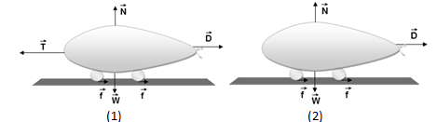
Figure 1: (1) initials forces over the car and (2) forces after the end of the gas propulsion.
4. Gas propulsion force
We must consider that this force is variable because of the variable pressure, mass and volume inside the balloon.
Temperature and molar mass (that depends on the used gas) will influence the pressure, influencing the propulsion force.
5. Drag force (resistance of the air)
The drag force can be calculated by the following formula^{[3]}:
$$D=\frac{1}{2}ρC_{x}AV² (2)$$
In this case, D is the drag force, ρ is the fluid density, C_{x} is the drag coefficient (that depends on the shape), A is the transversal section area and V is the relative velocity between fluid and car.
6. Friction force
But, in our case, we have a car propelled by the air inside the balloon and we don’t have a force producing torque directly over the wheels, just a propulsion force acting all over the car, producing a translational motion (of the body and of the wheels). In this situation the tendency of slipping is in the same direction of the motion, so the friction is contrary to the movement.
7. Rolling between wheel and axis
The friction existent in the rolling between wheel and axis must also be considered. This friction must be decreased in order to improve the rolling.
8. Propeller nozzle shape
Depending on the shape that we have in the car nozzle, we have a determined type of flow. This is going to depend on the shape that the balloon nozzle is disposed: square, rectangular, circular etc. In this problem we will consider two kinds of flow: laminar (characterized by its parallel fluid lines and overlapping layers) and turbulent (characterized by the chaotic state of the fluid), remaking that there is a region of transition between both.
In the case of the balloon car, it will be more efficient whether the fluid is laminar^{[4]}. We have some differences between car’s shapes because of the break of the boundary layer by a gradient of pressure^{[5]}.
9. Elastic properties of the balloon
If the balloon is stiffer, the pressure inside it is higher. So, the propulsion force would be higher too. There is a maximum number of times that one can use the same balloon to get similar results. The most used mechanism to quantify the elasticity of a body is the Hooke’s Law, which can be used just for a strip of the balloon in this case.
$$F=kx (3)$$
In which, F is the elastic force, k is the spring constant, x is the deformation.
11. Experiment 1: aerodynamic test
Solids made of cardboard and Styrofoam with the same transversal section area are put in the end of the wind tunnel (next to the fan). The lower the velocity of the solid that is pushed by the air to get out the tunnel, the lower the drag force, so the better the aerodynamics.
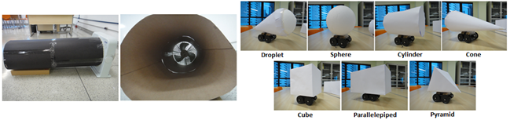
Figure 2: Wind tunnel (left) and used solids (right).
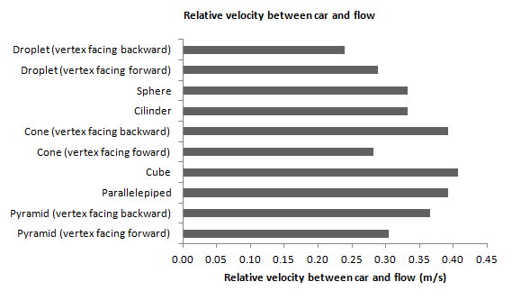
Figure 3: Chart of velocities of different solid's shapes.
As it is possible to notice, the droplet shape has had the best aerodynamic (lower velocity), as predicted by the theory. The lag time due to the chronometer use (≅0.4s) is a possible source of errors.
12. Experiment 2: nozzle test
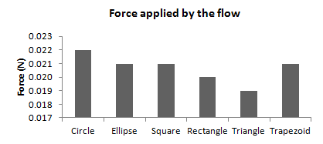
The air exit shape of a hair dryer is varied (with same area) and put from a standard height of 5cm in relation to the scale. The mass registered is converted to force according to the scale calibration.
The circle showed to be slightly better (no regional turbulence), although all the shapes showed similar results. Distance between dryer and scale (precision of the caliper rule: ±0.05mm) and precision of the scale (±0.1g) are possible source of errors.
Figure 4: Chart for forces of diffrent nozzle's shapes.
13. Experiment 3: test of a straw in the propeller
A test track was made to make the distance measurements easier. The same amount of air was used in all the experiments, with an air pump.
Table 1: Distance (measured in m) travelled with and without a straw in the propeller.
 | Without a straw | With a straw
 | 2.49 | 3.38
 | 2.12 | 4.05
 | 2.02 | 3.15
Average | 2.21 | 3.53
Standard deviation | 0.25 | 0.47
The paper straw directed the flow, so the car could travel a larger distance for the same amount of combustible. The flow tends to laminar. The precision of the measuring tape (±0.05cm) is a possible source of errors.
14. Experiment 4: chassis test
Two different chassis (wedge and parallelepiped shape) are tested in the same test track of the last experiment, using the pump to apply the same amount of air.
Table 2: Distance (measured in m) travelled for different chassis' shapes.
 | Parallelepiped | Wedge
 | 2,39 | 0,41
 | 1,89 | 0,35
 | 2,01 | 0,39
Average | 2,10 | 0,38
Standard deviation | 0,26 | 0,03
Even though the wedge shape was more aerodynamic, the chassis in parallelepiped had less rolling friction in its wheels, so it showed to be better. The precision of the measuring tape (±0.05cm) is a source of errors again.
15. Experiment 5: surface test
The test track and the same amount of gas (using an air pump) are used again. Both surfaces are made basically of the same material, but the first has slots and the second do not.
Table 3: Distance (measured in m) travelled over different surfaces.
 | With slots on the floor | Without slots
 | 2,39 | 2,49
 | 1,89 | 2,12
 | 2,01 | 2,02
Average | 2,10 | 2,21
Standard deviation | 0,26 | 0,25
Considering the standard deviation, there is no difference between the surfaces. But it is known, theoretically, that the more uniform the surface is, the larger the travelled by the car. The precision of the measuring tape is, again, a source of errors.
16. Experiment 6: elasticity test
Strips with the same dimensions of both used balloons are tested in order to take its spring constant. Marbles are used to apply the force. Then, the distance travelled for the same amount of gas, in the test track, for both balloons were measured.
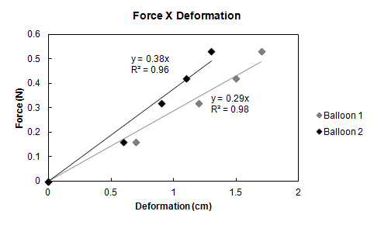
- Balloon 1: k = 0.29N/cm
- Balloon 2: k = 0.38N/cm
The precision of the caliper rule (±0.05mm) is a possible source of errors.
Figure 5: chart of the applied force versus deformation of the balloon strip.

Table 4: Distance (measured in m) travelled with balloons of different elasticities.
 | Balloon 1 (k=0,29N/cm) | Balloon 2 (k=0,38N/cm)
 | 2.49 | 2.06
 | 2.12 | 2.11
 | 2.02 | 1.89
Average | 2.21 | 2.02
Standard deviation | 0.25 | 0.12
The balloon 1 was more aerodynamic and its car travelled a larger distance because of it, even being less stiff. The precision of the measuring tape (±0.05cm) is a possible source of errors again.
17. Conclusion
Basically, the efficiency is improved when the driving force (air propulsion) is increased over the resisting ones (drag and friction forces). For it to happen, the car must be built presenting, essentially, the following characteristics (got empirically): droplet shape, circular nozzle a straw as propeller and wheels that produce less friction. The forces are the most relevant parameters for the distance as well.
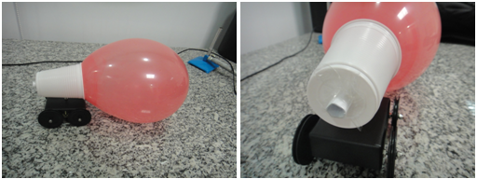
Figure 6: Built car based on tested parameters.
References
[1] http://www.epa.gov/chp/basic/methods.html
[2] http://www.grc.nasa.gov/WWW/K-12/airplane/thrust1.html
[3] http://www.portalsaofrancisco.com.br/alfa/resistencia-do-ar/resistencia-do-ar.php
[4] Prof. Dr. Guanis de Barros Vilela Júnior. Dinâmica dos fluidos
[5] Frank M. White. Fluid Mechanics: 429

