4. Breaking spaghetti

Matej Večerík^{[1]}, Tomáš Kulich^{[2]}, Michal Hledík^{[3]}
[1] School for Exceptionally Gifted Children and Grammar School, Bratislava, Slovakia
[2] Department of Computer Science, Comenius University, Bratislava, Slovakia
[3] Gymnázium Juraja Hronca, Bratislava, Slovakia

Problem:
Find the conditions under which dry spaghetti falling on a hard floor does not break.

Introduction:
So far a lot of research has been done in this area, considering mostly the bending waves and their interference. The accepted solution is that spaghetti is more probable to break in a point where these bending waves constructively interfere because stresses constructively interfere as well. These waves are well described by so-called Kirchhoff's equation. However, solving similar tasks analytically is quite hard and as far as we know, it is possible only for very specific scenarios^{[1]}. In the given problem we encounter several difficulties such as non-trivial boundary conditions and wave reflections.

Therefore, for the given problem, we have written a computer simulation. It basically simulates Kirchhoff's equation by midpoint method^{[2]} on discrete 20 points. Furthermore, for obtaining more precise results, we include term that describes two different kinds of friction.

Theoretical model:
We used numerical model, that is motivated by Kirchoff's equation for our simulation and we introduced new terms into our motion equations due to damping. We therefore assume following forces applied at each element: bending stiffness for a thin rod with nonuniform, non-zero equilibrium bending, bending damping, longitudinal stiffness, normal force from the surface, and friction force from the surface. Since spaghetti can not by considered as a straight thin rod because of irregularities we considered the equilibrium bending of each point of the spaghetti to be non-zero.

Longitudinal spring force:

Where d_{i} is the vector between i-th and i+1-th part of the spaghetti, x₀ is the equilibrium distance between two points and k_{l} is longitudinal spring constant.

Bending spring force:
We assumed that for a large curvature radius the torque restoring the equilibrium bending is proportional to the difference between equilibrium bending and current bending. As sin x = x for small x, we set the force to be proportional to the difference between equilibrium bending and sine of current bending:

Where k_{b} is bending stiffness constant for our spaghetti and b_{i} is the equilibrium bend. This force is created by every triple of subsequent points and their relative bend. From it we can derive the total force exerted on single point:

Bending damping force:

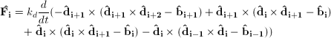
Where k_{d} is bending damping constant for our spaghetti.

Last thing in our numerical model was friction from surface which acts as a horizontal force on points touching the surface and trying to move. This force is proportional to normal force and coefficient of friction. This constitutes a complete numerical model which we simulated.

Parameters for theory:
Longitudinal spring force constant was estimated from Young's modulus of elasticity. Given the equation for simple harmonic motion we wanted to get the same result from our simulation and theory:

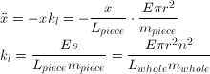

Where E is Young's modulus of elasticity, L is length of spaghetti, m is mass of spaghetti, s is cross section of spaghetti, r is radius of spaghetti and n is number of points in the model (20 in our case).

We have found out that if this parameter is correct in its order, then no higher precision is necessary as changing this constant by a factor of 10 in either direction way has almost no influence on final results.

Bending stiffness was chosen so that after holding the spaghetti horizontally on one end, the ratio of the relative vertical displacement to the spaghetti length was the same. For our spaghetti the relative vertical displacement to length was approximately 0.06.

Bending damping was measured from video using our own video analyzing software. We took a video of a few periods of the spaghetti such that one end was attached to table while the other one was displaced and let to oscilate. Then we chose the damping parameter such that the ratios of amplitudes of periods would be the same in simulation and experiment.
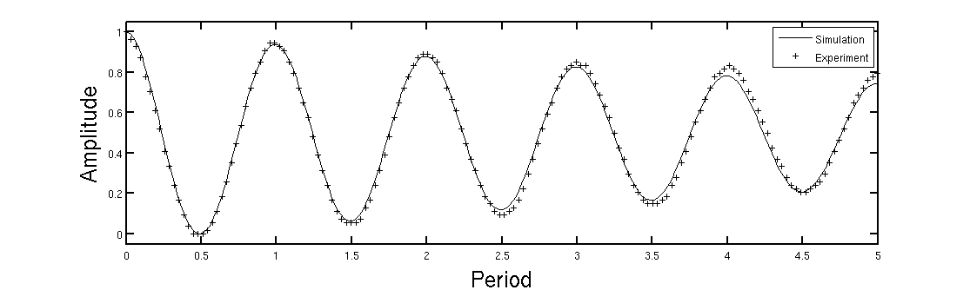
Figure 1: Fitting the bending damping value of spaghetti

Experiment:
To prove that our simulation is correct we decided to predict a dependency of probability of spaghetti breaking on angle under which it hits the floor and calculate from our theory the minimal curvature radius during the bending.
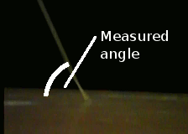
We can not predict probability from computer model as this probability is dependent on inner spaghetti structure which is not known. We also can not measure the minimal curvature radius from experiment as this would require very precise and accurate measurement of spaghetti shape during the whole process which is impossible in our conditions. This is not a big shortcoming though as there proved to be a strong correlation between minimal curvature radius and breaking probability. This proves our simulation to be valid.

In our experiment we let spaghetti fall from the height of 2m at a random angle and we were taking a video of the hitting process. We then determined the angle under which it hit the floor from the video by measuring the vertical length of spaghetti and comparing it to the known length of spaghetti. From this we could get the angle as arccos of this ratio.

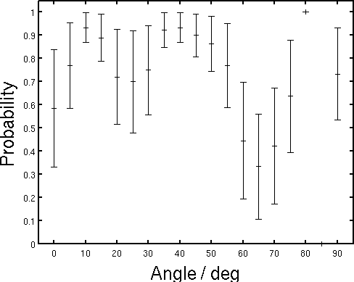
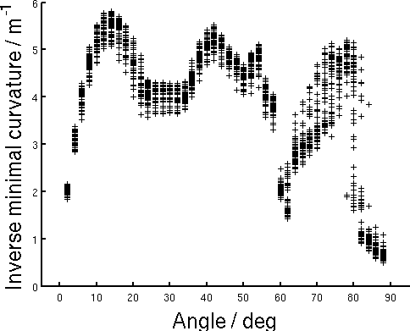
Figure 2: Comparison of simulated inverse minimal curvature(left) which for every simulated angle generated 50 different sets of equilibrium bending of spaghetti and experiment(right) in which we let spaghetti fall and then recorded the angle of hit and whether it broke.

Conclusion:
We can see that the shape of these dependencies is very similar, so our assumption about their strong correlation proved to be true. We can see a disagreement for very high and low angles. For very low angles our theoretical model is that spaghetti hits the floor and lays still. We suspect though that thickness of spaghetti is not negligible in this case for real spaghetti, since the speed is perpendicular to length. On the other hand, for very high angles where we can see that a very small piece of spaghetti (usually about 2-5mm) is ejected with relatively high velocity and angular velocity in the experiment . This can not be explained by our theoretical model as this phenomenon is strongly caused by longitudinal compression which does not appear in our chart.

For better understanding of the phenomenon we introduce the following chart where we again show the dependency of inverse minimal curvature, but this time dependent on both the angle of hitting the floor and the impact velocity:

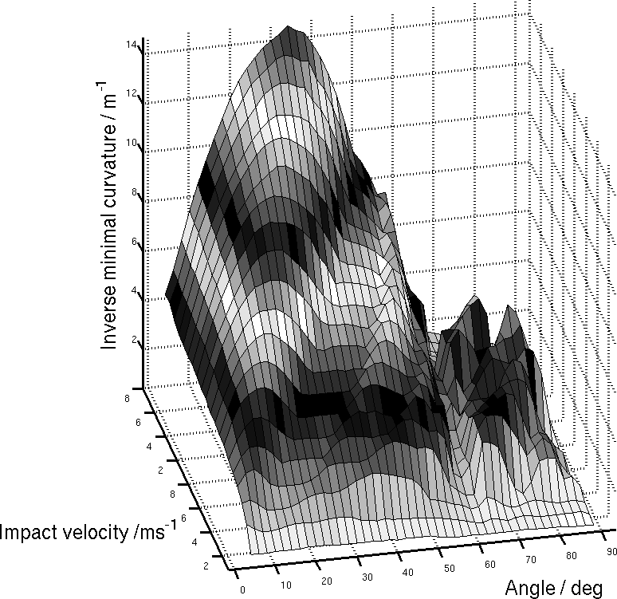
Figure 3: Simulation output for the dependency of inverse minimal curvature on impact velocity and angle of hit. Each value is an average of 5 different sets of equilibrium bending. We can see that for higher velocities we get higher Inverse minimal curvatures – higher probabilities of spaghetti break. There is also a node at approximately 60° which is caused by slipping of spaghetti.

This chart has three interesting regions. One is from 0° to 60° and it represents almost horizontally falling spaghetti. The relative error here are small and can be well described. In these cases spaghetti hits the floor, slips and then there is a bending wave coming across the spaghetti as the spaghetti is sticking to the floor. This bending wave causes maximal bending to appear at the end of spaghetti . We can see a node at approximately 60°, which is the critical angle for slipping in our system. If spaghetti hits the floor at this angle, it slips, but most of its energy is dissipated in this process. Therefore only a small part of its energy is left to cause bending. Processes where the angle of hit is higher than 60° are very chaotic as we can see from the figure. Spaghetti tends to bounce from its ends even several times before resting on ground.

From this we can conclude our solution to this task which is that spaghetti is least likely to break when its hitting angle is close to the critical slipping angle.

References:
1) B. Audoly, S. Neukirch, Phys. Rev. Lett. 2005, 95, 095 505.
2) W. H. Press, S. A. Teukolsky, W. T. Vetterling, and B. P. Flannery, Numerical Recipes (Cambridge University Press, Cambridge, 1992).

