BREAKING OF A FALLING SPAGHETTI
Hamid Ghaednia^{a,} Hossein Azizinaghsh^{b}
ªAmir Kabir University of Technology, School of Civil Engineering, I. R. Iran
^{b}Sharif University of Technology, School of Computer Engineering, I. R. Iran

Abstract:
Simulating the fracture of brittle materials with hard surfaces due to the collision of brittle materials with hard surfaces can be effective in different engineering applications. Investigating the deformation of a brittle rod in collision with a rigid body can be done using various algorithms. In this article we present a new simple algorithm using numerical methods to find the deformation and the fracture criterion of the collision in brittle material. Spaghetti as a brittle material shows a great deformation in respond to collision is used in our experimental setups. The contact of the spaghetti with rigid surface causes stresses to propagate along the spaghetti and hence the spaghetti deforms. Three different kinds of stresses have been considered, shearing stress, pressure (normal stresses) and tension caused by bending. By studying these stresses and considering the effect of them all together, the fracture criterion of brittle materials in collision with rigid surfaces has been investigated.

Introduction
The collision contact time when a brittle material hits a rigid surface is small (near .005 s), therefore the velocity of stress propagation caused by collision cannot be considered as infinite. Thus when the collision starts, there is concentration of stresses in the region near the collision point. However, the other regions of the spaghetti have not been affected by the collision yet because of low velocity of stress propagation.

The collision results into three kinds of stresses: shear stress, pressure and tension in some regions of spaghetti, which is caused by bending. Although, for each of these stresses there is a critical point in certain distances from the contact point, these three stresses should be considered all together in order to find the fracture point.

We divided the spaghetti in several elements using numerical method to find the deformation and stress distribution along the length of the spaghetti during collision then by defining a fracture unit, which finds the effect of all stresses together, the fracture point can be found.

The problem can be broken down into four parts, first the deformation of the first element will be found, second by having this deformation, the forces applied to the next element of the spaghetti can be found, third by having the stress distribution and using the fracture unit, the break point will be found and finally the angle of the crack in the breaking cross section of the spaghetti will be define in order to satisfy theoretical considerations.

Several experiments have been designed in order to find mechanical properties of spaghetti. The conditions, under which the spaghetti breaks, are also investigated experimentally.
Finally, we will discuss the reason and nature of fracture in different angles of contact and evaluate the theory by investigating the angle of crack.

Theory:
Theoretical analysis of the problem is based upon some assumptions:
- Ground is rigid, which means that we have not considered any deformation for surface.
- Spaghetti is a brittle material, which will be proved in further experiments
- The velocity of stress propagation is constant [7]
- Spaghetti is homogenous and uniform

We consider the length of the elements as formula bellow, thus each element will be one step underdeveloped from the last element.
$l_{Element}=v_{propagation}×dt$ (1)
$v_{propagation}=\sqrt{\frac{E}{ρ}}$ (2)
Where E is modulus of elasticity and $ρ$ is the density of material in use.

Deformation of the first element:
Because the surface was assumed as rigid the contact point remains on its first position but the other end of the element will continue to fall (Fig. 1), this will result in deformation of the first element (Formula. 3) [8]. Using this deformation the force applied to the first element can be found (Fig. 2).
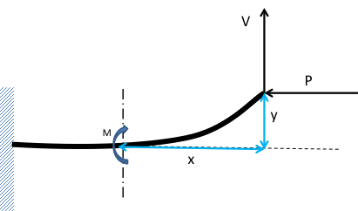
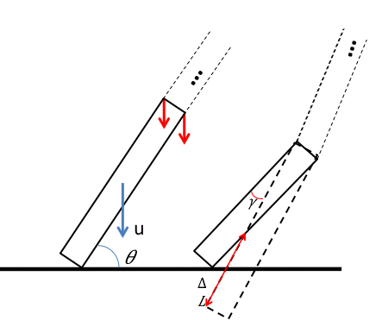
Figure 2: deformation of the first element
Figure 1: deformation of the first element

$M= Px+Vy$ , $\frac{M}{EI}=\frac{y^{''}}{{(1+{y'}^{2})}^{3/2}}$

$y=\frac{LV}{P}\sin{(\frac{P}{EI}x)}+\frac{V}{P}x$ (3)

Stress distribution:
In the first time step, the deformation and thus the forces applied to the first element can be found. Second element has not noticed the collision yet. In the second time step the deformation of the first element is developed again and the second element notices the forces resulted from the deformations of the first time step. By continuing this process until the spaghetti is stopped or broken, stress distribution during collision on the length of the spaghetti can be found.

Fracture unit
A fracture unit has to be defined in order to merge the effect of different stresses together and predict the break point: [8]
$F={(\frac{σ}{σ_{u}})}^{2}+{(\frac{τ}{τ_{u}})}^{2}<1$ (4)
Where $σ_{u}$ is the ultimate normal stress, $τ_{u}$is the ultimate shear stress,$σ$ is the normal stress applied to the cross section and $τ$ is the shear stress applied to the cross section. When the fracture unit is higher than one the section will break.

Crack investigation
Finding the angle of crack helps us to find out whether or not the prediction about amount of shear and normal stresses was correct. Formula 5 presents the angle of crack based on the amount of shear and normal stress in a cross section [8]:
$\tan\left(2θ\right)=\frac{τ}{σ}$ (5)
Experiments
We designed some experiments to find mechanical properties of the spaghetti such as modulus of elasticity, ultimate shear stress and ultimate normal stress, and in the next part the fracture criterion has been found which will be discussed in the following section.

Measuring coefficients:
- Modulus of Elasticity
A force is applied at the end of the spaghetti, while the other end is fixed. Δ was measured while the force was applied (Fig. 3). By using the following equation [8], modulus of elasticity was measured (Fig. 5).

$Δ=\frac{PL^{3}}{3EI}$ (6)
$$E=4.57×{10}^{9}N/{m^{2}}$$
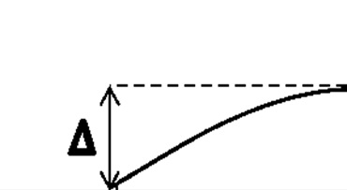
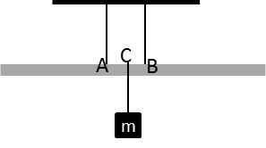
Figure 3: Δ was measured while increasing the force applied to the end of the spaghetti
Figure 4: The force was applied between two fixed points and ultimate shear load was measured

- Maximum tension stress
Force is applied to one spaghettis end while other end is fixed (Fig. 3), by finding the spaghetti failure load for different length, the ultimate tension can be found using bellow equation [8] (Fig. 6).
$p=\frac{σI}{LR}$ (7)
$σ_{u}=2.9±0.1 ×{10}^{8} N/{m^{2}}$
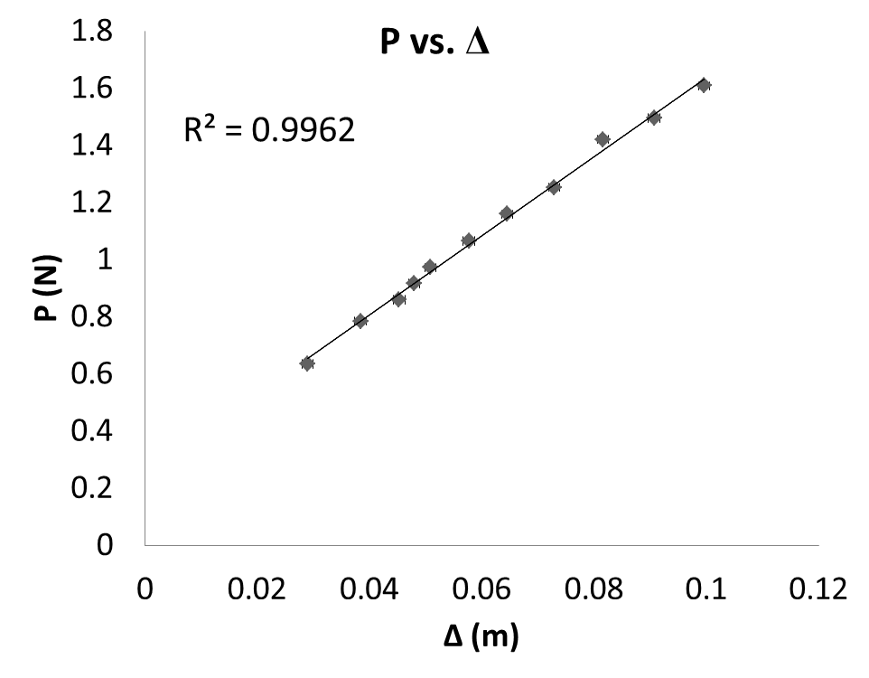
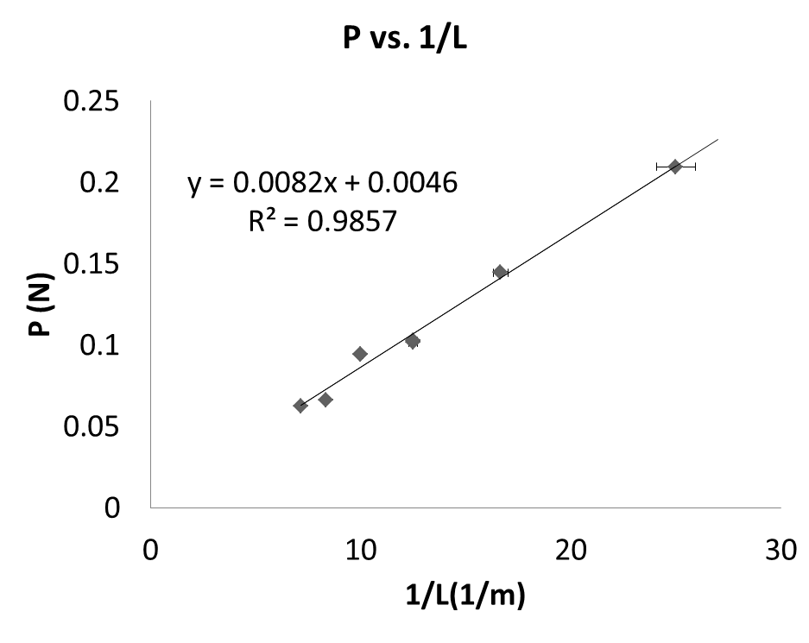
Figure 5: modulus of elasticity
This diagram also proves that spaghetti is a brittle material.
Figure 6: ultimate tension stress
c) Maximum shearing stress
The amount of shear stress under which the spaghetti will break was measured. Spaghetti is fixed at points A and B, the force is applied at point C, between A and B, (Fig. 4) when AB is small enough, bending can be neglected and shear stress will break the spaghetti.

Experiments analysis
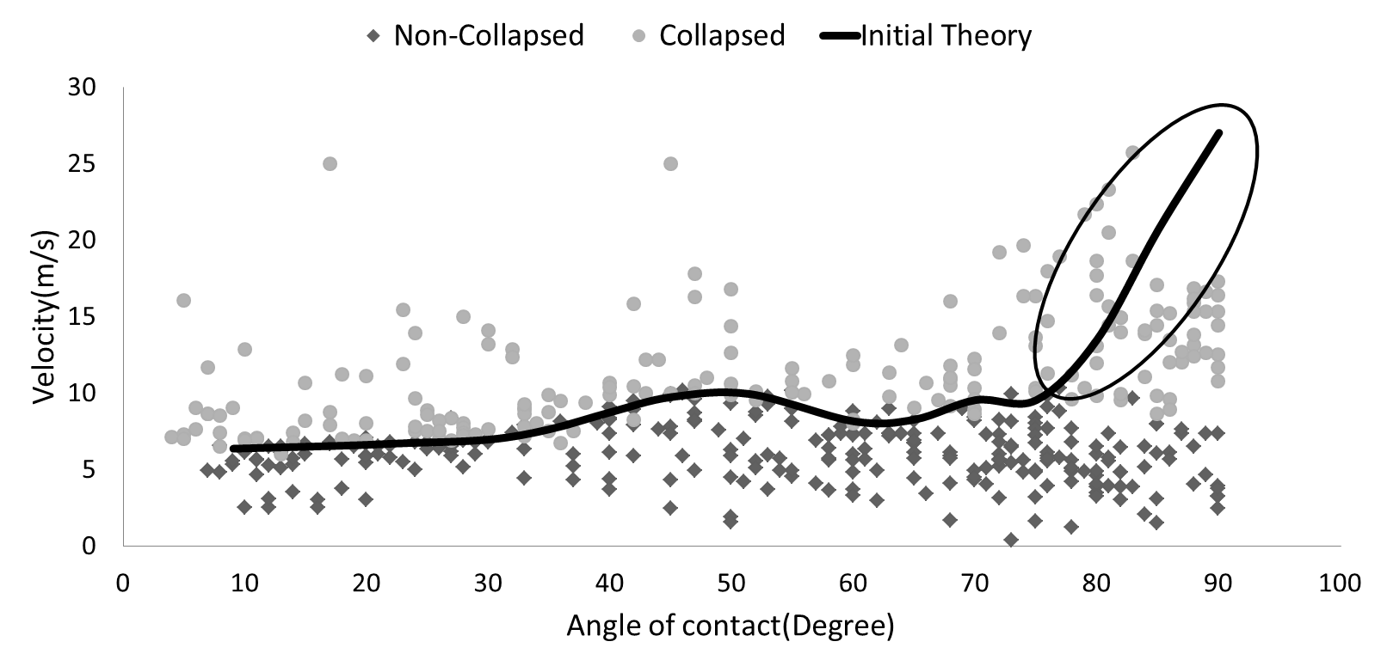
A high speed camera (1000 frame/sec) was used to capture the collision of spaghettis. By processing the videos the velocity of spaghettis at the time of contact and the angle of contact were found. The fracture criterion of collision was predicted based on the measured coefficients. Diagram bellow is consisted of more than 600 points resulted from the experiments and the fracture criterion, which is resulted from the theory (Fig. 7).
Figure 7: fracture criterion (initial theory)

It can be seen in (Fig. 7) that there is no good agreement between theory and experimental results, thus the theory must be revised.
Considering the effect of buckling in angles near 90 degrees, the new result is as Fig. 8.
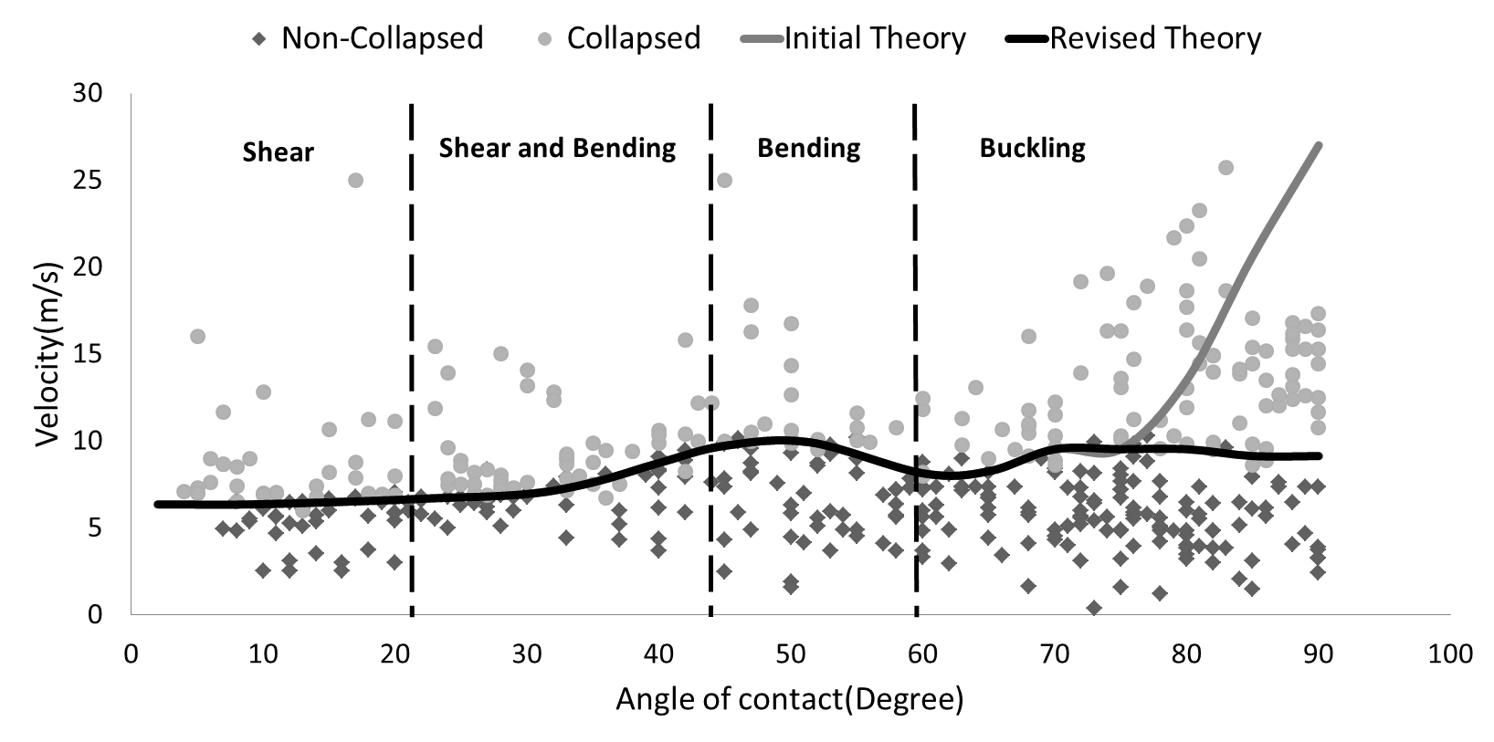
Figure 8: fracture criterion (revised theory)
Shear region:
Based on the theoretical model, in this region ($0<θ<20$ ), shear stress is the only type of effective stress. Thus based on formula 5, the angle of crack must be near 45 degree. This prediction is verified experimentally, for $θ=20$ amount of effect of stresses predicted by the theory are as bellow, and the angle of crack is as shown (Fig. 9)

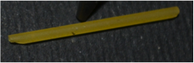
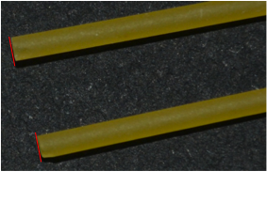
Figure 9: angle of crack when $θ=20$
$${ \left(\frac{τ}{τ_{u}}\right)}^{2}=.92 \\ {(\frac{σ}{σ_{u}})}^{2}= .08$$

Figure 11: the angle of crack when $θ=85$
$${\left(\frac{σ}{σ_{pu}}\right)}^{2}=.99 \\ {\left(\frac{τ}{τ_{u}}\right)}^{2}=.01$$

Figure 10: the angle of crack when $θ=60$
$${\left(\frac{τ}{τ_{u}}\right)}^{2}=.12 \\ { (\frac{σ}{σ_{u}})}^{2}= .88$$

Bending region:
By doing same process done for shear region:
For $θ=60$ amount of effect of stresses are as mentioned above, and the angle of crack is as shown (Fig. 10)

Buckling region:
In buckling region the reason of fracture is normal stress thus based on formula 5 the angle of crack must be near zero, for example:
For $θ=85$amount of stresses effect are as mentioned above and the angle of crack is as shown (Fig. 11).

References
[1] Audoly B and Neukirch S (2004). Fragmentation of rods by cascading cracks:
Why spaghetti does not break in half. Physical Review Letters, 95 (No. 9), 95505
(Dec 22) (http://www.lmm.jussieu.fr/spaghetti/index.html)
[Their website also contains several videos of spaghetti breaking]
[2] Belmonte A (2005). How spaghetti breaks.
http://www.math.psu.edu/belmonte/spaghetti.html
http://www.math.psu.edu/belmonte/PaperFile/PRL_pasta.pdf
[3] D’Andrea C and Gomez E (2006). The broken spaghetti noodle. American
Mathematical Monthly, June-July.
http://www.maa.org/pubs/monthly_jun_jul06_toc.html
[4] Feynman R. See video of Feynman breaking spaghetti at
http://heelspurs.com/feynman.html
[5] Nickalls O.J. and Nickalls R.W.D. (1995).
Linear spaghetti. New Scientist, 145, 18th February, p. 52. [Letter]
http://www.science-frontiers.com/sf099/sf099p15.htm
[6] Nickalls O.J. and Nickalls R.W.D. (1998).
Pasta puzzle: Why does spaghetti break into three pieces?
In: THE LAST WORD, New Scientist, 160, 12th December, p. 101.
[7] K.Sankara Rao 2007,3rd ed, Numerical methods for scientists and engineers, Prentice hall of India
[8] Ferdinand P.Beer, E.Russel Johnson, Jr., Jhn T. DeWolf, 4th ed, Mechanics of materials, ISBN 0-07-298090-7

