BREAKING OF A FALLING SPAGHETTI
Hamid Ghaednia^{a,} Hossein Azizinaghsh^{b}
ªAmir Kabir University of Technology, School of Civil Engineering, I. R. Iran
^{b}Sharif University of Technology, School of Computer Engineering, I. R. Iran

Abstract:
Simulating the fracture of brittle materials with hard surfaces due to the collision of brittle materials with hard surfaces can be effective in different engineering applications. Investigating the deformation of a brittle rod in collision with a rigid body can be done using various algorithms. In this article we present a new simple algorithm using numerical methods to find the deformation and the fracture criteria of the collision in brittle material. Spaghetti; as a brittle material shows a great deformation in respond to collision; is used in our experimental setups. The contact of the spaghetti with rigid surface causes to propagate stress in spaghetti and hence the spaghetti deforms. Three different kinds of stresses have been considered, shearing stress, pressure (normal stresses) and tension caused by bending. By studying these stresses and analysis the effect of them all together, the fracture criteria of brittle materials in collision with rigid surfaces have been investigated.

Introduction
Although Behaviors of brittle rods and their mechanical properties were the subject of many researches [1-6], the behaviors and fracture of brittle material in respond to collision have been rarely investigated.

The collision contact time when a brittle material hits a rigid surface is small (near .005 s), therefore the velocity of stress propagation caused by collision cannot be considered as infinite. Thus when the collision starts, there is concentration of stresses in the region near the collision point. However, the other regions of the spaghetti have not been affected by the collision yet because of low velocity of stress propagation.

The collision results into three kinds of stresses on the spaghetti, shear stress, pressure and tension in some region of spaghetti in its cross section, which is caused by bending. Although, for each of these stresses there is a critical point in certain distances from the contact point, these three stresses should be considered all together in order to find the fracture point

We divided the spaghetti in several elements using numerical method to find the deformation and stress distribution on the length of the spaghetti during collision then by defining a fracture unit, which finds the effect of all stresses together, the fracture point can be found.

The problem can be broken down into four parts, first the deformation of the first element will be found, second by having this deformation, the forces applied to the next element of the spaghetti can be found, third by having the stress distribution and using the fracture unit, the break point will be found and finally the angle of the crack in the breaking cross section of the spaghetti will be define in order to satisfy theoretical considerations.

Several experiments have been designed in order to find mechanical properties of spaghetti. The conditions, under which the spaghetti breaks, are also investigated experimentally.
Finally, we will discuss the reason and nature of fracture in different angles of contact and by comparing the angle of crack resulted by theory and experiments، the nature of fracture in each case has been found.

Theory:
Theoretical analysis of the problem is based upon some assumptions; ground is rigid, which means that we have not considered any deformation for surface; spaghetti is a brittle material, which proved in further experiments; the velocity of stress propagation is constant; the spaghetti is homogenous and uniform; we consider the length of the elements as formula bellow, thus each element will be one step underdeveloped from the last element.
$l_{element}=v_{propagation}×dt$ (1)
$v_{propagation}=\sqrt{\frac{E}{ρ}}$ (2) [7]
Where E is modulus of elasticity and $ρ$ is the density of material in use.

Deformation of the first element:
Because the surface was assumed as rigid the contact point remains on its first position but the other end of the element will continue to fall (Fig.1), this will result in deformation of the first element (formula.3). Using this deformation the force applied to the first element can be found (Fig.2).
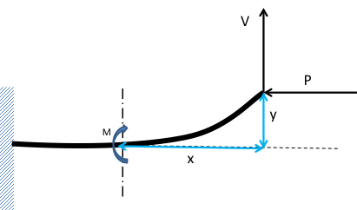
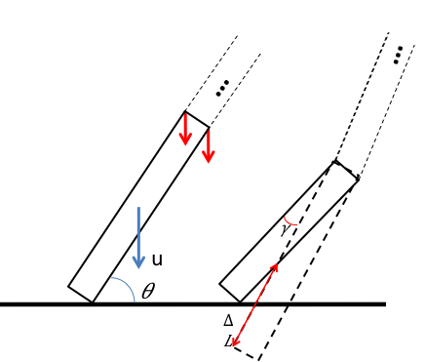
Figure 2: deformation of the first element
Figure 1: deformation of the first element

$M= Px+Vy$ , $\frac{M}{EI}=\frac{y^{''}}{{(1+{y'}^{2})}^{3/2}}$

$y=\frac{LV}{P}\sin{(\frac{P}{EI}x)}+\frac{V}{P}x$ (3) [8]

Stress distribution:
In the first time step, the deformation and thus the forces applied to the first element can be found; second element has not noticed the collision yet, in the second time step the deformation of the first element is developed again and the second element notices the forces resulted from the deformations of the first time step. By continuing this process until the spaghetti is stopped or broken, stress distribution during collision on the length of the spaghetti can be found.

Fracture unit
A fracture unit has to be defined in order to merge the effect of different stresses together and predict the break point:
$F={(\frac{σ}{σ_{u}})}^{2}+{(\frac{τ}{τ_{u}})}^{2}<1$ (4) [8]
Where $σ_{u}$ is the ultimate normal stress, $τ_{u}$is the ultimate shear stress,$σ$ is the normal stress applied to the cross section and $τ$ is the shear stress applied to the cross section. When the fracture unit is higher than one the section will break.

Crack investigation
Finding the angle of crack helps us to find out whether or not the prediction about amount of shear and normal stresses was correct.
$\tan\left(2θ\right)=\frac{τ}{σ}$ (5) [8]
Experiments
We designed some experiments to find mechanical properties of the spaghetti such as modulus of elasticity, ultimate shear stress and ultimate normal stress, and in the next part the fracture criteria has been found which will be discussed in the following section.

Measuring coefficients:
- Modulus of Elasticity
A force is applied at the end of the spaghetti, while the other end is fixed. Δ was measured while the force was applied. By using the following equation, modulus of elasticity was measured (Fig. 3).
$Δ=\frac{PL^{3}}{3EI}$ (6) [8]
$$E=4.57×{10}^{9}N/{m^{2}}$$
- Maximum tension stress
Force is applied to one spaghettis end when other end is fixed, by finding the spaghetti failure load for different length, the ultimate tension can be found using bellow equation (Fig.4).
$p=\frac{σI}{LR}$ (7) [8]
$$σ_{u}=2.9±0.1 ×{10}^{8}$$
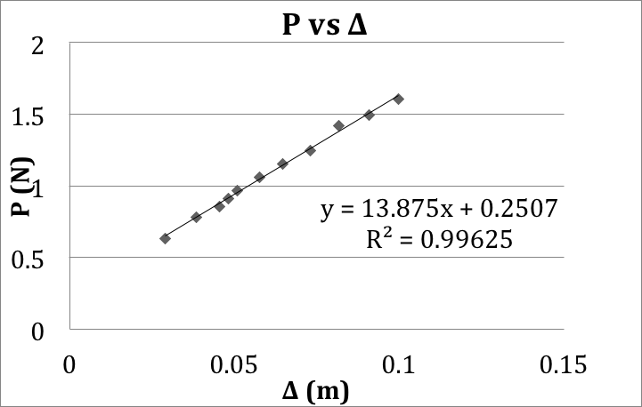
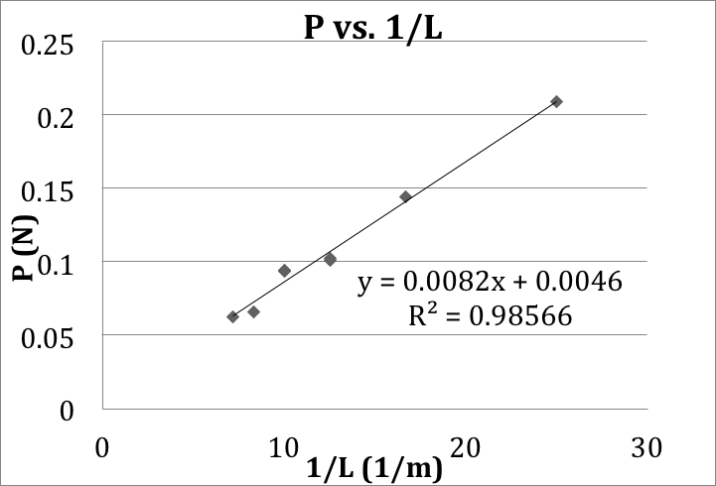
Figure 3: modulus of elasticity
Figure 4: ultimate tension stress

c) Maximum shearing stress
The amount of shear stress under which the spaghetti will break was measured. Spaghetti is fixed on points A and B while the force is applied at point C, when AB is small enough, bending can be neglected and shear stress will break the spaghetti.

Experiments analysis
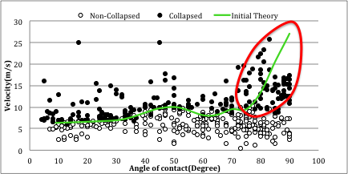
By using a high speed camera (1000 frame/sec) and processing the images the velocity and angle of contact founded for each spaghetti, and also by using the coefficients that founded from first experiments the fracture criteria of the collision was calculated it with theory. Diagram bellow has built up from more than 600 points collected from processing the experiments and the green line that shows the fracture criteria, which is the resulted from the theory (Fig.5).
Figure 5: fracture criteria (initial theory)
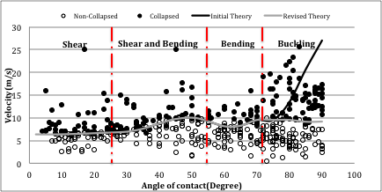
It can be seen in (Fig.5) there is no good agreement between theory and experimental results, thus the theory must be revised.
Figure 6: fracture criteria (revised theory)
By adding the effect of buckling. The new result for theory is as (Fig.6):

Shear region:
By calculating the angle of crack theoretically, when the effect of shearing stress is more than bending the angle of crack must be near 45 degree. Results of our numerical method shows that in $0<θ<30$ the shearing stress is much more effective, for example:
For $θ=20$ amount of effect of stresses are as bellow, and the angle of crack is as shown (Fig.7)
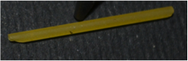
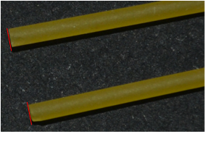
Figure 7: angle of crack when $θ=20$
Figure 8: the angle of crack when $θ=60$
Figure 9: the angle of crack when $θ=85$
$${\left(\frac{τ}{τ_{u}}\right)}^{2}=.12 \\ { (\frac{σ}{σ_{u}})}^{2}= .88$$

$${\left(\frac{σ}{σ_{pu}}\right)}^{2}=.99 \\ {\left(\frac{τ}{τ_{u}}\right)}^{2}=.01$$

$${ \left(\frac{τ}{τ_{u}}\right)}^{2}=.92 \\ {(\frac{σ}{σ_{u}})}^{2}= .08$$

Bending region:
By doing same process done for shear region:
For $θ=60$ amount of effect of stresses are as mentioned above, and the angle of crack is as shown (Fig.8)

Buckling region:
In buckling region reason of fracture is normal stress thus the angle of crack must be near zero, for example:
For $θ=85$amount of stresses effect are as mentioned above and the angle of crack is as shown (Fig.9).

References
[1] Audoly B and Neukirch S (2004). Fragmentation of rods by cascading cracks:
Why spaghetti does not break in half. Physical Review Letters; 95 (No. 9), 95505
(Dec 22) (http://www.lmm.jussieu.fr/spaghetti/index.html)
[Their website also contains several videos of spaghetti breaking]
[2] Belmonte A (2005). How spaghetti breaks.
http://www.math.psu.edu/belmonte/spaghetti.html
http://www.math.psu.edu/belmonte/PaperFile/PRL_pasta.pdf
[3] D’Andrea C and Gomez E (2006). The broken spaghetti noodle. American
Mathematical Monthly; June-July.
http://www.maa.org/pubs/monthly_jun_jul06_toc.html
[4] Feynman R. See video of Feynman breaking spaghetti at
http://heelspurs.com/feynman.html
[5] Nickalls O.J. and Nickalls R.W.D. (1995).
Linear spaghetti. New Scientist; 145, 18th February, p. 52. [Letter]
http://www.science-frontiers.com/sf099/sf099p15.htm
[6] Nickalls O.J. and Nickalls R.W.D. (1998).
Pasta puzzle: Why does spaghetti break into three pieces?
In: THE LAST WORD; New Scientist; 160, 12th December, p. 101.
[7] K.Sankara Rao 2007,3rd ed, Numerical methods for scientists and engineers, Delhi-110006
[8] Ferdinand P.Beer, E.Russel Johnson, Jr., Jhn T. DeWolf, 4th ed, Mechanics of materials, ISBN 0-07-298090-7

