BREAKING SPAGHETTI

Stanislav Krasulin
BSU Lyceum, Belarus
Awful disaster! Terrible crash! A pack of spaghettis hits the hard floor 5 seconds after the take-off! No survivors! Emergency services state, that new safety instructions could have saved hundreds!
Is this breaking news? Nope, it’s “Breaking spaghetti”! And we are going to help emergency services, because our task is to “find the conditions under which dry spaghetti falling on a hard floor does not break”.
First thing I had wanted to do, was to approximate spaghetti with a ball; but for some reasons my teammates were against. That is why we have to consider three different variants for spaghetti to hit the floor (instead of just one for a ball!): spaghetti can fall prone, it can jump in the tin-soldier position, also it can hit the floor at some angle between 0° and 90°.
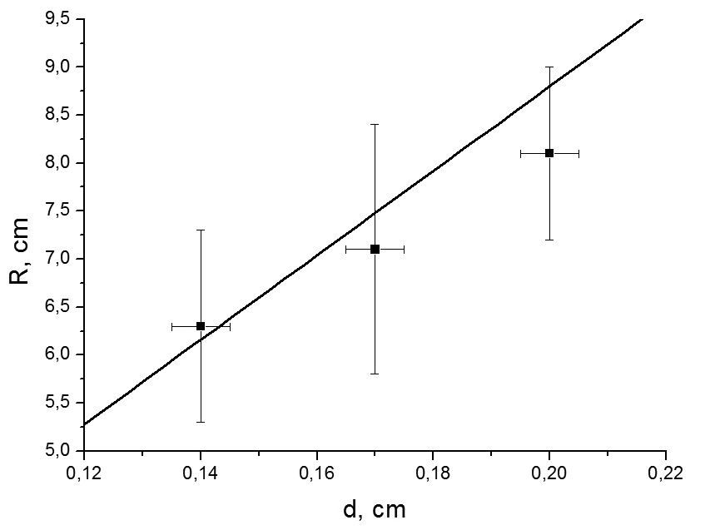
Let’s start with military service, and describe falling in the tin-soldier position. It, certainly, requires at least some information about the matter of the study – spaghetti itself. The best way to collect information about something is to destroy it, collect data about destruction, then collect broken parts. We have managed to get access to a machine for which those actions (with exception for collecting broken parts – we had to clean the mess on ourselves) are main purpose: a tearing apart mechanism for testing building materials. Since it’s a too long description we’ve called it simply – Claws. It is stretching spaghetti (or anything else, if it fits mounting) until it breaks, plotting applied force and relative deformation, calculating Young’s modulus. So, Claws told us: Young’s modulus is E=0.59±0.02 GPa; critical stress σ_{crit}=31.0±0.5 MPa; critical relative stretch ε_{crit}=5.25±0.05 %.
However, it is hard to believe that whole spaghetti during strike is stretched or compressed so much; it is more likely to break because of curving. Certainly, it’s also a combination of these deformations – some layers of spaghetti are stretched, some are compressed. And some are not deformed at all. Let’s assume that the very central part of spaghetti isn’t stretched whenever spaghetti is curved and has length L₀. Then, if radius of curvature is R and diameter of spaghetti is d, we can easily calculate relative stretch of it’s outer layer L₁:
Figure 1. Critical radius of curvature vs. diameter of spaghetti: points are experimental, line is theoretical.
If we want spaghetti not to break, this value should be smaller than ε_{crit}; thereby, maximal radius of curvature:
Certainly, we’d like to check this dependence. However, values ε_{crit} and d are difficult to change. We’ve only managed to find three types of spaghettis, which had different diameters, but were produced by the same manufacturer and under same recipe. So, behold fig.1, plot with just three experimental points! Why is it always happening to me? In previous year’s “Ice” I also had wires only of three different diameters; in fact it was even worse: I had to prove squared relationship…
The good news is that within accuracy of our measurements even this very simple mathematical model gives correct results. It means, that there’s no need in it’s improvement: anyway we can’t detect that it has come closer to the real value. And since we don’t have to work on it, let’s find some parameters, which we can vary…
For example, something in my head (maybe it’s brain, but teammates say I don’t have one) tells me, that breaking of spaghetti strongly depends on the velocity it has right before the strike. However, velocity isn’t very graphic value; everything will be easier to understand if use height of fall instead. Also, it is less difficult to measure and it can be easily recalculated into velocity. But that’s unless you take into account air drag:
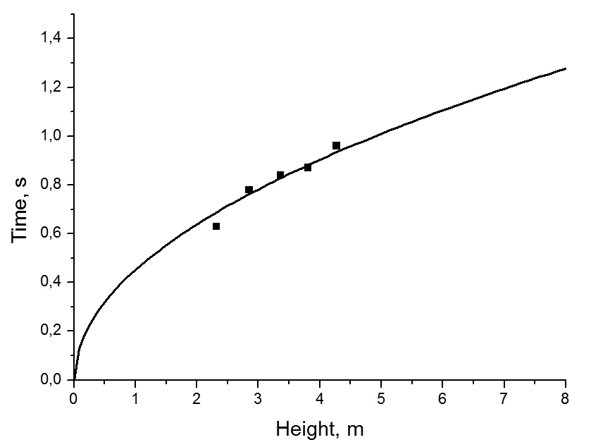
where S is reference area (for long cylinder it is it’s basement area), v is velocity, ρ is air density, C_{d} is drag coefficient (for long cylinder it is 0,82). Fortunately, it turned out that in our range of heights drag influence is negligibly small (see fig.2). However, we have taken some use from the drag force equation: it helped us to calculate the maximal velocity of the spaghetti, falling in the Earth’s atmosphere. This velocity is about 60 m/s; since most kitchens are situated on Earth, we can limit our work by this speed.
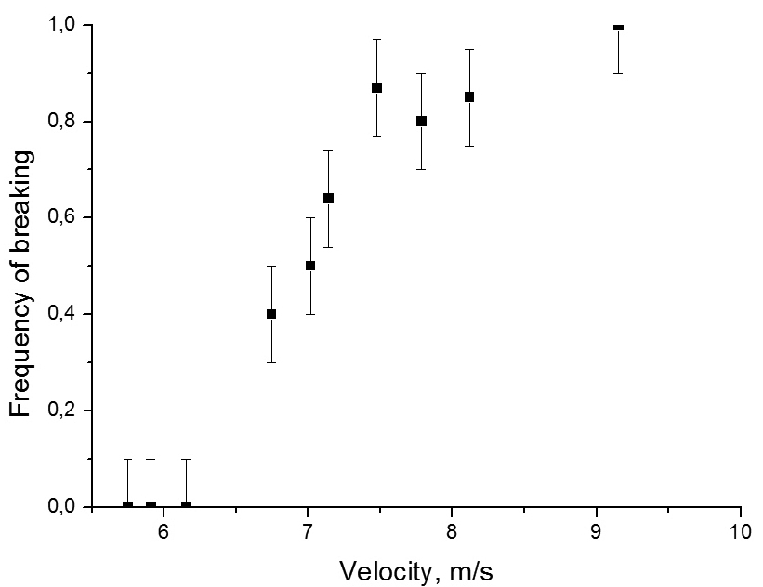
Now, it is finally possible to run an experiment, and find out at which exactly speed spaghetti should hit the floor in order to break. Oh no, not this, please… When I had just seen this task I thought: finally, an IYPT task which wants us not to “investigate” or “find relevant parameters”, but to answer a simple question. Imagine my disappointment, when I had realized that it is just impossible to answer this question precisely. Because of big amount of different slits and random fluctuations in spaghettis, and just because it’s a study of the strength of the material, the whole effect is completely stochastic; it is impossible to say that in this situation spaghetti will break, and in this it will not; we can say only about frequency of breaking under certain conditions.
Figure 2. Time of falling depending on height. Line is theory, without taking drag into account; dots are experimental.
So, on the fig.3 you can see dependence of frequency of breaking on the velocity of spaghetti. It shows, that there are velocities, for which this frequency is zero; but as velocity gets higher, frequency increases too. It is easy to explain: spaghetti breaks, if it reaches critical curvature; but this bending requires energy. So, the higher is the kinetic energy of spaghetti, the higher is possibility, that critical curvature will be reached.
Figure 3. Frequency of breaking vs. velocity.
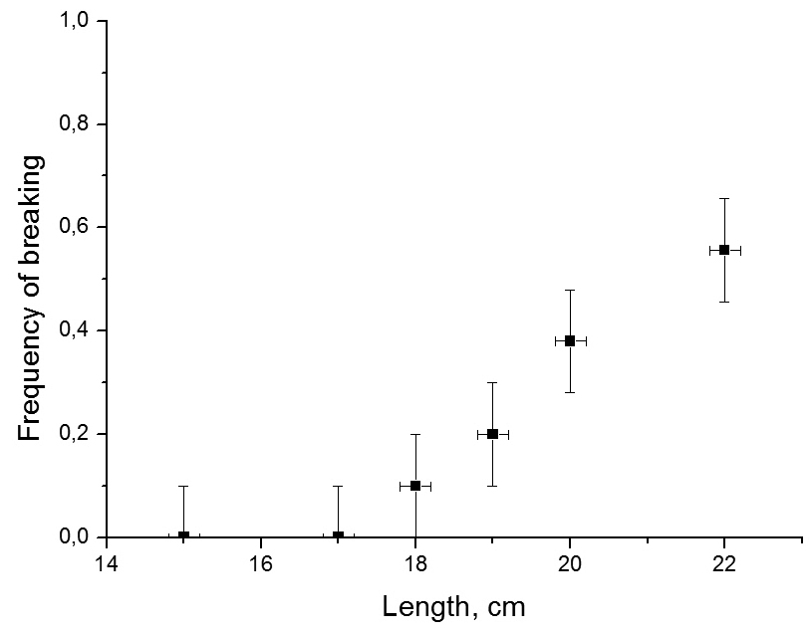
But changing velocity isn’t the only way of changing kinetic energy; mass of spaghetti also can be varied; for example, through cutting it’s head off. Or legs. Well, let’s just call it “varying it’s length”. However, changing mass will cause changing of gravity force; and before starting experiments we should prove that it won’t affect forces, which are acting during impact. When spaghetti hits the floor it usually jumps upwards, or, at least, stops. It means that it’s momentum changes at least by m*v, where m is spaghetti’s mass. Through filming strike on a high-speed camera, it was found out, that it lasts for about t=0.001 of a second. Therefore, average force acting on the spaghetti during strike is:
Figure 4. Frequency of breaking depending on spaghettis’ length for velocity 8 m/s.
At the same time gravity force acting on this spaghetti is about 4.5*10⁻⁴ N – thousand times smaller. So, varying mass can’t make any difference in forces.
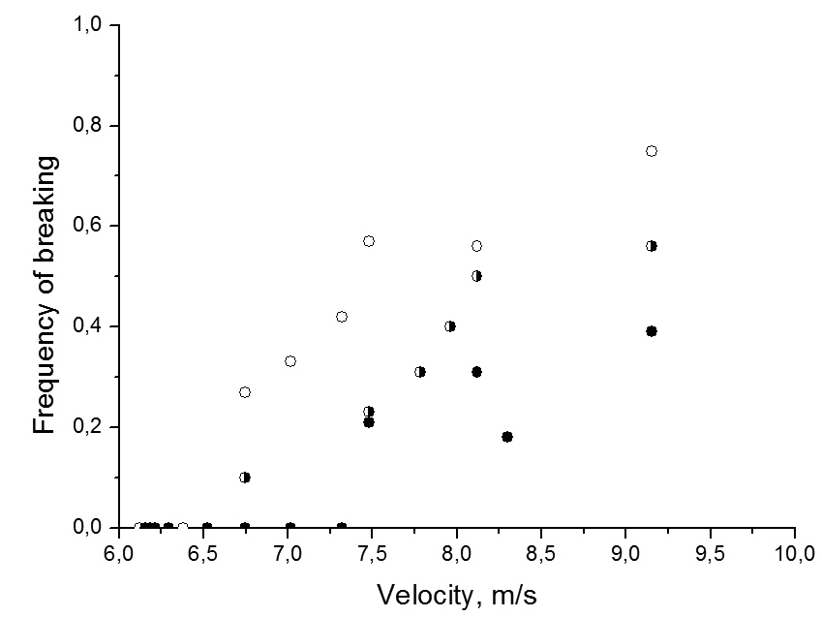
Fig.4 shows that increase in length (and, respectively, mass) causes increase in frequency of breaking – again, additional kinetic energy gives higher possibility of reaching critical radius of curvature. However, cutting heads off isn’t the only way of varying mass (though it’s funniest). Changing of diameter also will cause changing of kinetic energy. As you may remember, we’ve got only three different diameters; and even though I’m sure you did extremely like the three-points-plot, I won’t show you another one. You don’t deserve it. All you can have is fig.5 – dependence of frequency of breaking on velocity for spaghettis of three different diameters. But even here a lot of interesting things can be found; main of them is the fact, that here additional kinetic energy does not increase frequency: because of bigger diameter, it requires more energy to deform spaghetti to it’s critical curvature (even though the critical curvature itself decreases). The plot shows that this increase in required energy overcomes gain in kinetic energy.
Figure 5. Empty circles are for d=1.4 mm, half-full – d=1.7 mm, full – d=2 mm.
But do you remember what I’ve said were main actions to collect data about something? In case you don’t, I remind you that the last one was “collect broken parts”. Originally, this operation was required only because broken spaghettis on the floor for some reason does not count as humanitarian aid to starving mice; however, after experiment with different diameters, I had accidentally measured lengths of broken parts. To my big surprise, for all three diameters it was the same (fig.6). So I had taken out my raincoat, torch and shovel and waited for a dark stormy night to go to the cemetery, where spaghettis from previous experiments were buried. After having measurements done and gold teeth and rings removed, I had plotted fig.7. Again, length of broken part doesn’t depend on anything. Certainly, we have to explain this fact. Also we have to explain to police what we were doing at the cemetery at night…
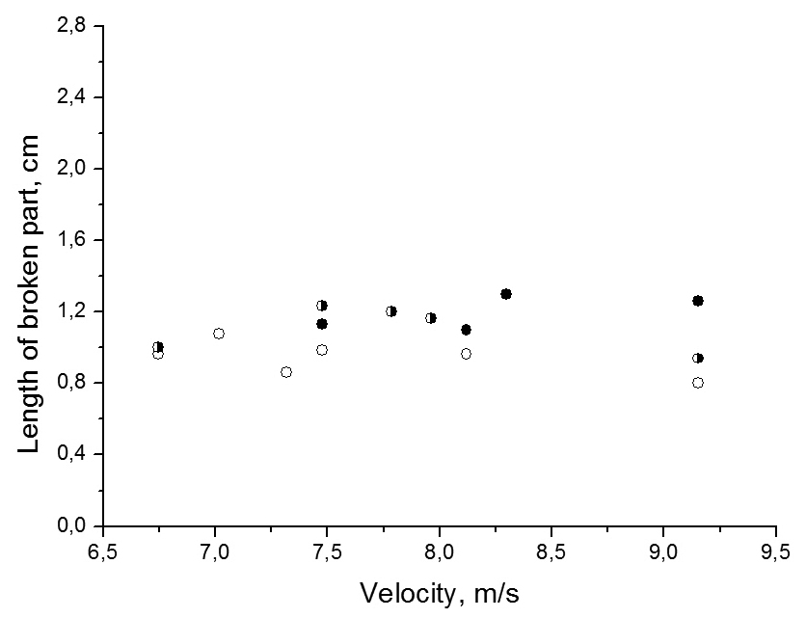
The first explanation we came up with was that all spaghettis’ had broken their necks, and neck is one centimeter away from spaghetti’s end. Well, if stop speaking allegorical, we decided that probably something in the way spaghetti are produced causes this point to be the weakest; however, when we had cut both ends of spaghetti off and then dropped it, once again length of broken part was 1 cm, proving that something in the process of breaking defines the point, not in the spaghetti initial structure. But what processes have certain points with increased value of parameters? Standing waves.
Figure 6. Length of broken part vs. velocity for three diameters. Circles show all the same.
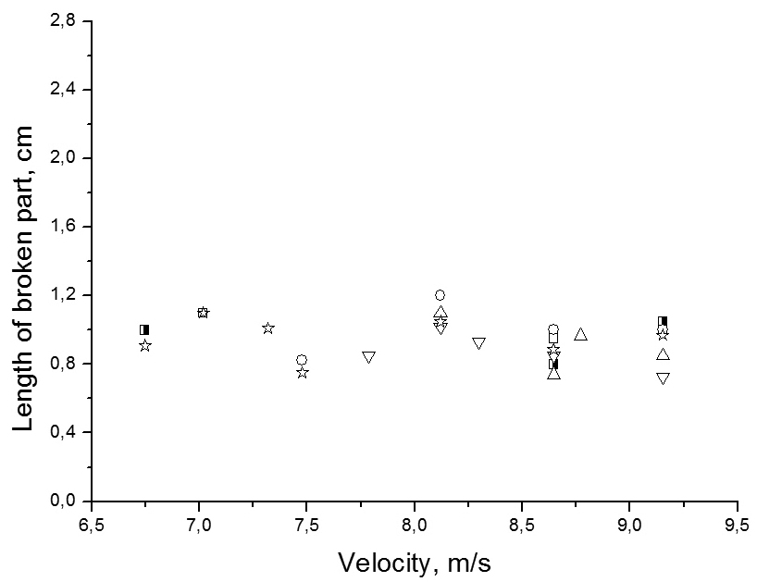
When spaghetti hits the floor a bending wave occurs. And if the wave reaches opposite end of spaghetti it is being reflected and summed with itself, producing standing bending wave. Now, spaghetti should break in the point of first antinode (since second one will be smaller due to losses). And we know, that hitting end of spaghetti is the place of first node. So, distance between the end of spaghetti and breaking point should be a quarter of wavelength; therefore, wavelength λ=4*x, where x is this magical one centimeter. At the same time, spreading rate of the wave can be estimated as spreading rate of the sound wave, travelling in spaghetti:
Figure 7. Length of broken part depending on velocity for different original length: empty square – 15 cm, half-full square – 17 cm, upwards triangle – 18 cm, circle – 19 cm, downwards triangle – 20 cm, star – 22 cm.
where ρ is spaghetti’s density. If spreading with this velocity, during time of impact wave can travel for about 87 centimeters, that’s enough to reach the opposite end of spaghetti and travel back, producing standing wave. Thereby, frequency of the bending wave is:
For further research, we had had an idea of vibrating spaghetti with this frequency, and finding amplitude after which spaghetti will break. Unfortunately, the best source of signals we could find had maximum frequency of 20 kHz (bad luck), so we had to stop our investigation about waves at this point.
Since there still was plenty of time left, we decided to use it for researching couple of another interesting dependences we faced during our work. First was the fact that frequency of breaking depends on spaghettis’ price: cheaper spaghettis are easier to break (fig.8). It can be explained by differences in the chemical structure: expensive spaghettis have eggs. As their ingredient. And in this situation eggs work as some kind of glue, increasing spaghettis’ critical relative stretch, therefore increasing energy, required for breaking.
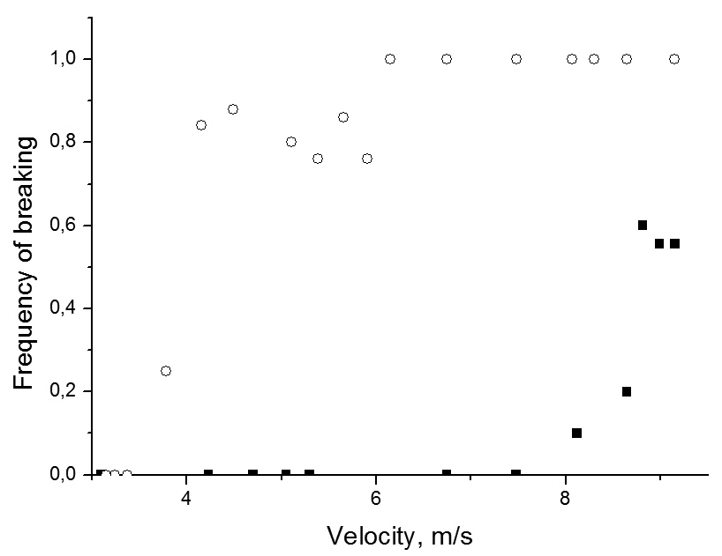
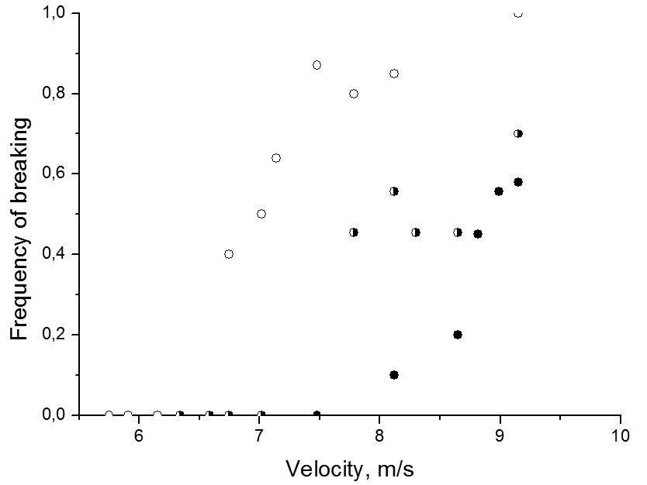
Another unexpected thing was that frequency of breaking changes with the weather. When we hadn’t known about it, we were wondering, why our results were different on different days. Or even worse: we had started experiment on one day, and continued it on the next. And we achieved some unexpected jump in the dependence. And whole experiment went to the nearest junkyard. Only some time later we had realized that humidity of air affects that of spaghettis; and very dry spaghettis are easier to break than usual ones (fig.9). Once again, this is caused by the changes in energy required for breaking: water increases elastic properties of spaghettis and decreases their fragility.
Figure 8. Empty circles are for cheap spaghettis, half-full are for medium priced, full are for expensive.
But while trying to change the weather by starting a rain of spaghetti, we’ve almost forgotten about one more situation: what happens if spaghetti falls prone? Funny thing is that nothing happens. Maybe you remember, that in the beginning we have limited our work with maximal speed, achievable by spaghetti in earth’s atmosphere. And for falling prone we have to recalculate this velocity (bigger drag coefficient and reference area); it turns out to be 5.6 m/s. And experiments say, that if falling prone with this velocity, spaghetti does not break. Good news for us – less work. Even better news for spaghettis – less broken necks.
Figure 9. Squares are for usual spaghettis, circles are for Spaghetti Extra Dry.
And this is first safety instruction for spaghetti – it should try to fall prone, since it just can’t reach velocity required for breaking in Earth’s atmosphere.
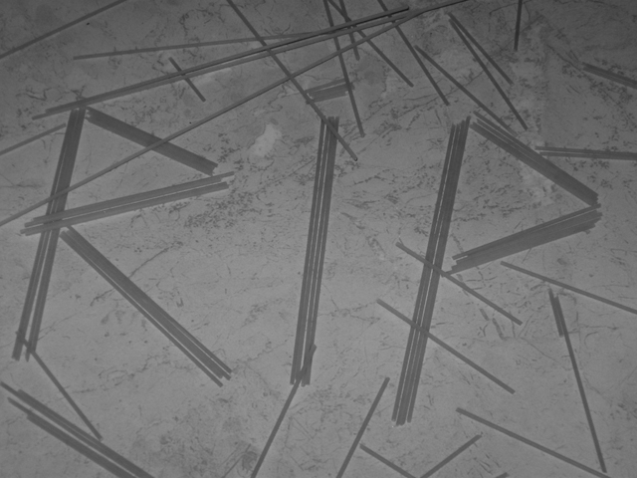
If spaghetti falls in tin-soldier position, it will be broken the first antinode of standing wave, which is situated 1 cm away from hitting end. Estimated frequency of this wave is 21.75 kHz. But breaking will occur only if spaghetti’s kinetic energy is higher, than energy required to bend spaghetti to it’s critical curvature. So, for spaghetti not to break, kinetic energy should be decreased; for example by decreasing velocity or mass (by decreasing length). However, if mass is decreased through changing diameter required energy decreases either. Other way of changing energy, required for breaking is changing chemical structure: adding water or eggs increases critical relative stretch, thereby requiring more energy for spaghetti to break.
However, in all this situations we can discuss only energy, required for breaking of ideal spaghetti. In real life, we can say only about increasing in breaking frequency, when close to described values.
During making of this report over 3000 spaghettis were harmed (fig.10).
Figure 10. Rest in pieces.

