FLAMES IN HORIZONTAL ELECTRIC FIELD, DEVIATION AND OSCILLATION

Rojin Anbarafshanª, Hossein Azizinaghsh^{b}, Reza M. Namin^{c}
ªRahe Roshd High School, I. R. Iran
^{b}Sharif University of Technology, School of Computer Engineering, I. R. Iran
^{c}Sharif University of Technology, School of Mechanical Engineering, I. R. Iran

Abstract
The current paper is an investigation on the behaviour and motion of flames in case where the flame is placed between two charged parallel metal plates with different charges. A physical experimental setup has been constructed to make precise experiments. Observations give detailed information about the deviation of the flames towards the negative plate, and in some special cases, the diffusion flames start “oscillating”. Theoretical explanation has been proposed for the phenomena and has been proved by the experiments in qualitative predictions. A numerical model has also been developed based on the theory to be compared with the experimental data quantitatively. This paper is based on the original solution of team of Iran on the 3rd problem of IYPT 2011.

Introduction
Flames have been reported to be ionized gases and in some cases to be plasmas [1]. The fact of being plasma or not, depends on the flame temperature and the burning material [1].

Asymmetrical division of the flame in two branches deviating toward different plates, in case where the flame is placed between two charged parallel metal plates, has been observed and investigated in few resources. A suggested explanation is the difference in the mass of the positive and negative ions existing in the flame [2]. In some investigations it is mentioned that the free electrons in the flame existing because of the ionization tend to react with the surrounding air molecules [2].

Other investigations have been made in different experimental situations, e.g. the effect of vertical electric field on flame stability has been investigated numerically by Belhi et al. [4] and it has been shown that flame stability increases in the presence of electric fields due to the momentum source which exists because of the electric force exerted to the ions within the flame (ionic wind).

We will discuss the effect of ionic wind on the shape and motion of the flame in horizontal electric field, and will show that the difference of the mass of the positive and negative ions is not a crucial matter in describing the phenomenon. The oscillatory motion of the flame is also a subject of investigation, which has been initially observed by the authors and no other references as we’ve seen, have reported such a motion.

Theory Base
Chemical analysis
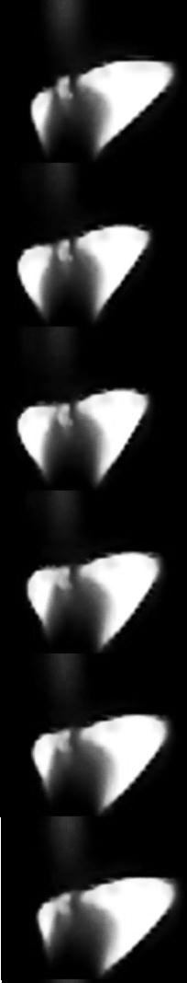
Aside from the combustion process, some other chemical and electro-chemical reactions occur in the flame. In order to determine the electric charge within the flame; which is of significant importance in this investigation, these reactions must be well understood.

The first set of chemical reactions in the flame are those related to the main fuel-Oxygen reaction; a highly exothermic reaction. This reaction produces enough heat to raise the temperature to obtain the ionization energy. The second reaction is the heat thermal ionization, decomposing the molecules into positive ions and free electrons in the high temperature zone. This reversible reaction causes free electrons to flow in the boundaries of the ionized zone.
Combustion:
Ionization:
In the presence of the electric field the forces acting on positive ions and electrons are in opposite directions, the charge separation will occur, and the contact of the electrons with oxygen molecules in the boundaries of the flame, increases. Thus, the electrons react with O₂ producing O₂⁻.
Electron reaction:

Due to the electron lost in the flame system, positive particles would be dominant, thus the flame will be positively charged. The rate of electron loss, which is equal to the rate of the charge gain, may be a function of several factors such as density, temperature and even the applied voltage. However, we have assumed it to be a constant amount.

Mechanical Analysis
To study the dynamics of the flame, we assume a control volume which’s boundary is the visible part of the flame. According to Newton’s second law, the derivation of momentum must be equal to the sum of the forces exerted. The derivation of momentum would equal to the changes of momentum inside the control volume plus the sum of the momentum entering the control volume: [4]
Figure 1: Bouncing motion
$$Σ\vec{F}=\frac{∂}{∂t}\iiint{\vec{V}}\left(ρdv\right)+∯{\vec{V}}\left(ρ\vec{V}⋅\vec{dA}\right) (1)$$
Where $Σ\vec{F}$ is the sum of the forces exerted to the control volume, t is time, $\vec{V}$ is the velocity vector of the flow, $ρ$ is the gas density, $v$ is volume, $A$ is area (Figure 2).
As an approximation, we assume that gas will be generated somewhere inside the flame and moves with a constant velocity $\vec{V }$and exits the control volume from the cross-sectional area A. According to this assumption, the above formula changes to:
$$Σ\vec{F}=m\frac{d\vec{V}}{dt}+ρAV\vec{V} (2)$$
Assuming that the gas takes a specific time ∆t to exit the mentioned control volume, the position vector ($\vec{r}$) of the flame tip would be ∆t$\vec{V}$. This leads to equations regarding the position vector:
$$Σ\vec{F}=mΔt\frac{d\vec{r}}{dt}+ρA{Δt}^{2}r\vec{r} (3)$$
The forces exerted to the control volume are the pressure from the boundary, which will be modeled as the buoyancy force, and the electrical force exerted because the flame is a charged body in an electric field (E).
$$Σ\vec{F}=Eq\hat{x}+\left(∆ρvg\right)\hat{y} (4)$$
The internal charge of the control volume is needed to find the electric force. Assuming that the combustion process produces charge with a constant rate Q_{in}, for the total charge in the control volume (q) the control volume formulation for the charge would state:
$$Q_{in}=\frac{dq}{dt}+AV\frac{q}{v}=\frac{dq}{dt}+ArΔt\frac{q}{v} (5)$$
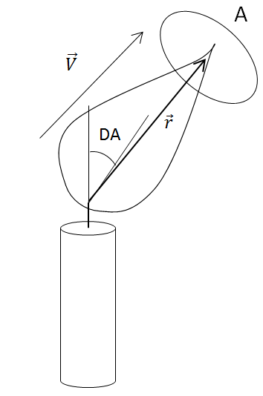
The two recent differential equations are the main equations describing the motion of the flame. In the case of steady flow, the changes could be set to zero, and solutions lead to exact constant amounts for the r vector and q.
This equation describes the derivative of charge when no external charge exchange happens. However, the flame is conductive in high voltages [5] this means that electric discharge can occur if the flame electrically touches the plate. We assume a specific distance in which discharge happens, and if the horizontal distance would reach this amount, the total charge of the control volume would be set to zero. This leads to sudden reduction in the electric force and causes the flame to draw back, and again total charge increases, causing to a repetition of the phenomenon and leading to oscillation. The general unsteady case was solved numerically.
Figure 2: Declaration of parameters
Numerical Solution
To solve the general unsteady motion, a numerical solution was used. Equations (3), (4) & (5) lead to the derivations of position and charge as a function of the charge and the constants present in the problem. There is also one more assumption to describe the discharge phenomenon; that is, we assume that if the tip of the flame approaches a specific horizontal distance from a plate, the q will be suddenly set to zero. This assumption or any other assumption describing the discharge phenomenon is crucial in describing the “bouncing” effect (Figure 1), since the discharge is responsible for such a motion. With all these assumptions, this problem is an Ordinary Difference Equation, which we solved numerically using MATLAB ®. We used ODE45 function of MATLAB, which solves the ODE using an explicit Runge-Kutta formula and the Dormand-Prince pair [6]. Our codes are available as a supplementary material to this paper.

Experimental Method
- Experimental Setup
The experimental setup consists of several types of flame (candle or Bunsen burner), two parallel aluminum metal plates connected to a high voltage device with the maximum voltage of 14 KV and adjustment resolution of 0.1 KV. Distance between the two plates is precisely adjustable. In order to reach a uniform electric field around the flame, size of the plates is large enough comparing to the size of the flame. The flame is placed exactly in the middle of the two plates.

The corresponding behavior of the flame, under electric field was recorded using a high-speed camera (1000 FPS), placed exactly in front of the flame. Using this video, some precise experimental data was extracted.

- Video Processing
The recorded video has 1000 frames per second, using MATLAB image processing tool-kit, the relative position of the center of area of the flame (estimated as the center of mass) and the wick of the candle (lower part of the flame) was found. The angle between this vector and vertical line (DA) was measured in each frame (Figure 3). DA as a function of time and voltage was extracted from different experiments.
Figure 3: MATLAB image processing. Left picture: Original picture, Right picture: Processed picture

Experiment
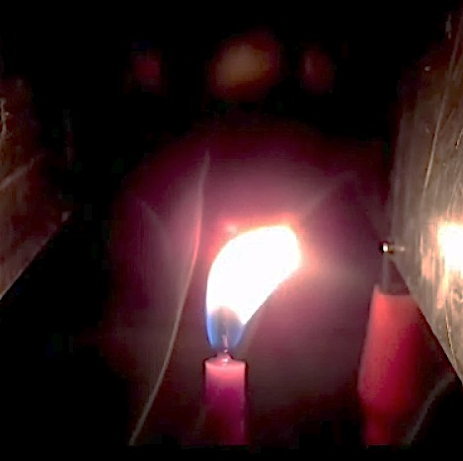
Initially, some qualitative experiments were designed to evaluate the basic theory.
Figure 4: Smoke Experiment

Streams of rising smoke were used in order to detect the flow around the flame while it is oscillating. Flows of negative ions toward the positive plate and also positive ions toward the negative plate; were both observed (Figure 4); which verifies the validity of ionic wind theory. These laminar flows also reject the possibility of turbulent flows as the cause of oscillatory motion.

In case of oscillating candle flame, a layer of non-conductive material was placed between the flame and the plates by coating the aluminium plates, avoiding electrical dischargeinteraction between the flame and plates. As a result, the oscillatory motion of the flame was diminished, verifying the main reason of the oscillation as the electric discharge.

Most of the experiments were done using a candle flame; however the behavior of other flames was also observed. Pre-mixed flames mostly showed no oscillation at all. This is a result of the sufficient ionization degree, which can keep a steady current within the flame in the electrically touching condition with the plate. Some flames; e.g. the diffusion petroleum flame, were highly turbulent; and unsteady motion could be observed even in cases where no external field exists.

Three quantitative experiments were also designed, in order to compare the experimental results with the numerical model predictions. Candle flame was used in all the experiments.

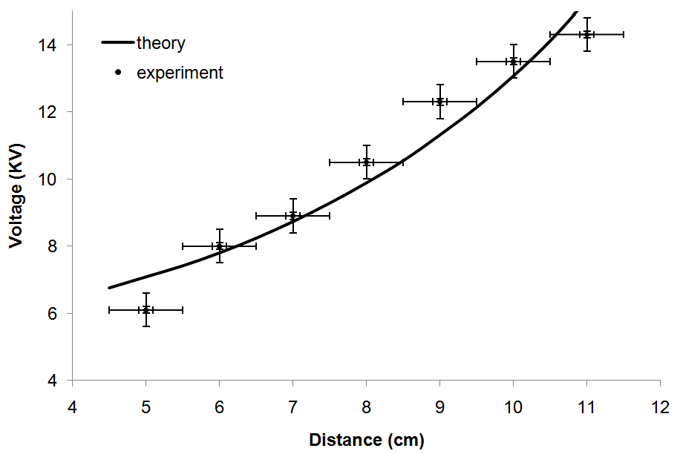
- Critical Voltage of Oscillation
According to previously proposed theoretical explanation, the “Oscillation” occurs when the flame touches the plate electrically and discharges. For the flame to reach the plate there is a critical deviation angle and its corresponding voltage. This voltage is a function of the distance between the plates. The less the distance is, the lower voltage is required for oscillation to occur. The critical voltage of oscillation was measured by gradually increasing the voltagein different distances between the plates.
Figure 5: Critical Voltage of Oscillation

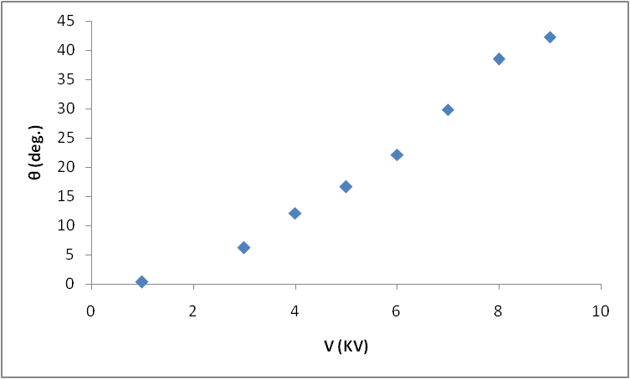
- Deviation Angle (DA) vs. Applied Voltage
Before the flame starts oscillating, it deviates and reaches to a stable condition. DA (Figure 2) is proportional to the applied voltage. By increasing the applied voltage, DA will also increase. A candle flame was placed between the plates; distance between the two plates was fixed, the applied voltage was gradually increased and using image-processing method, the angle of deviation was measured in each voltage.
Figure 6: Deviation Angle
- Frequency of oscillation
It was observed that the oscillatory motion of the flamehas a well-defined frequency. In a fixed distance between the plates, this frequency was measured in different voltages using image-processing methods.

Discussion
The behaviour of the flame, under different situations has been shown in figures 5, 6, 7, 9. These results will be discussed in more details.

1. DA vs. Voltage
Figure 7 indicates a linear correlation between the term $\frac{\tan{DA}}{\sqrt{\cos{DA}}}$ and the applied voltage.
In case of deviation the flame is in equilibrium state. Formulae (3), (4), (5), (6) give:

$$\frac{dq}{dt}=0 , \frac{d\vec{r}}{dt}=0 (6)$$

$$\frac{\tan{DA}}{\sqrt{\cos{DA}}}=\frac{EQ_{in}}{∆ρg∆t}\sqrt{\frac{ρ}{∆ρvgA}}=C∙\frac{V}{d} \left(7\right)$$

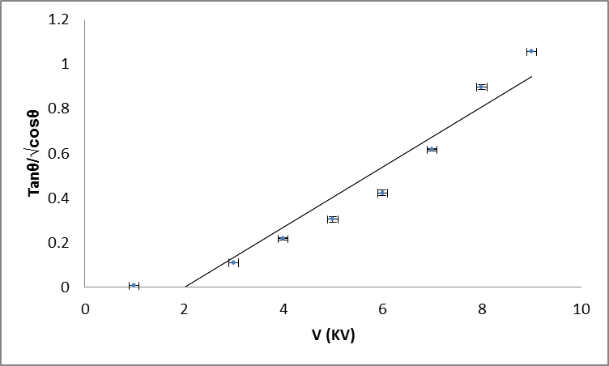
Where, $d$ is the distance between the plates, $V$ is the voltage. The linear correlation of $\frac{\tan{DA}}{\sqrt{\cos{DA}}}$ and voltage indicates that the term $\frac{Q_{in}}{∆ρg∆t}\sqrt{\frac{ρ}{∆ρvgA}}$ in formula (7) remains unchanged during deviation. It can be implied that the input electric current ($Q_{in})$ of the flame and the buoyancy force are not affected in presence of electric field. Equivalently, electric field doesn’t affect the combustion process and volume of the flame considerably. This fact was assumed in the theory which is now approved.

Fig 7. Indicates an x-intercept which is not implied by formula (7). When 0 < V < 2 the flame does not deviate. It can be explained by considering the internal electric field resulted from charge separation, which cancels the external electric field and prevents the flame deviation in this range of voltage.
Figure 7: Flame in steady condition (Deviation)

2. Position vs. Time:
Assuming x and y to be the position components of the tip of the flame, plots for x and y vs. time were generated both in theory and experiments (Figure 8). Because of the simplified assumptions in the theory, we see sharp-edge diagrams for the motion which is not observed in experiments. The reason could be that the discharge does not only occur in the touching condition, but also can be possible in other distances. Another cause may be the assumption that the position vector and the velocity vectors are the same direction, which is just an approximation and may not be true.

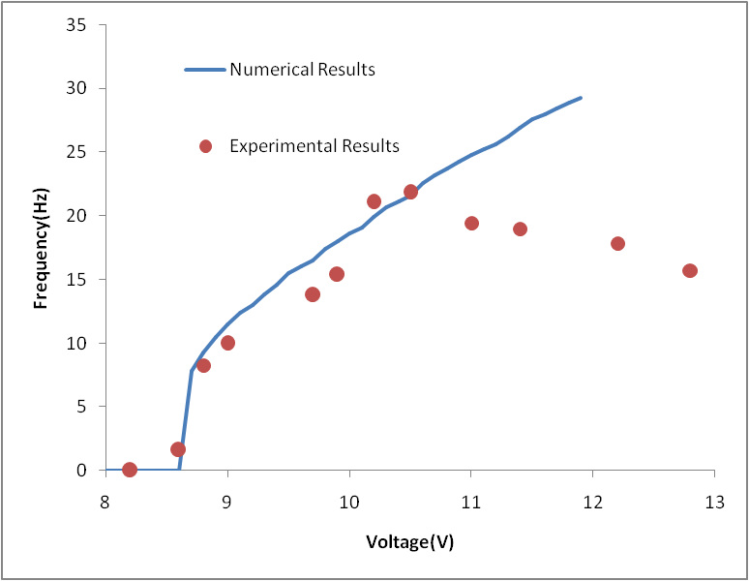
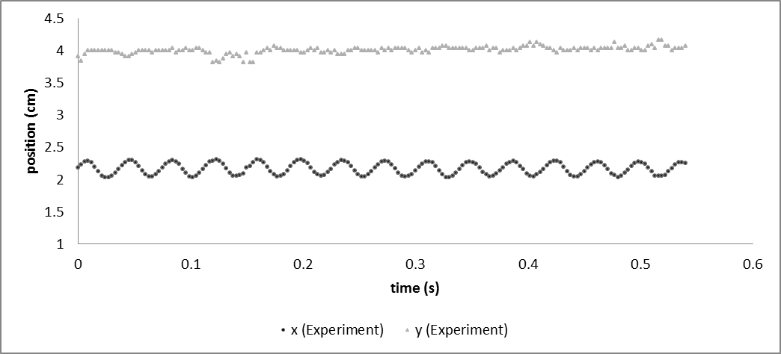
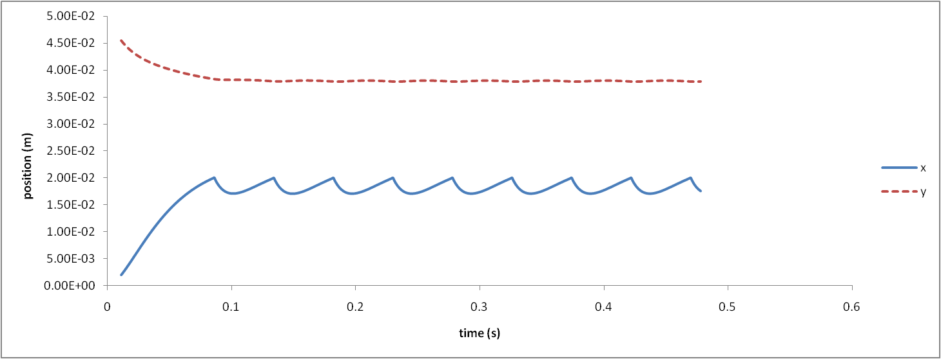
Figure 9: Frequency of Oscillation
Figure 8: x and y component of position vector of the tip of the flame, resulted from theory and experiments
3. Frequency vs. Voltage:
According to Figure 8, the frequency of oscillatory motion of the flame has a well-defined frequency. Electric discharge of the flame triggers the oscillatory motion. The voltage must be high enough to increase the DA and provide this condition. In Figure 9 this minimum voltage is 8.5 KV, thus when 0 < V < 8.5 the flame does not oscillate and the frequency of motion is non-existent (Figure 9). By increasing the voltage, the electric force, which is responsible for the motion, increases. Thus, it speeds up the process and increases the frequency; the theory also predicts an increasing trend for the frequency. When V > 10.5, decreasing behaviour is observed. Air drag; which is not considered in the theory, may be responsible for decreasing behaviour in high voltages.

References

[1] Gerald R Paul R Plasma and Flames - The Burning Question Coalition for Plasma Science 2008

[2] Leh Y K Fei WCW 2010 Visual Pelangi Kbsm 2010 Physics Spm Pelangi Publishing Group Bhd

[3]M. Belhi, P. Domingo, P. Vervisch, "Effect of Electric Field on Flame Stability"

[4] Shames I 2002 Mechanics of Fluids McGraw-Hill Science

[5] Wilson H A 1931 Electrical Conductivity of Flames Rev. Mod. Phys

[6] Fausett L V Applied Numerical Analysis Using MATLAB Prentice Hall

[7] Goodings J M Bohme D K , Chun-Wai N G 1979 Detailed ion chemistry in methane-oxygen flames. II. Negative ions Combustion and Flame 45 62

