REMOVING A PIECE OF ADHESIVE TAPE FROM A HORIZONTAL SURFACE

Hossein Azizinaghshª, Hamid Ghaednia^{b}
ªSharif University of Technology, School of Computer Engineering, I. R. Iran
Hossein.Azizi@gmail.com
^{b}Amir Kabir University of Technology, School of Civil Engineering, I. R. Iran
Ghaednia.Hamid@gmail.com

Abstract
The current article is an investigation on possible methods of determining the force, necessary to remove a piece of adhesive tape from a horizontal surface. Initially, the force was determined based on concepts of surface energy and elastic deformation. In order to increase the accuracy and avoid some simplifications, a numerical simulation was developed.
The force was accurately measured and based on experimental measurements, theoretical predictions were verified.

Introduction
Adhesion occurs due to various types of interactions between the molecules of the adhesive and adherend materials. Depending on the type of the adhesive tape and adherend, different types of interactions are involved e.g. Van der Waals forces, physical interlocking, diffusion of polymers, electrostatic forces, etc.
There are various adhesion theories. None of these theories cover all the different aspects of adhesion. “A promising combination of different adhesion theories does not exist” [1] thus, adhesion is not a well-known phenomenon.

Adhesive tapes are a subject of various measurements [1][2][3][4]. But there is no comprehensive method to model the adhesive tape and predict its behaviour under different conditions. Various types of chemical and mechanical bonds [4] involved in adhesion, seem too complicated to be theoretically modelled. In the present work, a simplified model will be introduced. Despite its simplicity the predictions are quite accurate and are in great agreement with experimental measurements.

It was observed that in some cases (Low peel angle), detaching of the adhesive tape from the adherend material is mainly due to deformation. A significant difference was observed when a paper-backing adhesive tape and a plastic-backing adhesive tape with similar adhesive layers were removed. Thus, aside from adhesive layer and its properties, the properties of the adhesive tape backing are also decisively important.

When the force is applied, stresses propagate along the adhesive tape. These stresses cause the adhesive layer to deform. When the force reaches a critical magnitude, the bonds between adhesive-adhesive or adhesive-adherend or adherend-adherend cannot provide enough force. Therefore they will be removed. In either case, the adhesive tape is removed from the surface.

“The dependence of the peel force on the peel rate is complex. It has been shown that several regimes can be obtained as a function of the peel rate” [2] In order to avoid the complex behaviour of the adhesive material related to peel rate, all the experiments have been done under a static condition ($v_{peeling}→0)$.

Theoretical Analysis:
In order to remove a piece of adhesive tape, all the bonds between adhesive-adhesive or adhesive-adherend or adherend-adherend should be removed. Removing each of these bonds requires a certain amount of energy. We define this energy as: $Aγ$, A is the area of the adhesive tape that has been removed from the surface and $γ$ is the adhesion energy per area. $γ$ is a function of environmental conditions. Aside from this, the deformation of the adhesive tape also consumes energy.

The theory is based upon some assumptions:
- Removing the adhesive bonds consumes energy. This energy is described by $γ$, surface energy density discussed above.
- Adhesive tape shows considerable strain in respond to stress. This deformation consumes energy and is described by modulus of elasticity, E, which is considered to be constant.
- In the whole process, adhesive tape behaves elastically.
- Wasted energy (energy converted to heat or radiations) is considered negligible
- Small deformations of adhesive layer consume energy. This energy is considered negligible.
- The work done by the peeling force is equal to the change in the energy of the system.

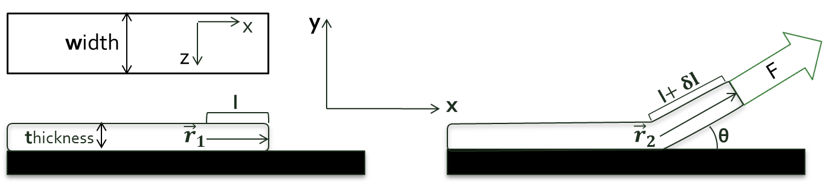
Based on these assumptions, and conservation of energy, the force F can be found. (Fig. 1)
Figure 1: Illustration of parameters

Numerical Analysis
The simple analysis of the problem using energy concepts is highly effective (as it will be approved in further experiments). In this method some simplifications are inevitable, most importantly, adhesive layer and its deformation and its corresponding energy that are completely neglected. Furthermore, the energy method is highly abstract and it cannot illustrate what really occurs in the process of adhesive tape removal. Thus, in order to avoid several simplifications and also to have a better understating of the phenomenon (which is a really important objective of this paper), a simple numerical model was developed to describe the phenomenon down to the micro level (see online supporting material: Modelled adhesive tape removal video).

The adhesive tape was modelled as series of vertical and horizontal springs (Fig. 2). Vertical springs indicate the adhesive layer and the horizontal springs indicate the adhesive tape backing material. Node is where the vertical and horizontal springs connect to each other, small circles in figure 2. When the force is applied to the first node, the equilibrium state of system (All the nods are in equilibrium state) will be found. At his point, if the length of the first spring is higher than a critical length, the adhesive tape is removed and the necessary force is found. Otherwise the force will gradually increase and the process will repeat (Fig. 3, 4, also see online supporting material: Source code).

The numerical model is based upon some assumptions:
- Wasted energy (energy converted to heat or radiations) is considered negligible.
- In the whole process, both adhesive layer (vertical springs) and adhesive tape backing (horizontal springs) behave elastically.
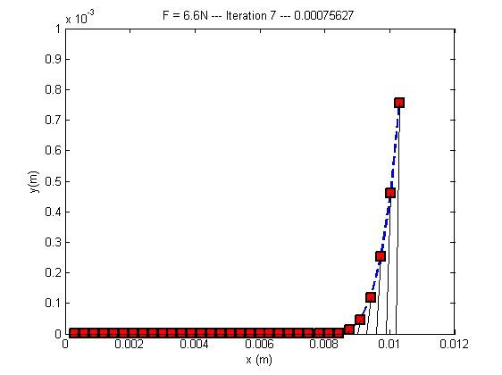
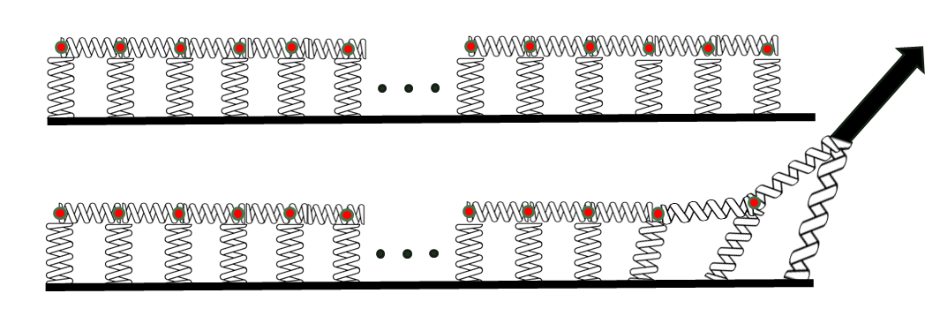
- The adhesive tape removes because the strain of the adhesive layer (length of the first spring) reaches to its limit.
Figure 2: Modeling the adhesive tape as series of vertical and horizontal springs, circles indicate the nodes
Figure 3: The adhesive tape when removing. Squares indicate the nods, dashed lines the horizontal springs and lines the vertical springs (adhesive layer)
Resulted from the numerical model, developed with MATLAB
Parameters involved in the numerical model:
Four parameters are involved in the numerical model:
- N, Number of the springs. This parameter affects the accuracy of the model and is not a determinant itself. This parameter was set to 100 springs per millimetre.
- $K_{v}$, constant of vertical springs. This parameter is proportional to modulus of elasticity of the adhesive layer and its dimensions (thickness and width). These parameters are measured in experiment part.
- $K_{h}$, constant of horizontal springs. This parameter is proportional to modulus of elasticity of the adhesive backing and its dimensions (thickness and width). These parameters are measured in experiment part.
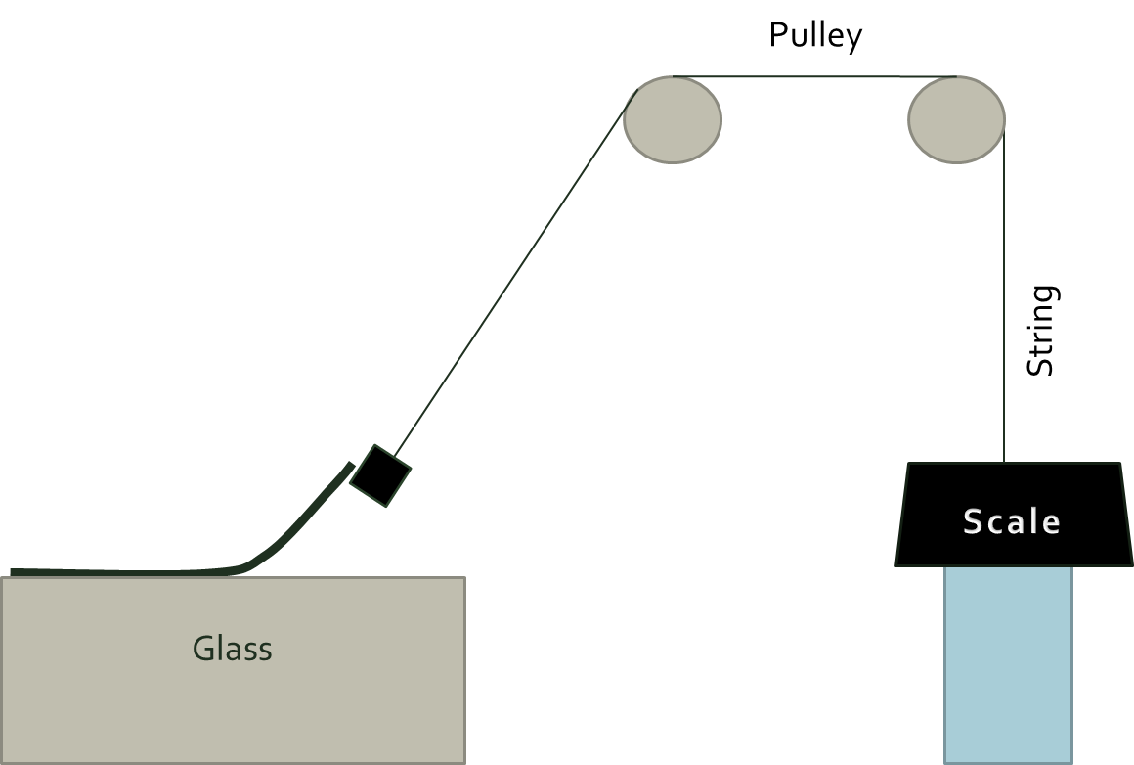
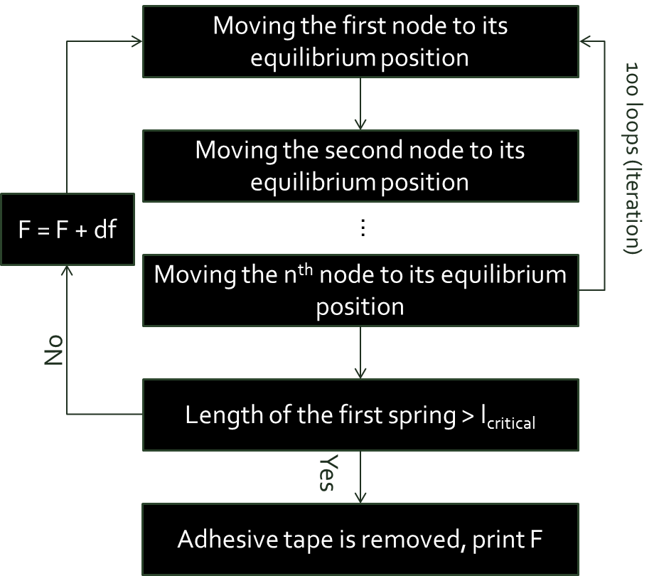
- $l_{critical}$, maximum length of the first spring. When the adhesive tape removes, the first spring removes either from the adhesive backing (horizontal springs) or from the surface, because it has reached to its ultimate strain. This ultimate strain is similar to $γ$parameter discussed in the analytical theory and it is related to chemical and physical properties of both adhesive and adherend materials, their interaction and environmental conditions. This parameter will be calibrated in experiment part.
Figure 5: The experimental setup
Figure 4: Numerical algorithm

Experiments:
Measurement of the force:
The force necessary to remove a piece of adhesive tape under a static condition was measured. A digital scale with the resolution of 0.1 g is placed on a surface. The height of this surface is adjustable. One end of a string is attached to the scale; the other end is attached to the adhesive tape (Fig. 5). By decreasing the height of the scale, the tension in the string will gradually increase until the adhesive tape starts to peel off from the surface. The number indicated by the scale is the force necessary to remove the adhesive tape. Two types of adhesive tape were experimented, paper-backing and plastic-backing. The comparison between these two demonstrated the significance of the adhesive tape backing material.

Measurement of modulus of elasticity
The applied force was measured when the adhesive tape is deformed (Fig. 6).
A scale with the resolution of 0.1 g is placed on a surface. The height of the surface is adjustable. One end of the adhesive tape is attached to the scale. The other end is attached to a fixed point. By decreasing the height of the surface, the adhesive tape will deform and the corresponding force is indicated by the scale. This force was measured as a function of deformation (Changes in the width and length of the adhesive tape). Modulus if elasticity can be found by calculating the slope of force-strain graph (Fig. 7). This experiment was repeated three times in order to increase the accuracy.
The measured modulus is equal to $E=E_{layer}+E_{backing}$. By washing the adhesive layer and repeating this experiment, $E_{backing}$ can be found. This way modulus of elasticity of both materials can be measured. In the analytical theory E is required, but the numerical model requires both.

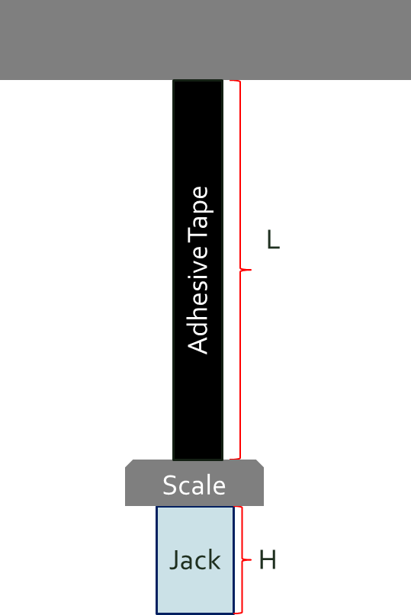
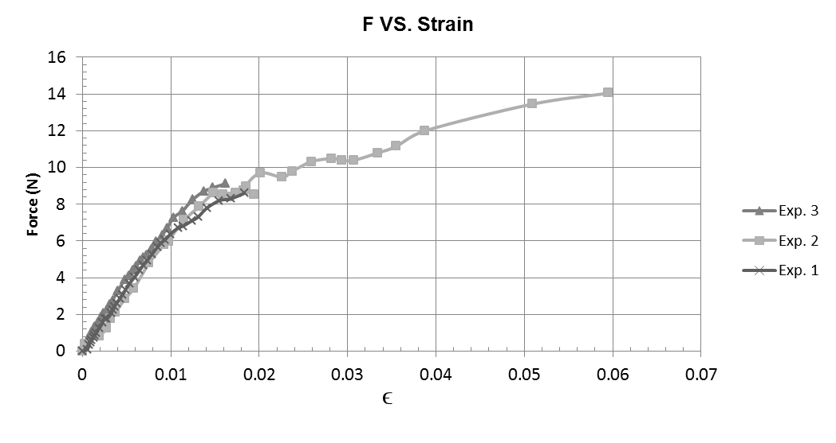
Figure 6: The experimental Setup
Figure 7: Force vs. Strain, the slope of initial, linear part is proportional to the modulus of elasticity

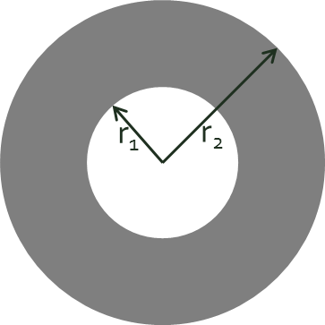
Measurement of thickness:
$π\left(r_{2}^{2}-r_{1}^{2}\right)=Lt$ (10)
Figure 8: measurement of thickness
Internal and external radius of the adhesive tape roll (Fig. 8, $r_{1}$ and $r_{2}$) and length of the adhesive tape (Fig 8, L) were measured. Based on formula (10) thickness of the adhesive tape can be measured. This thickness is equal to $t= t_{layer}+t_{backing}$. By washing the adhesive layer and repeating the measurements, $t_{backing }$can be measured. This way both $t_{backing}$ and $t_{layer}$ are found.

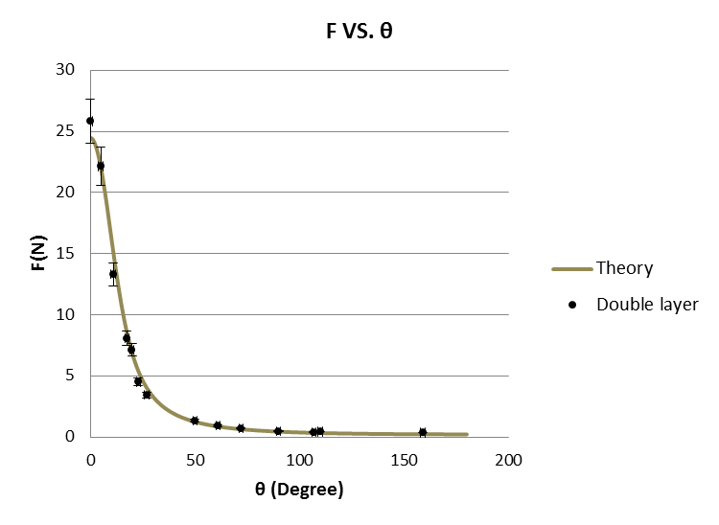
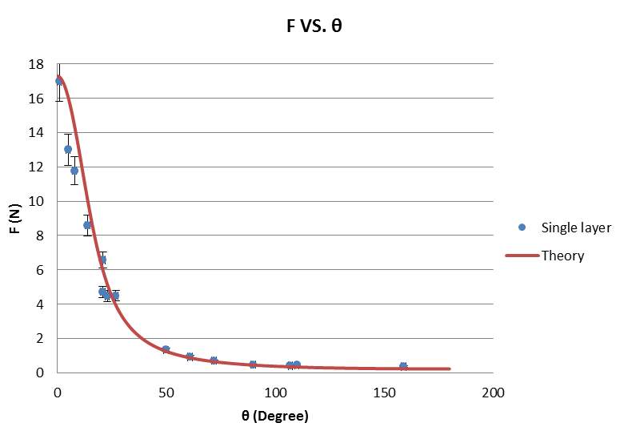
Figure 9: the theory was calibrated (left graph-single layer adhesive tape), and then the calibrated theory was verified in another experiment (right graph-double layer adhesive tape)

Calibration:
The theory requires some parameters that are dependent on environmental conditions and chemical properties of adhesive and adherend material, thus, they cannot be directly determined. These free parameters are $γ$, mentioned in the analytical theory and $l_{critical}$, mentioned in the numerical model. In order to measure these parameters, based on the experimental force vs. peel angle $(θ)$ graph, both theories were calibrated and then another experiment was designed in order to verify the calibrated theory: A double layer adhesive tape was used, and force vs. peel angle ($θ)$ was measured, the result was compared to the prediction of the calibrated theory (Fig. 9).
It is notable that the same type of the adhesive tape was used in both experiments. Therefore, neither $γ$ nor $l_{critical}$ will change. The only parameter that changes in two experiments is thickness of the adhesive tape, which will affect the t parameter in formula (9) and $K_{h}$, constant of horizontal springs in the numerical model. Thus, the calibrated parameters will not change in double-layer adhesive tape experiment.

Discussion
Both analytical and numerical methods provide accurate predictions (Fig. 10). The prediction of the numerical method is more precise at a low peel angles (θ) while the prediction of the analytical method is more precise at higher peel angles.

In the following, we discuss main sources of difference between theoretical prediction and experimental measurement.
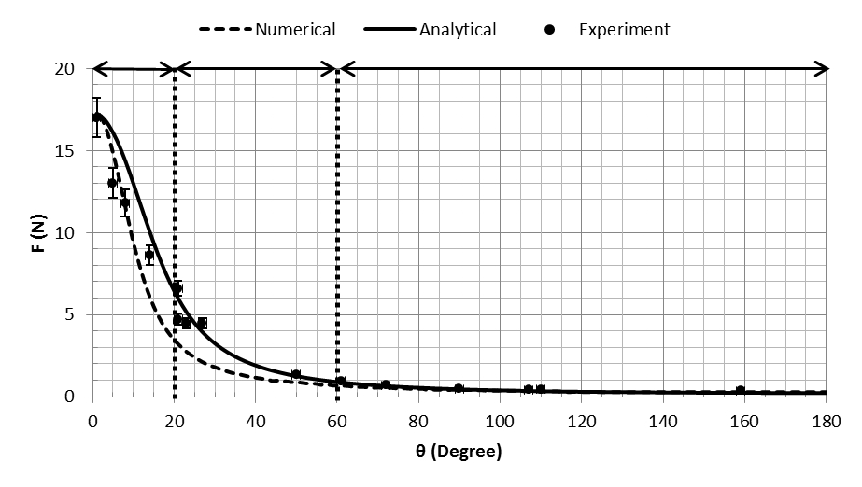
Experimental error: Error of force measurement was mainly due to the lack of reproducibility in measurements. Especially, in cases when detaching of the adhesive tape requires large force. The error was minimized by repeating the measurements. Furthermore, the static condition of the system and gradual increase of force during the measurements ($v_{peeling}→0)$, prevents some dynamic and complicated behaviors of adhesive material and enhances the reproducibility of measurement.
Figure 10: Predictions of numerical and analytical theories and experimental measurements

Elastic behavior of the adhesive: In both theoretical approaches, it was assumed that adhesive tape behaves elastically during the peeling process. According to Fig. 7 this is only true when the strain of the adhesive tape is lower than 0.02. At low peel angles deformation of the adhesive tape would be more significant, thus it may not behave elastically as it is assumed in the theory. As it is shown is Fig. 10 there is no good agreement between the analytical theory and measurements when $0<θ<20$.
Neglected energy in the theory: according to formula (1), the total energy spent to remove the adhesive tape, will be used to remove the adhesive-adherend bonds and deform the adhesive tape. The deformation of the adhesive layer also consumes energy which is not considered in formula (1).
Neglected parameters in the numerical model: There are two different types of stresses applied to the adhesive layer. Shear stress resulted from horizontal component of the force and normal stress resulted from the vertical component of the force. In the numerical model different nature of these stresses is neglected. The constant of vertical springs is responsible for both shear stress and normal stress applied to the adhesive layer. In reality these two stresses are described by two different modulus, modulus of elasticity (Normal stress) and modulus of rigidity (Shear stress). As it is shown in Fig. 10, when $0<θ<20 and 60<θ<180$, there is good agreement between the numerical theory and measurements. In these ranges only one type of stresses is dominant. While in $20< θ<60$ the prediction is not quite accurate, because two different types of stresses are both effective. Adding another type of spring to the model may improve the accuracy.
Conclusion:
According to figure 10 and formula (9), the chief task of this investigation is achieved. However theoretical predictions and experimental measurements are based upon some simplifications (e.g. static condition of the system). The problem has been investigated using two different methods:
- Energy analysis of the system based on concepts of surface energy and elastic deformation of the adhesive tape which leads to accurate results (Formula (9) and Fig. 1, 9).
- Numerical modelling of the system based on the elastic nature of the adhesive tape, which describes the phenomenon down to the micro level and also provides accurate predictions (Fig. 2, 3, 4, also see online supporting material: Modelled adhesive tape removal video).
In the experiment part, the dimensions (Fig. 8) and the modulus of elasticity of the adhesive tape (Fig. 6, 7) have been measured to be used in the theory. One free parameter of the theory, related to chemical properties of adhesive and adherend material, was calibrated (Fig. 9). Finally theoretical predictions were compared to experimental measurements (Fig. 10) and their agreement or lack of agreement in different parts was discussed.

Online supporting material:
Modelled adhesive tape removal video
http://archive.iypt.org/iypt_book/2011_1_Adhesive_tape_Iran_HA_HG_Adhesive_Removal.mp4
Numerical model source code
http://archive.iypt.org/iypt_book/2011_1_Adhesive_tape_Iran_HA_HG_Source_Code.txt

References:
[1] G.Gierenz, W. Karmann (2001), Adhesives and Adhesive Tapes, Wiley-VCH.
[2] Istvan Benedek (2004), 2nded, Pressure-Sensitive Adhesives and Applications, Marcel Dekker Inc., New York – Basel.
[3] Sina Ebnesajjad (2008), 2nded, Adhesives Technology Handbook, William Andrew, Norwich - NY- USA
[4] Gerd Habenicht (2009), Applied Adhesive Bonding, Wiley-VCH

