ADHESIVE TAPE

Stanislav Krasulin

BSU Lyceum, Belarus
Introduction
This task asks us to “determine force necessary to remove a piece of adhesive tape from a horizontal surface”. Relevant parameters are also to be investigated.
Word “necessary” points that we have to find minimal force required, and, therefore, the most effective way of removing should be used: peeling. It is also said that surface should be “horizontal”; however, there is no affect of the gravity forces on the interactions between tape and surface. Therefore, our surface should be just flat; not necessarily horizontal.
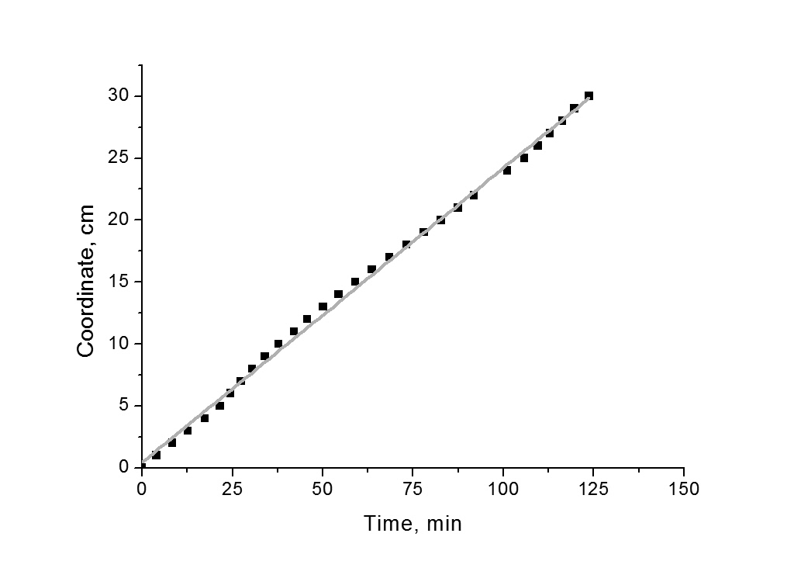
Experimental setup
Everything will be much easier if tape is peeled with constant force. At the same time, since the tape is peeled, the point of application of force is all the time moving. That is why the best option is to use gravity force: it’s constant, it always follows the object. So, experimental setup will be like this: a flat sheet of material (we used acrylic resin), which can be placed at different angles to the horizon in order to change peeling angle – angle between already peeled tape and surface (this is why we replaced word “horizontal” with word “flat”). The tape is placed on the lower side of the sheet, and a weight is attached to tape’s end. Then, dependence of coordinate of the border of still attached to the sheet tape on time is measured.
Figure 1. Peeling weight is 0.5 kg, velocity is (2.38±0.02) mm/min.
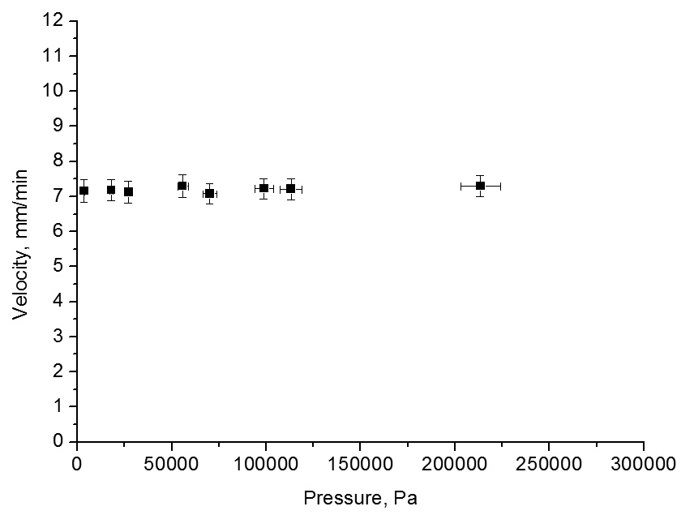
As seen in fig. 1, this dependence is linear, therefore force, holding tape, is equal to the gravity force, acting on the weight. However, if attached mass is changed, dependence remains linear. Conclusion: tape “resists” detaching with the force equal to applied. To study this phenomenon, we should take a closer look at the clue behavior and interaction between tape and surface.
Pressure sensitive adhesive
There exist different types of adhesives; however, we had focused our research on the tapes, which used pressure sensitive adhesives (PSAs). This is the type of adhesive, which doesn’t require heating, or adding water to start adhesion; that is why it is the most common one. The adhesive itself is generally a viscoelastic non-Newtonian fluid^{1,2,3}. It uses van der Waals interactions between its and other surface’s molecules.
Figure 2. Is this pressure sensitive? Peeling weight is 0.5 kg, pressing mass ranges 0.1-30 kg.
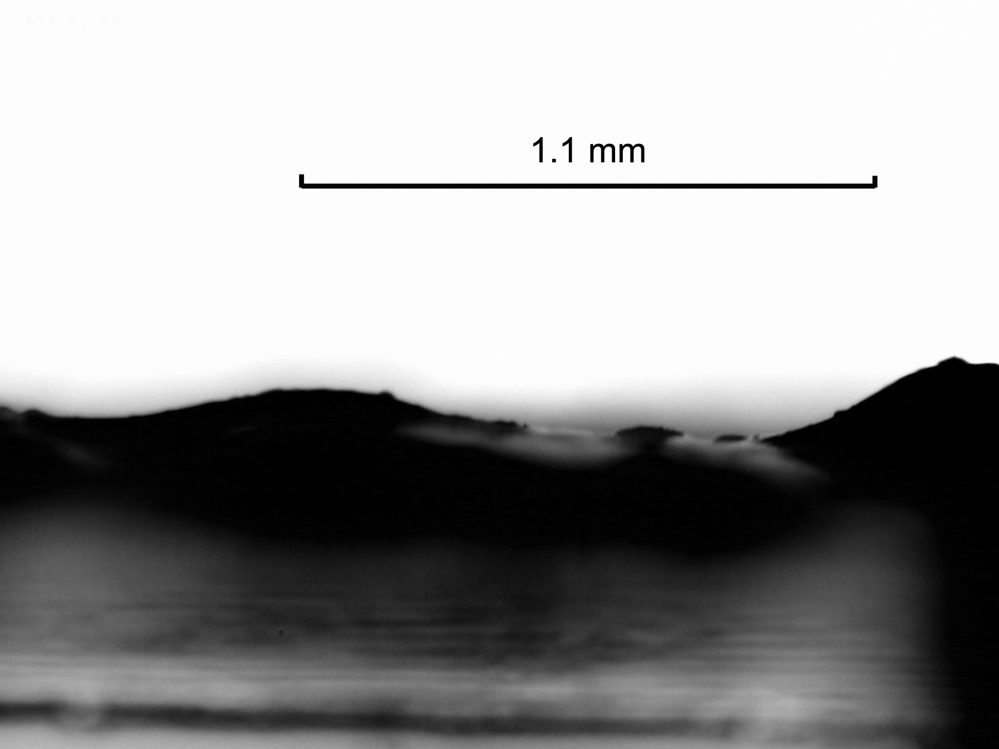
Most people think that “pressure sensitive” means that the higher pressure is applied when sticking tape to the surface, the better will be interaction between them¹. It is true for most double-sided tapes; however, as shown in fig. 2, it doesn’t work for the usual scotch tape (which is probably the most widely-used). In order to explain this fact, we had decided to study the reasons why double-sided tape does respond to the applied pressure.
“Contact area”
Figure 3. Double-sided tape through the microscope.
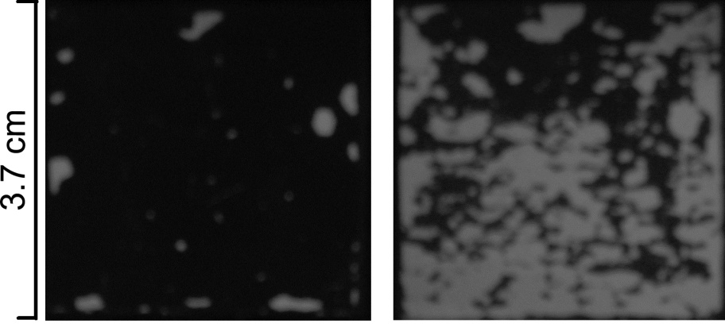
Two-sided tape has rather not flat surface: there are notable “hills” on it (see fig. 3). That is why, when putting this tape to some object, first the “hills” meet surface; and to make the lower parts of glue to reach the surface “hills” should be compressed. To describe this effect we had used “contact area” – area of the glue which actually interacts with the surface, in percents of all area of a sample.
To measure this value another experimental setup was built. With one side tape was attached to a small panel (area of the panel was equal to the area of the sample). The other side of the tape was attached to the upper side of a sheet of glass and weights were placed on the panel. A small LED was attached to the side of the sheet and under the sheet a camera was placed. Then everything is set in the dark place.
Figure 4. Same sample after putting on it just a panel (89 g) and after putting on that panel 6 kg weight.
The main idea is that the glue, which interacts with surface, is in optical contact with it; and other glue is not. Therefore, light, emitted by diode, is scattered by the interacting glue, causing it to glow. A picture of the sample is taken (fig. 4), and then percentage of bright pixels is calculated using software.
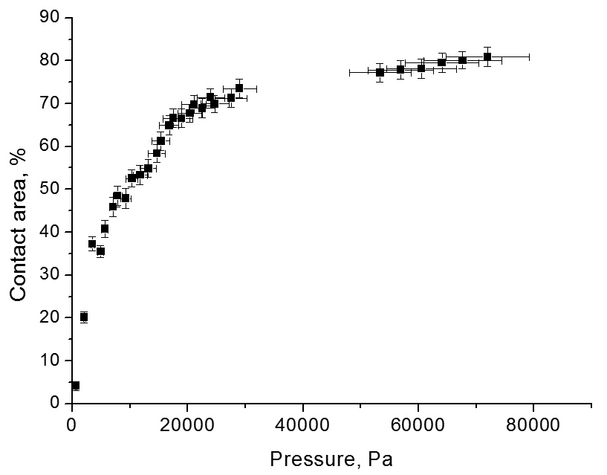
Fig. 5 shows dependence of the contact area on the applied pressure. At first it grows very fast: not many hills are touching the surface, and it’s not necessary to press hard to deform them. However, when the pressure is increased, the amount of glue which should be squeezed increases too; at the same time, deformation of the already compressed glue also increases. Therefore, 100% contact area is almost unachievable (even after putting over 60 kg on the panel it became only about 96%). It can be noticed that with growth of pressure its error increases significantly. The reason for it is that with bigger weights it is more and more complicated to distribute the pressure uniformly.
Figure 5. Pressing mass ranges 0.1-10 kg, sample area is 3.7X3.7 cm
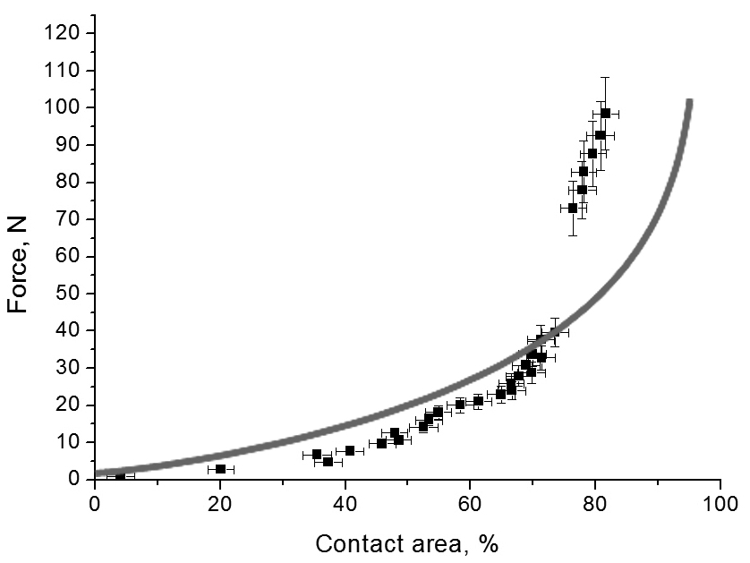
Mathematical model
Qualitative explanation can be expanded into quantitative model. Certainly, to create it we need some information about the shape of the glue’s surface; or, being more specific, we need to know how big total area of glue, which has some specific thickness is. We can consider, that thickness of glue follows some distribution; and for the simplest mathematical model we will approximate that it is Gauss distribution. Then, if after applying some force distance between the panel and the surface became x, amount of glue, which isn’t interacting yet, will be:
Figure 6. Line shows output of our mathematical model. Dots are, in fact, re-plotted fig. 5.
where μ is average thickness of glue, and σ is difference between biggest and smallest thickness, divided by 6. Now, if we want to find the force, caused by the deformation of glue (considering, that it behaves according to Hooke’s law):
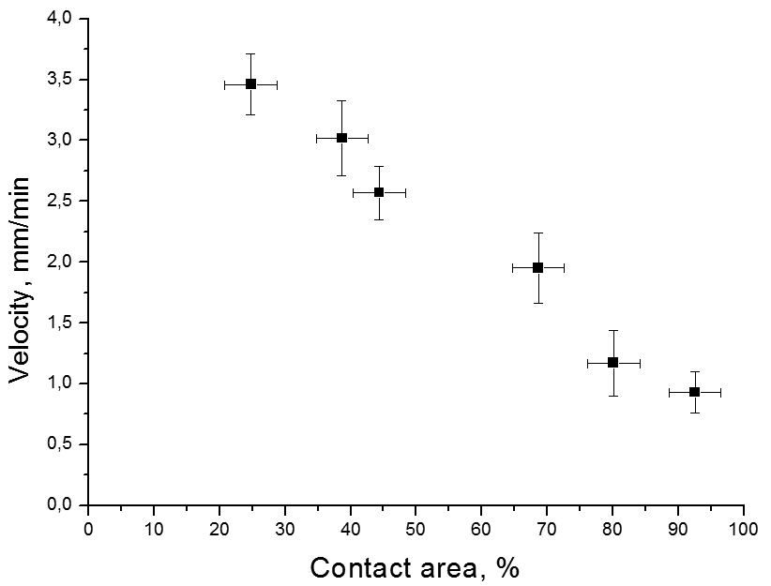
where X_{max} is highest thickness of the glue, S is area of the sample, (N(x_{n}+Δx)-N(x_{n}))*S describes area covered with the glue, which had original thickness between (x_{n}) and (x_{n}+Δx), and ((x_{n}-x)/x_{n}) shows relative deformation of such glue. And contact area C(x) will be calculated as C(x)=(1-N(x))*100%. Now, using software, it is possible to plot F(x) vs. C(x). Comparison between results of the model and actual experimental data can be seen in fig. 6. Differences can be explained by the fact, that our approximations with Gauss distribution and Hooke’s law are not 100% correct; however, results are rather close: for contact areas less than 70%, difference between theory and experiment doesn’t exceed 10%.
Dependence of the detaching velocity on the contact area is linear (fig. 7): the higher is contact area (respectively, the higher was applied pressure) the lower is detaching velocity. So, we have successfully explained why applying pressure to the double-sided tape increases its resistance to peeling. And since we were right with our theory of uneven surface of the glue being the main reason of dependence on applied pressure, we now have an explanation for the lack of such dependence for scotch tape: its glue has rather even surface. That is why, when scotch tape approaches a surface, whole area of the sample interacts with the surface at once, and all possible bonds are established. And once a bond is established, applying pressure doesn’t change anything.
Figure 7. Peeling weight 0.5 kg. Here we face increased errors, because it is difficult to take a high-quality picture of a long piece of tape.
Measurement of Young’s modulus
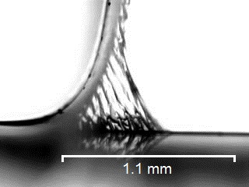
Calculation of the F(x) in previous chapter required knowing of the Young’s modulus E of the glue. To measure it a thin stripe of the tape was taken, and a very small weight (8.8 g) was attached to it. Then everything was put under the microscope (fig. 8). In the very beginning of detaching small oscillations can be observed. Approximating the whole system as a spring pendulum it is possible to find Young’s modulus through the period of these oscillations.
Figure 8. Picture taken when measuring Young’s modulus of usual scotch tape, period of oscillations 0.7 s.
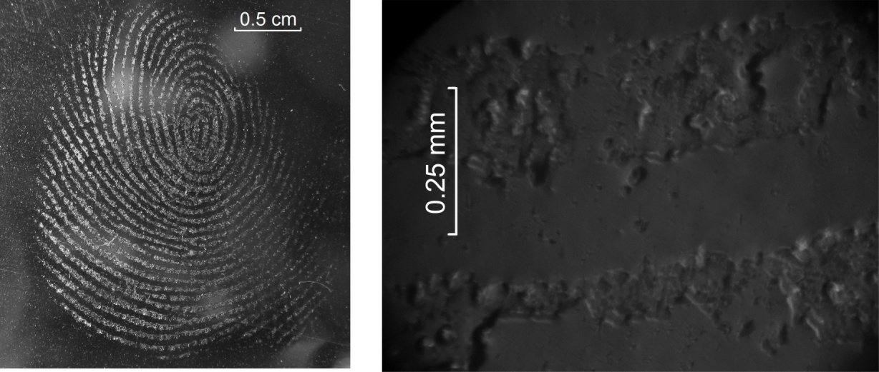
However, after several oscillations glue stops following Hooke’s law, and finally starts tearing. It should be noticed, that it’s exactly glue tearing into two parts – not glue detaching from the surface (fig. 9).
Minimal force
Figure 9. A fingerprint left on the tape, as seen in real life and through the microscope. On the right picture it can be noticed that big part of glue is missing – it had remained on the finger. However, finger doesn’t become sticky because glue on it has very uneven surface – contact area effects are applied.
Once the glue stopped following Hooke’s law it can be described as a viscoelastic non-Newtonian fluid^{2,3,4}. While behaving like this, all interactions in glue will depend on the velocity and applied forces. Exactly this behavior explains why tape resists detaching with the force equal to applied.
In fig. 10 you can see dependence of the detaching velocity on applied force. Experimentally, we have found that it is a parabola:
It shows that velocity will be zero only if no force is applied. It means that a piece of tape, attached to the lower side of the sheet of material, can be pelt off by its own weight. Experiments show, that it is true: for example, a 3.7X3.7 cm piece of double-sided tape, attached with contact area of 75%, will fell off in 4 days. However, it can happen not because of mechanical processes, but because of chemical: in such a long periods of time chemical reactions between glue and the surface may occur. There is no way of checking what exactly happens (mechanical destruction of glue or chemical). That is why we decided to reject using term “minimal force” or “force necessary to remove”; we described dependence between applied force and velocity of peeling instead.
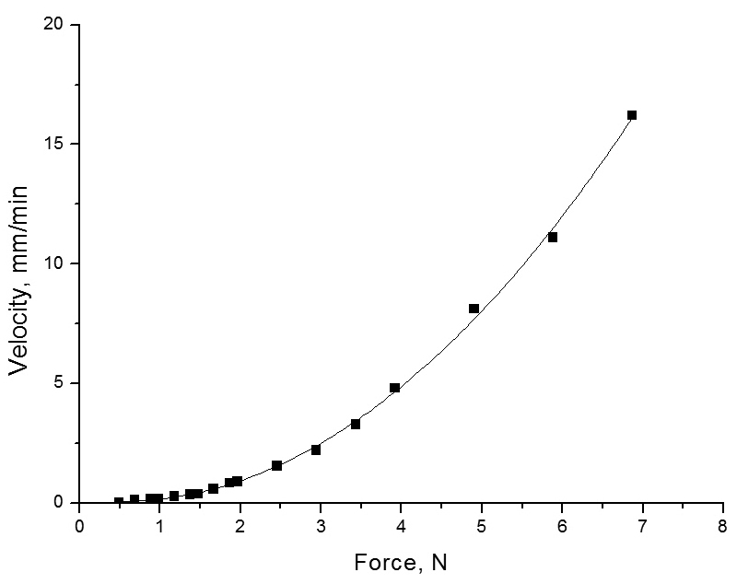
Angle of peeling
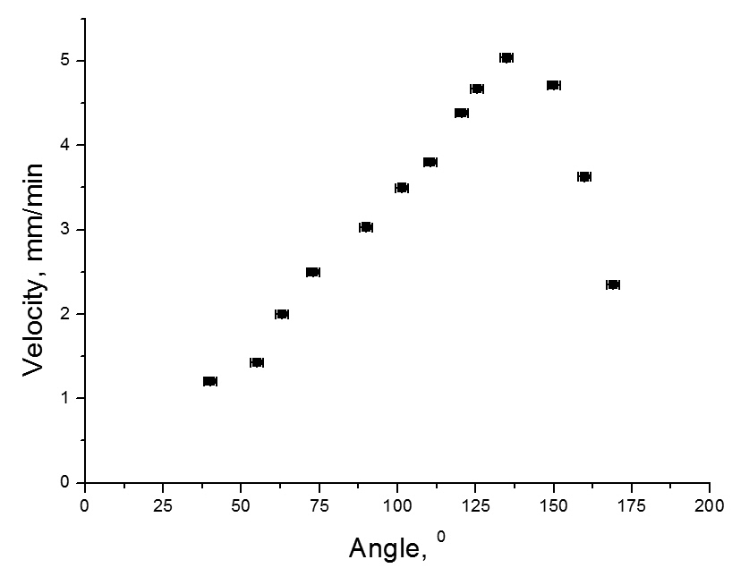
As shown in fig. 11, angle of peeling (angle between the detached tape, and the side of surface, from which the tape is already removed) significantly influences velocity. It is explained by the fact, that applied force is used for two purposes: its projection, normal to the surface, stretches and tears glue apart; while its projection, parallel to the surface, moves the point of detaching. That is why, if angle is 180° velocity is low: projection of the force, which should stretch the glue is zero. The same reason for low velocity if angle is 90°: now we don’t have projection, which moves point of detaching forward. And the peak of velocity is when projections are equal: when peeling angle is about 135°. If we use peeling angles smaller than 90°, projection of the force, parallel to the surface, is opposite to the peeling direction; therefore, peeling is extremely slow. And, finally, if we try to peel at the 0° angle a slip-stick phenomenon will occur: because of the force applied, tape will slip; but since there is no force projection which can move it away from the surface, new bonds will be established and tape will stick to the surface again. This slip-stick cycle will continue while force is applied; so, in general, tape will be moving parallel to the surface with very low speed⁵.
Figure 11. Peeling weight is 0.5 kg.
Figure 10. Dependence of velocity on force. Line shows fit with parabola. Average error of force is 0.05 N, of velocity 0.02 mm/min.
It is interesting to note, that a small social study had shown that in average, people are peeling tape at the angle of 136.4°, which is really close to the optimal value. However, it can be explained by the fact that person’s hand just moves so that resisting force is minimal, therefore choosing optimal angle.
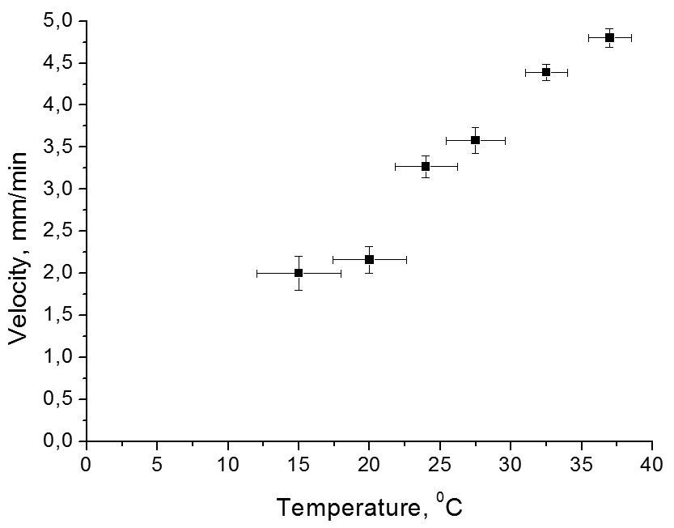
Environment influence
During our work we have noticed, that all long-lasting experiments (especially if they lasted over one day) were giving big errors and sudden jumps of dependences. It is explained by changes in the environment temperature and relative humidity⁶. Unfortunately, we could not control relative humidity of the air; but we had run an experiment with different temperatures (fig. 12). Still, it was hard to keep temperatures, lower than surrounding temperature, constant during whole experiment; this is why measurements at lower temperatures have higher errors. However, the plot shows quite well that increase in temperature causes increase in peeling velocity: glue behaves as a viscoelastic non-Newtonian fluid, and temperature impacts both its viscosity and elasticity significantly.
Figure 12. Peeling weight is 0.5 kg. The higher is temperature, the easier it is to detach the tape.
Conclusions
Main conclusion of our work is that since tape will detach if any (other than zero) force is applied, there is no such thing as “force necessary to remove”; only dependence between applied force and velocity. This dependence appears to be parabola. The parabola can be affected by the temperature, peeling angle and contact area. Contact area effects are applied if thickness of the glue layer isn’t constant (for example, on most double sided tapes). For quantitative analysis we can consider that thickness of glue follows Gauss distribution, and glue behaves according to Hooke’s law. Same approximations can be used if measuring Young’s modulus of glue through the period of small oscillations. However, if we are describing detaching of the tape, we should take into account, that glue behaves as a viscoelastic non-Newtonian fluid. That is why tape resists detaching with force, equal to the applied.
References
[1] Wikipedia contributors, “Pressure-sensitive Adhesive”, Wikipedia, The Free Encyclopedia, 30 December, 2011;
[2] Jeffrey D. Miller, “Surface Chemistry Measurements For Evaluating Coatings Formulations”, Pressure Sensitive Tape Council, 2007;
[3] Gareth McKinley’s Non-Newtonian Fluid Dynamics Research Group at MIT, “Stretching and Breakup of Polymeric Liquids in a Microfilament Rheometer”;
[4] The Adhesive and Sealant Council, Inc website,
http://www.adhesives.org/adhesivessealants/adhesivetechnologies/pressuresensitive.aspx;
[5] Seung-ho Moon, Mark D. Foster, “Scanning Probe Microscopy of PSAs: Recent Developments”, Pressure Sensitive Tape Council, 2002.
[6] Christopher C. White, Kar Tean Tan, Bryan D. Vogt, Donald L. Hunston, “The Origin Of Critical Relative Humidity in Adhesion”, Pressure Sensitive Tape Council, 2009.

