DESCENT OF A PAPER-MADE DEVICE

Hossein Azizinaghshª, Reza M. Namin^{b}
ªSharif University of Technology, School of Computer Engineering, I. R. Iran
^{b}Sharif University of Technology, School of Mechanical Engineering, I. R. Iran

Abstract
The ultimate goal in this article is to design a device, using one sheet of A4, 80 g/m² paper that takes the longest possible time to fall to the ground from a specific height. A large number of varied devices have been made. These observations, as a starting point, led us to find some of the specifications of the most appropriate device. A general numerical model of a falling rigid paper device was developed in order to optimize the device. The validity of numerical modelling was then verified by precisely capturing the motion of falling devices. Ultimately the ideal device was designed using the predictions of verified numerical model. This article is based on the solution of team of Iran for the 15th problem of IYPT 2011.

Introduction
For us, there is no certainty in finding the best possible device. Because a theoretical method to predict the best possible device is undeniably unreachable as both mediums; air as a fluid and paper as a flexible material are too complicated to be modelled comprehensively and there is an infinite number of totally different devices to be considered. Therefore the most effective method to find an answer for this problem seems to be observation. A large number of observations can lead us to approach to the answer. However this method requires a broad range of varied paper-made devices and a high level of creativity in the matter of designing.

In order to maximize the efficiency of this method, this stage of problem was investigated from different points of view and varied devices were made by different individuals. A great number of diverse paper devices were made during a period of four months. Rotating and non-rotating devices, stable and unstable devices, devices inspired by airplanes, helicopters and even birds were designed. Based on these observations some deductions were made.

In different falling devices, generally two main types of motion were observed: Rotating motion and non-rotating motion. However the rotating motion is not necessarily a rotation about a specific axis, the rotation is usually observed without any primary rotation axis. The motion of devices was classified in three main categories: 1) rotating without a primary axis (e.g. a sheet of paper), 2) rotating with a primary axis (e.g. paper whirligig), 3) non-rotating (e.g. paper airplane)
A statistical analysis of data led us to find our ideal category. This analysis was based on the average time of fall and the variance of time of fall in each category. The result of this analysis is as follows:

- Rotating devices without a primary rotation axis (e.g. a sheet of paper): the variance of time of fall for these devices was considerably high (about 0.5 second in 10 measurements) and average time of fall was usually low (about 2.5 seconds). However in some test cases the time of fall was significantly high. Without any exceptions the reproduction of these numbers was not easily possible. Equivalently the motion of these devices is too unstable to be reliable. Due to the instability and random-like motion of these devices, there is no well-defined time of fall, thus our ideal device is not included in this category.

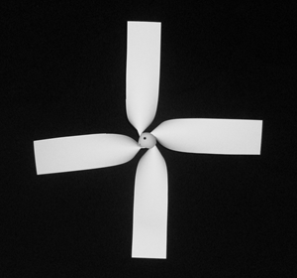
- Rotating devices with a primary rotation axis (e.g. figure 1): in this category due to the high stability of the motion of devices the variance of time of fall was relatively low (about 0.1 seconds). This stability is because of the large angular momentum, which critically increases the stability of motion. Therefore the time of fall can be defined as the average time of fall.
Figure 1: helicopter model
20 cm

- Non-rotating devices: in this category the variance of time of fall was relatively low. In most cases, the rotating motion was diminished either because of large amount of rotational inertia or aerodynamic shape (e.g. paper airplane). However the average time of fall was lower compared to rotating devices (about 3 seconds).
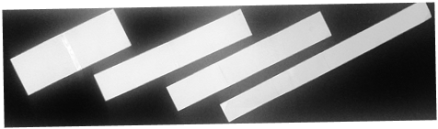
Figure 2: rectangular rotating devices, rotation axis is parallel to the length
30 cm
Based on this classification, further investigations are specific to rotating devices with primary rotation axis.

Two major types of motion were observed: rotation about a horizontal axis and rotation about a vertical axis.
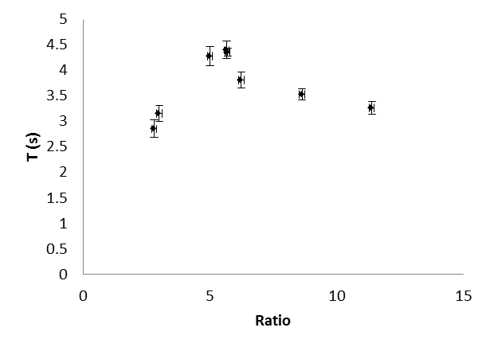
Figure 3: time of fall vs. the ratio of width and length of the rectangular rotating device
For devices with a horizontal rotation axis a rectangular device was designed (Figure 2). The rotation of this device not only increases the stability of motion, but also critically increases the time of fall. Since the ratio of width and length is the only influential parameter, based on adequate experimental data, optimization is easily possible (Figure 3).

For devices with a vertical rotation axis, a model inspired by helicopters was designed (Figure 1). The blades were firmly attached to a conic shaped center. The whole device could be considered rigid and deformations were negligible.

Since due to the variety of influential parameters, experimental optimization is not easily possible, a comprehensive numerical model was developed in order to optimize this device.

Theoretical Analysis
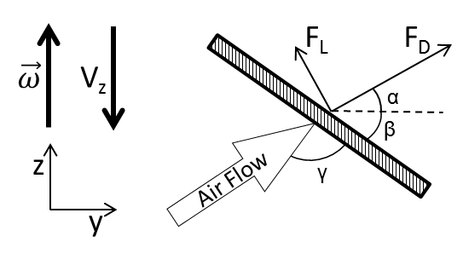
Figure 4: Declaration of parameters.
The upper rectangle is the blade of the helicopter. An infinitesimal element is indicated by two dashed lines. The lower image indicates the parameters related to an infinitesimal element.
In order to simulate the motion of the helicopter, the total force and total torque applied to the helicopter during the descent should be known.

Since the helicopter is rotating, the velocity of each element is determined by this formula:
$$\vec{V}= {\vec{V}}_{cm}+\vec{Ω}×\vec{R}$$
Air drag force is proportional to the velocity, thus, according to the above formula, the force applied to each part of the helicopter is different. We consider infinitesimal elements along the length of the helicopter and calculate the force and torque applied to that part. By summing up these infinitesimal forces, the total force and total torque applied to the falling and rotating helicopter can be found.

${dF}_{D}=\frac{1}{2}C_{D}ρ(dA)\left(l^{2}ω^{2}+{V_{z}}^{2}\right) \left(1\right)$
$${dF}_{L}=\frac{1}{2}C_{L}ρ(dA)\left(l^{2}ω^{2}+{V_{Z}}^{2}\right) \left(2\right) \\ dτ={dF}_{D}\cos{α}-dF_{L}\sin{α} (3)$$

In formulae (1) and (2) C_{D} and C_{L} are respectivley drag and lift coefficients. For an infintesimal element indicited in figure 4, we assume that this coefficient is constant. Drag and lift coefficients are dependant on the angle of attack of the flow. Air is assumed to be stationary in far enough from the device, thus the relative velocity of the flow and infinitesimal element and angle of attack would be:
$${\vec{V}}_{rel}=0- {\vec{V}}_{cm}+\vec{Ω}×\vec{R}= V_{z}\hat{z}-ωl\hat{y} \\ γ= \tan^{-1}{(-\frac{ωl}{V_{z}})}+\left(\frac{π}{2}-β\right)(4)$$
Where β is the angle of blades with horizon, V_{z} is velocity of center of mass, and ω is angular velocity of the helicopter (Figure 4).

The total force and torque applied to the helicopter is the integration of infinitesimal forces, according to formulae (1), (2) and (3):

$$F_{z}=ma_{vertical}=n\int_{0}^{L}{\frac{1}{2}ρ\left(l^{2}ω^{2}+{V_{z}}^{2}\right)\left(C_{D}\sin{α}+ C_{L}\cos{α}\right)(w∙dl)}-mg (5) \\ τ_{z}=Ia_{angular}= n\int_{0}^{L}{\frac{1}{2}ρl\left(l^{2}ω^{2}+{V_{z}}^{2}\right)\left(C_{D}\cos{α}- C_{L}\sin{α}\right)\left(w∙dl\right) (6)}$$

Where n is the number of the blades, L is the length of the blades, $α= \frac{π}{2}-\tan^{-1}{(-\frac{ωl}{V_{z}})}$ (Figure 4).

C_{L} and C_{D} are functions of angle of attack (Formula (4)), which is dependant on the radial distance of the element from the center ($l$ in figure 4). Thus, each infinitesimal element has a different coefficient.

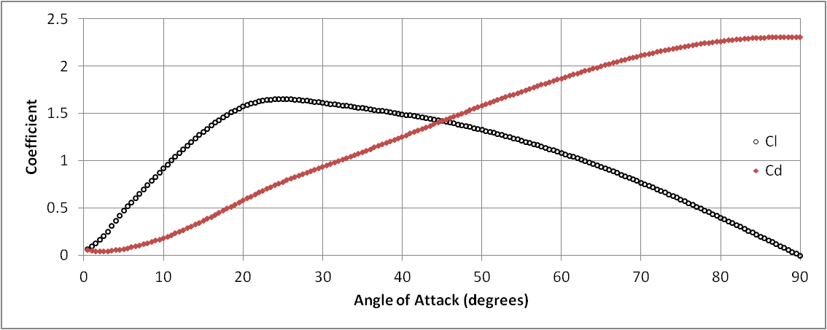
To find the drag and lift coefficients, we simulated the flow motion around a 2D flat plate using the Computational Fluid Dynamics Solver Fluent ®. Assuming the reynolds number to be $\frac{ρVd}{μ}$, it would have a maximum amount of about 10⁵, so we shall have a fully turbulent motion around the wings in most of the parts [1]. For this reason, the flow could not be assumed laminar, and we used the K-Epsilon viscousity model in our CFD simulation to model turbulence [2]. We used an unsteady model in which the velocity direction changes slowly with time, covering the range between 0 to 90 degrees with 0.5 degree steps. The changes were made using a user defined function. The time-steps would proceed if all the residuals (including continuity, momentum, k and epsilon) would be less than 0.005. As a results, the amount of drag and lift forces were computed, and were used to find the drag and lift coefficients. (Figure 5)
Figure 5: The Results of the CFD Simulation, Showing the Drag and Lift Coefficients

Numerical solution:
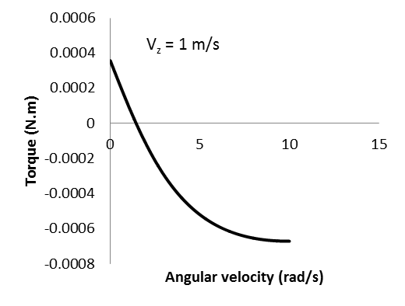
Fomulae (5) and (6) present the main equations of motion. C_{L} and C_{D} are not analytical functions. But their numerical values are obtained from FLUENT solver, for different angles of attack (Formula 4, Figure 5). A c++ program was developed to calculate the force and torque integration during the descent. Explicit Euler method with the time-step of 10⁻³ seconds was used to simulate the motion (see online supproting material: source code).
Figure 6: Torque-angular velocity correlation

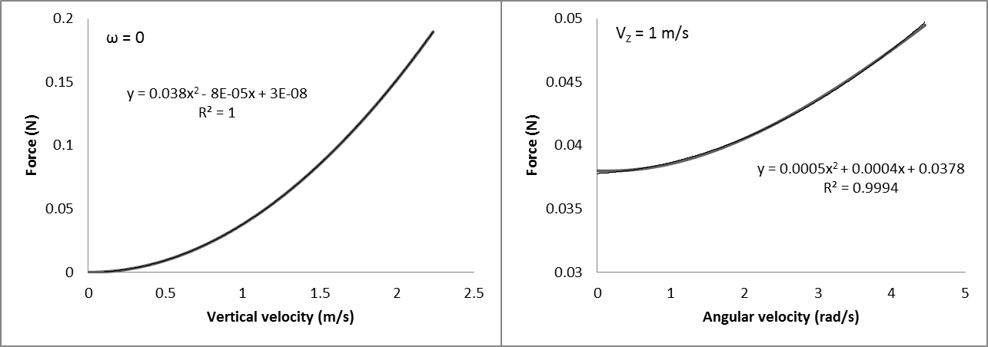
Figure 7: Force-velocity correlations resulted from the numerical integration of formulae (5) and (6).
Experiments
The vertical motion of a falling helicopter was recorded using a high-speed camera in 1000 FPS. Using image processing techniques, the location of the lower point of the helicopter was found in each frame. Velocity as a function of time was then derived from these data and was compared to the prediction of the numerical theory (see online supporting material: processed video of a falling helicopter). In order to minimize the error, ratio of the distance of camera and the height of fall was about 5. The behaviour of velocity vs. time graph presented in figure 8 is predictable. Initially gravity accelerates the helicopter, according to figure 7, the drag force increases until it completely cancels the gravity; this is the maximum point in figure 8. At this point velocity starts to decrease but air drag force (which is proportional to velocity) increases even more. This is because of rotation. Angular velocity is still increasing (Figure 6, torque is positive) and according to figure 7, air drag force increases. Without rotation, velocity wouldn’t have had a maximum.
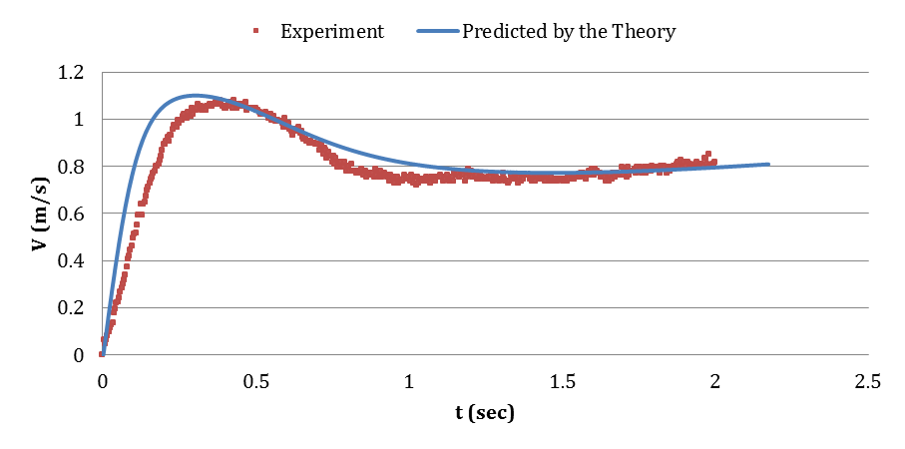
Figure 8: Predicted velocity as a function of time vs. measured velocity resulted from image processing
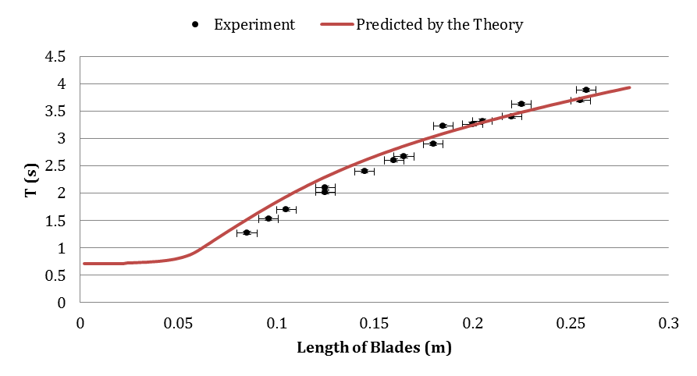
Numerous helicopters were made with different lengths and fixed widths of wings. The time of fall was measured for each device. By increasing the number of measurements the error of each number was minimized. The time of fall as a function of the length of blades was then compared to the prediction of the numerical theory (Figure 9).
Figure 9: Predicted time of fall vs. length of the blades, the width of blades is fixed

Discussion
Validity of the theory is approved with the experiments. The motion of a helicopter device with a set of specifications (number of blades, length of the blades, etc.) is completely simulated. The optimal specifications of the helicopter can be easily identified based on the prediction of the theory. Three diagrams were obtained from the theory in order to optimize the helicopter device.
The total area of the A4 paper is fixed, thus:

$$A=n∙w∙L=const.$$

Where L is the length of the blades, W is the width of the blades and n is the number of the blades. These parameters are not independent. If we change one of these parameters, one of the other two must also change.
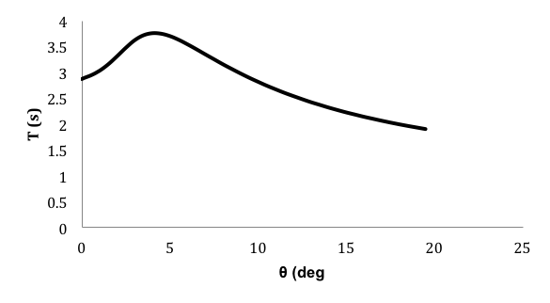
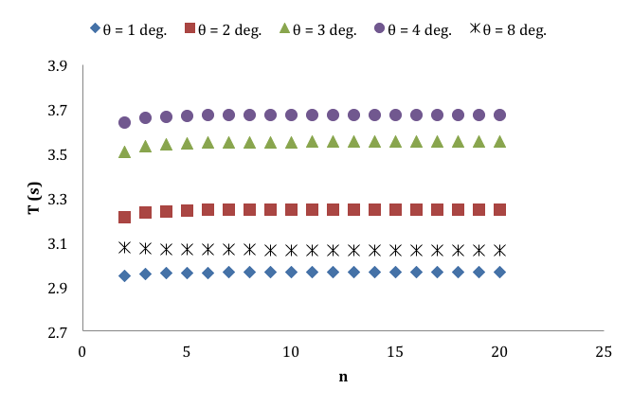
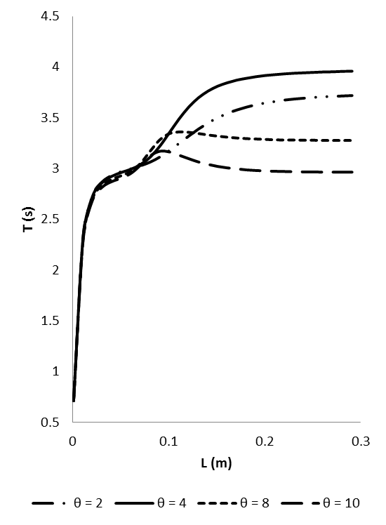
Figure 10: Time of fall vs. length of the blades. Number of the blades is fixed. Width and length vary
Figure 11: Time of fall vs. number of the blades. Length is fixed. Width and number of blades vary
Figure 12: Time of fall vs. angle of blades with horizon. β in figure 4.
Figure 10 demonstrates the time of fall as a function of length of blades. Number of the blades is fixed, therefore by increasing the length, the width of the blades decreases. It is implied by figure 10, that no optimum length for the blades exists. The length of blades should be large enough (more than 23 cm). Designing the helicopter with paper has some limitations. For example the length of the blades cannot be too long. Because the thin blades will loose and they wouldn’t function as wings. But since 25 cm is an optimal length for the blades, and it is easily achievable, this limitation is not an obstacle.

Figure 11 demonstrates the time of fall as a function of number of the blades, the length of the blades is fixed. Number of the blades and width of the blades vary. The time of fall is not highly dependent on the number of the blades. This result is predictable. According to formulae 5 and 6, the force and torque are proportional to $n∙w$ which remains unchanged. It is implied that the number of blades is not a determinant.

Figure 12 demonstrates the time of fall as a function of angle of blades with horizon. A maximum amount for the time fall is expected. When angle of blades is zero (they are parallel to the ground), the device will not rotate and time of fall would be low, when angle of blades is 90 degrees (they are perpendicular to the ground), the device will not rotate and reference are is zero and the time of would be low. Thus, between zero and 90 degrees there must a maximum point.
Based on these three diagrams, optimal specifications of the helicopter are determined.

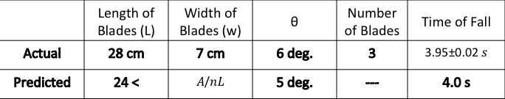
Figure 13: Specifications of the optimized helicopter based on diagrams resulted from the theory
Conclusion:
The chief task of this investigation is achieved through three stages:

- Making numerous paper-made devices and analysing the results. The method used in this part of investigation was trial and error and it was based on the creativity in the matter of designing. The motion of paper made devices was categorized and the most appropriate category was identified.

- The helicopter device was chosen as the ideal device. In order to maximize the time of fall, a numerical theory was developed to simulate the motion of this device. Drag and lift coefficients, corresponding to infinitesimal elements along the blade of the helicopter were found by simulating the air flow around 2D surface using FLUENT. These coefficients were used to find the total force and torque applied to the helicopter during the descent. This way, the motion of the helicopter was simulated.

- The motion of the helicopter device was tracked using image-processing technique and it was compared with the prediction of the theory. In another experiment, numerous helicopters were made with different lengths of blades. Time of fall of each device was compared to the prediction of the theory. This way the simulation was verified and its reliability was proved. The optimal specifications of the device were identified by the theory and finally it was designed.
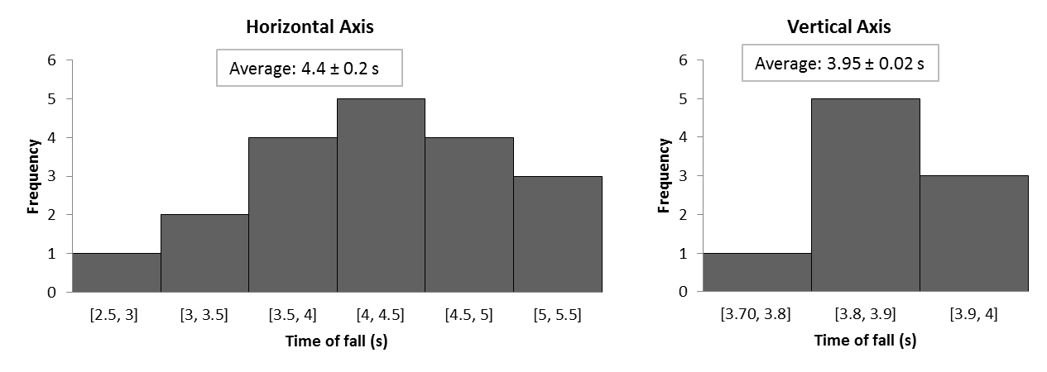
Figure 14: Histogram of falling time of best devices. Left histogram is for the rectangular device and right histogram is for the helicopter device. The relative stability of helicopter device is evident.

According to the results of measurements, both rotating devices can be considered the best device (Figure 14). For the vertical axis device, due to the rotation and high angular momentum, the motion is highly stable compared to other devices, this fact is implied by figure 14. For the horizontal axis device, it may fall within a longer time but due to instability it is not reliable. Both time of fall and variance of time of fall are significant parameters.

Online supporting materials:
Source code of the simulation program:
http://archive.iypt.org/iypt_book/2011_15_Slow_descent_Iran_HA_RMN_motion_simulation_source_code.txt
Processed video of a falling helicopter:
http://archive.iypt.org/iypt_book/2011_15_Slow_descent_Iran_HA_RMN_Falling_Helicopter_Theory_vs_Experiment.mp4
The red line indicates the predicted location of the helicopter, and the white line indicates the measured location of the helicopter.
Contours of static pressure:
http://archive.iypt.org/iypt_book/2011_15_Slow_descent_Iran_HA_RMN_Contours_of_static_pressure.mp4
Video resulted from CFD solution regarding the contours of static pressure in different angles of attack.

References:
[1] Shames I 2002 Mechanics of Fluids McGraw-Hill
[2] Garde R J 2010 Turbulent Flow New Age Science

