**IYPT 2011 PROBLEM 13: LIGHT BULB**

**Katja Kustura  
University of Zagreb, Croatia**

Introduction  
 Determining efficiency of a light bulb is a very useful task, since light bulb is a very present and widely used object in everyday life. This was our task in this year’s IYPT problem – the goal was to determine the ratio between the thermal energy and the light energy emitted from a small electric bulb depending on the voltage applied to the bulb. Our first and main plan was to distinguish useful part of emitted energy (light) from the energy losses (heat).  
 We approached this problem in two different ways. First, calorimetric method was used to experimentally separate light and thermal energy and to determine the ratio. Besides this method, theoretical method was proposed and developed, by using Planck’s law of radiation and approximating the light bulb as a grey body.

The light bulb   
 The light bulb filament is a resistor. Electrical current causes heating. When heated to temperatures high enough, the filament emits light. The law of conservation of energy for a light bulb is: electrical energy → thermal energy + light. The energy is transferred in three ways: conduction, convection and radiation (fig.1). Conduction is heat transfer by direct contact (wires, glass). Convection is heat transfer by gases, caused by buoyancy (warmer gas is lighter and thus moves upwards, transfering the energy). By conduction and convection, the electrical energy is converted to thermal energy. Since the main purpose of a light bulb is producing light, conduction and convection are the causes of energy loss. The third way of energy transfer is radiation. All bodies with temperature T>0K emit continuous electromagnetic spectrum. They radiate waves of all wavelengths, which means ultraviolet, visible, infrared, microwaves… Planck’s law of radiation explains the radiation and gives a connection between intensity of emitted light and the wavelengths, for a given temperature (fig.2). On higher temperatures the total intensity is higher. A little part of the spectrum (390-750nm) is visible. Human eye can only detect light at higher temperatures (because of the greater intensity). This is why the light bulb is heated in the first place – for the light to be detected.  
 We defined efficiency of a light bulb as a ratio between visible energy (useful) and electrical energy (total) → $η=\frac{P_{visible}}{UI}$.  
  
Calorimetry method  
 The idea of this experiment was to separate infrared and visible part of the spectrum. The bulb mostly radiates in the infrared part of the spectrum, which means that the most of its radiation energy goes to thermal energy. Separating the little part of light energy may seem as a difficult task. For this purpose, a very precise experimental setup was made to detect the light. The most famous and the most affordable visible light filter is water. It has a very high absorbance factor for all the spectrum, except for that little part of visible light (fig.3). The only flaw of this filter is that it does not absorb the 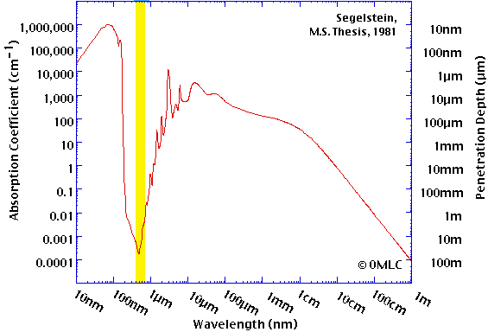radiation 300-900nm. This interval is a little greater than the interval of visible light, so a little amount of infrared and ultraviolet radiation is not absorbed, which caused small error in experiment. But, the results were still valid since they were comparable with the already obtained values (from the literature).  
 The light bulb was put in the glass vessel with water and turned on. Due to water absorbance factor for each wavelength, only visible light passed through the vessel (fig.4a). The rest of the spectrum stayed in the vessel and heated the water. The water temperature was measured with the precision of ${10}^{-4}K.$ Graph showing the change of 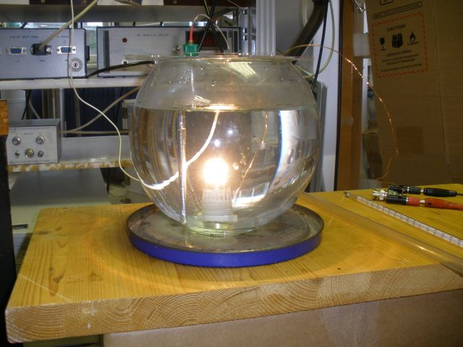temperature in time was obtained (graph 1). The measurement was repeated, but this time *carbon* was put inside the water, which made it black, not transparent for visible 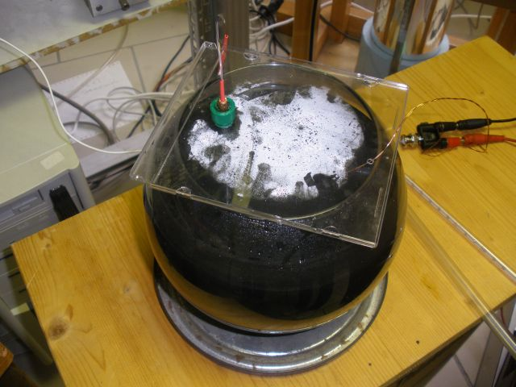light (fig.4b). All the energy produced by the light bulb stayed in the water and heated it.   
 We obtained another temperature-time graph. By comparing heating rates we measured the ratio between visible and total energy (efficiency of a light bulb). Power heating the water in the first case: $P_{1}=UI-P_{300-900nm}=C{\left(\frac{dT}{dt}\right)}_{1}=Ca$. Power heating the water in the second case: $P_{2}=UI=C{\left(\frac{dT}{dt}\right)}_{2}=Ca^{'}.$ Here *C* is heat capacity of the system, and a,a’ are heating rates – slopes in T,t diagrams. Efficiency of a light bulb is

Planck's Law

$$I\left(λ,T\right)=\frac{2hc^{2}}{λ^{5}}\frac{1}{e^{\frac{hc}{λhT}}-1}$$

cond.+conv.

Figure 2. Black body radiation for 3 different temperatures

radiation

P=UI

Figure 1. Transfer of energy



Segelstein,  
M.S. Thesis, 1981

a  
b  
s  
o  
r  
b  
a  
n  
c  
e

λ/nm

Figure 1. Absorbance factor of water

Figure 2b. Light not passing through

Figure 4a. Light passing through

$$a_{3}$$

$η=\frac{P_{300-900nm}}{UI}=1-\frac{a}{a'}$.

Black body method  
 Light bulb was considered as a grey body. It behaves as a non ideal black body – it radiates electromagnetic spectrum with intensity dependant on temperature, but with emissivity factor ε (constant over all wavelengths and temperatures). Stefan-Boltzman law: $σSεT^{4}=P_{visible}+P_{IR}$ where S is the surface of the body, and T its temperature (here we neglected all the other parts of the spectrum, ultraviolet, microwaves… because these energies are much smaller than in infrared and visible spectrum). If we relate this law to law of conservation of energy, we can derive ratio $\frac{P_{IR}}{P_{V}}$ as a function of temperature, i.e. $\frac{P_{IR}}{P_{V}}=f(T)$. The final formula is $η=\frac{σSεT^{4}}{UI\left(\frac{P_{IR}}{P_{V}}+1\right)}$. Thus, for calculating the efficiency we need to know temperature of a filament as a function of voltage, value of σSε constant and ratio of powers PIR/Pv as a function of voltage.  
 From the literature, we knew the connection between filament resistivity and temperature. Measuring U-I characteristics of a bulb, we determined resistance (in dependence on voltage). By knowing the resistance at the room temperature, with little transformations we got final graph showing the dependence of temperature of a filament on a voltage applied (graph 2).

**Graph 1. Temperature-time dependance**

- phase 2: light bulb turned on  
- phases 1 & 3: light bulb turned off (small temperature change!)

- determining dT/dt: $$a=a_{2}-\frac{a_{1}+a_{3}}{2}$$



We rewrite the law of conservation of energy: $UI=α\left(T-T_{0}\right)+σSε(T^{4}-{T_{0}}^{4})$, where the first member is due to conduction and convection, and the second is from radiation. We can write this as $\frac{UI}{T^{4}-{T_{0}}^{4}}=\frac{α(T-T_{0})}{T^{4}-{T_{0}}^{4}}+σSε$. It is obvious that for $T$ ≫ $T_{0}$ value UI/T equals σSε. From this graph we determined the constant σSε (graph 3).   
 The program was created in C programming language to determine the ratio PIR/Pv as a function of temperature. In this program the only input was the temperature. The program then plotted Planck's curve and numerically integrated the visible part of the spectrum (the limits were 300 - 900nm) and then the ratio of visible and total energy was calculated. This result was compared with the result obtained in the calorimetry method.  
  
Final results  
 By calorimetry method, efficiency of light bulb (ratio PIR/Pv) was determined for 4 different voltages. Using black body method, we got theoretical predictions for light bulb for a greater interval of voltages. The results were put on the same graph to compare the methods. In experimental setup, light of wavelengths 300-900nm was considered as visible light (because water did not absorb that part of the spectrum and we were able to separate it from the rest of the spectrum). In our theoretical calculation, limits were the same, because the goal was to compare these two methods for their validation.  
 From the graph it can be seen that both methods got similar results (graph 4). Theoretical prediction for 300-900 nm limits matches the experimental results. Although in our limits we took 300-900nm instead of a smaller interval of visible part of the spectrum, from this results we see that the theory is valid, which means it can be used to determine the real efficiency of a light bulb (limits 390-750 nm).  
 Finally, since the initial task was to determine the ratio between thermal energy and the light energy, that is what we did in our last graph (graph 5). The efficiency was defined as $η=\frac{P_{v}}{UI}=\frac{P_{v}}{P_{v}+P_{IR}}$. Transformations of expression lead to formula $\frac{P_{IR}}{P_{V}}=\frac{1}{η}-1$.



**Graph 3. UI/T^4-temeprature dependance**

**Graph 2. Temperature-voltage dependance**



$$a_{1}$$

$$a_{2}$$

**Graph 4. Efficiency-voltage dependance**

**Graph 5. Ratio PIR/Pv** **-voltage dependance (real light limits)**

Conclusion  
 In this paper the efficiency of a light bulb was studied and determined. Two methods were proposed. We experimentally determined efficiency using calorimetry method. In this experiment we assumed that the visible part of the electromagnetic spectrum was 300-900nm, because these are the limits between which water does not absorb the radiation. This property of water was used to separate light energy from thermal energy. The results were then compared with the expected results that we got using our theoretical method. In this method we created a program that calculated PIR/Pv ratio for each temperature, between wanted limits. For limits 300-900nm, the theoretical results were compared with our experimental values. Two approaches showed a good agreement. Once we confirmed our theoretical method, we changed the limits in the program to 390-750nm and obtained the final results and the dependance of ratio of thermal and visible energy on voltage applied to the bulb.  
  
References  
[1] Ilya Martchenko, Université de Fribourg & Lunds universitet , 2011. *–* Preparation to the Young Physicists’ Tournaments’ 2011   
[2] Charles de Izarra and Jean-Michel Gitton, *Eur. J. Phys.,* 2010. *–* Calibration and temperature profile of a tungsten filament lamp  
[3] H. A. Jones, *Physical review,* 1926. *–* A temperature scale for tungsten  
[3] G.M. Hale and M.R.Querry, *Appl. Opt. 12, 555-563,* 1973.  *–*  Optical constants of water in the 200nm to 200μm wavelength region  
[4] Segelstein, D., M.S. Thesis, University of Missouri, Kansas City, 1981. – The Complex Refractive Index of Water