Problem No 4 (2010). “SOAP FILM”
Alexander BARNAVELI
I.Vekua Phys-Math school No 42. Tbilisi, GEORGIA
( s.barnaveli@gmail.com )

Problem: Create a soap film in a circular wire loop. The soap film deforms when a charged body is placed next to it. Investigate how the shape of the soap film depends on the position and nature of the charge.

- The Soap Film Structure

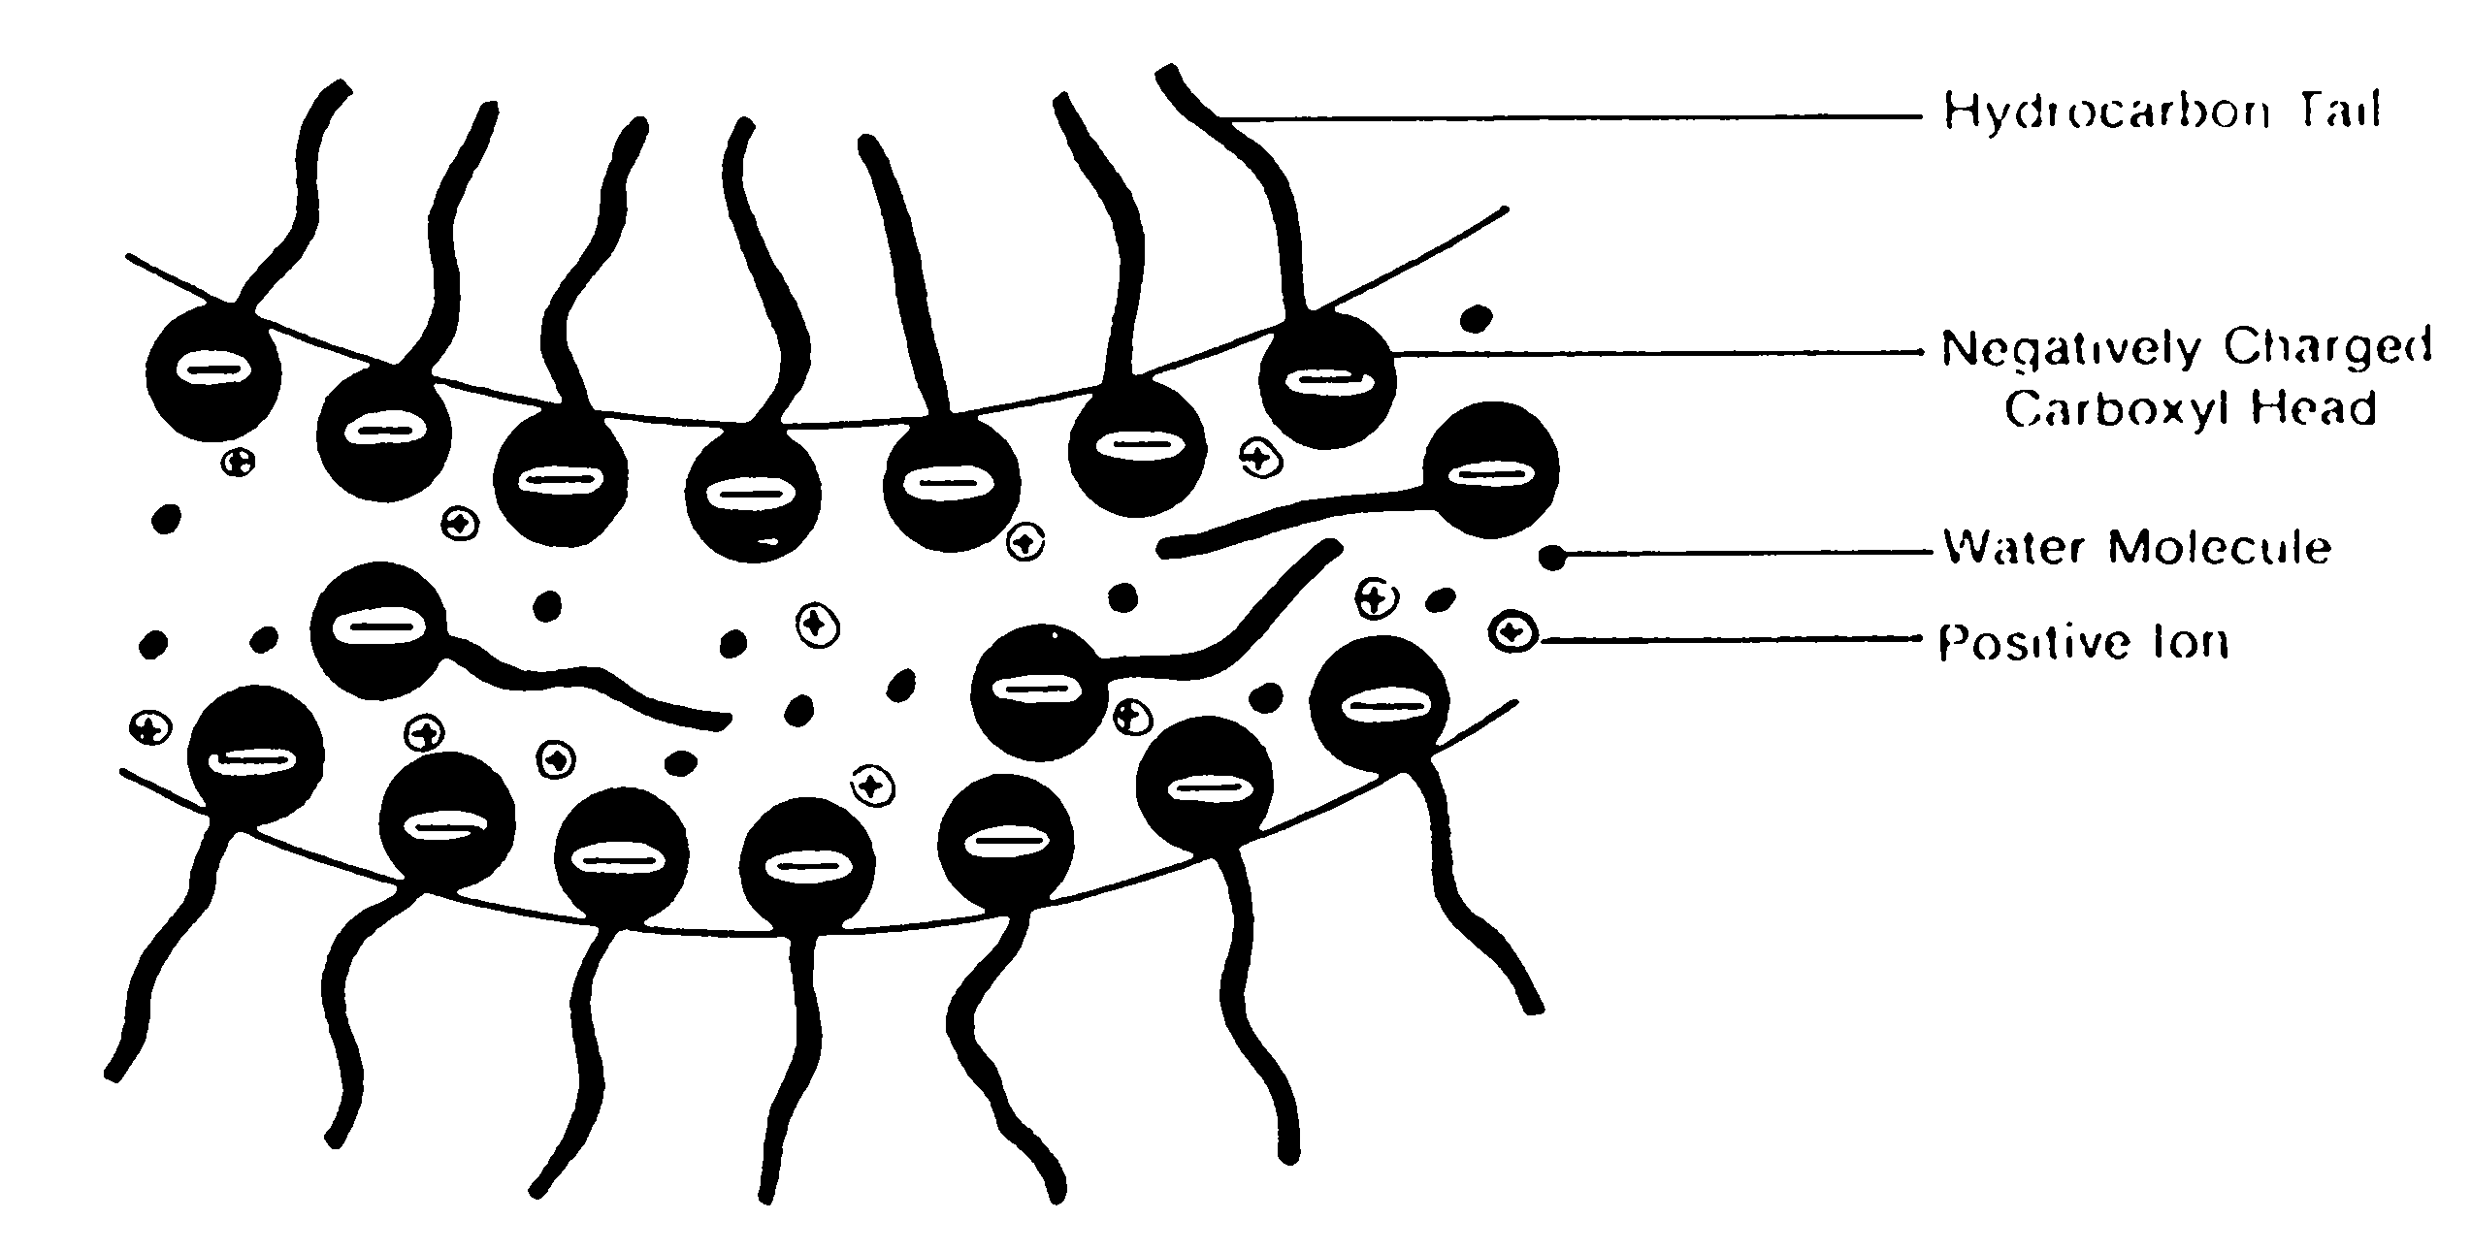
Let us start investigation of this problem by considering the soap film structure ^{[1]}. Soap film is formed by surface active agents (Surfactants). There are two layers of soap molecules, between which there is water (see figure).
Soap molecule is divided into positive Na⁺ and negative C₁₇H₃₅COO ⁻ ions.
Negative ions collect on the surface of film and they form surface structure.
Between two layers of film there are water and Na⁺ ions.
Figure 1. Soap film structure.

Soap molecules play the important role in the film formation. They:
- Form the surface structure of soap film;
- Decrease the evaporation of water;
- Decrease the surface tension.

Also, this difference in the positive and the negative ion distribution in a soap film causes a very interesting phenomenon, which will be discussed below.

In some of our experiments we added a small amount of glycerin to soap, because the glycerin decreases the water evaporation from the surface and also stabilizes the soap film. So, due to the glycerin a soap film gets an "extra duration of life" and becomes more elastic.

- The experimental Setup
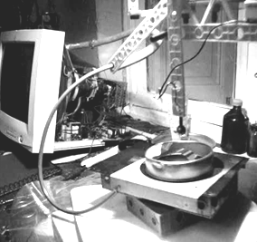
Now let us describe our experimental setup. We used:
- A voltage source - an old CRT monitor, which provides 27 000 Volts;
- Electrodes of different forms;
- Different distances between the electrodes and the soap film;
- A metal loop (frame) for the soap film - grounded one and not grounded;
- A dielectric loop (frame);
- Different sign of body charge (and this gave Figure 2. Experimental setup.
different results !!!).
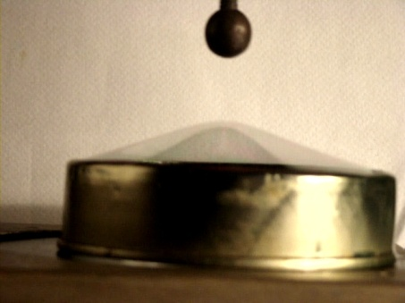
- A spherical charged body
We began experiments with an interaction between a spherical charged body and a soap film.
It was observed, that:
- As larger the distance d between sphere and film - the less the influence (deformation);
- In the case of d~5 cm, the height h of the film deformation in the center was about 1 cm and the film remained stable;
- For the small d~h, the stable state did not occur. Film continued to stretch, discharge developed and film exploded. Figure 3.

Let us explain this theoretically. In such interaction the electrostatic force is balanced by the surface tension force. The latter can be calculated by means of Laplace equation while the electrostatic force between the charge and the film can be calculated using an "electrostatic image method". Equating the Coulomb and the surface tension forces we can calculate the dependence of h on the sphere charge Q and d. We will use the approximation, when the deformation is much less than the loop radius and the distance to the charged sphere.
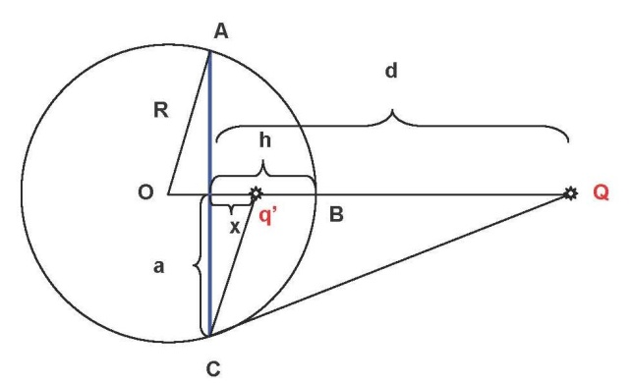
Electric force.
- The external field redistributes the charges on the film;
- The film surface is equal-potential;
- The interaction between the charge and the grounded sphere film can be "effectively" presented as the interaction between the two point charges;
- The value and the place of "effective" charge must give equipotential film surface;
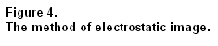
- We assume that the film is a sphere segment ABC of the height h
- AC – the loop (frame) of a radius a.
- Q – the external charge, at the distance d>>h
- q’ – the "effective" charge at the distance x from the loop.
From the Figure 4 the condition of φ_{B} = φ_{C} = 0 (a grounded film) leads to the following values:

$x=\frac{2a^{2}h- a^{2}d+ h^{2}d}{a^{2}+ 2dh- h^{2}}$ ; $q^{'}=-Q\frac{a^{2} + h^{2}}{a^{2}+ 2dh- h^{2}}$ , (1)

and the effective electrostatic interaction force will be:

$F_{k}=kQ^{2}\frac{{(a}^{2} + h^{2})(a^{2}+ 2dh- h^{2})}{4{(d-h)}^{2} {(a^{2}+ dh)}^{2}}$ . (2)
This force must be balanced by the surface tension force.
Surface tension force.
Using the Laplace formula P_{l} = 4σ₀ / R and taking into account, that
$$R=\frac{a^{2}+h^{2}}{2h}$$
we obtain
$p=\frac{4σ_{0}}{R}= 4σ_{0} (\frac{2h}{a^{2}+h^{2}})$ .

If we write down F_{l} = pS , we will get that the force of the surface tension is
$F_{l}=8πσ_{0} h$ . (3)

Balance of Electrostatic and Surface tension forces.
Using the force equilibrium condition F_{k}=F_{l} for (2) and (3) we get:

$kQ^{2}=\frac{32πσ_{0} h (d- {h)}^{2}{(a^{2}+ dh)}^{2}}{(a^{2}+h^{2}) (a^{2}+ 2dh-h^{2})}$ . (4)

It is quite a complicated formula, so to make it clearer, let us use the approximation, when h << a ; h = a = R. We can do it for our case, since the film stretch in our experiments was small compared to the frame radius. In this approximation the equations (1),(2),(4) get the form:
x ≈ 2h – d ; q’ ≈ -Q ; F = kQ²/(4d)² ; kQ² = 32π$σ_{0}$hd² , (5)

where from we get the dependence of h on Q and d:
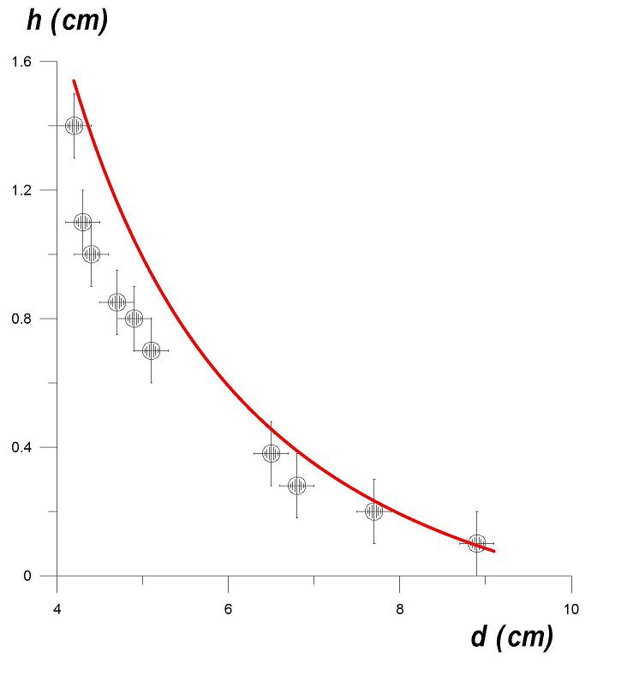
$h= \frac{k}{32π}∙\frac{Q^{2}}{σ_{0}d^{2}}= \frac{1}{128 π^{2} ε_{0}}∙\frac{Q^{2}}{σ_{0}d^{2}}$ . (6)
Let's calculate h for our experiment. This dependence is given on the graph.
For a 1cm radius charged sphere, at the potential φ = 27 000 v, we get:
Q = Cφ = 4πε₀r· φ ≈ 3 · 10⁻⁸ Coulomb.
Noting that σ₀ ≈ 25 · 10⁻³ n/m, for the distance d = 5 cm from (6) we get h ≈ 1 cm, that is quite near to our experimental results.

Figure 5.
The dependence h(d) for the stable states: (experiment - points; theory - curve).

Let us make some notes. From the (3) and (2): F_{l} ~ h ; F_{k} ~ 1/(d-h)². If h << d, the F_{l} increases with h faster than F_{k}. So the stable equilibrium is reached. If h ~ d, situation is opposite - F_{k} increases with h faster than F_{l} , so the film stretches and explodes.
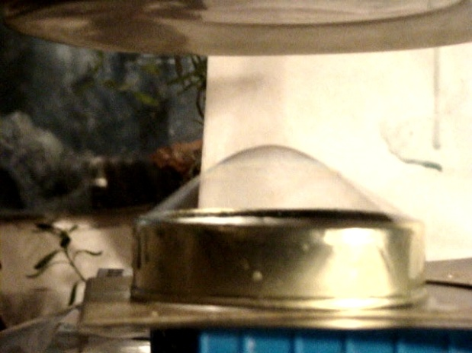
- A flat charged body
By the flat charged body the film deformation was larger (see Figure 6) because the field was stronger.
However without grounding the stretch of the film was significantly less because in that case the ions could not “leave” the film.

- An approximately uniform field
To obtain the uniform field we used two parallel large lids. The bottom lid was grounded while to the top lid the high voltage was applied. The film was formed Figure 6.
on a plastic (dielectric) loop. In the uniform field Flat charged body.
the film did not stretch, due to the force symmetry.
In the strong field the film simply was torn by the forces acting on the positive and negative charges.

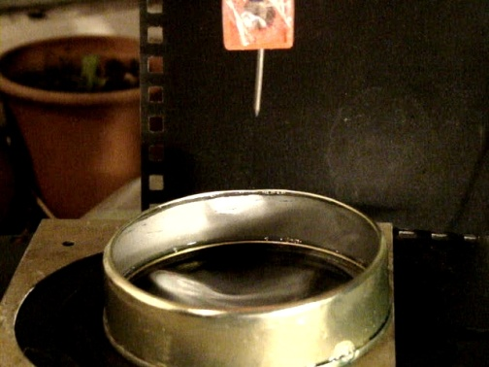
- Interaction of film with charged nail.
In this case the soap film did not stretch out, but the dip was formed, as if there blew the wind from above. The observed dip (instead of a "hill") was caused by so called "electric wind", which blew rather strong and this strength was greater than the strength of attraction.
Electric wind takes place when the density of charge on the electrode is very high (like the case of nail-type sharp electrode) and electric field near it is very strong. The field at the bottom of the nail polarizes the air Figure 7.
molecules and strongly repels the electrons. Sharp-ended body.
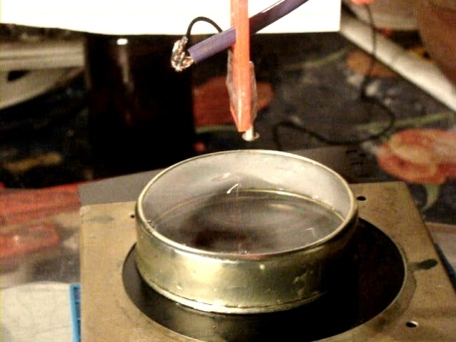
They hit the film and form the above-mentioned dip. The fact that this wind was caused by charged particles we proved by the following experiment. Instead of soap film we placed the detector of charged particles and it fixed a large amount of accelerated particles.

- Interaction of film with small-headed
charged body.

In this case the observed behavior reveals both processes - the electric wind and the attraction towards electrode. Both – Figure 8.
the "dip" and the "hill" are formed. Small-headed charged body.

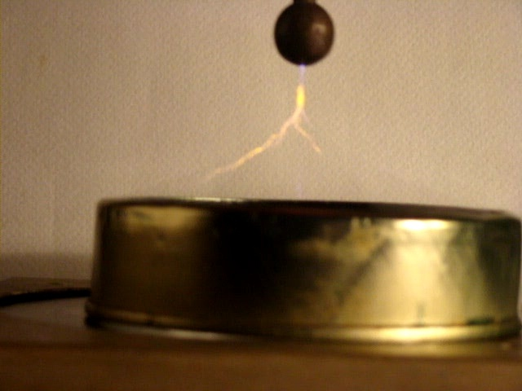
- The asymmetry with respect to the change of poles.
As we mentioned in the beginning of this article, the difference in the positive and the negative ion distribution in soap film causes a very interesting phenomenon. It took place when we changed the poles, i.e. the charge sign of the body. It seems to be the most interesting result and now let’s carefully consider it.

In our experiments we observed, that change of the poles (i.e. charge sign of the body) affects the shape and the color of discharge on the soap film. Parameters Figure 9.
of spark are dependent on the sign of Discharge (yellow). Positively charged body.
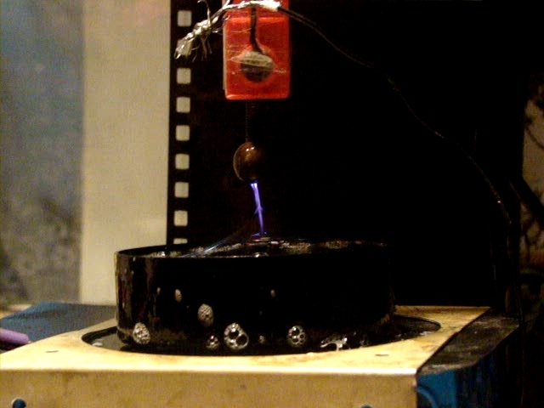
the electrode charge. When electrode was charged positively, discharge was spread and yellow, while when the electrode was charged negatively, discharge was bluish and straight.

What is the reason of this?
At high temperatures the atoms emit the electromagnetic waves (photons). Frequency of emitted light depends on the transition energy between two levels in atom: E_{Photon}=hν, where h – is Planck constant, and ν - frequency of emitted light. It is known, that Sodium (Na) emits yellow light, while Nitrogen - bluish- lilac light. Thus we can conclude Figure 10.
that when electrode is charged negatively Discharge (blue). Negatively charged body.
the light is emitted by the atoms of Nitrogen
(which are present in air) while in the case of positively charged electrode, the light is emitted by Sodium (Na) atoms. Why it is so?

The Negative external charge accelerates the electrons toward the film. The accelerated electrons strike the Nitrogen atoms of air and cause their bluish-lilac emission. Also, in this case the positive Na⁺ ions in soap are attracted by the negative external body, move freely towards the point nearest to it, concentrate there and cause the straight form of discharge.

In the case of positive external charge heavy ions of air accelerate towards the film. These ions hit the film and punch out of it the positive Na⁺ ions which cause yellow color of discharge. Besides, in this case the punched out Na⁺ ions are attracted by the negative ions of soap (these negative ions form the soap film structure and are more or less “spread-fixed” around the film surface area). Thus discharge becomes more "spread" (here we see the charge shape asymmetry with respect to pole sign. It is caused by the soap film ionic structure – different “flaw freedom” degree of the positive and the negative ions). In this case we also saw that most upper part of the spark is blue, while the main yellow region is under the level which can be reached by the punched out Na⁺ ions.

- Conclusion.

In this work we studied the soap film interactions with the charged bodies. The different shapes of the charged bodies were tested and the resulting film deformations were examined
We found out that film deformation strongly depends on:
  - The shape of the charged body
  - The charge value
  - The distance from the film
  - The grounding of the loop on which the film is formed
  - The soap film structure
Also, a very interesting phenomenon of the discharge asymmetry with respect to the change of poles was observed. We explained it by the specific ionic structure properties of a soap film.

Finally I want to thank my grandfather Tengiz Barnaveli for his help in the experiments with the high voltage.

References
[1] Cyril Isenberg. The science of Soap Films and Soap Bubbles. Dover Publications, NY 1992.

