SOAP FILM

Una Pale
XV gymnasium, Faculty of electrical engineering and computing,
University of Zagreb, Croatia

1. Introduction
When a soap film is created and placed into the electrical field it deforms. Aim of this paper is to explore and explain why the electrical field affects the soap film. It will also investigate how the parameters: electrical field (voltage), distance from charge and radius of soap film determine the shape of soap film.
2. Theory
2.1. Soap film
Soap is a molecule that consists of two parts: long hydrocarbon chain and ionic end. Long hydrocarbon chain is non polar and therefore hydrophobic, while ionic end on the other side is polar and creates ion-dipole bond with water [Figure 1] It means that it is hydrophilic and soluble in water. Hydrophilic part of molecule orientates towards water molecules, while hydrophobic tends to be the furthest form water and goes to surface. This helps to visualize how the soap film looks in microscopic scale. It consists of two layers of soap separated with water layer. [Figure 2] If there is too high concentration of soap soluted in water soap molecules start to form clusters. While soap molecules are pretty compact on the surface, water molecules, ions and charges in water layer are free to move. Thickness of film is between 20μm and 5nm.
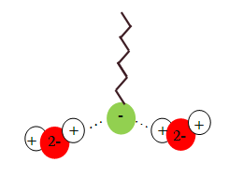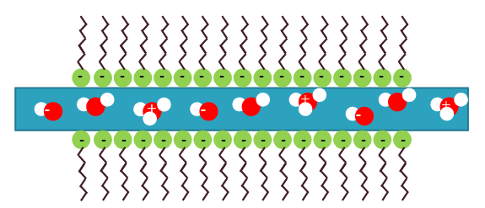
Figure 1: Soap molecule Figure 2: Soap film

Since there are attractive Van der Waals forces between molecules, soap film as liquid in general tends to have the smallest surface area. Because of the 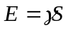 where E is energy and is surface tension, the liquid, or in this case soap film has a resistance to change of shape because it would mean greater energy.
2.2. Soap in an electrical field
When we put soap in an electrical field there are few possibilities: soap can be isolated in air, or can be grounded through the framework it is stretched on.
When it is isolated it means that it is neutral as a whole, and when it is put near charge the charged particles in water move and the charge redistributes. Here the potential is not zero. In other case, when it is grounded and put near charge, free charges come from or go into the ground. Now the number of positive and negative charges in film is not equal and film is charged as a whole and the potential is zero. [Figure 3] The soap film deforms. Because of the radial electrical field the forces are not the same on all parts of the film. They are the strongest in the middle because there is the smallest distance. That’s why opposite charges of the one causing electrical field come in the middle of the film and elongate the film. But in fact, the polarity of charge doesn’t effect the direction of elongation of the film. In one case positive charge in film comes in the middle of the film and in another negative comes in the middle but it always elongates towards the charge causing the electric field.

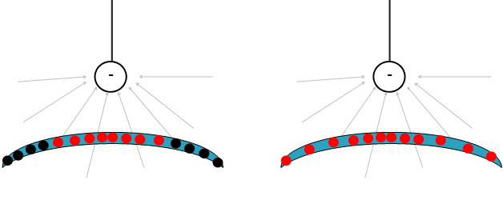
Figure 3: a)isolated soap film b)grounded soap film near charge (in radial electric field)
If soap is in homogenous electric field e.g. between two oppositely charged plates a different behaviour occur. If the soap film is isolated nothing happens [Figure 4a]; there is no deformation because the force on positive and negative charges are equal but in opposite directions. If the film is grounded additional charges come to soap and they tend to be far from each other. The surface is stretching until achieving the equilibrium when electrical force is the same as the surface tension force. [Figure 4b] Instead of putting soap inside two metal charged plates (huge capacitor) soap was stretched on one of these two plates. Now if the plate with soap was isolated the 20kV wasn’t enough to notice the deformation that could be measured, and if the plates were too close sparks appeared. If the soap was grounded nice deformations were noticed and for this case theory will be presented later. This situation is almost the same as when grounded soap is between plates.
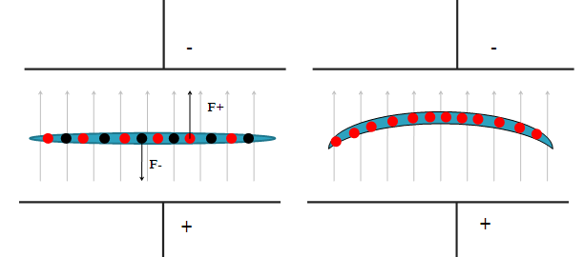
Figure 4: a) isolated b) grounded soap between two oppositely sharged plates
22.3. Homogenous field
When the effect is achieved, it can be noticed that the deviation is small (less than 4 cm) and later when the shape was more precisely observed that it could be described as a parabola. Since the deformation was small two assumptions were made: the surface charge density is homogenous; 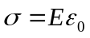 and secondly that parabola could be approximated as a part of the circle. From [Figure 4a] the equation of the parabola describing the shape of elongated film can be written: 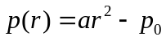 and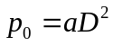, where a is coefficient of parabola, (r,p) are (x,y) coordinates of some point on the soap film curvature, 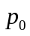 is elongation and D is radius of the hole in plate. If it is approximated with a part of circle it can also be written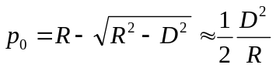, where R is radius of imaginary circle the soap is part of. From last three equations a relation between radius of imaginary circle and coefficient of parabola can be found: 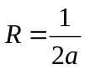.
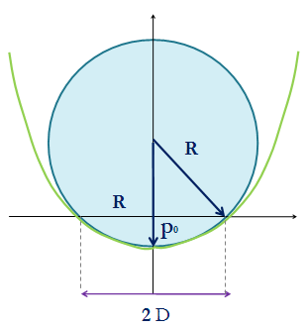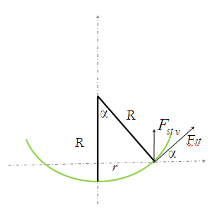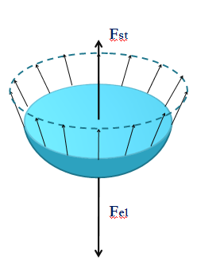
Figure 5: a)geometry of soap film b)surface tension c) net force is zero

When the film is elongated it means that resultant force is 0. It means that the surface tension force and electrical force are equal but in opposite directions. [Figure 5c] Surface tension acts in tangential direction [Figure 5b] but for the stabilisation (when film stop with stretching) only the vertical component matters. Total surface tension force is 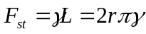 where is surface tension and r can be seen on [Figure 5b]. Using the geometry [Figure 5b] 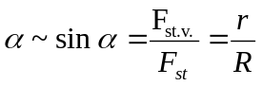 a vertical component is 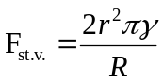. At the same time the electrical force is 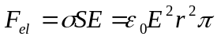. Net force is zero; 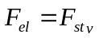. From that equation 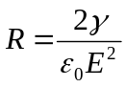 and 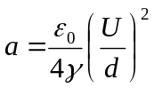is get; where U is voltage between soap (plate on which soap was stretched) and plate and d is distance between those two plates.
2.4. Radial field
In this case the shape of the film is more complex and the surface charge density is no more homogenous. Moreover here is possible to observe case when soap is grounded and when it isn't. All these parameters affect the shape which was too hard to predict and explain theoretically because everything starts with the distribution of charges on surface which wasn’t possible to observe or determine. But the measurements were made.
In all cases the effect of gravity was neglected because preresearches showed that the effect is too small to be measurable.
3. Apparatus
A voltage source from 1-25kV was necessary to create electrical field strong enough to deform film enough to be able to recognize it. The soap film was stretched on one metal plate with a whole. Plates with three different diameters of holes were used; 13, 26, 39 cm. And there was one without a hole. Between those plates was always isolator so there wouldn’t be arcing. [Figure 6a] A steel sphere was used to create a radial electrical field. It was put above the plate with soap [Figure 6b].
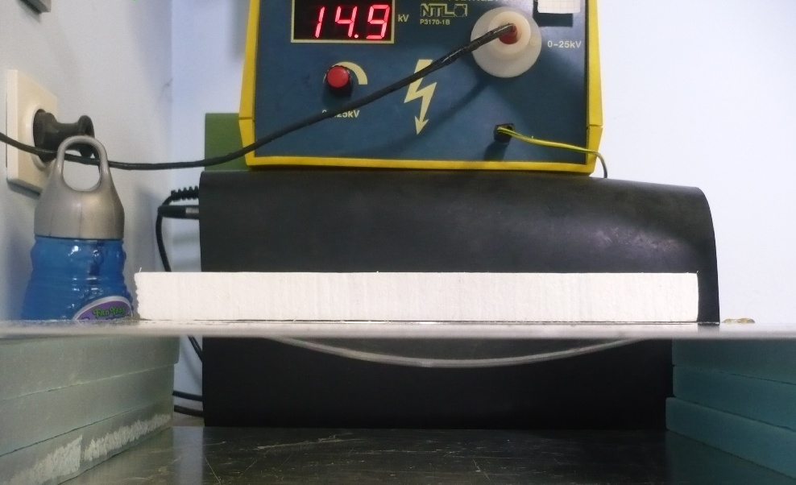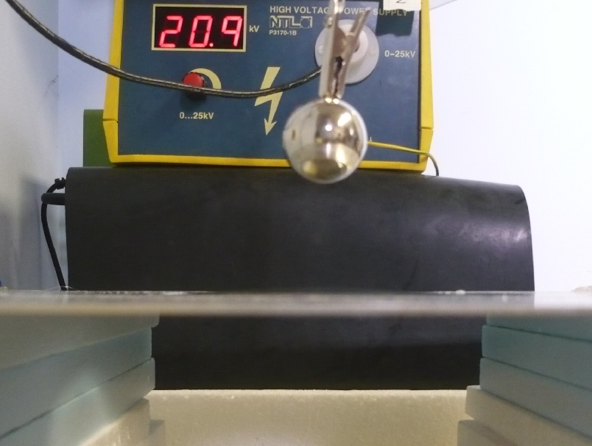
Figure 6: a) soap in homogenous field b) soap in radial field

4. Methods
The shape was described with coefficient of parabola and the elongation. These two values were measured and determined from pictures made from side view. They were processed the program “ImageJ”. This way the dots of the shape were chosen and then a mathematical function could be fitted. The equation that determines shape was determined [Figure 7a,b].
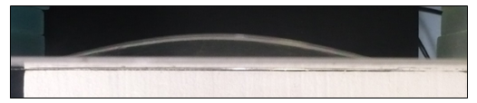
Figure 7: a) soap film photographed from side wiev, ready to process

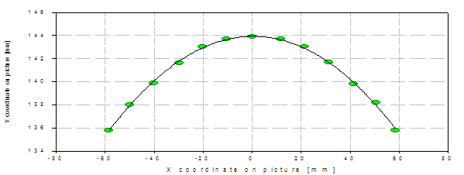
Figure 7: b) the picture processed, mathematical function fitted

The extension of soap film and coefficient of parabola shape were determined for different diameters of soap film, different voltage and different distance from charged body or distance of plates. First soap was stretched on a plate with a hole which was above another plate. These plates were at certain distance and voltage. Second case was with a radial electric field where a spherical metal ball was hold above soap film. A distance and voltage between plate and sphere was changed. Also the measurements for isolated and grounded soap were conducted.
5. Results
5.1. Homogenous field
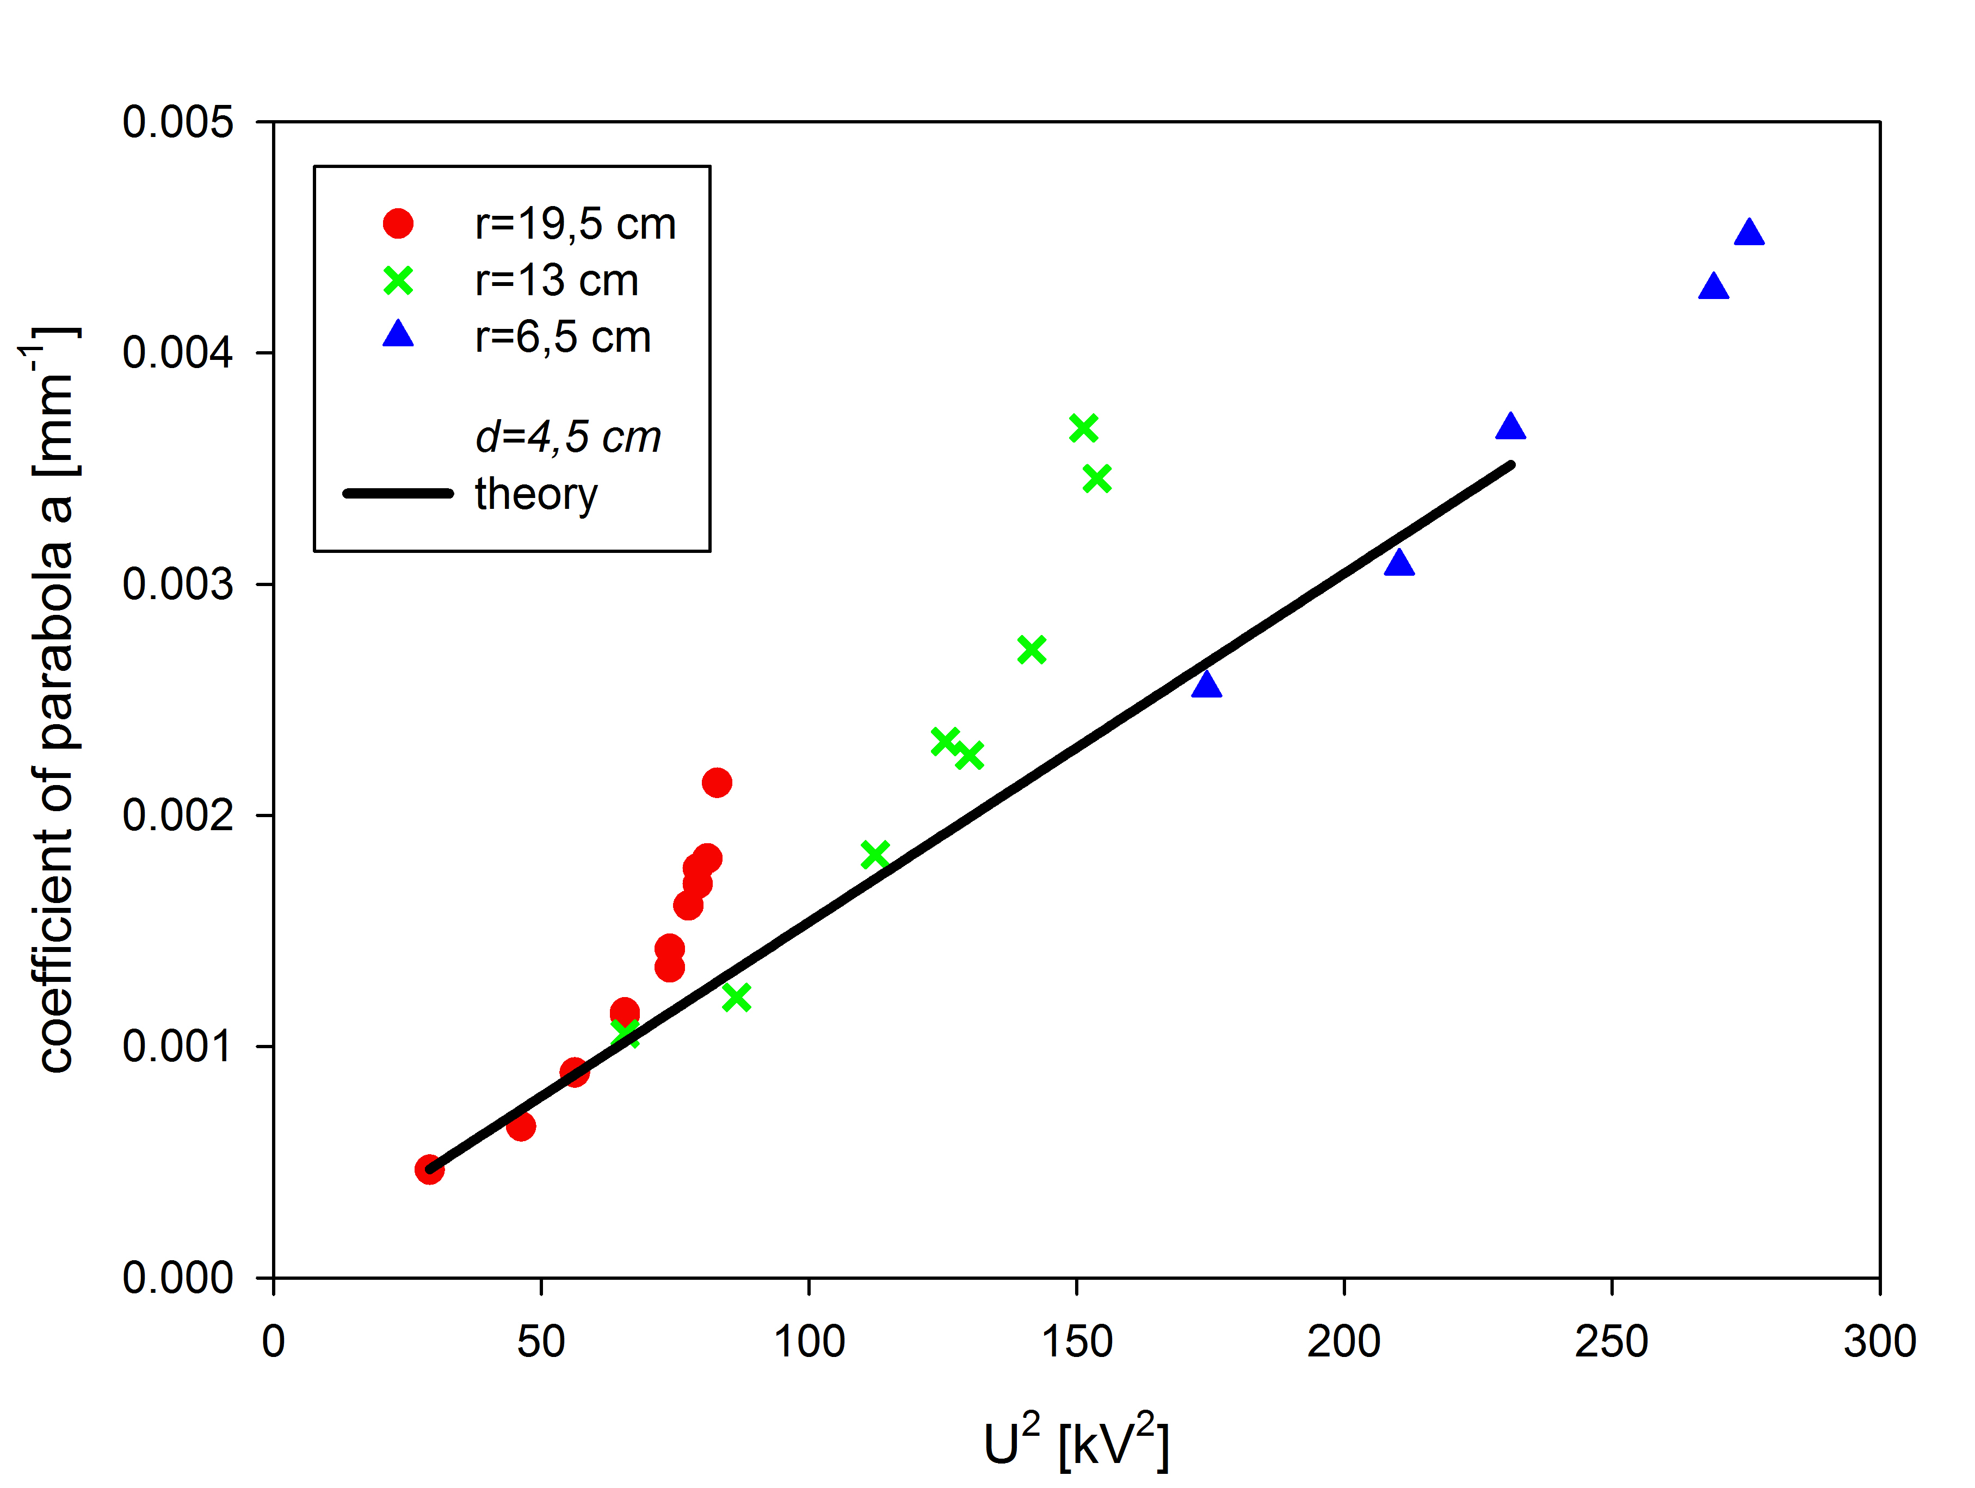
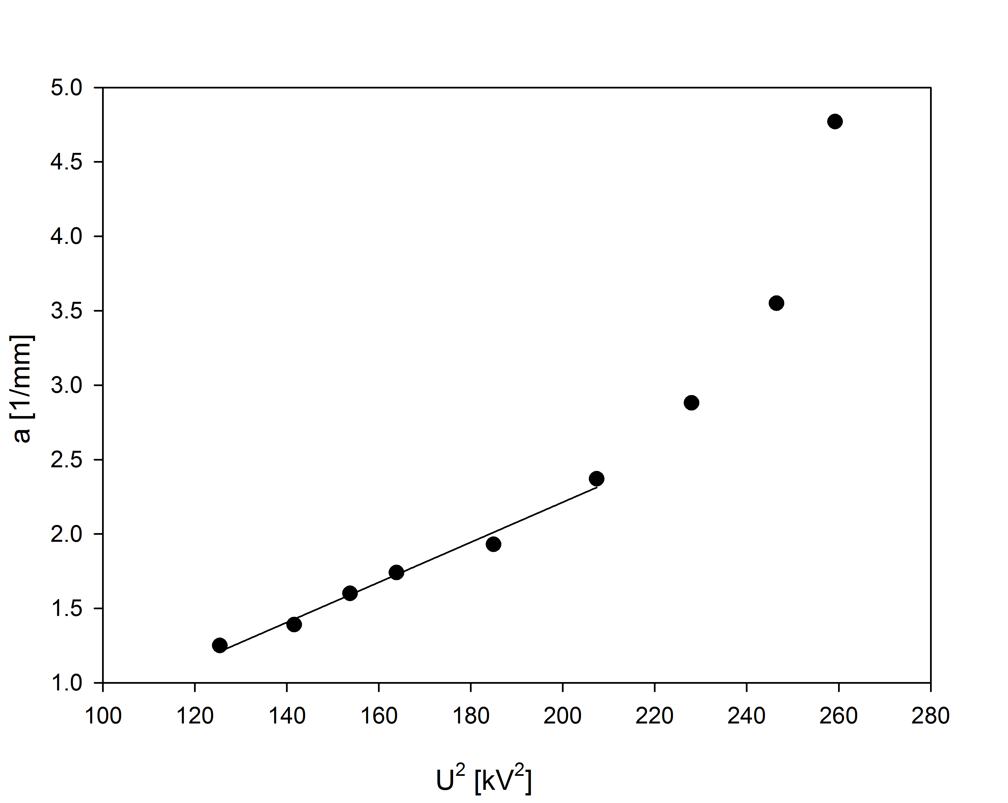
Graph 1: Parabola coefficient dependance on voltage
Graph 4: Parabola coefficient dependance on the radius of soap film
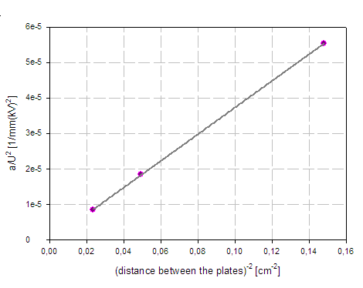
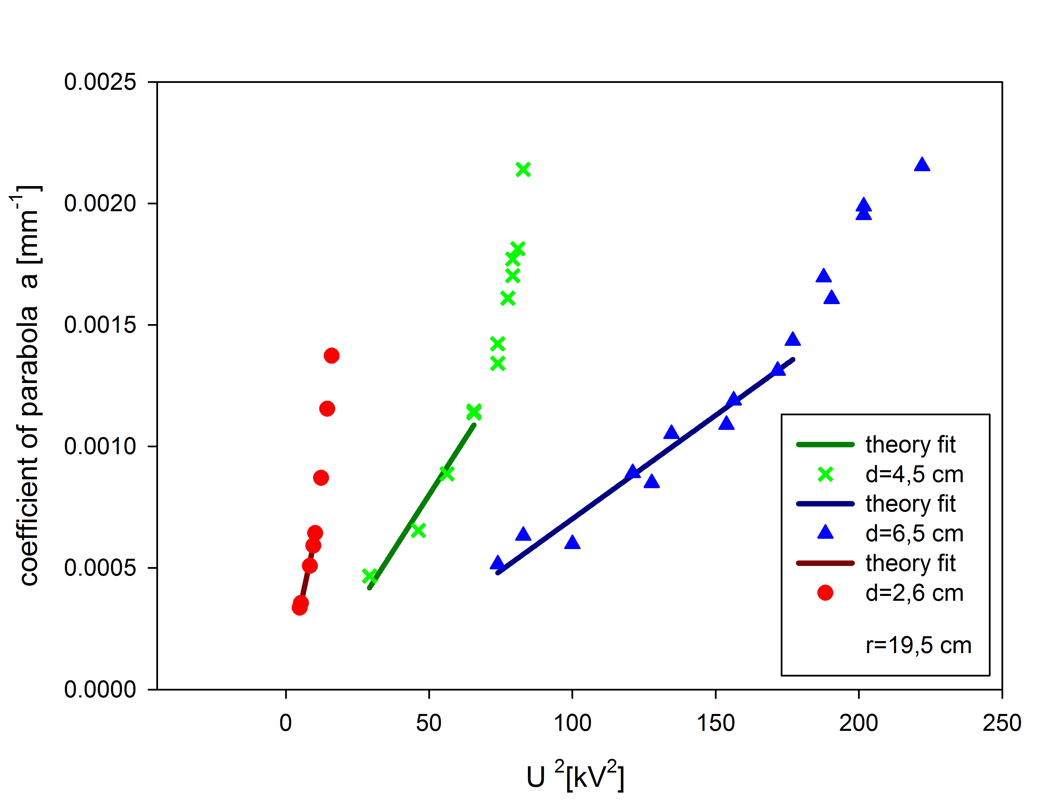
Graph 2: Parabola coefficient dependance on voltage for different distanced from plate
Graph3: Coefficient of lines from previous graph b; in dependance on distanced from plate
On [Graph 1] it can be seen that coefficient of parabola is proportional to the square of voltage which agrees with. The coefficient of line is free parameter, because too many parameters affect it which couldn’t be precisely measured. It can also be seen that after certain voltage dependence is not linear any more. It's because above that voltage the deformations become bigger and shape is more complicated. Moreover, assumption that the surface charge density is homogenous wouldn't be appropriate any more. Also, it was observed that the soap film becomes very unstable; starts to vibrate up and down and soon bursts. From [Graph 2] coefficient dependence on square of voltage for different distances of plates is noticed. These lines have different slopes. The coefficient b is slope of lines which is shown on [Graph 3]. Here is clearly seen that they depend linearly on 1/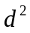 because of 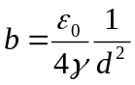. [Graph 4] shows that coefficient of parabola a doesn’t depend on the radius of plate D. This is also good correspondence with theory.
5.2.Radial field
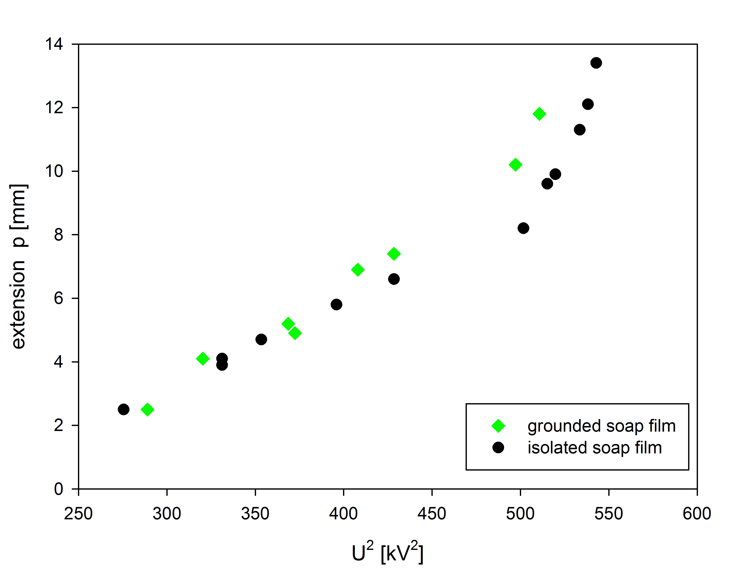
In this case the shape of film was too complex so only the elongation was measured. In [Graph 5] extension p for different voltage is shown for both grounded and isolated soap film. It can be seen that there is a difference, but it's hard to say how important the difference is. It is logical that for isolated film greater voltage is necessary than for grounded because in grounded there are additional charges that came from ground and affect the electrical force. From [Graph 6] and [Graph 7] it’s seen that the diameter of soap film and distance from charged ball also affect the extension. For smaller radius the surface tension force is greater so bigger voltage is necessary for the same extension. Also if the steel ball is closer the electrical forces are greater so smaller voltage is needed for same extension. In case of radial field there is qualitative explanation but quantitative conformation of measurements with theory is missing.
Graph 5: Extension p for grounded and isolated soap film
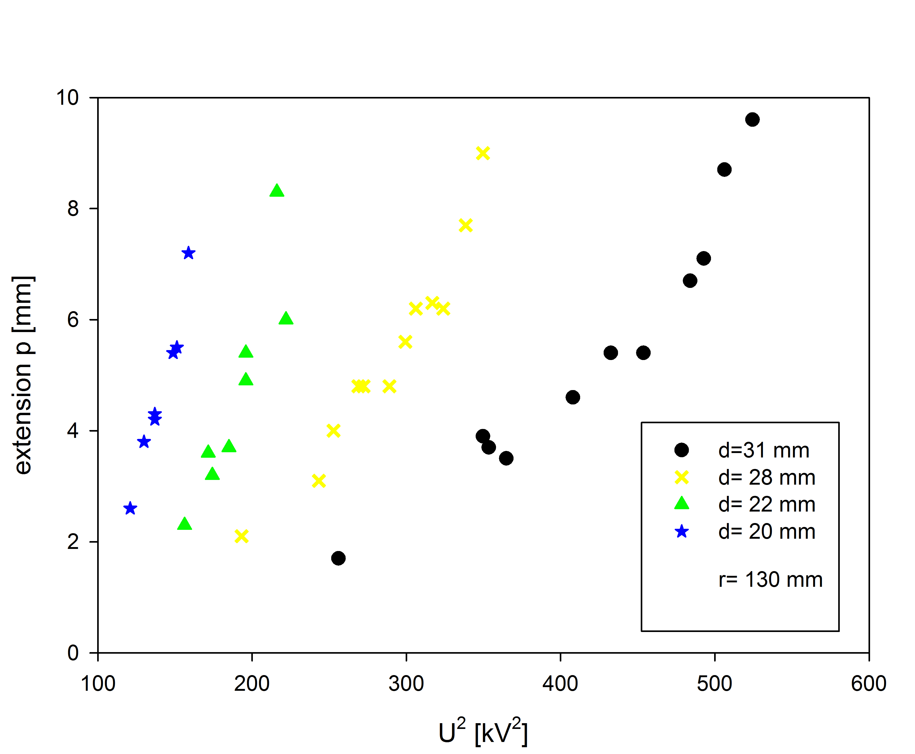
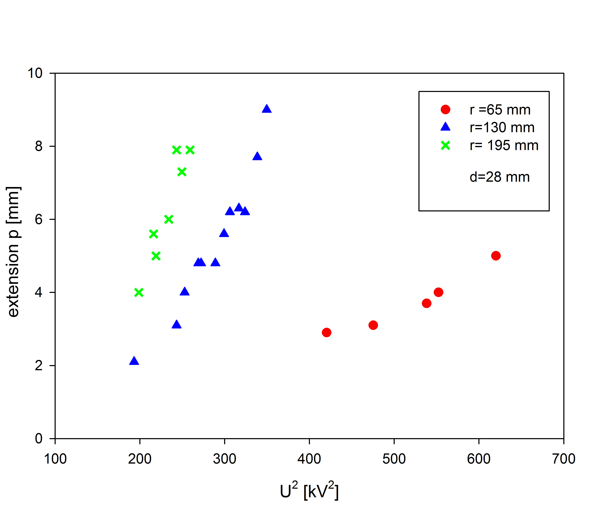
Graph 6: Extension dependence on voltage for different distance from steel ball
Graph 7: Extension dependence on voltage for different radius of soap film

6. Conclusion
The effect of shape deformation of a soap film in different electrical fields was observed. Two cases were studied; when a charged body is a sphere which creates a radial electrical field and if a charged body is a plate which creates homogenous field. If the soap is between two oppositely charged plates there is no deformation because the forces on positive and negative charges inside of film are the same. That’s why soap was stretched on a hole in one of these parallel plates. Also two cases were studied, with isolated soap and with grounded. If it was isolated the 20kV was not enough for film to elongate more than few millimetres and measurements couldn’t be done. That’s why the paper is orientated to grounded soap film. For small deformations the distribution of charges on film is homogenous, and shape was represented as parabola, part of the circle and the quantitative predictions were made. Parabola coefficient which describes a shape is proportional to the square of voltage, and inversely proportional to the distance. It doesn’t depend on the radius of soap. This was confirmed with the measurements and excellent agreement was achieved. In the case of radial field the shape was to complex and charge distribution wasn’t possible to determine so there is no quantitative theory but qualitatively the dependence of extension on voltage, distance and radius of film was explained.

7. Literature
[1] Halliday, Resnick, Walker: Fundamentals of Physics, 6th Edition
[2] Cyril Isenberg: The science of soap films and soap bubbles

