The Electromagnetic Cannon
Saba Zargham, Hamid Ghaednia
Sharif University of Technology, School of Electrical Engineering, Iran
Amirkabir University of Technology, School of Civil Engineering, Iran
Abstract: Kicking a ball by means of an RLC circuit can be done using various systems. The explanation of one such design is the main goal of this paper. When a capacitor is discharged into the solenoid, it forces the ferromagnetic plunger to slide through the solenoid and eventually kick the ball. Terminal speed of the ball is proportional to the velocity of the plunger which itself is only determined by the force applied to the plunger by the solenoid. Therefore calculating this force and studying the related factors are necessary which has been done both theoretically and experimentally. Numerical results were compared with experiments in order to prove and examine theoretical conclusions.
Keywords: plunger, solenoid
Introduction
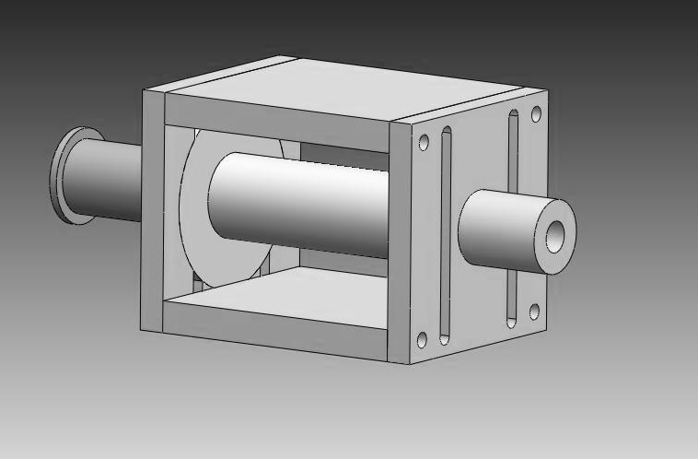
Building shooting device that uses a solenoid and a capacitor (as voltage source), is the goal of this article. Such systems are also used in Robocup soccer robots. When a capacitor is discharged into a solenoid, the solenoid generates a magnetic field, which can exert force on ferromagnetic material, (ex. ferromagnetic plunger). In order to provide the system with the necessary force required to kick a ball, a “plunger” was used which was consisted of two parts, a ferromagnetic part and a non-ferromagnetic shooter, that could slide through the solenoid with the minimum amount of friction possible. (See picture) Experiments were done with a golf ball of 45 grams mass.
Solenoid
Figure 1: Solenoid and Plunger
Plunger (Diamagnetic part, Shooter
)
Plunger
Ferromagnetic
part
Terminal velocity of the ball is dependent on the factors listed below: 1-Initial voltage 2-Capacitance, 3-Diameter of the solenoid’s wires, 4-Solenoid’s inner diameter, 5-Solenoid’s body material, 6-Plunger’s diameter, 7-Plunger’s length 8-Plunger’s mass, 9- Initial position of the plunger, 10-Initial distance between the plunger and the ball, 11-Number of wire turns.
The problem can be classified into three chief sections; we will first discuss the capacitor’s discharge procedure. In the second section, the motion of the plunger is studied. And finally, in section three, we present the equations governing the collision between the plunger and the ball. In order to reach a quantitative theory and investigate
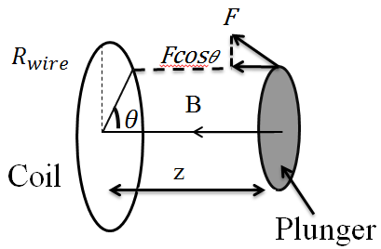
all three sections together , a MATLAB program was developed to simulate the design and solve the resulting differential equations (by Runge-Kutta method). Various effective factors mentioned above, are studied both theoretically and experimentally in order to find the optimized solenoid, which results in the maximum velocity at all times.
Figure 2: Exerted force to each element
from each wire
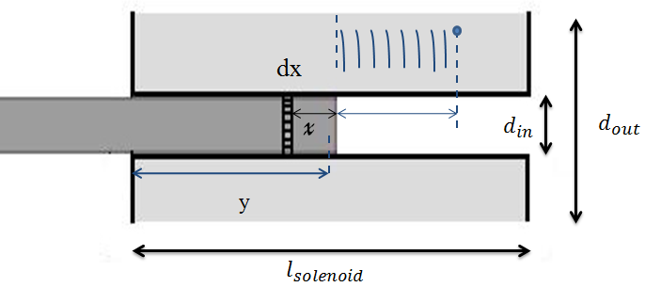
Theory (Mathematical model)
Section 1
Interactions between the capacitor and the solenoid are simulated (The solenoid being an inductor:
Figure 3: Total force exerted to each element
$+\frac{q}{c}+IR+L\frac{di}{dt}=0$ (1)
$L=μ_{0}n^{2}{A l}_{s}$(2), $R=\frac{ρ}{A_{w}}\left(\frac{l_{s}}{d_{wire}}\right)=\sum_{i=0}^{\left[\frac{d_{out}-d_{in}}{d_{wire}}\right]n}{2π\left(R_{p}+\frac{2i+1}{2}\right)}$ (3)
Where A is the surface area of the solenoid, $A_{w}$ is the cross section of the wire, $d_{wire}$ is the diameter of the wire, and $l_{s}$ is the length of the solenoid.
Section 2
There are two general methods for simulating magnetic materials- the dipole method and the current ring method, with the second method having a higher accuracy, which we have chosen to use. Thus, we have considered the ferromagnetic part of the plunger to be made up of a finite number of disks (or current rings) with the same radius as the plunger and a current, which depends on the thickness of the disk, magnetic field of the solenoid and the plunger’s magnetic properties.
$μ_{0}\vec{M}=\left(k_{m}-1\right)\vec{B}$ (4)
The magnitude of $\vec{M}$ is defined as the magnetic moment per unit volume of a substance. As you might expect, the total magnetic field B at a point within a substance depends on both the applied (external) field B0, and the magnetization of the substance.
Considering the properties of the solenoid results in equation number 5; which simulates the rings current intensity.
$i=\frac{dv}{πR_{p}^{2}}(1-k_{m})\frac{N}{l_{s}}I$ (5)
Where dv is the volume of each element, $k_{m}$is a constant dependent on the magnetic properties of the ferromagnetic plunger, $R_{p}$ is the radius of the plunger, $l_{s}$is length of the solenoid, N is the number of current rings and I is the solenoid’s current. Substituting for i, (equation number 5), the force exerted on each element of the plunger:

$f_{x}=\frac{µ_{0}iI}{2}R_{wire}R_{plunger}z\int_{0}^{2π}{\frac{dθ}{{(z^{2}+R^{2}\cos^{2}θ+{\left(Rsinθ-R_{plunger)}\right)}^{2})}^{5/2}}}$ (6)
When the capacitor is discharged into the solenoid, the plunger tends to slide through it, in response to the force it feels from the magnetic field. But, we must take into account that each current ring of the solenoid tends to attract the plunger, therefore, as the plunger moves forward it will start to feel a force opposite the direction of it’s velocity. (Hence the minus term in the formula below)
Thus, the net force exerted on the plunger can be calculated by integration:
$$F_{x}=λ\sum_{j=0}^{(\frac{l_{s}-y+x}{d_{w}})}{\sum_{n=0}^{(\frac{d_{out}-d_{in}}{d_{wire}})}{\int_{0}^{2π}{\frac{zdθ}{{({\left(\frac{2j+1}{2}d_{w}\right)}^{2}+{\left(R_{p}+\frac{2n+1}{2}d_{wire}\right)}^{2}\cos^{2}θ+{(\left(R_{p}+\frac{2n+1}{2}d_{wire}\right)sinθ-R_{p})}^{2})}^{\frac{3}{2}}}}}}-λ\sum_{j=0}^{(\frac{y-x}{d_{w}})}{\sum_{n=0}^{(\frac{d_{out}-d_{in}}{d_{wire}})}{\int_{0}^{2π}{\frac{zdθ}{{({\left(\frac{2j+1}{2}d_{w}\right)}^{2}+{\left(R_{p}+\frac{2n+1}{2}d_{wire}\right)}^{2}\cos^{2}θ+{(\left(R_{p}+\frac{2n+1}{2}d_{wire}\right)sinθ-R_{p})}^{2})}^{\frac{3}{2}}}}}}$$
$λ=\frac{µ_{0}iI}{2}R_{wire}R_{plunger}$ (7), (8)$F_{x}=\frac{μ_{0}i I}{2}R_{wire}{ R}_{plunger }z\int_{0}^{2π}{\frac{dθ_{i}}{{\left[z^{2}+R^{2}\cos^{2}{θ+{\left(R\sin{θ}-R_{plunger}\right)}^{2}}\right]}^{\frac{3}{2}}}}$$F_{x}=λ\sum_{j=0}^{\left[\frac{l_{s}-y+x}{d_{w}}\right]}{\sum_{n=0}^{\left[\frac{d_{out}-d_{in}}{d_{wire}}\right]}{\int_{0}^{2π}{\frac{z dθ_{i}}{{\left[{\left(\frac{2J+1}{2}d_{w}\right)}^{2}+{\left(\left(R_{p}+\frac{2n+1}{2}d_{wire}\right)\right)}^{2}\cos^{2}{θ+{\left(\left(R_{p}+\frac{2n+1}{2}d_{wire}\right)\sin{θ}-R_{p}\right)}^{2}}\right]}^{\frac{3}{2}}}}}} -λ\sum_{j=0}^{\left[\frac{y-x}{d_{w}}\right]}{\sum_{n=0}^{\left[\frac{d_{out}-d_{in}}{d_{wire}}\right]}{\int_{0}^{2π}{\frac{z dθ_{i}}{{\left[{\left(\frac{2J+1}{2}d_{w}\right)}^{2}+{\left(\left(R_{p}+\frac{2n+1}{2}d_{wire}\right)\right)}^{2}\cos^{2}{θ+{\left(\left(R_{p}+\frac{2n+1}{2}d_{wire}\right)\sin{θ}-R_{p}\right)}^{2}}\right]}^{\frac{3}{2}}}}}}$$λ=\frac{μ_{0}i I}{2}R_{wire}{ R}_{plunger }$
Section 3:
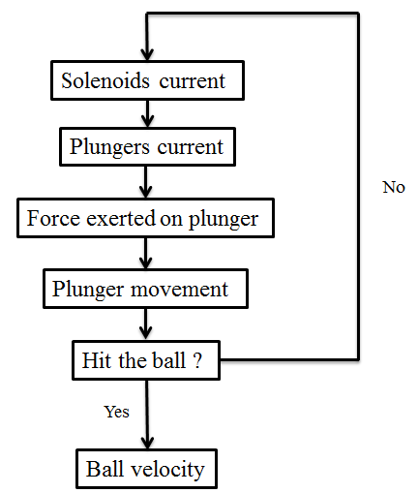
After solving energy and momentum equations, the terminal velocity of the ball is determined: [1],[2]
$v_{b}=\frac{2μkv_{p1}+\sqrt{{(2μkv_{p1})}^{2}+4(1-μ)(μk^{2}+μk)}}{2(μk^{2}+μk)}$ (8)
Where $k=\frac{M}{m}$ (M is mass of the ball and m is the plunger’s mass), $v_{p1}$ is the velocity of the plunger before collision and µ is the contact coefficient.
Figure 4: Calculating Terminal Velocity
Experimental Setup
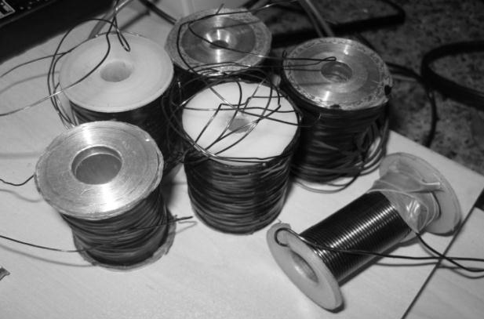
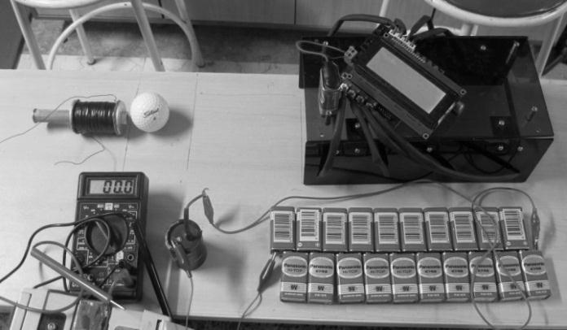
The entire system consists of a solenoid, a plunger and a ball. Both Aluminum and Teflon have been used for the solenoid’s body material. The plunger, as mentioned before, has two parts; the ferromagnetic part is made of iron and the diamagnetic part, aluminum.
Figure 6: solenoids used in experiments
Figure 5: experimental setup

A “speedometer” was designed to determine the speed of the ball. This device is consistent of four sensors in order to reach the most accurate result. Experiments were done with solenoids of 5 cm length, 3 cm outer diameter, and three different inner diameters of 10, 8, 6 mm. (Fig.5)

Experimental Analysis
The concurrence between the theory and experiments enables us to use this method in finding the optimum dimensions of the system for any given initial conditions. The theory shows that the velocity would alter linearly in respect to the increase of voltage. Experimental results are also in good agreement with this (Fig.7).
A capacitor with higher capacity, stores a greater amount of energy, but since it also has an extended discharge time, the plunger won’t absorb all the energy before the collision. Therefore increasing the capacitance, more than a certain amount will not result in any changes in the velocity of the ball (Fig.8 & Fig 9).
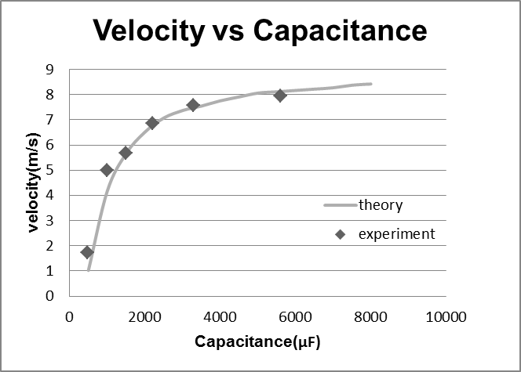
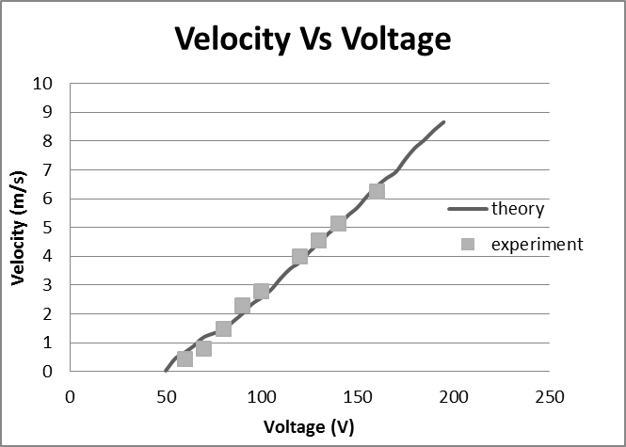
Fig.8 Velocity vs Capacitance
Figure 7: Velocity vs Voltage

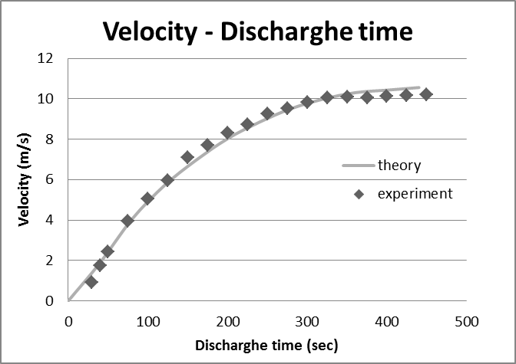
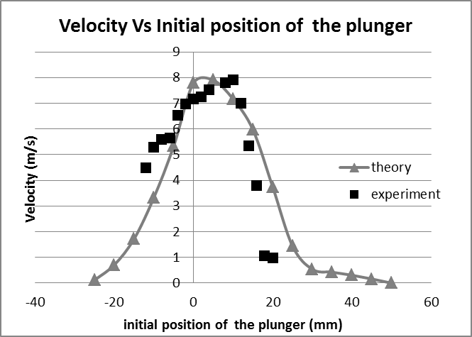
This is why the initial position of the plunger is an important factor; since the energy absorption of the plunger is altered also by the discharge time of the capacitor. The plunger must
Figure 10: Velocity vs initial position of the plunger
Figure 9: Velocity vs discharge time
be inside the solenoid when the current intensity reaches its maximum, in order to hit the ball with maximum velocity . Therefore, as u can see in Fig.10, this factor has an optimum.

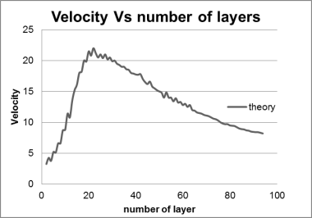
Increasing the number of layers has two different effects on the ball’s terminal speed. As the number of layers increase, the resistance of the circuit will also increase. As a result the current intensity inside the solenoid will decrease. Ergo, velocity reduces escalation of the number of layers also increases the inductance of the RLC circuit, so a greater force is exerted on the plunger. Consequently, there should be an optimum number for both of these factors. This point is where the inductor acquires the maximum quality factor, which can be calculated by our numerical method (Fig.11 & Fig.12)
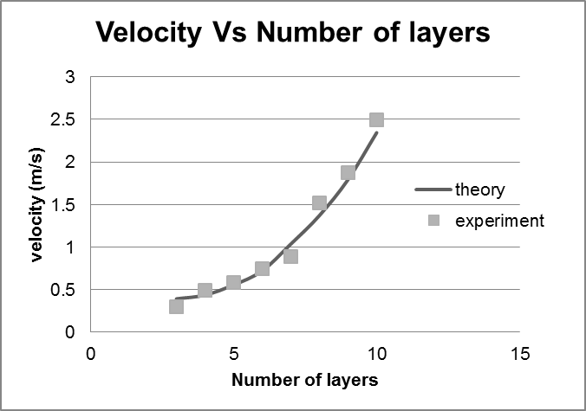
Figure 11: Velocity vs number of layers
Figure 12: Velocity vs number of layers
The material of the solenoid can significantly affect the strength of the magnetic field inside the solenoid. The solenoid’s body is usually made of either diamagnetic or paramagnetic material.
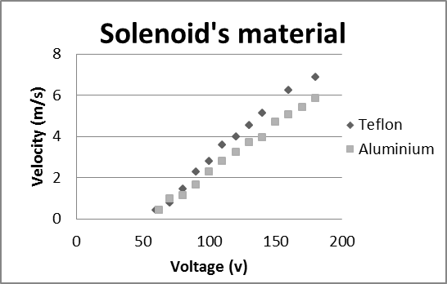
In broad terms, diamagnetism and paramagnetism are different types of responses to an externally applied magnetic field. Diamagnetism is a natural consequence of Lenz's law, according to which the electric current resulting from an applied field will be in the direction that opposes the applied field. In other words, the induced current will flow in the direction that creates a field opposite to the applied field. In other words, diamagnetic material can weaken an external applied magnetic field.
Paramagnetism occurs in materials whose atoms lack permanent magnetic dipole moments, whether they are spin types or orbital moments. Thus these materials won’t affect the inner magnetic field. Since they tend to align with any external magnetic field.
Figure 13: Velocity vs Voltage for different materials

Fig.13 shows the velocity vs voltage for two different materials used as the solenoid’s body, Teflon as a diamagnetic material and aluminum as a paramagnetic one.

Conclusion
Comparisons between theoretical and experimental results prove our numerical model, hence the numerical solution, has the proper accuracy to predict the outcome of further experiments and can be used to find the optimum system, of any desirable size; One that creates the strongest magnetic field, so that the plunger can absorb maximum energy from the solenoid in the minimum time interval.
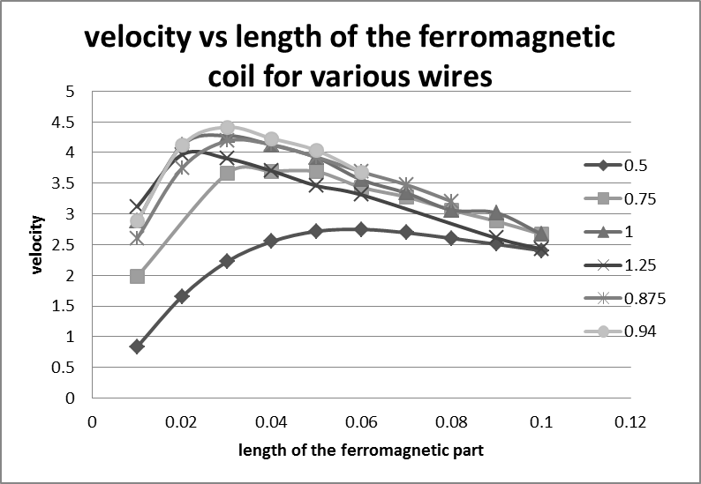
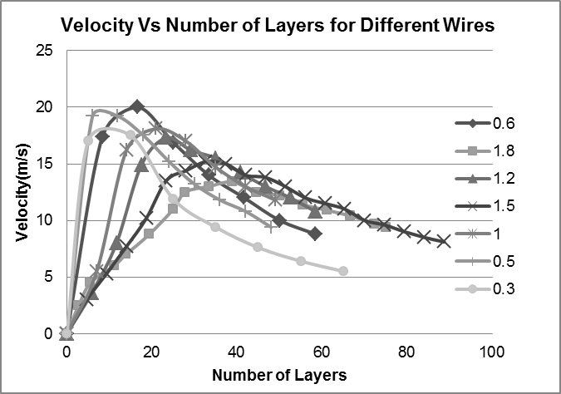
For each solenoid of certain dimensions, length of the ferromagnetic plunger, diameter of the wire and the number of layers should be optimized. e.g. for a solenoid with 5 cm length, 3 cm outer diameter and 1.4 cm inner diameter, the outer diameter is proportional to number of wire layers which is 20 for a wire of 0.6 mm diameter. (Fig. 14 & Fig. 15)
Figure 15: Velocity vs number of layers for different wires
Figure 14: Velocity vs length of the ferromagnetic coil for various wires

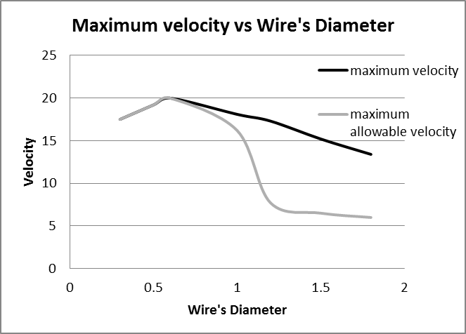
For instance, to find the maximum possible velocity for a certain system with the 45 mm outer diameter, 10 mm inner diameter, 2mm thickness of the Teflon solenoid’ body, 2000 $μF$ capacitor charged with a voltage of 220 volts, (using Fig.15) the maximum possible velocity for different wire’s diameter can be found theoretically.
In Fig.16 the black line shows the maximum possible theoretical velocity, and the gray line shows the maximum possible velocity after applying geometrical limitations.
Figure 16: Maximum possible velocity
References
[1]Mechanics by Kenith R.Symon, Addison Wesley, Third edition, 1971
[2] Analytical mechanics by Grant R. Fowles, Fourth edition CBS international editions, 1987
[3]physics by Robert Resnik, David Halliday and Kenneth S. Krane, Fifth edition, 2002
[4]Nayfeh M.Hasan, Electricity and Magnetism by Monir H. Nayfh, Morton K. Brussel, university of Illinois at Urbana-Champaign, first edition, 1985
[5]Introduction to Electrodynamics, David J.Griffiths, Third edition, Prentice Hall, 1999
[6]Numerical Methods for Scientists and Engineers, K.Sankara Rao,, Third edition, Prentice-Hall of India 2007
[7]B.P.T.vangoch, Optimizing a Solenoid for a Robocup kicker, DCT-number: 2006.051

