Problem No 17 (2010). “Kelvin’s dropper”
Alexander BARNAVELI
I.Vekua Phys-Math school No 42. Tbilisi, GEORGIA
( s.barnaveli@gmail.com )

Problem: Construct Kelvin’s dropper. Measure the highest voltage it can produce. Investigate its dependence on relevant parameters..

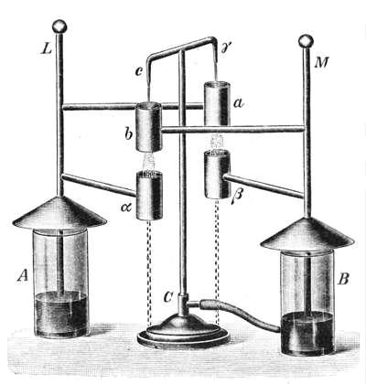
- Kelvin’s dropper working principles
In XIX century 60-ies William Thomson, later to be known as Lord Kelvin, invented a very interesting device and showed it on special occasions (see Fig. 1). It was a water-drop electrostatic generator, which he
called the “water-dropping condenser”. It was sometimes referred to as “Kelvin’s Thunderstorm”. The device uses falling water drops to accumulate charges and generate a high difference in the voltage^{[1-3]}.
Let us describe the working principle of this device. It consists of a bowl to which two droppers are attached (see Figure 2). Under these droppers two metal rings are Figure 1.
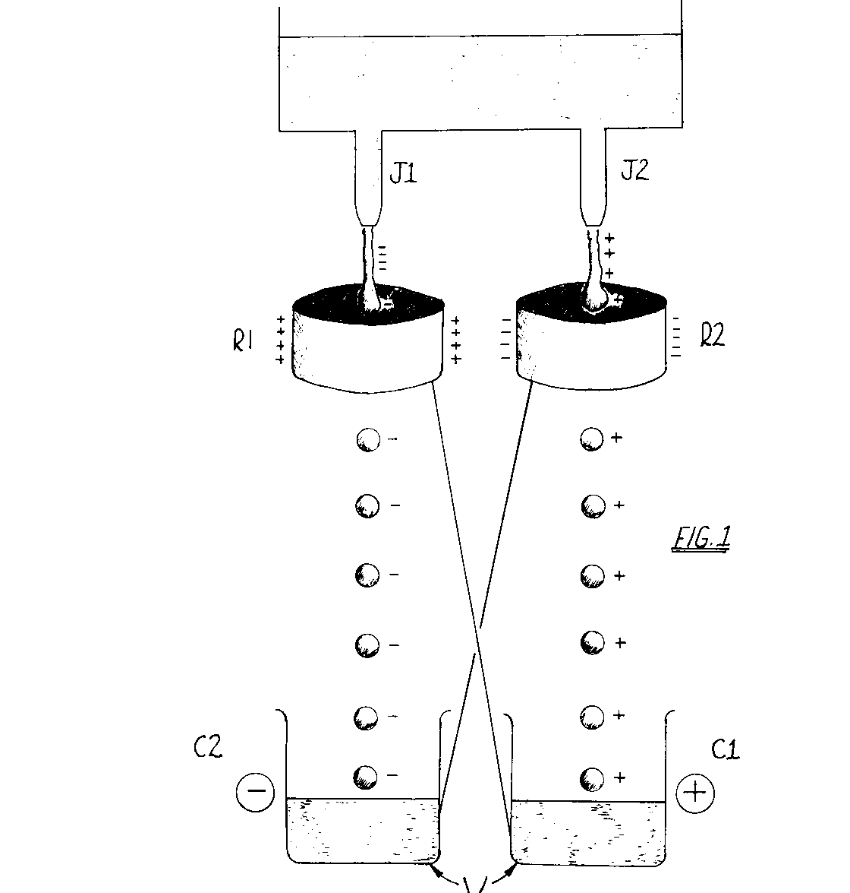
placed (so-called “inductors”) which are cross-wise “Kelvin’s Thunderstorm”
connected to the two metal jars (so-called “collectors”). When one fills the upper bowl with water, jets begin to flow through droppers. The water jets J_{left}, and J_{right} are adjusted so that they break up into droplets near the induction rings R_{left}, and R_{right}, which (as we said) in turn are connected cross-wise fashion to two metal containers C_{left}, and C_{right}.
At first, when the water starts to flow out from the droppers, nothing happens, but as soon as occasionally, due to some fluctuation a negatively charged drop falls e.g. from the left dropper, it passes through the inductor R_{left} and falling into the collector C_{left} charges it (and connected to him right inductor R_{right}) Figure 2.
negatively. This negatively charged right inductor attracts Dropper’s scheme
the positive ions from the bowl and accumulates them in
the right collector C_{right}. Respectively the right collector and connected to him the left inductor R_{left} get positive charge and start to attract negative ions from the bowl (increasing this way the negative charge flow through the left dropper) and so on... Thus more and more similarly charged droplets fall in each collector and they become more and more charged. Such process is called “Positive feedback” (we often witness such positive feedback when we put the microphone attached to PC near the speaker – noise becomes stronger and stronger).
Here we have to mention, that though water in the bowl is electro-neutral, it always contains at least positive H⁺ (or H₃O⁺) and negative (OH)⁻ ions. Due to some fluctuation it can happen that in one or several drops falling through the one of droppers there are more ions of one sign, so drop becomes charged, thr symmetry violates and the above-described avalanche-like process starts.
Here are several more important moments:
- The jets must split into drops in the vicinity of collectors not to let the system discharge. In other case the difference of potentials between two collectors will cause current flow through the water in the opposite direction and thr system will not be able to gather the charges.
- Water conductivity ensures the charge flow in the bowl so that ions can flow to the droppers under the influence of inductor’s field.
- The energy source here is gravitation, which enforces the charged drops to fall through the inductors towards collectors. If not gravity, the charged drops attracted by oppositely charged inductors would fall on them and would not reach the collectors. So the work on the charge separation is done by the gravity forces.
Thus to summarize, the main factors responsible for working of Kelvin’s water generator are:
- The existence of H+ and (OH)- ions in water;
- The violation of symmetry as a result of fluctuation;
- The separation of ions under the influence of charged inductors;
- A “Positive feedback”;
- Electric conductivity of water;
- Water jets splitting into drops in the very vicinity of the inductor’s center;
- Accumulation of charged drops in collectors due to gravitation force.

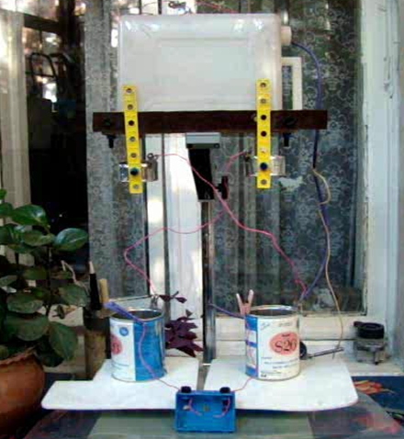
- The experimental Setup
Here is our experimental setup (see figure 3).
In our experiments we evaluated the voltage between collectors with the help of the gap between the electrodes attached to the collectors. The spark jumped when the gap was 1 cm that at ordinary conditions corresponds to U = 10 000 – 30 000 Volts. For our measurements we also used the electrostatic Voltmeter. We also tried different conditions and different parameters of the setup. The results of the experiment strongly depend on the environment conditions – humidity etc. Figure 3. Experimental setup.

- Evaluations of voltage growth rate
Let’s evaluate the parameters which will help us to optimize the experiment, starting with calculation of the voltage growth velocity.
Due to the positive feedback the speed of the voltage growth is proportional to the voltage itself:
$\frac{dU}{dt}=αU$ ;
Where from
$U=U_{0}e^{αt}$ , (1)
i.e. both the voltage and correspondingly the charge are increasing exponentially.
Let's discuss a coefficient α. One can assume that
$α \sim \frac{1}{C+ C_{Load}} ∙\left(nC_{Drop }- \frac{a}{R_{Ground}}- \frac{b}{R_{(1↔2)}}\right)$ (2)
Where:
C – is the joint capacity of the collectors and inductors;
C_{Load} – is the capacity of voltmeter and other "loads";
C_{Drop} – is the capacity of water drop;
n – is the number of drops, falling into collector in unit of time;
R_{Ground} – is the Resistance between the generator and ground, through which the parasite current flows;
R₍₁ ₂₎ – is the resistance between the collectors. Through it the parasite current will flow as well.
a, b – are the coefficients.
This expression was obtained via following considerations:
- Higher is the capacity of the system - slower is the increase of the voltage (for given speed of charge delivery); So capacity is in denominator.
- There is the "competition" between the accumulation of charge in collectors (the first term in brackets) and its leek through the parasite currents (the last two terms in brackets);
- Charge accumulation rate is proportional to the number of drops per second and to the charge of each drop (The form of the first term in brackets).
- Parasite currents are back-proportional to the Resistance (insulation) of the system (the form of the last two terms in brackets).
From (2) it is clear that if
$nC_{Drop }< \frac{a}{R_{Ground}}+ \frac{b}{R_{(1↔2)}}$ (3)
charge accumulation will not take place.
Now let’s derive the voltage growth formula using other considerations. Let’s draw the electrical scheme equivalent to the Kelvin’s dropper (Fig. 4).
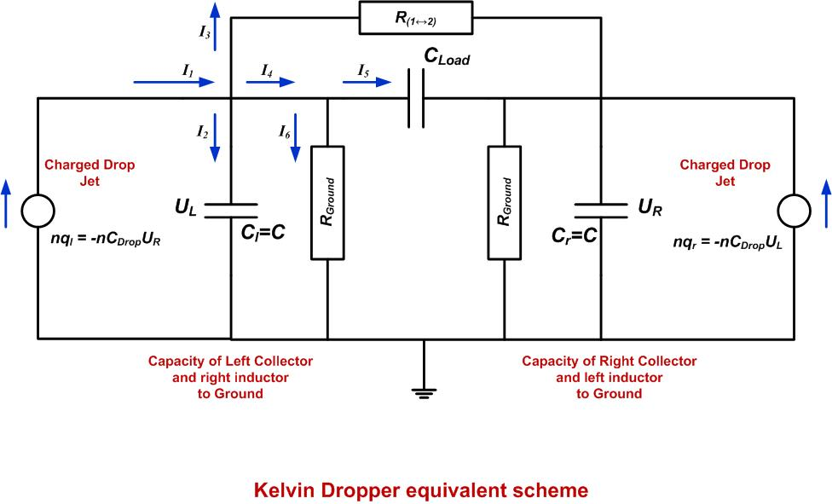

Figure 4.

Here:
U_{L} – is the potential of “Left Collector and Right Inductor” to Ground;
U_{R} – is the potential of “Right Collector and Left Inductor” to Ground;
C_{l}=C_{r}=C, where C_{l} is joint Capacitance of “Left Collector and Right Inductor” with respect to Ground and C_{r} – is the same for “Right” side;
Charge of drops q_{r} = -C_{Drop}U_{L} and q_{l} = -C_{Drop}U_{R} where C_{Drop} is the “effective drop capacitance” – coefficient of proportionality.
Writing Kirchhoff’s laws for the currents and taking into account that
$I_{1}=-nC_{Drop}U_{R}$ ; $I_{2}=C\frac{dU_{L}}{dt}$ ; $I_{3}=\frac{U_{L}-U_{R}}{R_{Load}}$ ;
$I_{4}=I_{5}+I_{6}=\frac{{C_{Load}·d(U}_{L}-U_{R})}{dt}+ \frac{U_{L}}{R_{Ground}}$.
We can write from the sum of currents for Left side:
$\left(-nC_{Drop}+\frac{1}{R_{Load}}){ U}_{R}-(\frac{1}{R_{Load}}+\frac{1}{R_{Ground}}\right)U_{L}= C\frac{dU_{L}}{dt}+ \frac{{C_{Load}·d(U}_{L}-U_{R})}{dt}$ .
Similarly from the sum of currents for Right side
$\left(-nC_{Drop}+\frac{1}{R_{Load}}){ U}_{L}-(\frac{1}{R_{Load}}+\frac{1}{R_{Ground}}\right)U_{R}= C\frac{dU_{R}}{dt}+ \frac{{C_{Load}·d(U}_{R}-U_{L})}{dt}$ .
From the symmetry considerations U_{L}=U_{R} or U_{L}= -U_{R}. Let’s consider these cases.
- For U_{L}= -U_{R}, the voltage growth equation for the left side takes the form
$$\left(C+2C_{Load}\right)\frac{dU_{L}}{dt}-\left(nC_{Drop}-\frac{2}{R_{Load}}-\frac{1}{R_{Ground}}\right)U_{L}=0$$
and the similar is for U_{R}.
- For U_{L}=U_{R} the voltage growth equation for the left side takes the form
$$C\frac{dU_{L}}{dt}+\left(nC_{Drop}+\frac{1}{R_{Ground}}\right)U_{L}=0$$
and the similar is for U_{R}.
The complete solution is the sum of solutions (A) and (B)
$U_{L}=A·e^{αt}+ B·e^{-βt}$ , (4)
where
$α=\frac{1}{\left(C+2C_{Load}\right)}\left(nC_{Drop}-\frac{2}{R_{Load}}-\frac{1}{R_{Ground}}\right)$ ; (5)
$β=\frac{1}{C}\left(nC_{Drop}+\frac{1}{R_{Ground}}\right)$.
It is clear, that solution (B) vanishes exponentially, while for the solution (A) for the voltage growth it is necessary, that
$nC_{Drop}>\frac{2}{R_{Load}}+\frac{1}{R_{Ground}}$ . (6)
Comparing the equations (4),(5),(6) with (1),(2),(3) we can see that a=2 , b=1. Also we can conclude, that to obtain large charges and high voltage we must provide good insulation R_{load}→∞ ; R_{ground}→∞ and also the intensive jets of charged drops nC_{Drop} in the constructed generator.
- Evaluation of accumulated charge.
Let’s evaluate what possible charge can be accumulated in the Kelvin’s dropper in ideal conditions.
In normal conditions 1 liter of water contains ~10⁻⁷ moles of ions, or N ~ 10¹⁶ ions; The charge of each ion is e = 1.6 • 10 ⁻¹⁹ Coulomb. If all of ions will accumulate in collectors, the whole charge will be
Q = N • e ~ 10 ⁻³Coulomb (7)
though it is obvious, that this charge is huge, and unreal.

- Evaluation of the accumulated charge.
Now let’s evaluate what voltage can be achieved by means of the Kelvin’s dropper.
It is not very difficult to estimate the voltage between the two charged cylinders. After some calculations we get:
$U=\frac{σ}{πε_{0}ε}∙ln\frac{d-R}{R}$ , (8)
Where σ=Q/h_{cyl} - is charge per unit of cylinder height, d is the distance between the cylinder’s axises of symmetry, R is the radius of each cylinder ; d > 2R. From this formula we also can see, that the larger is the distance d between the collectors - the higher voltage can be achieved.
Using parameters of our setup: d=0.3m, R=0.05m, ε=1, the hight of collector h_{cyl}=0.2m and noting that for this height from (7) one gets σ=5•10⁻³C/m we obtain from (8):
U≈ 5 ·10 ⁸V (9)
(if we assume that all the ions of 1 Liter of water were separated).
It is obvious that, this voltage as well is huge and unreal. In real experimens there are factors that prevent achieving such huge charges and voltages (though several ten thousands of volts we did get).

- Factors affecting the result.
In the real conditions there are factors that prevent a high charge and voltage growth in Kelvin’s dropper and also factors which support obtaining a higher result.
Preventing factors are:
- Electrostatic Corona discharge;
- Electric forces affecting the water drops;
- Humidity of environment;
- "Parasite" currents.
Supporting factors are:
- Increase of the number of ions in liquid;
- Increase of the number of drops per second;
- Increasing insulation and distance between collectors.
Let us discuss these factors.

a) Electrostatic Corona discharge.
Electrostatic discharge in air takes place when the voltage of electric field reaches 10 - 30 kV/cm. Thus it is real to get 30 000 Volts with our “Kelvin’s dropper”. Obtaining higher voltage will be possible in the case of covering the parts with good dielectrics (insulators). On the other hand, at high humidity discharge takes place at smaller voltage as well.

b) Forces affecting the water drops.
Let us estimate what forces are acting on charged drops in Kelvin’s dropper to see at what conditions drops will not fall into collectors. If 1 Liter of water contains 10¹⁶ ions, then in 1 mm³ drop there will be n~10¹⁰ ions. If in 1 drop there are only ions of the same sign, then the charge of drop will be q =ne ~ 10⁻⁹Coulomb. The gravitation force acting on 1mm³ drop F_{Grav} =10⁻⁵N. If the distance between the drop and collector (or inductor) is ~0.1m then the electric force affecting the drop is
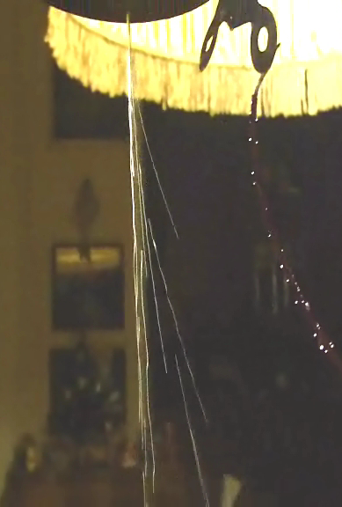
$F_{El}\sim k\frac{qQ}{{10}^{-2}}\sim {10}^{10}•\frac{{10}^{-9}Q}{{10}^{-2}}\sim {10}^{3 }Q$.
Drop will not fall into collector if F_{Grav} < F_{El} , i.e. when affecting charge is about Q~10⁻⁸Coulomb. This corresponds to voltage U~ 10 ⁴ V. So we again obtain the tens of thousands volts. In course of experiment we have seen the deviation of water streams from vertical, caused by electric fields (fig.5).

- Humidity of environment.
We made our experiments in humid and dry environ-
ments. We saw, that the higher was humidity – the less Figure 5.
was voltage. It was due to electrostatic discharge at Deviation of water streams
smaller gap for high humidity.

d) "Parasite" currents (bad insulation).
When during the experiment the device was getting wet, there took place the leak of charge from collectors by means of so called "parasite" currents and as a result the voltage decreased as well.

- Experiments with different parameters.
Taking into account all factors affecting the above mentioned evaluations and results we carried out experiments with changing the following parameters:
- Adding the salt to water (i.e. adding ions);
- Increasing the water jets (though providing their decay into drops);
- Increasing the distance between the collectors;
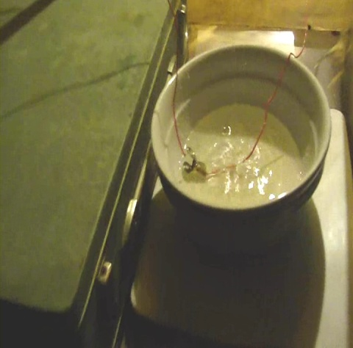
- Improving the insulation of system.
Voltage was measured with the help of electrostatic voltmeter
We observed that:
- Addition of salt to water forces generator to start its action much faster and provides higher voltage. This is due to Na⁺ and Cl⁻ ions in salt which increase the number of ions in bawl. It makes the amplitude and the probability of initial fluctuation higher. Also, additional ions Increase charge accumulation speed as compared with charge leak speed since in this case each drop has larger charge. Figure 6.
- Making water jets stronger also increases the charge Porcelain collectors accumulation speed as compared with speed of charge
leak. So charge grows faster.
- Increasing the distance between the collectors enlarges the obtained voltage. As we saw from (8), the further are the collectors from each other, the more voltage is achieved.
- Increasing the degree of insulation gives higher final voltage. We also tried to replace the iron collectors with those, made of porcelain plates. The electrodes were directly inserted into water in these plates (See Fig.6). This gave very good results.

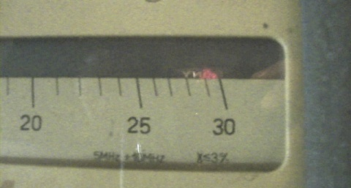
Thus Fulfilling these four conditions, improving the insulation (that is very important), we get 30 000V voltage. We measured the voltage with help of electrostatic voltmeter (see Fig. 7).

- Conclusion.
In this work we studied the working principle of
Kelvin’s water generator and influence of different Figure 7.
parameters on the values of obtained charge and Achieved voltage.
voltage. We constructed our model and observed that
by means of the Kelvin dropper it is possible to obtain tens of thousands volts.
The result strongly depends on the surrounding conditions. To obtain a high voltage one must provide:
- The insulation, as good as possible. May be locating the device upon the two tables, to separate the poles;
- The less humid environment;
- The strong jets of drops. May be usage of several droppers;
- Adding more ions to water. (e.g. adding salt);
- Increasing the device dimensions.
We managed to obtain 30 000 Volts.

Finally I want to thank my grandfather Tengiz Barnaveli for his help in the experiments with the high voltage and helpful discussions on the Kelvin dropper equivalent scheme.

References
[1] John Vanderkooy. An Electrostatic Experiment of Lord Kelvin with Running Water. University of Waterloo
Canada 1984.
[2] Matthew Trainer. Celebrating the Life of Lord Kelvin. University of Glasgow, Glasgow, UK
[3] Markus Zahn. AJP Vol 41/ p.196. 1973

