A NUMERICAL AND EXPERIMENTAL ANALYSIS ON THE EXPANSION OF HORIZONTALLY ROTATING HELICAL SPRINGS

Reza Montazeri Namin

School of Mechanical Engineering, Sharif University of Technology, I. R. Iran.

Abstract
The present paper is a solution to IYPT 2010 problem no. 16, “Rotating Spring”. The main objective is to investigate the expansion of a helical spring rotated about one of its ends around a vertical axis. The effect of an additional mass attached to its free end is also a subject of investigation. This investigation is done in means of approximations leading to an analytical solution, as well as a developed numerical solution solving the differential equations assuming equilibrium of the forces in the rotating coordinate system. Both the analytical and numerical solutions are compared to physical experiments made by the author to examine the theoretical achievements.

Introduction
“A helical spring is rotated about one of its ends around a vertical axis. Investigate the expansion of the spring with and without an additional mass attached to its free end.”

Assuming the equilibrium condition in the rotating coordinate system, three forces would be exerted to every differential mass. The gravitational force, the spring force caused by its deformation, and the figurative centrifugal force that must be considered since an accelerated coordinate system is being used. The spring tension force will be calculated assuming the Hooke’s law. This law is applicable in a limited range of strain in the spring; the range in which it remains elastic. So the spring tension force will be a function of the spring modulus (μ), the spring initial length (l) and the change of length (∆l).
(1)
Note that the modulus was used instead of the spring constant because of being independent on the spring dimensions. For the same reason, the spring linear density (λ) will be used as the parameter instead of the spring mass.

The solution of this problem in the case where the mass of the spring causes extra tension and strain is complicated to solve. To solve this general case, we will later present a numerical solution. However, initially an approximation will be given to describe the case when the mass of the spring is negligible compared to the additional mass attached. In this case, the spring could be considered as a whole, absolutely linear and weightless. So the three forces acting on the additional mass must be in equilibrium.
Equilibrium in the x direction states:

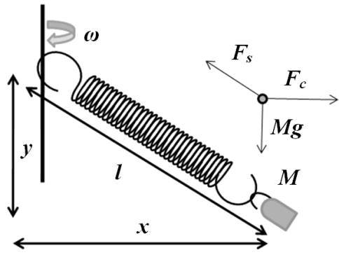
$m x ω^{2}-\left(l-l_{0}\right)k \frac{x}{l}=0$ (2)

Which can be satisfied by x=0, or:
$l=\frac{μl_{0}}{μ+ml_{0}ω^{2}}$ (3)

Equilibrium in the y direction states:
$l=l_{0}(1+\frac{mg}{μ\cos\left(θ\right)})$ (4)

Here θ is the angle between the spring and the rotation axis. If x = 0 then cos(θ) = 1, so:
Figure 1: The free body diagram for the additional mass in equilibrium
$l=l_{0}(1+\frac{mg}{μ})$ (5)

Note that according to (4) the length cannot be smaller than this value. It can be shown that in the case where equation (3) predicts a larger length than equation (5), the one predicted by (3) is stable and the one predicted by (5) is unstable. Otherwise the prediction of (5) is impossible. So the spring length is:

$l=max⁡(l=\frac{μl_{0}}{μ+ml_{0}ω^{2}} , l_{0}\left(1+\frac{mg}{μ}\right))$ (6)

This result will be addressed as the analytical solution and will be compared to the physical experiments in the discussion.

Governing Equations
Because of the mass distribution of the spring along its length, the force needed to hold and rotate the free part of the spring differs in different points along its length. Thus the tension in the spring is not constant, making the linear density also a function of position. So the mass distribution of the spring itself is a function of the tension along the spring.

The equilibrium condition states that for each differential segment of length on the spring, the sum of the forces must be zero. Thus:
$\left(λ x ω^{2}\right)\hat{x}-\left(λ g\right)\hat{y}-\frac{d\vec{T}}{dl}=0$ (7)
Here T is spring tension, as a function of position, ω is the angular velocity, λ is the linear density, a function of position as well, $\hat{x}$ and $\hat{y}$ are horizontal and vertical unit vectors. T in one point may be assumed to be parallel to the spring in that point, i.e. the spring does not stand any tension normal to its length. Thus:
(8)
Derived from the Hooke’s law, the linear density of the spring as a function of T is:
(9)
And the limitation of the boundary is the total mass of the spring:
(10)
L is the length of the spring after expansion, which is supposed to be the main unknown parameter to solve.

Numerical Solution
To solve the equation, the continuous medium of the spring is converted to a discreet medium. The spring is divided to n parts with the same initial length and mass. These are represented as n mass points which are connected with differentially small springs. Each point is being pulled by two springs. The position of equilibrium for each point is to be found. Transient method was used by to solve the problem; releasing the spring from an unstable position and iterating towards equilibrium. During iteration, every point will move towards the direction of the sum of the forces exerted to the point. The repetition of the iterations goes on until the movement of the points approaches to zero, i.e. the stable equilibrium condition is achieved.
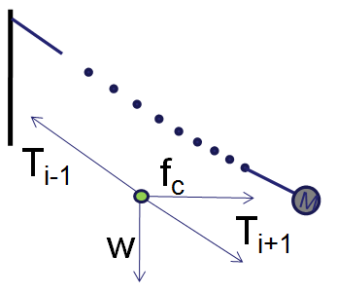
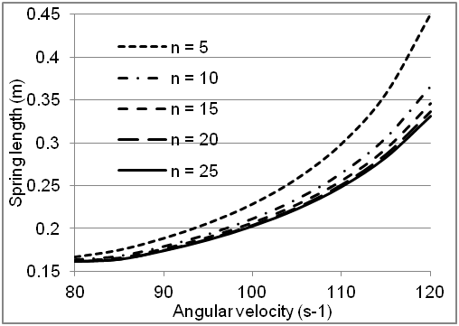
The numerical solution was developed in QBasic programming language. It takes about 10’000 iterations for each test case to reach convergence. The convergence was assumed to be achieved when the displacement of each of the points during iteration would be less than 1/100000 of the spring length. To make sure about the independency of the results to the mesh size and the discretization number, this number was changed in a test case. The result (Figure 3) shows that the program’s result approaches to a constant value when n increases. n = 20 was used in the rest of the test cases.
Figure 3: Mesh Independency Check.
n: Number of mesh points
Figure 2: Discretization Assumption: to each point four forces are exerted.

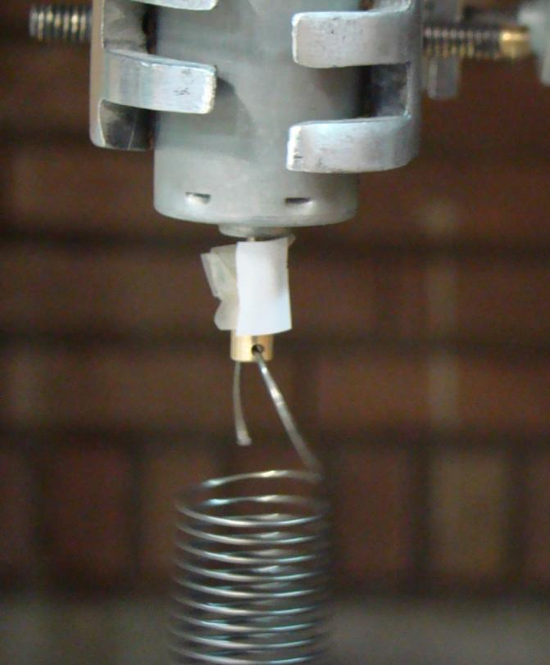

Physical Experiments
The relation between the spring length and angular velocity was investigated in physical experiments in several cases, to be compared with the numerical and analytical results.

The spring was rotated using a DC 12V motor, covering the spin range of 100 to 400 RPM. The spin was variable by changing the input voltage to the motor. The connection between the motor and the spring was designed so that the end of the spring would be precisely in the axis of rotation; by putting the spring end inside a hole in the middle of the axis instead of sticking it to the side. Otherwise, standing wave motions could have been observed, especially in cases with high angular velocities. The standing waves would make the spring a fully curved shape, with different parts of the spring in different sides of the axis.
Figure 4: Connection of the Motor and the spring
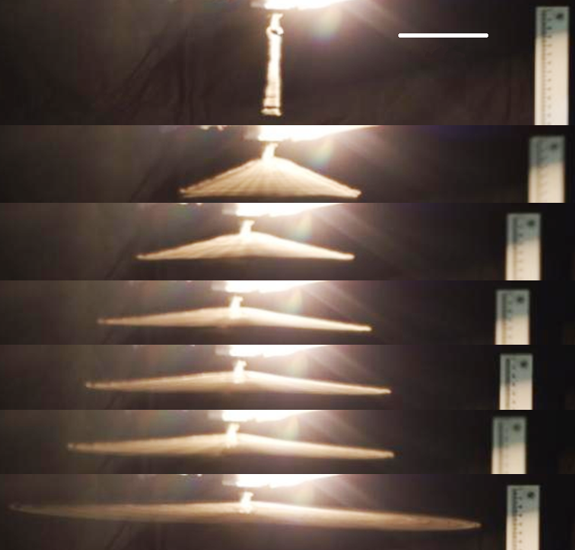
The angular velocity of the motor was measured by means of a tachometer. To measure the length of the spring, long exposure time photos were captured from the rotation, so that the entire motion of the spring in one round would be visible. The length of the spring would be measured by scaling the picture, measuring the distance between the two ends of the spring.
10cm

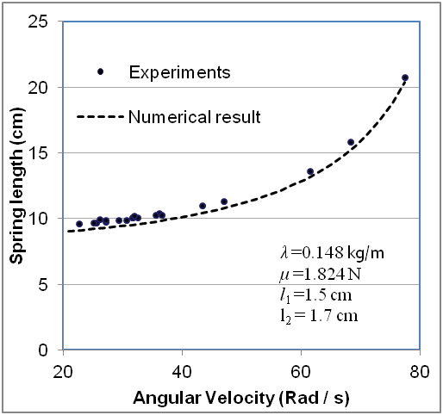
The modulus of the spring was measured by suspending masses with a spring of a known length, finding the spring constant and modulus. The mass of the spring was directly measured, used to find the linear density. These parameters were used as numerical input to the program and to the analytic solution to be compared with the experiments.
Figure 5: Long Exposure Time Photos Used to Measure Spring Length. Lower pictures have higher angular velocity.

Discussion
The numerical theory showed perfect match with the physical experiments in several test cases. The length of the spring was measured while changing the angular velocity in one test case (Figure 6), in different initial lengths (Figure 7) and in different additional masses (figure 9).

It was not possible to make an experiment with the exact same angular velocity more than once; because the Motor would slightly change the angular velocity over time. Thus, exact error measurements were not quite possible. However, as we see in Figure 6, in the case where there are many measurements in a small region of angular velocity, the differences between the experimental data are small compared to the discrepancy to the numerical results. This fact suggests that the discrepancy between the experimental and the numerical results is not because of direct errors in the measurements. But it may be caused by the uncertain values given as the input of the numerical solution, e.g. initial spring length, which has a precision of about 1mm, and the results are very sensitive to it.
Figure 6: Comparison of the numerical results and physical experiments
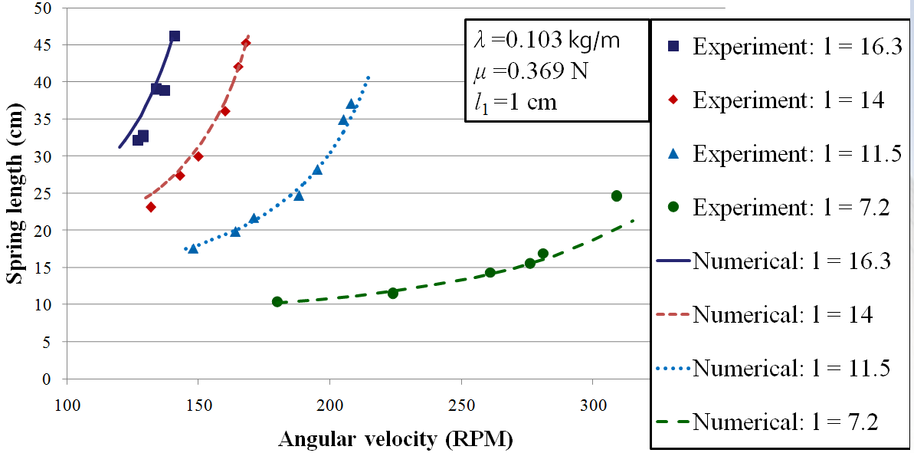
Figure 7: Comparison of the numerical results and experiments in different initial lengths of the spring. Units are in Centimeters.

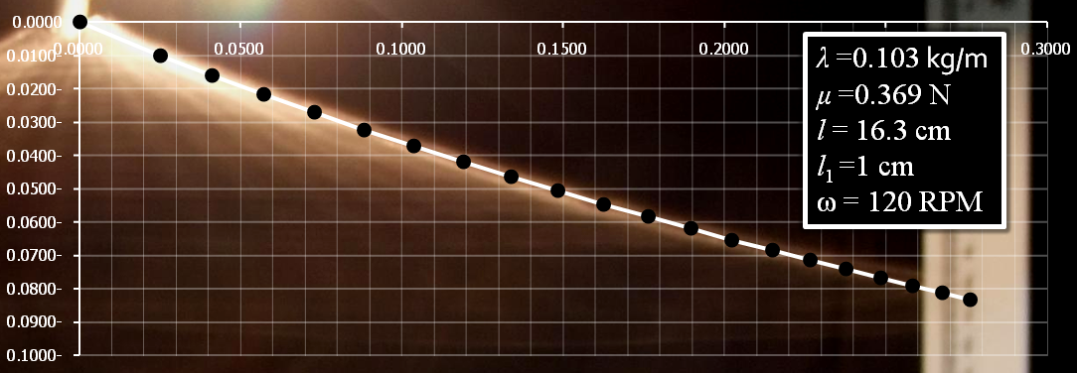
Figure 8: The results of the numerical theory and experiments regarding the spring shape. Axis units are in meters.

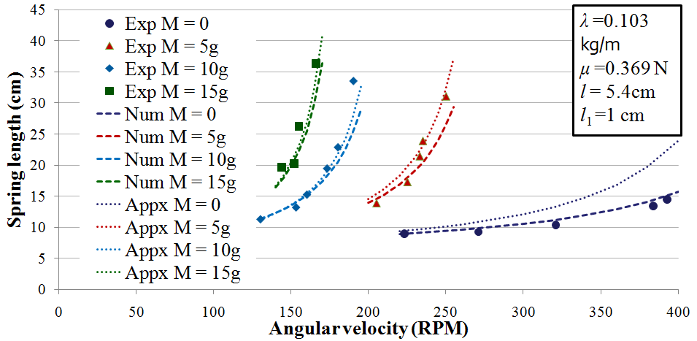
Figure 9: Comparing Analytical and numerical theories with physical experiments in different additional masses
The shape of the spring was also calculated numerically and compared with the experiments. Figure 8 shows this comparison. The Background image is an experiment, and the black points connected with white lines are the predicted positions of the points on the spring outputted from the numerical solution. The shape of the spring is not fully linear; it has a slight curve upwards. The results all show an agreement between the numerical theory and the experiments.

Investigating different additional masses, the analytical theory was also compared with the experiments and the numerical method. As we see in (Figure 9), the analytical solution does not provide the accuracy of the numerical solution especially in small additional masses compared to the spring mass. However it is clear that the errors decrease as the additional mass increases.

As a result, the method of the numerical approach used was fully proved experimentally in the experiment range; and the analytic solution was shown to have an increasing accuracy with the increasing of the additional mass.

References
[1] Beer F, Johnson E R, Dewolf J, 2005, Mechanics of Materials, 4th Edition, McGraw-Hill.
[2] Atkinson K E 1989 An Introduction to Numerical Analysis 2nd Edition, Wiley.
[3] IYPT 2010 Problems, Official IYPT Website: http://iypt.org/Tournaments/Vienna

