The report for Electromagnetic cannon
Electromagnetic cannon
A solenoid can be used to fire a small ball. A capacitor is used to energize the solenoid coil. Build a device with a capacitor charged to a maximum 50V. Investigate the relevant parameters and maximize the speed of the ball.
題目:一個螺線管可以被用來發射一個小球，其中電容可被用來供給
線圈能量。架設一個裝置，且電容充電最大電壓為50V。
研究相關的參數並找出球最大的速度。

一、認識電磁砲
★電磁砲的結構和原理
電磁砲聽起來很神秘，其實它的結構和原理很簡單．電磁砲是利用電磁力代替火藥曝炸力來加速彈丸的電磁發射系統，它主要由電源、高速開關、加速裝置和炮彈四部分組成。目前，國外所研制的電磁砲，根據結構和原理的不同，可分為以下幾種類型：
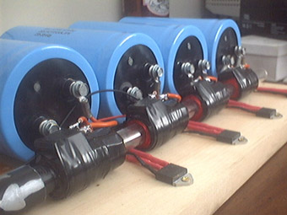
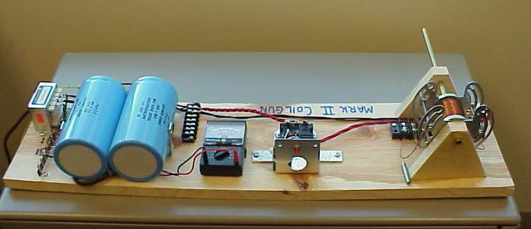
（一）線圈砲：線圈砲又稱交流同軸線圈砲．它是電磁砲的最早形式，由加速線圈和彈丸線圈構成。根據通電線圈之間磁場的相互作用原理而工作的。加速線圈固定在炮管中，當它通入交變電流時，產生的交變磁場就會在彈丸線圈中產生感應電流。感應電流的磁場與加速線圈電流的磁場互相作用，產生洛侖茲力，使彈丸加速運動並發射出去。

★電磁砲實驗與製作
一、做一個有趣的電磁砲
電磁砲是一種利用電流磁場產生的作用力驅動炮彈加速運動的武器,由於它具有無聲,無煙,可控等特點,所以它己引起許多軍事科學家的興趣和重視。
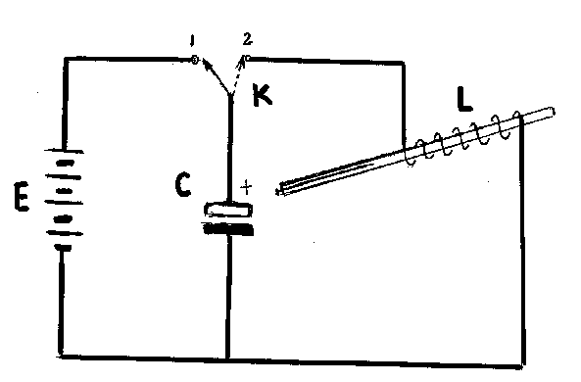
這可以通過下面簡單電磁砲的實驗原理裝置進行實驗研究,圖中K為單向雙擲開關,C為容量較大的電容,L為電磁砲的驅動線圈(自製),實驗時先將K扳向1,使C處於充電狀態,然後將K扳向2,這時C進入放電狀態,電容C內的約0.1庫倫的電量在1毫秒之內通過L進行放電,形成瞬間強大放電流(近100A),從而產生一個瞬態較大的磁場力,使電磁砲管內的縫衣針很快飛出。
電磁砲的驅動線圈是用直經0.5毫米的漆包線在外經6毫米的空心玻璃管上亂繞50匝即可,電磁砲的”砲彈”可用大頭針或細鐵絲替代。
二、認識電容的充放電
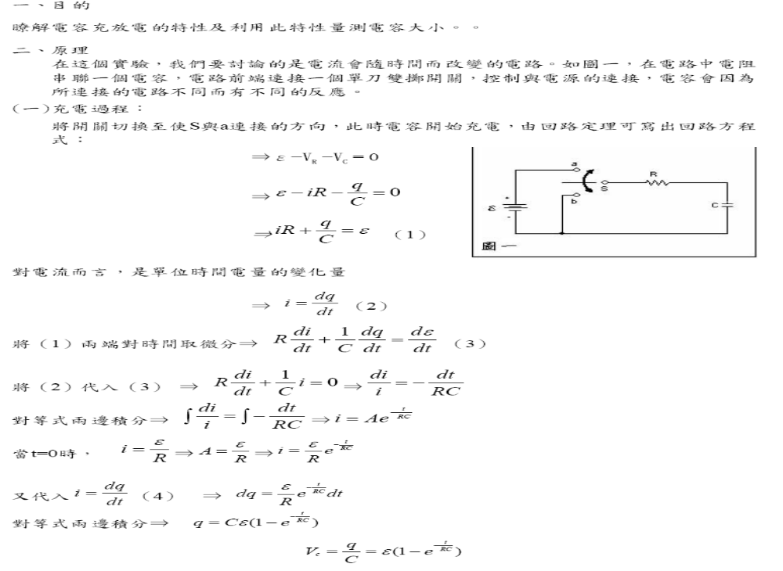

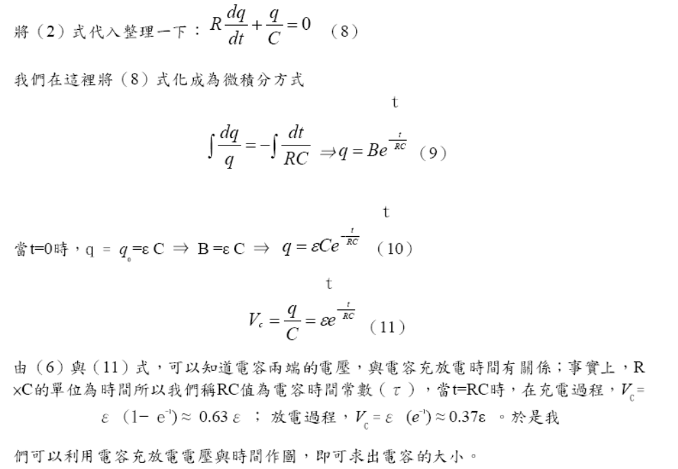
I
τ
0.37I₀
I₀=V₀/R
t
I₀=ε/R
τ=RC
cε
t
q
0.63cε
τ
圖1 電容充電時，電容兩端的q-t關係圖

圖2 電容充電時，電阻兩端的I-t關係圖

q
τ
0.37cε

cε
t
0.37I₀
τ
I
t
I₀=ε/R
圖3 電容放電時，電容兩端的q-t關係圖

圖4 電容放電時，電阻兩端的I-t關係圖

三、認識螺線管的外部磁場
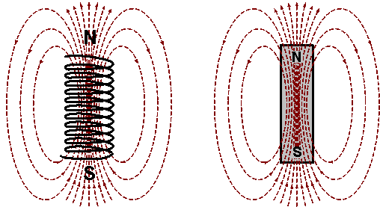
把電線繞成一個圓柱狀線圈，而它的直徑比圓柱的高度小時，這個線圈就稱為螺線管。通電螺線管中的磁場是均勻的，與磁鐵的磁場相似，而磁場方向與螺線管的中心軸平行，見圖1。

圖1: 螺線管的磁場與磁鐵的磁場相似
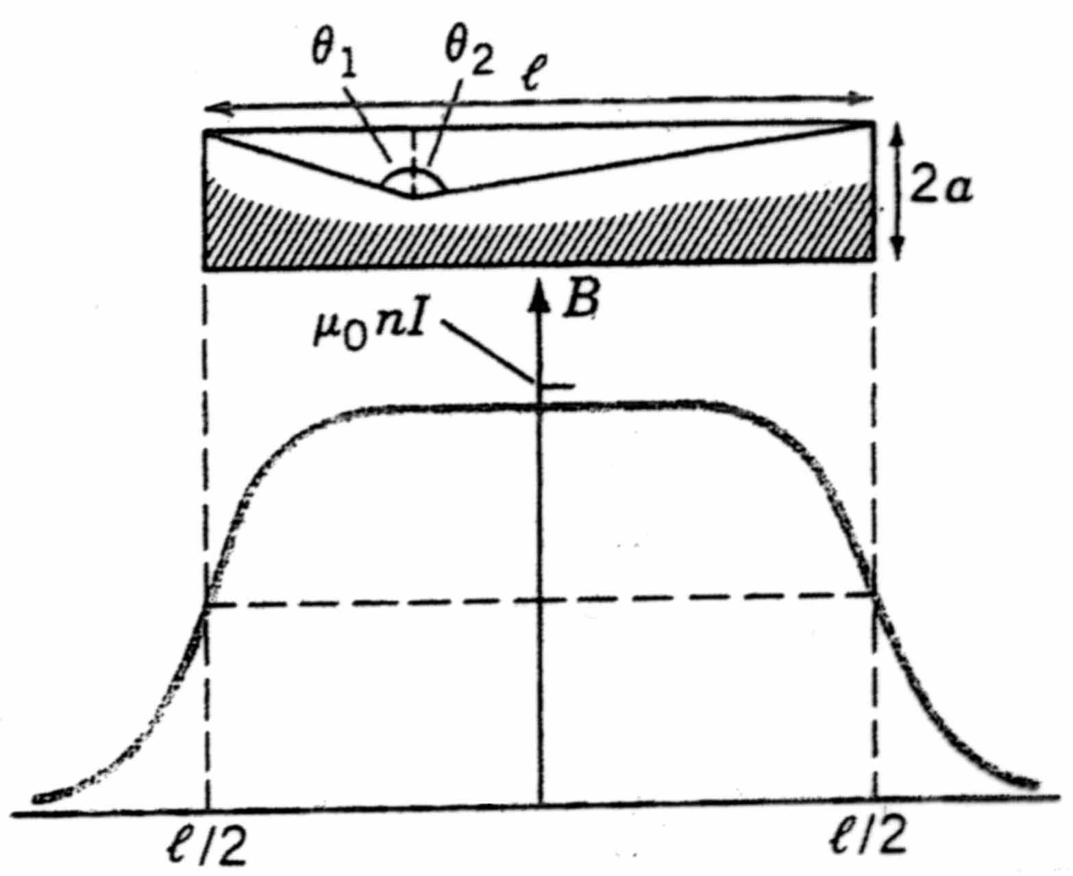
- 螺線管磁場分佈

1.Coilgun introduction

In search for an appropriate shooting mechanism for our robot a lot of possibilities were investigated including the creating of acceleration (and thus velocity) by use of “simple” magnetism. Obviously there is more than one way of creating velocity with (electro-) magnetism. One can, for example, accelerate a simple wire in the magnetic field of two other wires all conducting the same electric current. This possibility was immediately excluded since this would require large constant amounts of current which are not available in out robot. Other possibilities are creating forces between permanent magnets and electro magnets (electro magnets can be controlled) in which possibilities are almost infinite. However a seemingly very promising method would be a so called coil gun. This accelerating device is based on the magnetic principle of induction. If a magnetic flux is generated in a current carrying solenoid (by increasing or decreasing the current) a conducting material (such as iron etc.) that is placed in the core of such a solenoid will create its own induced magnetic field trying to compensate for the change of magnetic field. The two fields (magnetic field of the solenoid and induced magnetic field in the material) exert a force on each other thus creating an acceleration of the conducting material in the coil. In principle this acceleration can be used to accelerate our football. The principle should now be clear intuitively but we have to make sure enough velocity can be generated in this manner. Calculation of the force between the field of the solenoid and the induced field in the conducting material is very difficult since this induced field is a time dependent and difficult measurable property. We therefore performed the calculations for the force between the solenoid and a permanent magnet which is simpler, we can in this way estimate the order of magnitude of the currents needed if we want to perform the same velocity generation with a conductor (and not a magnet!) The calculation for the magnet is written down below.

2. Theory

2.1 Magnetic field of a coil

Within an ideal solenoid, this means a cylindrical coil of infinite length, it is known that B = μ₀ n I with n the number of turns per unit length, I the current through the coil and μ₀= 4π x 10⁻⁷ Tm/A. In real life however no such coil exists, and the fact that the solenoid is not infinite has to be accounted for. Hence for a coil of finite length l and radius r

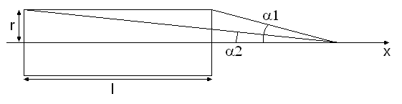
It can be proven that on the axis of the coil,
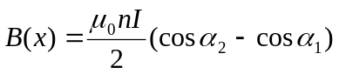.

Or that
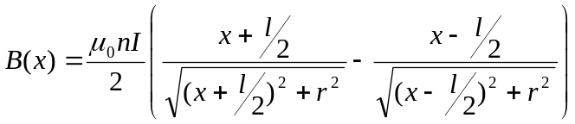.
Then in the middle of the coil, for 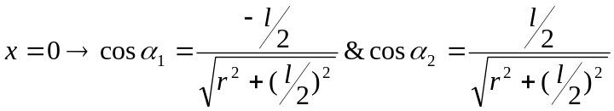 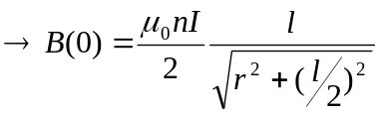. Thus we can see that for 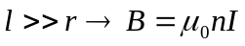. At the end of the coil 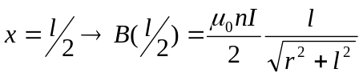 thus for 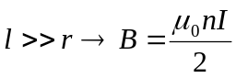 this is half of the induction of a coil with infinite length.

2.2 Magnetic force

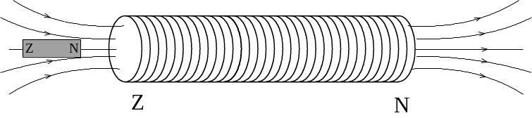We can now create a magnetic field in the coil by creating an electric current in the coil. If this current flows from the left to the right this generates a south-pole on the left side and a north-pole on the right.
If we now consider a magnet in the neighbourhood of the coil, on the axis of the coil, the coil exerts a force on this magnet.
The force on the magnet depends on the change of the magnetic field on the axis of the coil and the magnetisation of the little magnetic bar. If we now consider a coil with the axis of the coil on the x-axis and the middle of the coil that corresponds with x=0 then we can prove that for a small bar 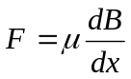 with
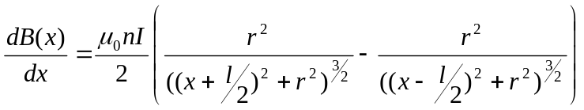
In the following picture the gradient of the B-field is plotted for μ₀nI=1, r=1cm and l=10cm.
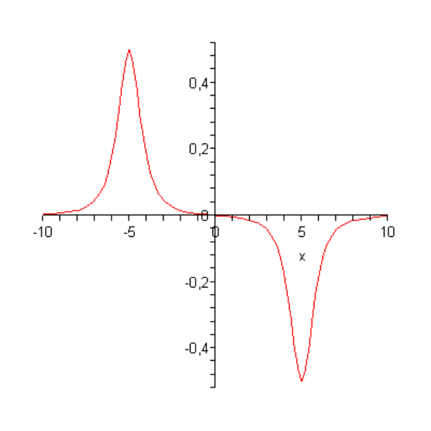
fig.: B-field gradient.

If we take a closer look to this figure we can see that once the magnet is situated in the coil the magnet oscillates from left to the right.

If the force can be calculated we also can calculate the kinetic energy. Because the change in kinetic energy is equal to the work delivered by the force.
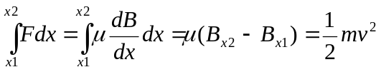
This results in :
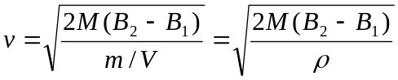
With M the magnetization density.
If we consider that 80% of the energy of the magnetic bar can be transferred to the ball than:
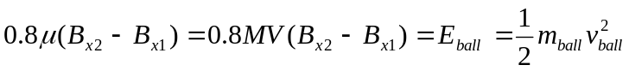
With V the volume of the magnetic bar.
If we now consider a coil of l=10cm and r=2.5cm and magnetic bar of dimensions 0.5x0.5x3 cm³.
The maximal magnetization of iron is M=2.0x10⁸A/m³. Than for a starting-point of x₁=-5cm, end-point x₂=0cm and m_{ball}=0.430kg,
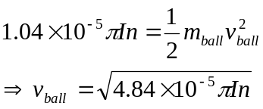
For n=5000 we get the following figure.
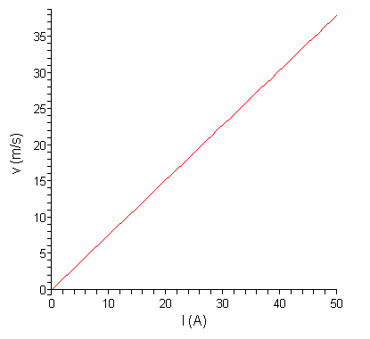
And for I=20A.
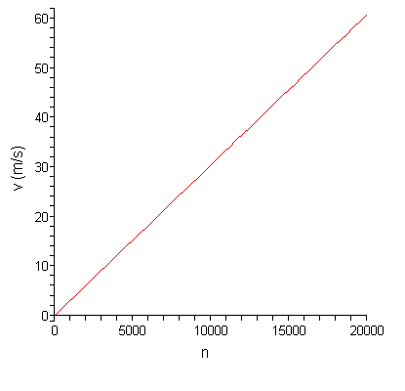

Conclusion
The calculations above prove that with a carefully selected solenoid (amount of turns) and a well designed electric circuit to provide enough power one should be able to give a ball enough velocity to play robocup. Practical obstacles remain however; timing is crucial in this case and requires regulating circuitry which could be quite complicated. Recharging time could be large since capacitors will have to be used in order to get enough power from a battery supply such as the one in a robot, and of course these capacitors need time to recharge. Finally it is at this time not possible to conclude anything about the size or weight of such a system. For these reasons further investigations are necessary before one can conclude which shooting device is preferred.

四、RLC電路振盪
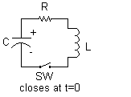
＊The voltage V and current I as a function of time:
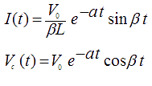 where 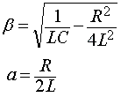
＊Critical Damping
Look at the term under the square root sign, which can be simplified to: R²C²-4LC
- When R²C²-4LC is positive, then α and β are real numbers and the oscillator is over-damped. The circuit does not show oscillation. | 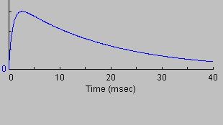
- When R²C²-4LC is negative, then α and β are imaginary numbers and the oscillations are under-damped. The circuit responds with a sine wave in an exponential decay envelope. | 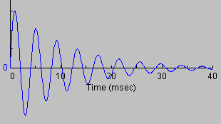
- When R²C²-4LC is zero, then α and β are zero and oscillations are critically damped. The circuit response shows a narrow peak followed by an exponential decay. | 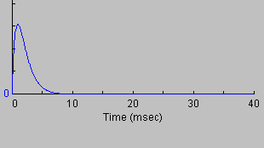

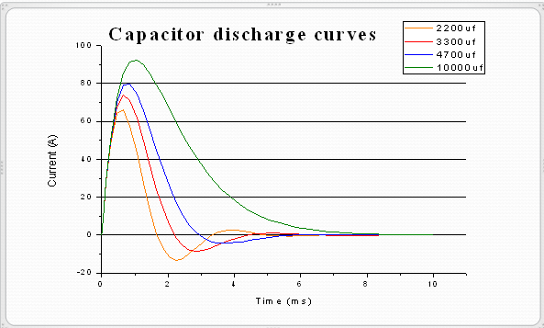
上述RLC電路振盪結果，可藉由電容隨時間的放電曲線得到符合的結果。

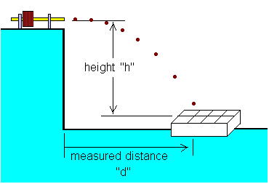
五、速度的測量
水平拋射的運用
以初速度v₀，高度為h時，
    - 歷時：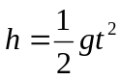 ∴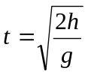
    - 水平射程：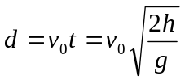
此實驗是利用的公式，量測水平射程d以及出射高度h，
帶入計算可得出射速度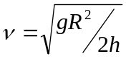。

六、實驗裝置
本次實驗使用3個串聯的電源供應器，提供電容充電最大電壓到50V。
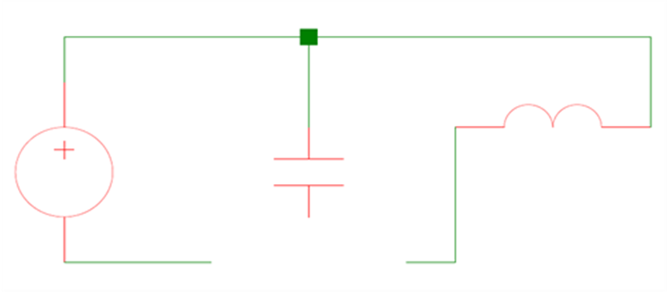
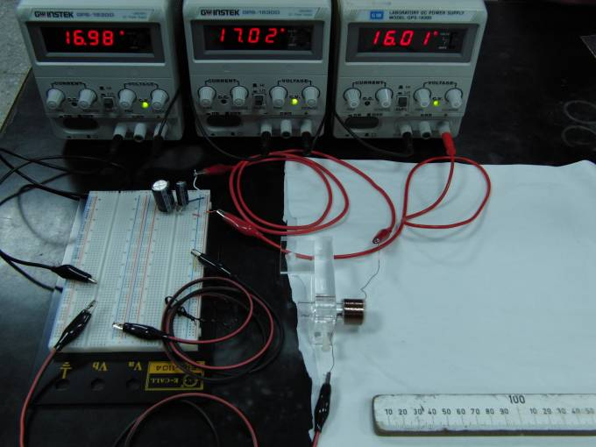
A
B

七、實驗步驟
1.架好儀器線路，並記下電容值大小，計算電容常數，預估何時充電完成，並將開
關接至A端點開始充電，且須記下電壓值大小(此時螺線管為斷路!)。
2.充電完畢時將電源供應器改為斷路，將開關接至B端點，使其形成通路，電容開
始對螺線管放電。
3.砲彈射出後，量測砲彈射程距離和砲彈質量及發射砲台高度，計算實驗所得之
速度。
4.改變實驗變因重複實驗，請見問題處!

九、問題
1.Ball在炮管內的放置位置與速度大小是否有關? 實驗研究結果Ball距螺線管左端多少為最佳?或放入螺線管多少為最佳?
2.螺線管的磁場大小和速度大小是否相關，試著探討線徑相同之螺線管相同長度、不同匝數(1公分約100匝和1公分約200匝)；及不同長度(1和2公分)、相同單位匝數(每1公分約100匝)的速度大小比較。
另外亦比較不同線徑大小之螺線管的速度大小。
3.電源E的電壓高低, 與速度大小是否有關? 試一下並說明其原因?
4.電容器C的電容量與速度大小是否有關? 通過多個電容器並聯或串聯改變電容器的總容量試一下速度大小和效果,並請分析和說明其原因?
5.Ball的重量和速度大小是否相關?是輕好還是重好?
6.是否還有其它變因，試著找看看!

十、結果

- Speed vs. Voltage
(1)Parameter:Voltage (from 30V ~50V)‏
Initial Condition :
Capacitance: 1470μF
Number of Layers: 5 layers
Length: 1.5 cm
Position of Cannon: In front of the
solenoid (0 mm)‏
Mass: 0.014 g

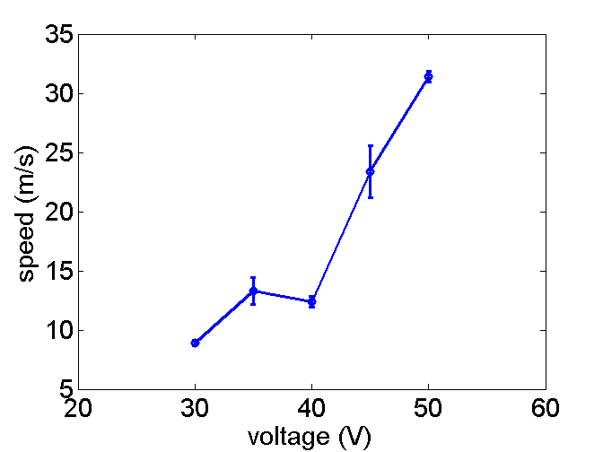
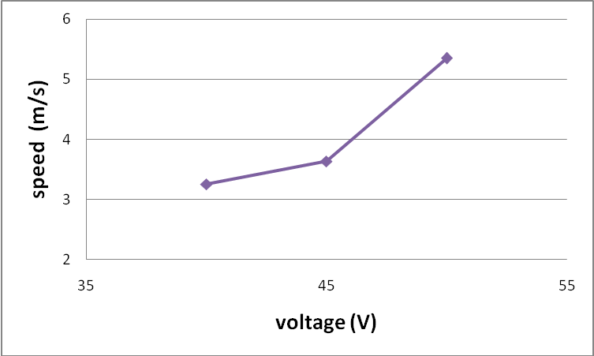

(2)Parameter: Voltage (from 40V ~50V)‏
Initial Condition :
Capacitance: 3300μF
Number of Layers: 6 layers
Length: 1 cm
Position of Cannon: In front of the
solenoid (0 mm)‏
Mass: 0.014 g

Speed is positively related to the voltage.

- Speed vs. Capacitance

(1)Parameter : Capacitance (from 470~3300μF)‏
Initial Condition :
Voltage: 50 V
Number of Layers: 5 layers
Length: 1.5 cm
Position of Cannon: In front of the
solenoid (0 mm)‏
Mass: 0.014 g
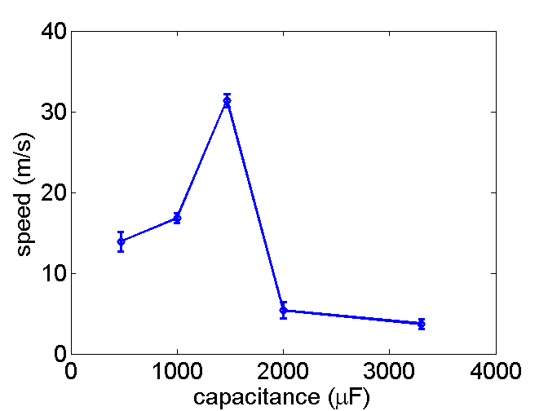
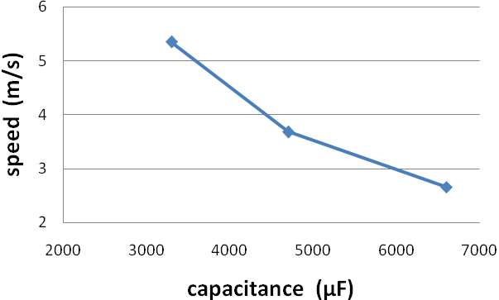

A peak occurs at 1470 μF.
(2)Parameter:Capacitance (from 3300~14100μF)‏
Initial Condition :
Voltage: 50 V
Number of Layers: 6 layers
Length: 1cm
Position of Cannon: In front of the
solenoid (0 mm)‏
Mass: 0.014 g

- Speed vs. Number of Layers

(1)Parameter : Number of layers (4~8 layers)‏
Initial Condition :
Voltage: 50 V
Capacitance: 1470 μF
Length: 1.5 cm
Position of Cannon: In front of the
solenoid (0 mm)‏
Mass: 0.014 g
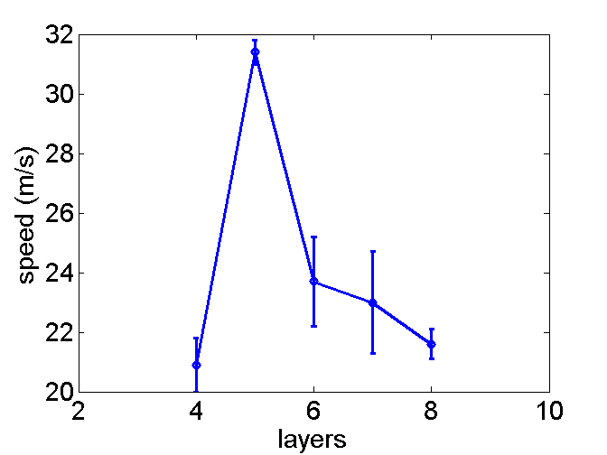
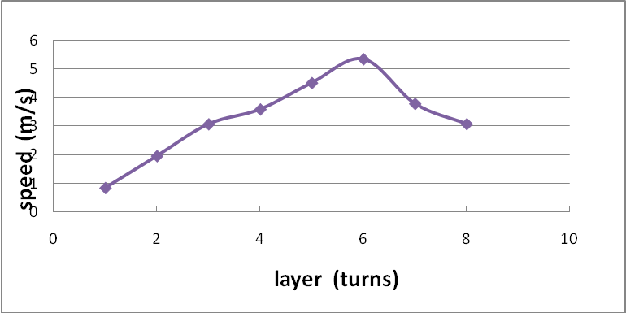

(2)Parameter : Number of layers (1~8 layers)‏
Initial Condition :
Voltage: 50 V
Capacitance: 3300 μF
Length: 1 cm
Position of Cannon: In front of the
solenoid (0 mm)‏
Mass: 0.014 g

A peak occurs at 5 layers.
A peak occurs at 6 layers.

- Speed vs. Solenoid length

(1)Parameter : Length (1, 1.5, 2, 2.5, 3 cm)‏
Initial Condition :
Voltage: 50 V
Capacitance: 1470 μF
Number of Layers: 5 layers
Position of Cannon: In front of the
solenoid (0 mm)‏
Mass: 0.014 g
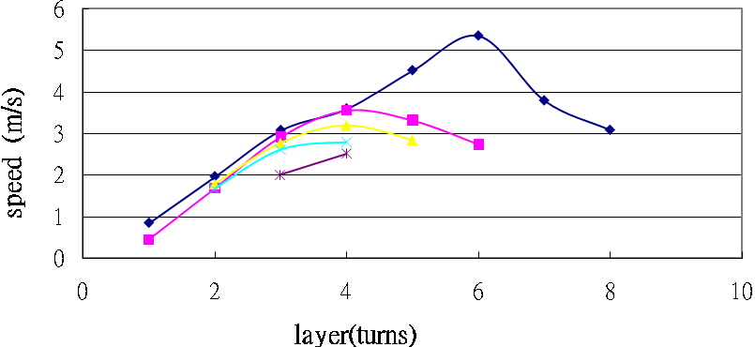
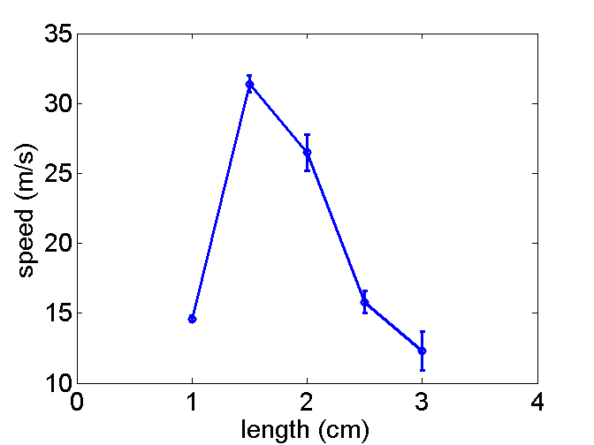

Solenoid 2.5cm

Solenoid 3cm

(2)Parameter : Length (1, 1.5, 2, 2.5, 3 cm)‏
Number of Layers: 1~8 layers
Initial Condition :
Voltage: 50 V
Capacitance: 3300 μF
Position of Cannon: In front of the
solenoid (0 mm)‏
Mass: 0.014 g

Solenoid 1cm

Solenoid 1.5cm
Solenoid 2cm

A peak occurs at 1.5 cm.
The fastest velocity occurs at 1cm and 6 layers.

- Speed vs. Position
(1)Parameter : Position (0~10 mm)‏
Initial Condition :
Voltage: 50 V
Capacitance: 3700 μF
Length: 1.0 cm
Mass: 0.083 g
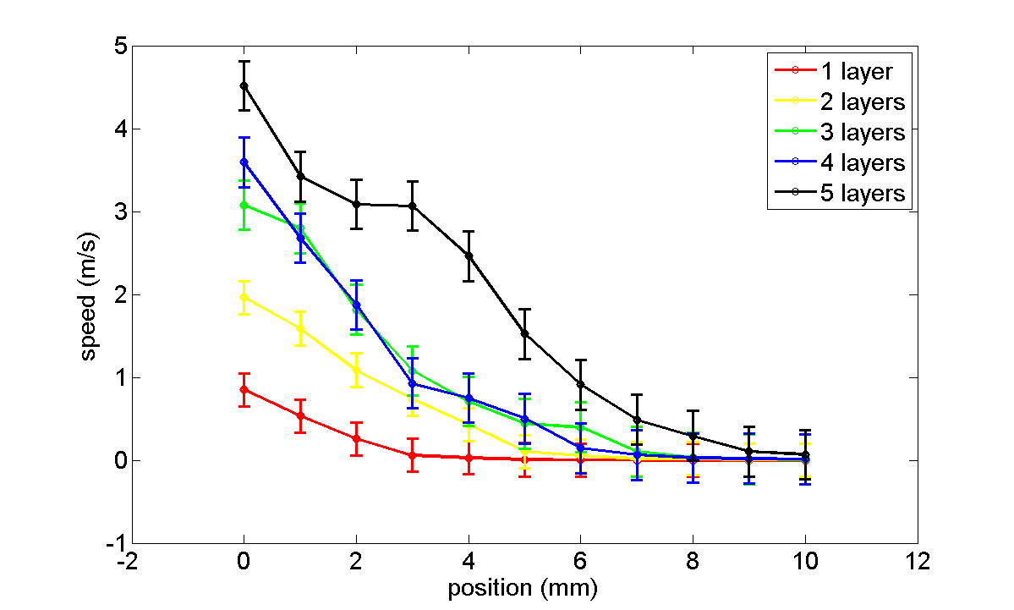
1 layer
4 layers
3 layers
2 layers
5 layers

(2)Parameter : Position (0~10 mm)‏
Initial Condition :
Voltage: 50 V
Capacitance: 3300 μF
Length: 1.0 cm
Mass: 0.083 g
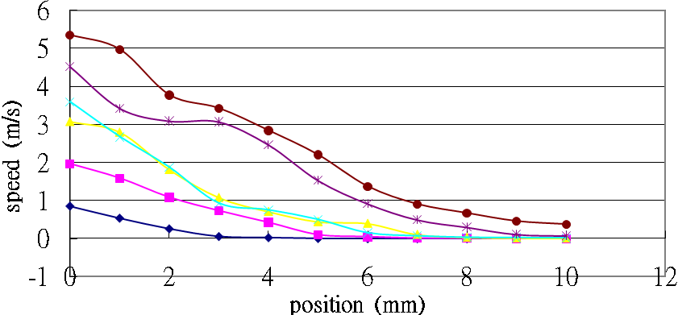
6 layers
1 layer
5 layers
2 layers
3 layers
4 layers
Speed reaches maximum when the ball is at the front of the solenoid.

- Speed vs. Mass
- Parameter : Mass (0.014, 0.083, 0.19 g)‏
- Initial Condition :
Voltage: 50 V
Capacitance: 1470 μF
Number of Layers: 5 cm
Length: 1.5 cm
Position of Cannon: In front of the solenoid (0 mm)‏
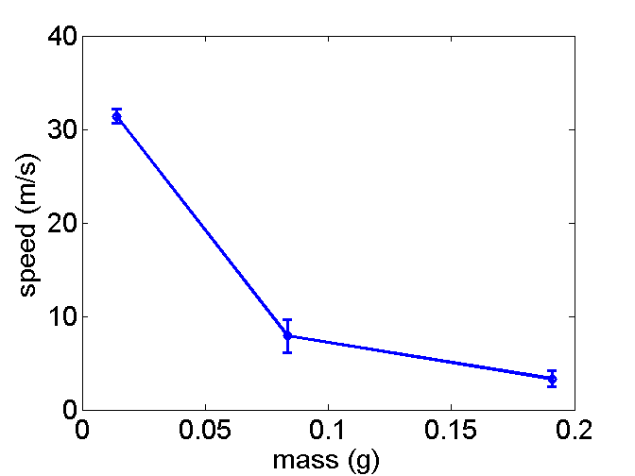

Faster when the projectile is lighter.

- Speed vs. Material
- Parameter : Material (iron, cobalt, nickel, copper)‏
- Initial Condition :
Voltage: 50 V
Capacitance: 1470 μF
Number of Layers: 5 cm
Length: 1.5 cm
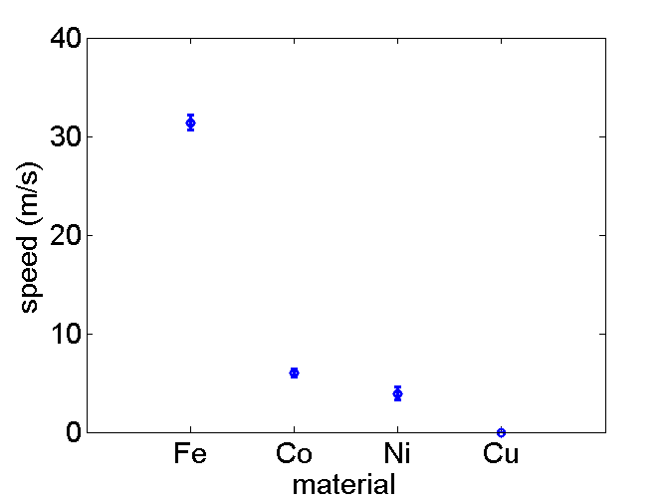
Position of Cannon: In front of the solenoid (0 mm)‏

As a good ferromagnetic material, iron flies faster than any other ones.

※引用Barry's Coilgun Design http://www.coilgun.info/about/home.htm

Finite Element Magnetics Model(FEMM)
you can analyze coilguns without building them and study effects that you can't build, by using finite element analysis (FEA) software and simulate your coilgun.Thanks to David Meeker, there is a free modelling package, FEMM v4.0. The software is powerful and free. You can write scripts to move parts and change parameters.
- FEM Models - Hollow Cylinder Projectile
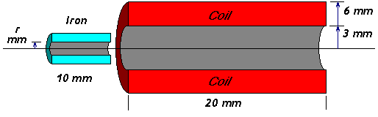
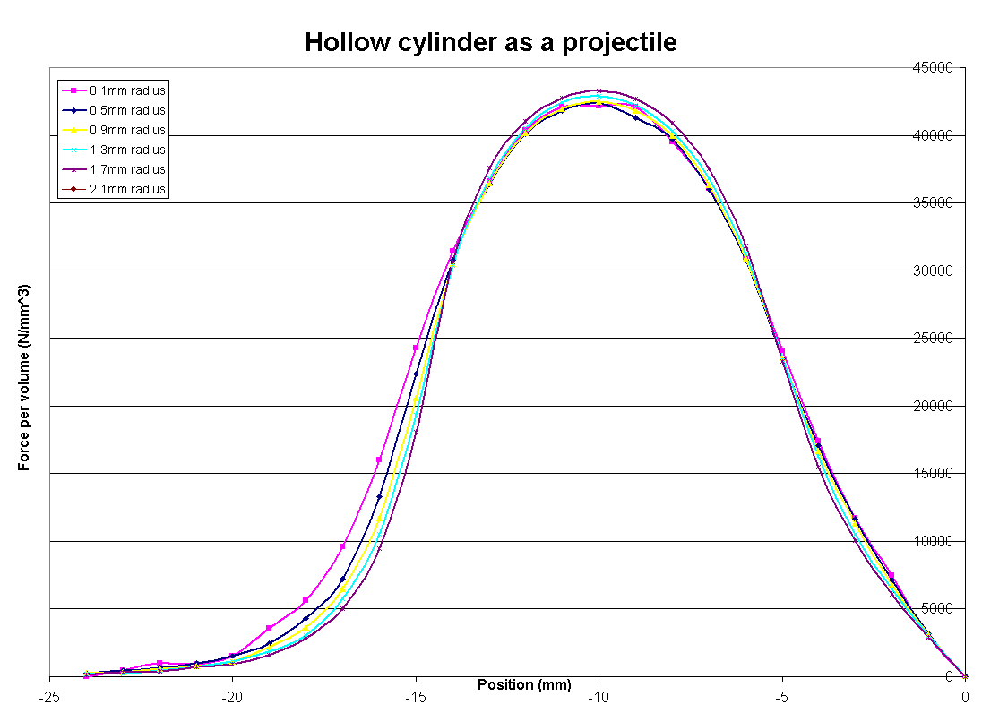

The graphs for seven different projectiles are practically on top of one another. Therefore, the force per unit of mass does not depend on the inside radius of a hollow cylinder of iron.

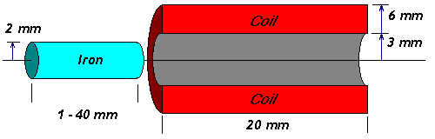
- FEM Models - Projectile Length
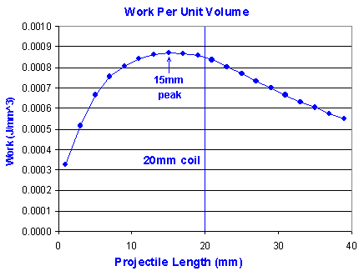
These results confirm the rule-of-thumb that projectiles should be about the same lengthas the coil.

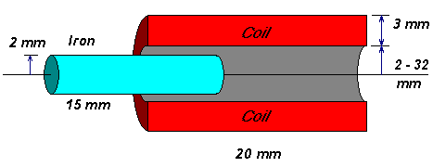
- FEM Models - Coil Diameter
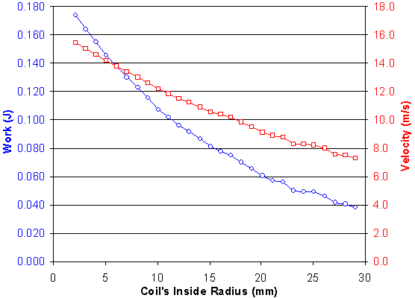
Smaller openings are better than bigger coils. In fact, smaller is always better. The graph proves that minimizing the air gap is important.

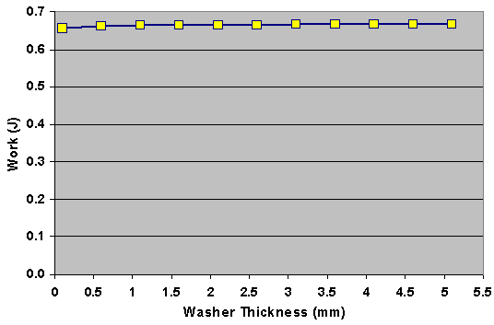
- FEM Models - Iron at Coil Entry
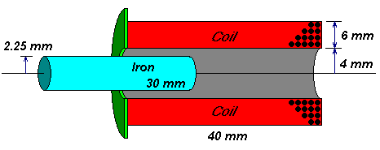
There is no dependence on work and washer thickness. The total kinetic energy is practically the same for every washer!

十一、討論
由前述通有電流的螺線管，會產生一磁場，能吸引具有磁性的物質移動，其磁力的圖如下，

fig.: B-field gradient.

由此可知當砲彈在螺線管的邊邊時具有最大的受力，但此種受力在左半邊屬於加速，在右半邊屬於減速。
若考慮螺線管邊緣場之磁力作用，則當電容放電時間常數較長的時候，會使螺線管一直有相同方向之磁場存在，使砲彈在通過原點時會受到一個反向的力而減速。
此時若考慮電容放電時間常數較短的時候，且只有一次震盪，此震盪會使磁場反轉，使磁力也發生反轉的效應，若條件控制在最理想的狀況，即砲彈受到磁力感應進入螺線管，在通過螺線管的中點前，會受到一往前加速的力，當砲彈通過螺線管的中點時，電容電流恰好下降為零，而後砲彈一通過中點時電容放電電流經過一次震盪反向後，磁場反轉也使磁力反轉，使砲彈一樣繼續受到往前加速的力，如此一來砲彈在整個過程中都是受到加速的!


